 |  | Riverside Hospital  742 Evergreen Terrace Springfield, IL, 62704 Main  Phone: (217) 555-1212 Gastroenterology Department: (217) 555-3434  Patient Information Line: (217) 555-9090
Procedure: Colonoscopy  Date of Procedure: May 20, 2025  Physician: Dr. Eleanor Vance, MD  Activity:  Rest at home for the remainder of today. You received sedation and may feel sleepy or dizzy. You must not drive a car, operate any machinery, or make any important financial or legal decisions for 24 hours. Strenuous exercise should be avoided for 48 hours.  Diet:  Begin with clear liquids such as water, broth, or ginger ale for the next 4 hours. If clear liquids are well tolerated, you may advance to a soft diet (e.g., scrambled eggs, mashed potatoes, plain chicken). Avoid alcohol, spicy foods, fried foods, and high-fiber foods for 24 hours. Resume your normal diet on May 22, 2025, as tolerated. Drink at least 8 glasses of water over the next 24 hours to ensure adequate hydration.  What to Expect:  1. You may experience some abdominal bloating, gas, or mild cramping for the next 12-24 hours. Passing gas frequently will help to relieve this.  2. A small amount of blood (a few streaks on toilet paper) might be present with your first one or two bowel movements. This is not unusual. |  |  | - Normal Colon  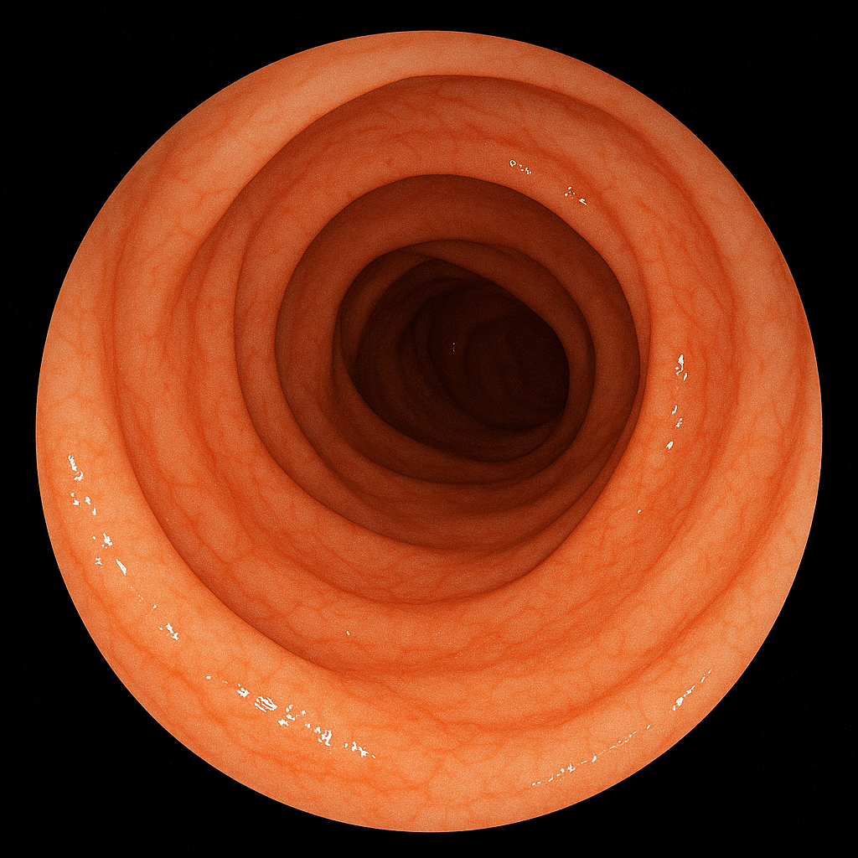
- Colon
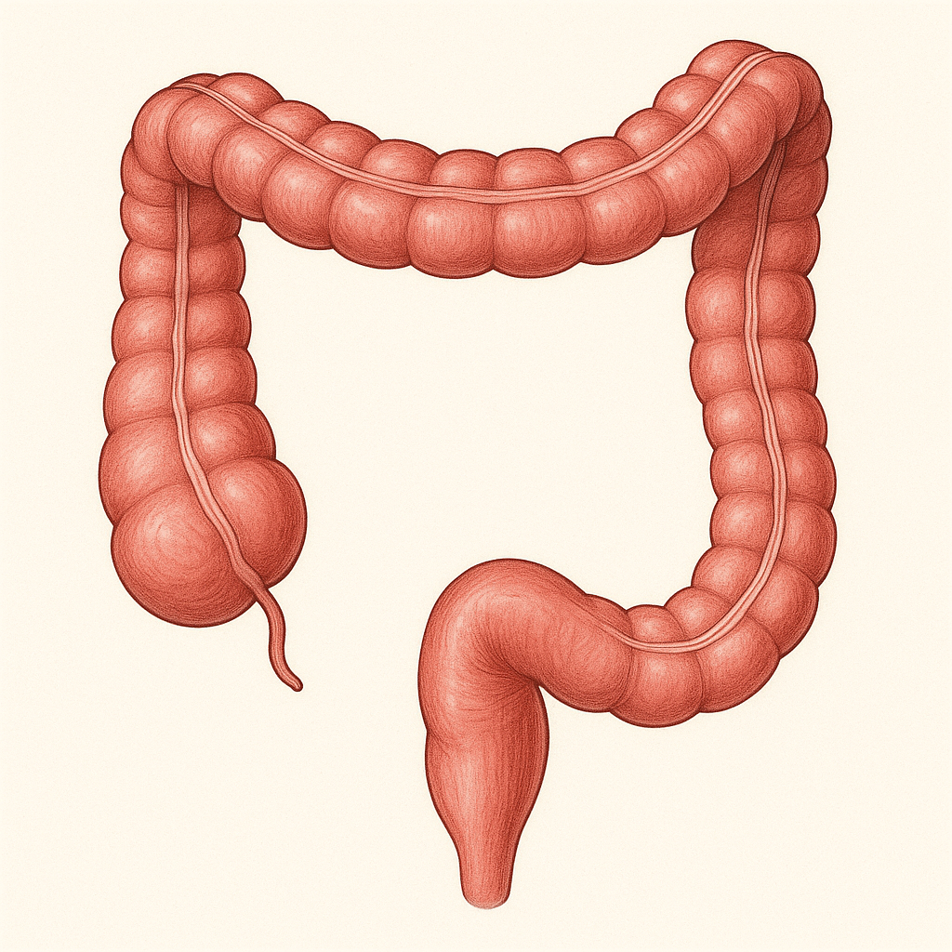
Findings:
1. The colonoscopy was successfully performed, with scope advancement to the cecum. The cecum was visualized and appeared normal.
2. The entire examined colon, from the cecum to the rectum, showed a normal pink mucosa with usual vascular patterns.
3. No polyps, masses, diverticula, inflammation, or other abnormalities were identified during the examination.
The overall impression is a normal colonoscopy.
Follow-Up:
As your colonoscopy was normal and no biopsies were taken, no immediate follow-up appointment is required regarding this procedure.
You will receive a letter summarizing these findings by mail within 10 business days.

