 |  | Cityside Gastroenterology Clinic  4500 Metro Parkway Metropolis, CA 90210 Phone: (310) 555-4321  Fax: (310) 555-4322
You have had a colonoscopy under sedation. Because of the medication you received, it is required that a responsible adult drives you home and stays with you. For your safety over the next 24 hours, you must not drive, operate machinery, or make any legal decisions. Please rest for the remainder of the day. |  |  | - Normal Colon  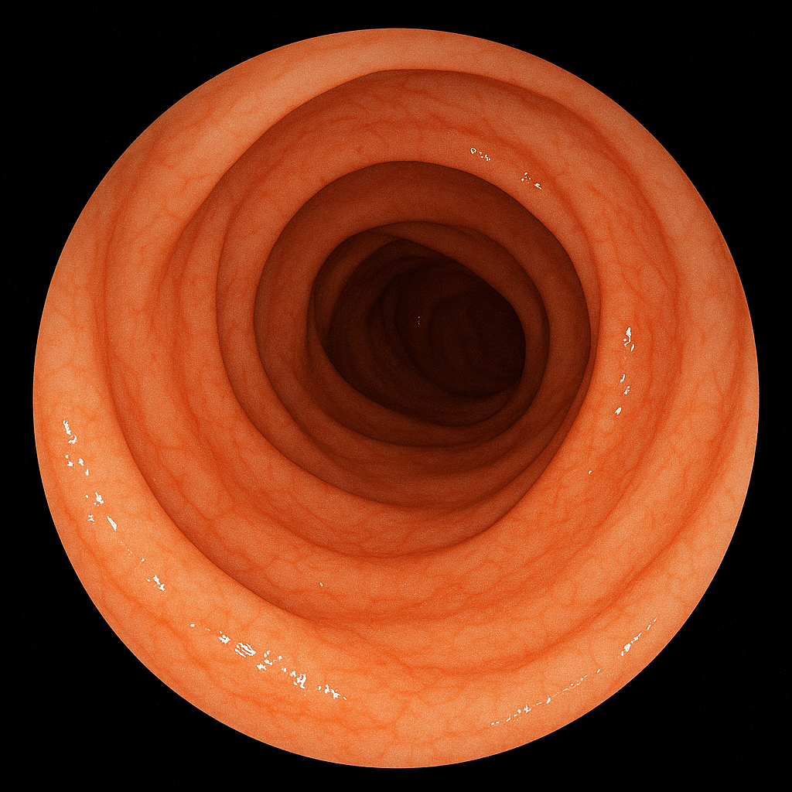
- Colon
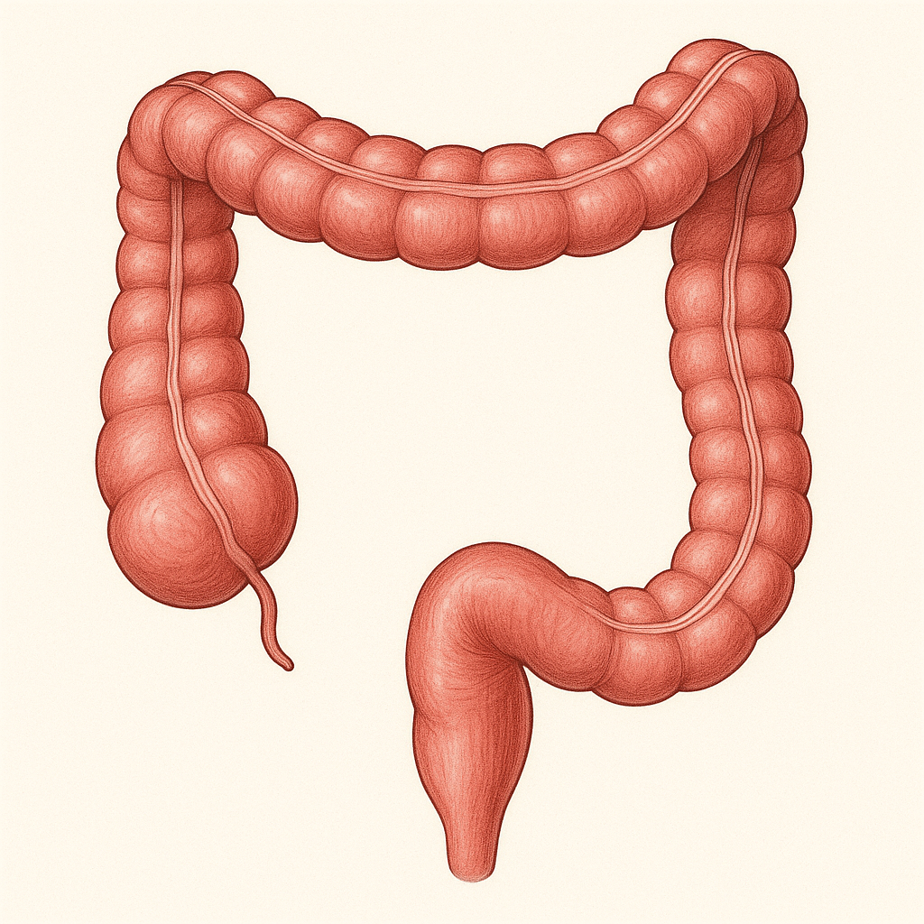
Impressions:

Normal Colonoscopy: The examination of the entire colon, from the rectum to the cecum, was successfully completed and revealed no abnormalities. The colonic mucosa was normal in appearance throughout. No polyps, masses, or evidence of inflammation were identified.
Diet: Begin with liquids and light foods (e.g., soup, toast). You may advance to your regular diet as you tolerate it. Do not consume alcoholic beverages for at least 24 hours.
Activity: You may resume your normal activities, including work, tomorrow.
Follow-Up: Given the normal findings, your next screening colonoscopy is due in 10 years.
Warning Signs: Please contact our office or proceed to the nearest emergency room if you develop severe abdominal pain, significant rectal bleeding, fever, or persistent nausea.

