 |  | Tri-County Digestive Health Specialists 789 Wellness Boulevard, Suite 200 Oakmont, PA 15139  Phone: (412) 555-3456  Fax: (412) 555-3457  Procedure Date: 06/21/2025
You have completed your colonoscopy, a procedure performed under sedation to examine your large intestine. The anesthetic medications administered during your procedure will continue to significantly impair your reflexes, cognitive function, and judgment for a full 24 hours. For your health and safety, it is absolutely essential that you and your designated caregiver read and strictly adhere to the following detailed discharge instructions.  CRITICAL SAFETY PRECAUTIONS (Next 24 Hours)  Your safety is our primary concern. The sedative effects are long-lasting and can create a risk for accidents and injury.  Driving and Transportation: You are legally and medically prohibited from driving any type of vehicle, including a car, motorcycle, or even a riding lawnmower, for 24 hours. You must be driven home by the responsible adult you have designated. Under no circumstances may you take a taxi, bus, or rideshare service alone.  Activity Restrictions: Do not engage in any strenuous or potentially hazardous activities. This includes exercising, going to the gym, jogging, or lifting heavy objects (anything over 10 pounds). Avoid activities that require balance and coordination, such as cooking over a hot stove.  Decision Making: Do not make any important or legally binding decisions. This includes signing contracts or documents, making significant financial transactions, or engaging in complex work-related discussions. Your judgment is considered impaired. |  |  | - Normal Colon  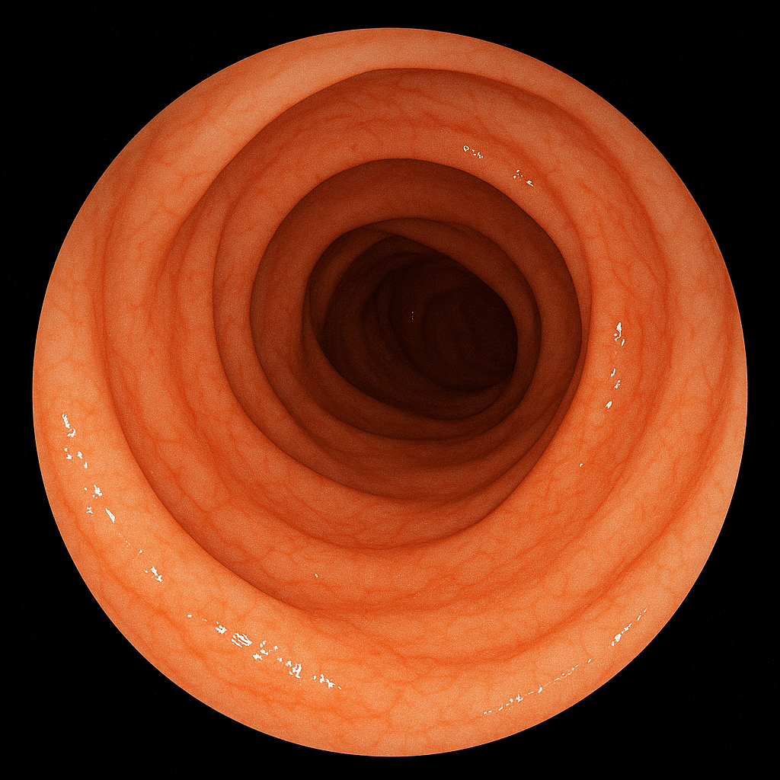
- Colon
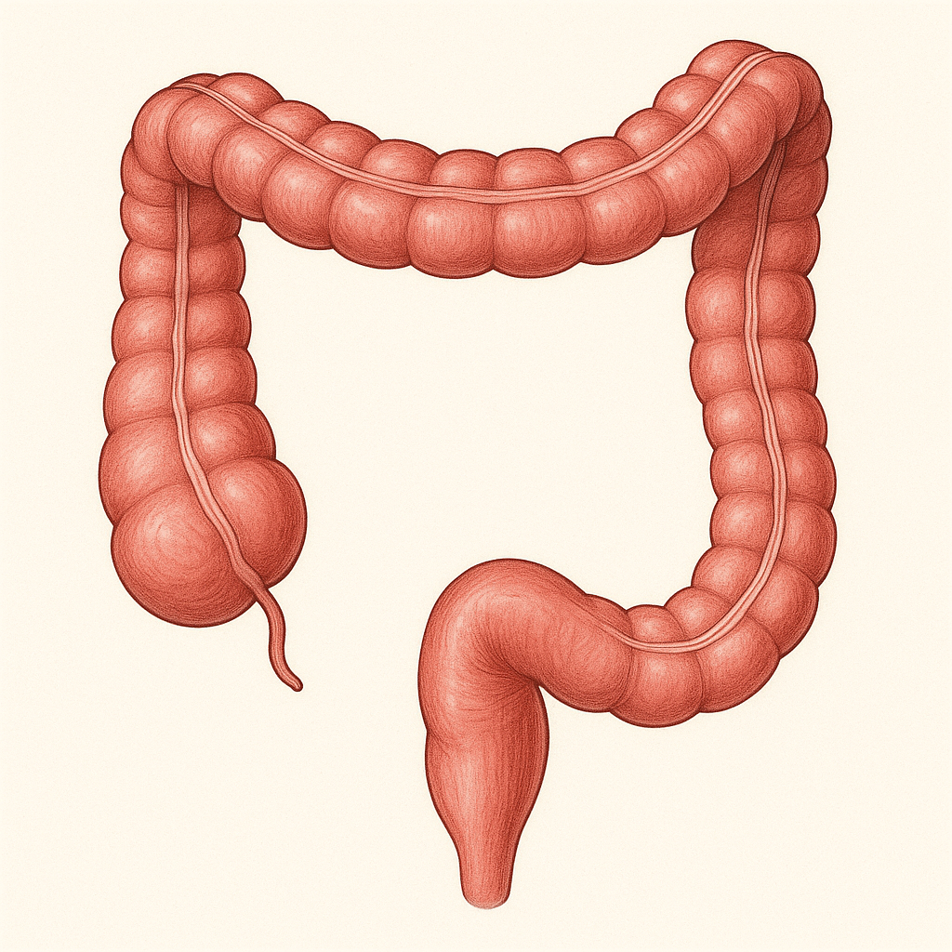
Impressions:

Normal Colonoscopy: A complete examination to the cecum was performed. The colonic mucosa was pink and healthy, with a normal vascular pattern throughout the visualized segments of the large intestine. There was no evidence of polyps, tumors, diverticulosis, inflammation, or other mucosal abnormalities.
Biopsy Information: No polyps were found, and no tissue samples (biopsies) were taken during your procedure. Therefore, you will not be receiving a separate pathology report.
Follow-Up Plan: Based on today’s normal findings, your risk profile indicates that your next routine screening colonoscopy should be scheduled in 10 years. We will send a reminder to you and your primary care physician.

