 |  | University Health System - Digestive Diseases Center  1000 Academic Medical Drive Lakeside, MI 48823  Phone: (517) 555-8900  Fax: (517) 555-8901  Procedure Date: 06/21/2025
You have undergone a colonoscopy today. The sedation you received will affect your coordination and judgment for the rest of the day. For your safety, you must have a responsible adult drive you home and stay with you. For the next 24 hours, do not drive, operate any form of machinery, drink alcohol, or sign legal documents. You should rest at home for the remainder of the day and can resume normal activities tomorrow. |  |  | - Normal Colon  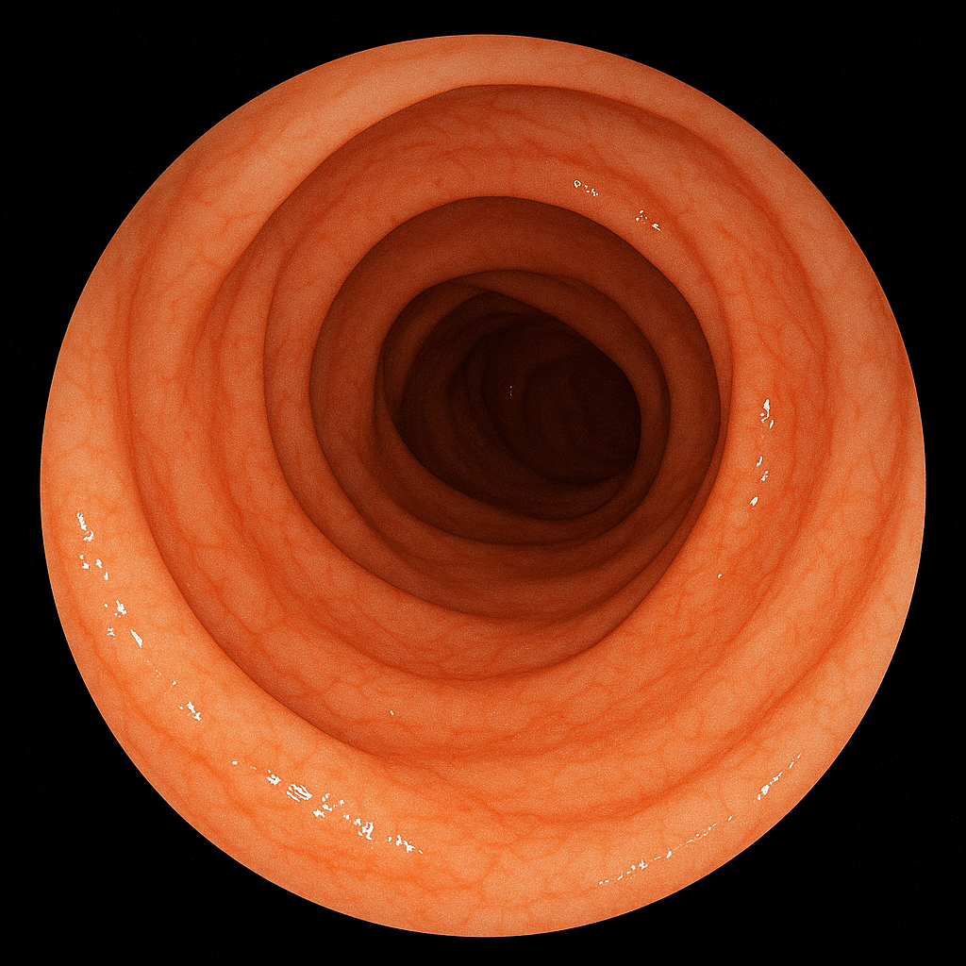
- Colon
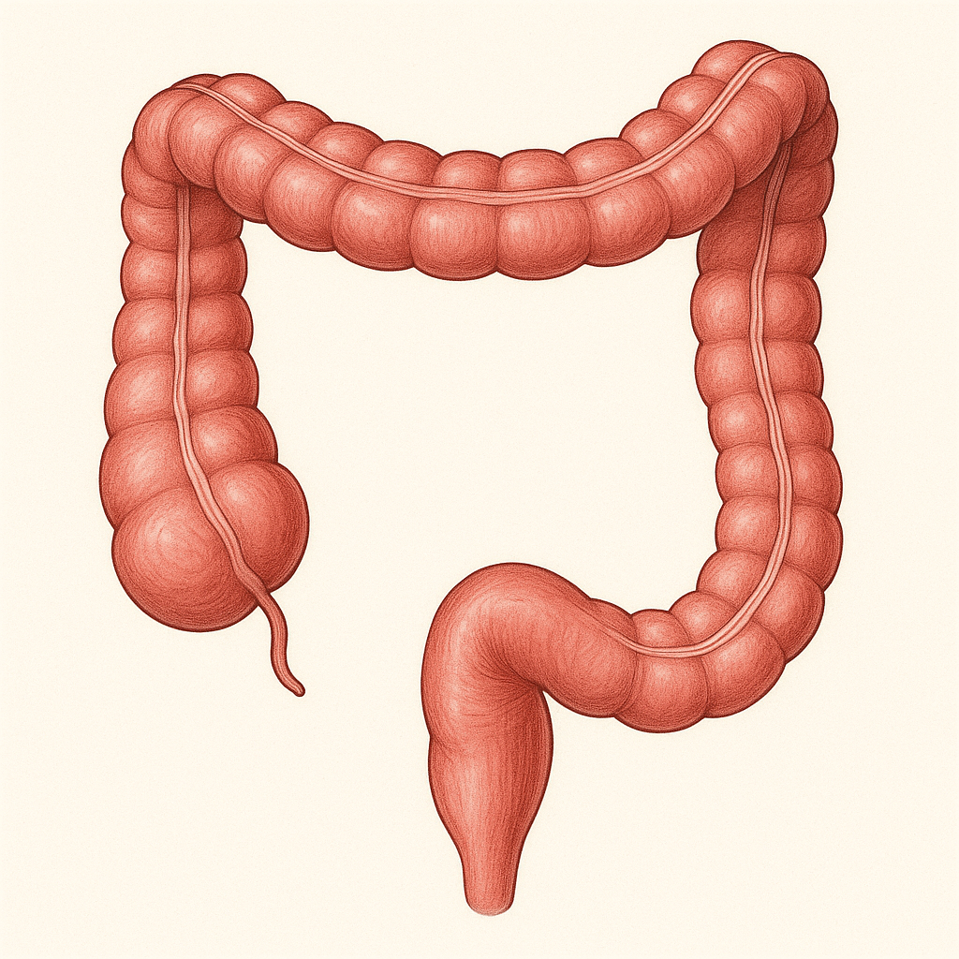
Impressions:

Normal Colonoscopy: The procedure was complete to the cecum. Bowel preparation was excellent, affording clear views of the entire mucosal surface. The colonic architecture was normal, with no evidence of polyps, masses, diverticula, or inflammatory changes.
Diet: You may resume your diet as tolerated. We recommend starting with light foods and liquids and avoiding heavy or greasy meals for your first meal.
Activity: Rest today. You may return to your usual activities 24 hours after your procedure.
Follow-Up: As the examination was normal, your next routine screening colonoscopy is recommended in 10 years.
Important: Please proceed to the nearest emergency room if you develop severe abdominal pain, a fever, or significant rectal bleeding.

