 |  | Desert Bloom Gastroenterology  123 Sonoran Health Circle, Suite B Phoenix, AZ 85004  Phone: (602) 555-7000  Fax: (602) 555-7001  Procedure Date: June 21, 2025
You have undergone a colonoscopy with intravenous sedation. The medication will remain in your system for several hours, affecting your judgment and physical coordination. For this reason, you must be escorted home by a responsible adult who can also stay with you.  For the next 24 hours, your safety depends on following these rules:  Do not drive a car or operate any type of machinery. Your reaction time is slowed, making these activities dangerous.  Do not consume any alcoholic beverages. Alcohol can have an adverse interaction with the sedatives you were given.  Do not make any important decisions or sign any legally binding papers.  Rest and relax for the remainder of the day. You can return to your normal routine tomorrow.  It is common to feel bloated and experience gas or mild cramping after the procedure. This is normal and should resolve as you pass the air that was used during the exam. Walking can help this process. You may start with clear liquids and light foods (like soup or toast) and advance to your regular diet as you feel comfortable. |  |  | - Normal Colon  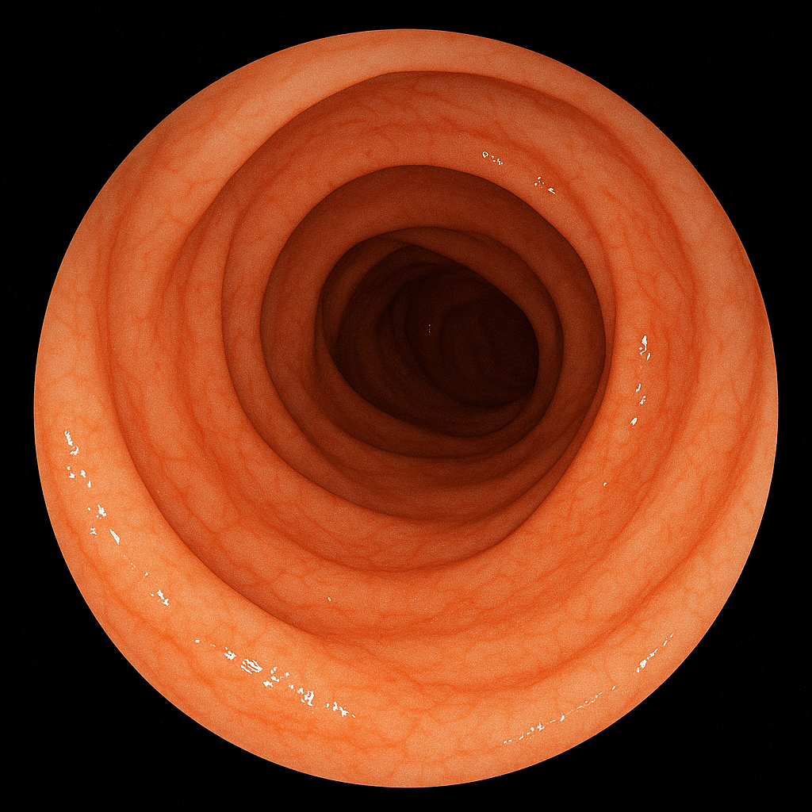
- Colon
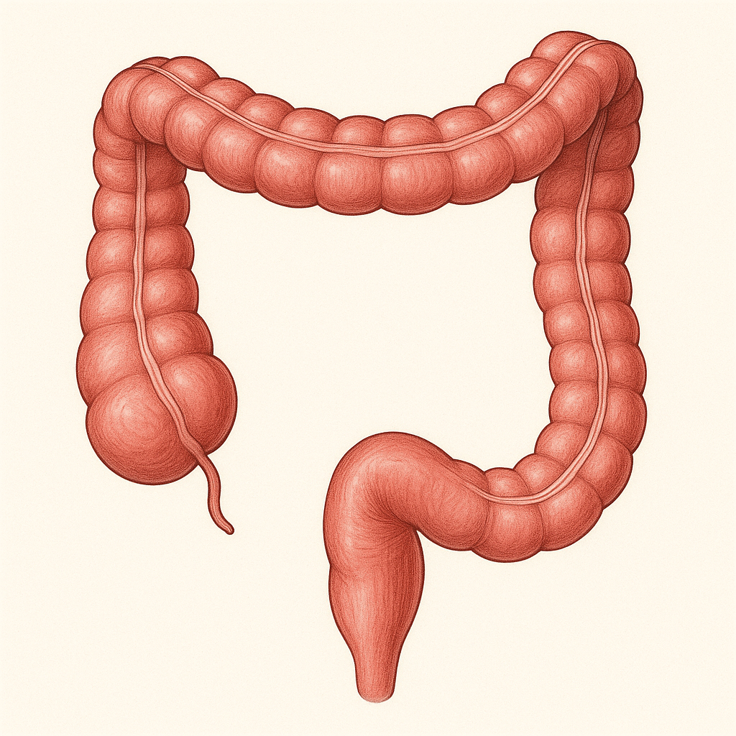
Impressions:

Normal Colonoscopy: A complete and successful examination of the entire colon was performed, with the tip of the endoscope reaching the cecum. The bowel preparation was excellent. The colonic mucosa appeared healthy and normal throughout. A retroflexion view in the rectum was also normal. There was no evidence of polyps, diverticulosis, or inflammation.
Findings: The results of your examination are normal. No tissue samples or biopsies were required.
Follow-Up: We recommend repeating this screening exam in 10 years, or sooner if new symptoms arise.
Communication: A copy of this report will be sent to your primary care physician, Dr. Angela Chu.
When to Seek Care: While complications are very rare, please go to the nearest emergency department if you develop severe abdominal pain, a fever, significant rectal bleeding, or persistent vomiting.

