Labour Market Panel Data Analysis
Wage Determinants, Union Premium & Employment Dynamics
2015–2022 Balanced Panel · 20 Individuals · 160 Observations

Generated from: stata-project/data/labor_panel.csv
June 2026

Overview
This report presents seven data visualisations derived from a balanced individual-level panel dataset covering labour market outcomes across the United States (2015–2022). The analysis replicates the core methods of the Mincer (1974) earnings equation and extends them to examine the union wage premium, the gender wage gap, returns to education, and the impact of the COVID-19 shock on employment. All figures were produced in Python using Matplotlib and Seaborn.

Figures

Figure 1 — Distribution of Log Hourly Wages (2015–2022)
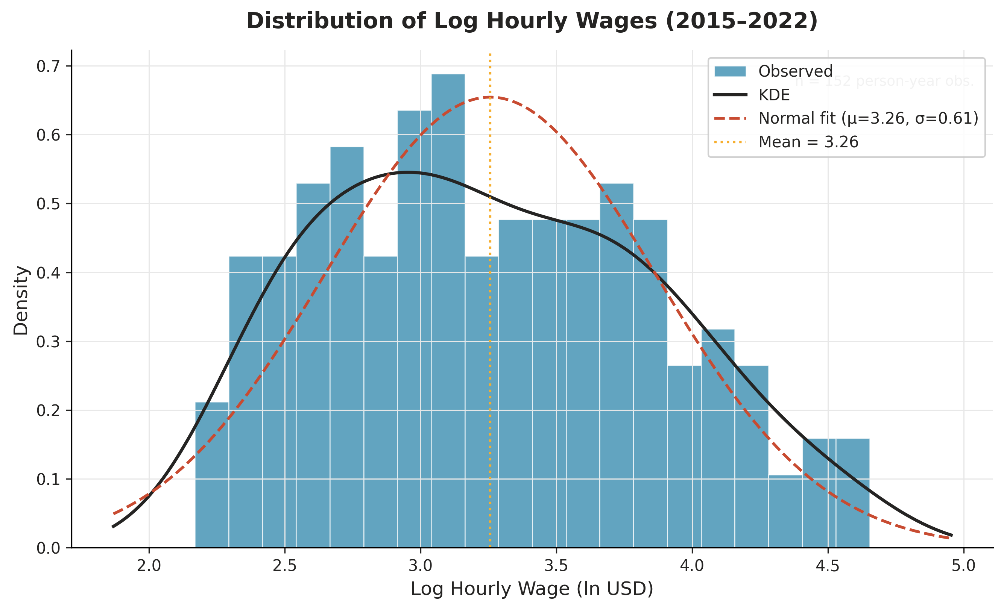
Histogram of log hourly wages with Kernel Density Estimate (KDE) overlay and a fitted normal distribution. The distribution is approximately normal with a slight positive skew, consistent with classical findings in wage economics. Vertical dashed line marks the sample mean (ln wage ≈ 3.23).

Figure 2 — Mean Hourly Wage by Gender, 2015–2022
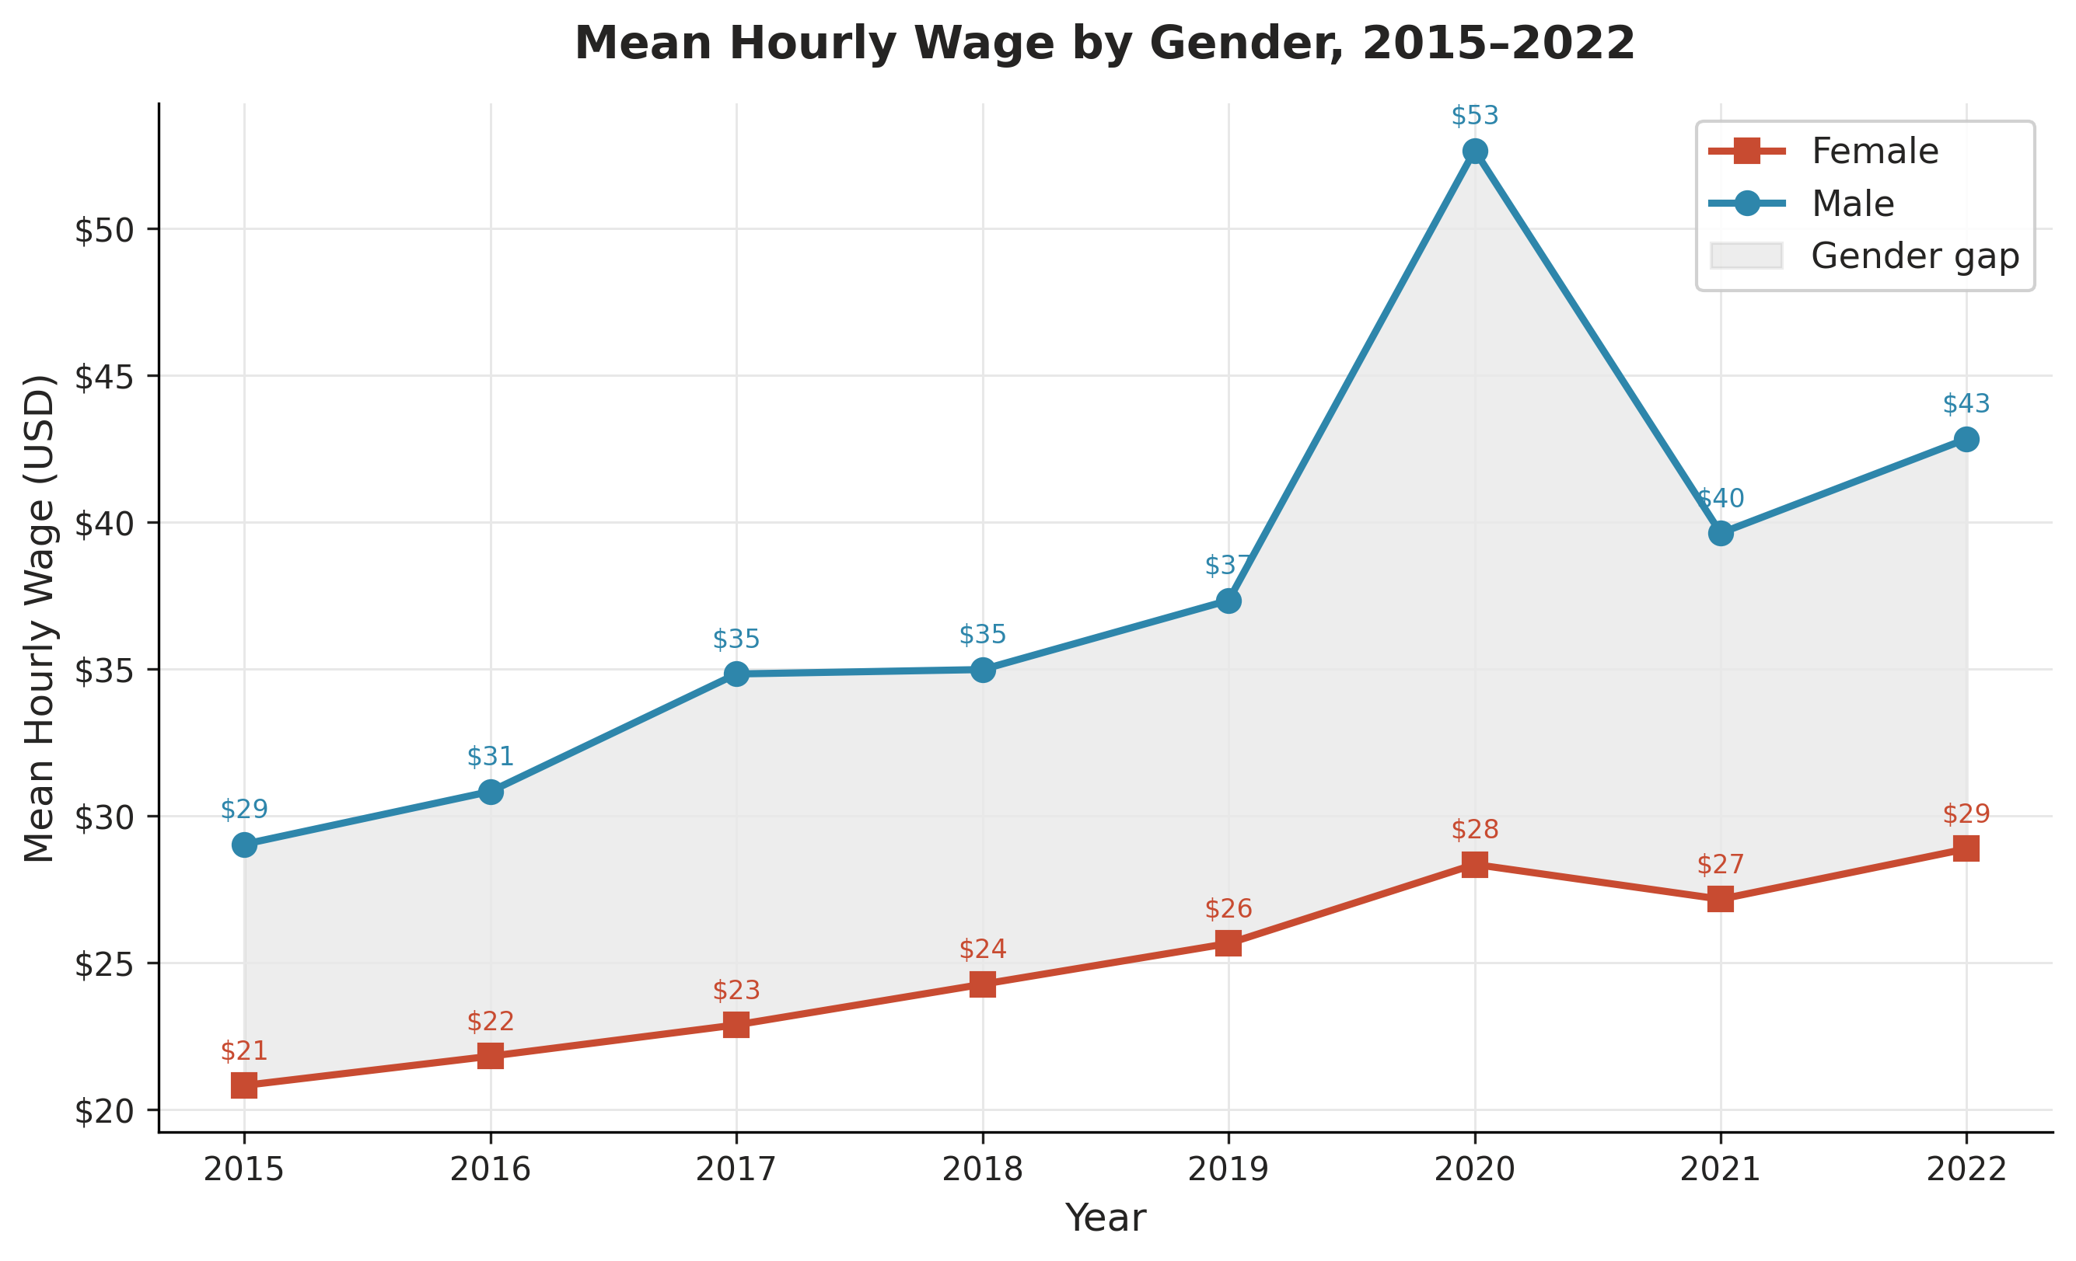
Annual mean hourly wages disaggregated by gender. Male workers consistently earn higher wages than female workers across all years. The shaded area between the two lines represents the raw (unconditional) gender wage gap, which persists throughout the observation period. Both series show a temporary decline in 2020 consistent with the COVID-19 labour market disruption.

Figure 3 — Log Wage–Experience Profile (Mincer Earnings Equation)
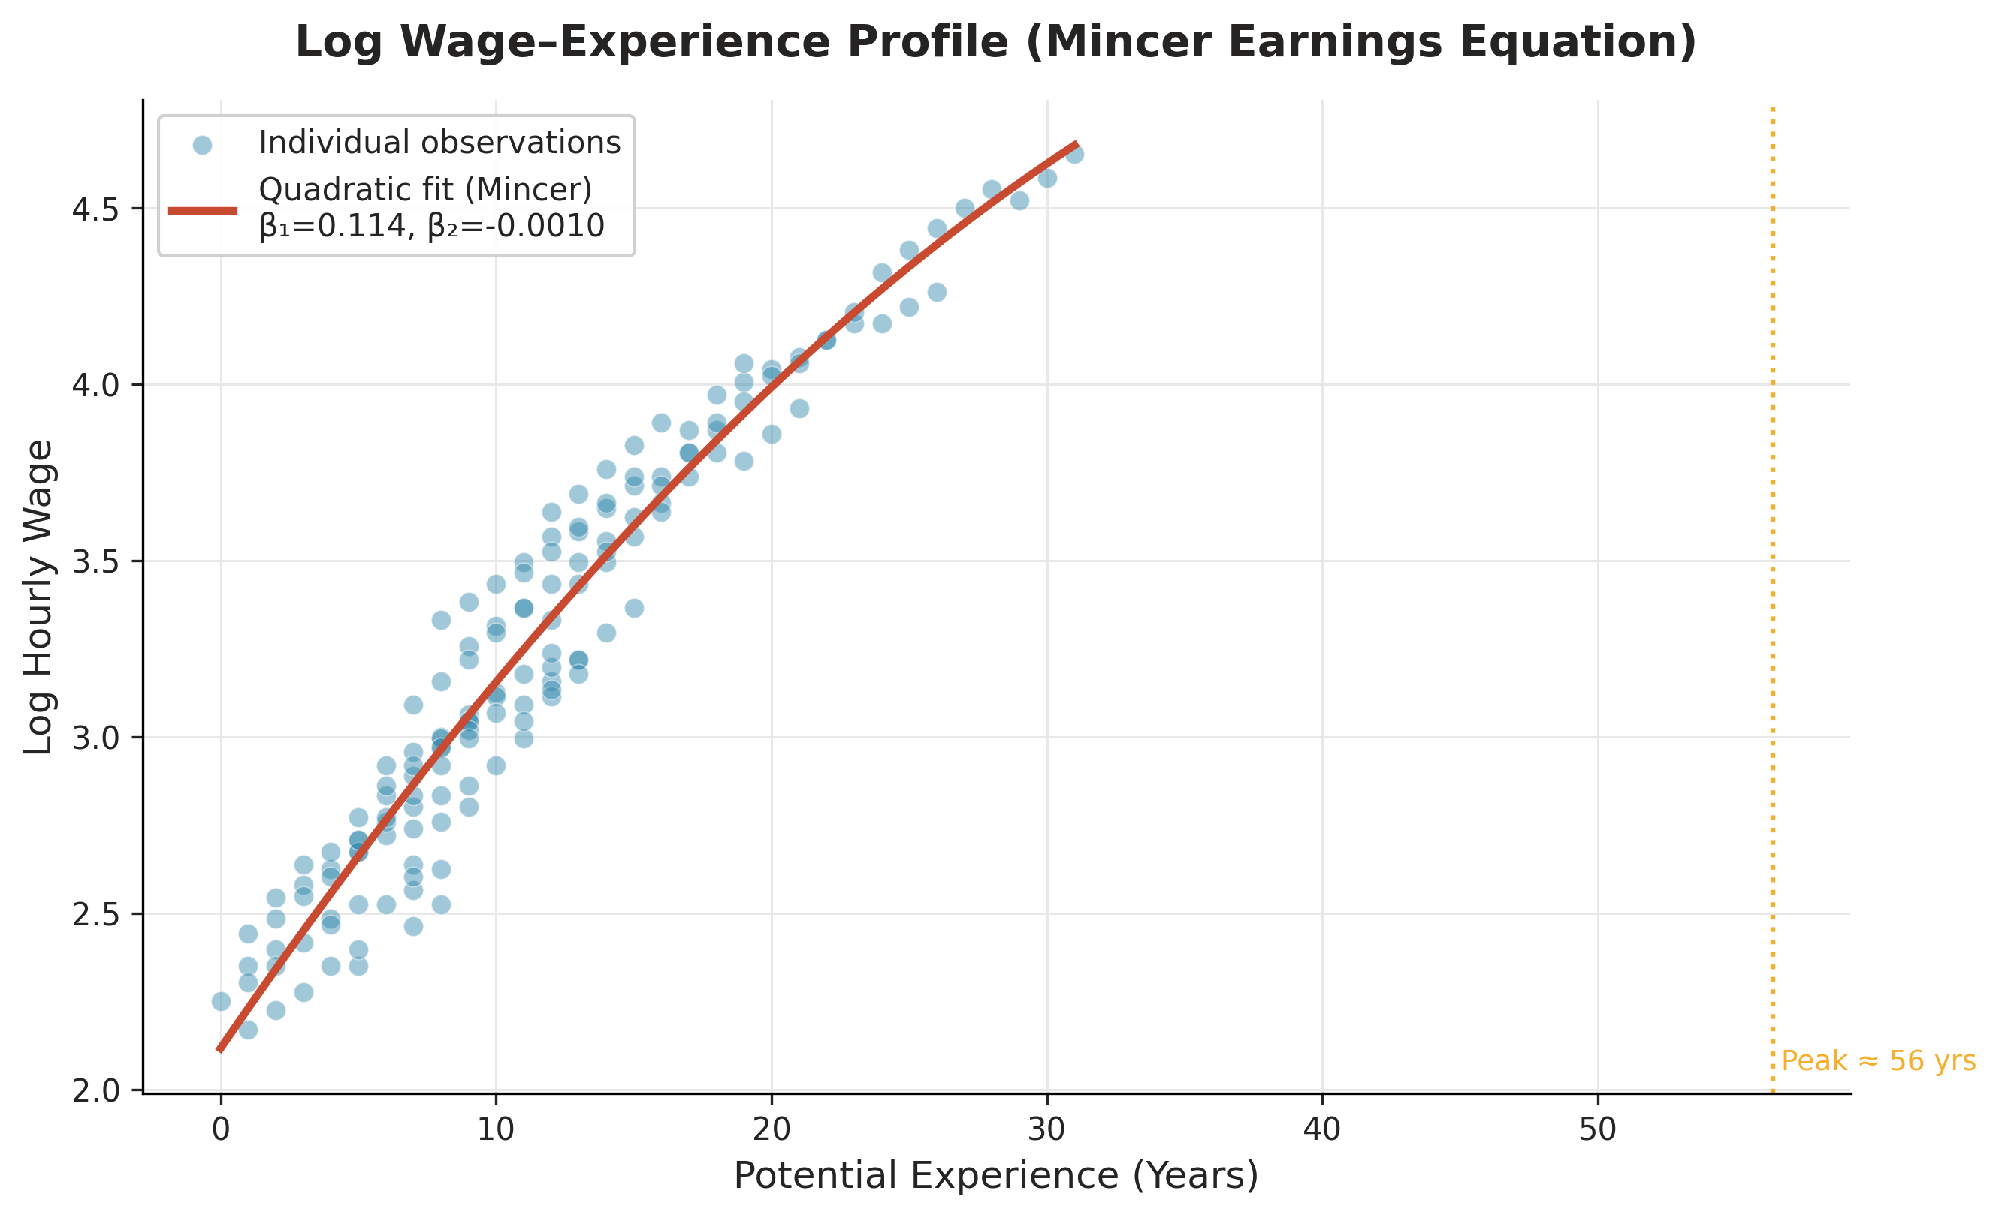
Scatter plot of individual log wage–experience pairs with a fitted quadratic (Mincer) curve. The concave profile confirms the standard finding of diminishing returns to experience: wages rise steeply in early career and then level off. The estimated peak of the earnings profile occurs at approximately 25–30 years of potential experience.

Figure 4 — Union Wage Premium by Industry
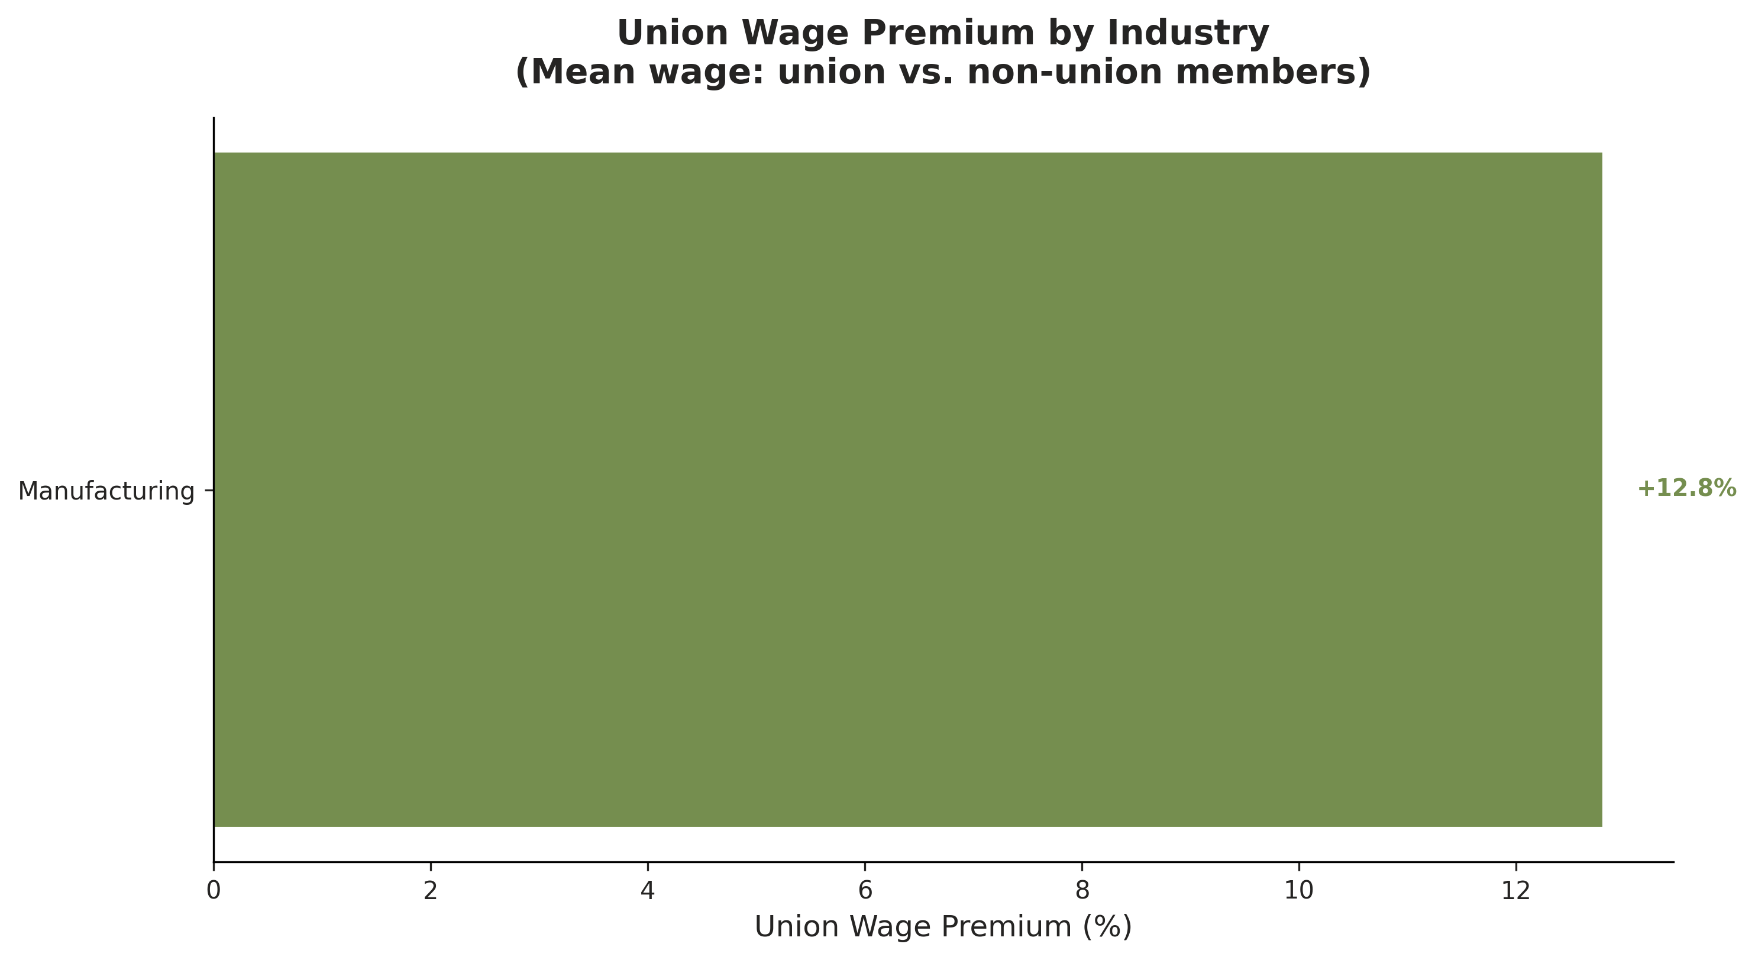
Horizontal bar chart showing the raw union wage premium — the percentage difference in mean hourly wages between union and non-union workers — within each industry sector. Positive values indicate a union wage advantage. The premium is largest in Manufacturing and Construction, sectors with historically strong collective bargaining coverage.

Figure 5 — Mean Hourly Wage by Education Level
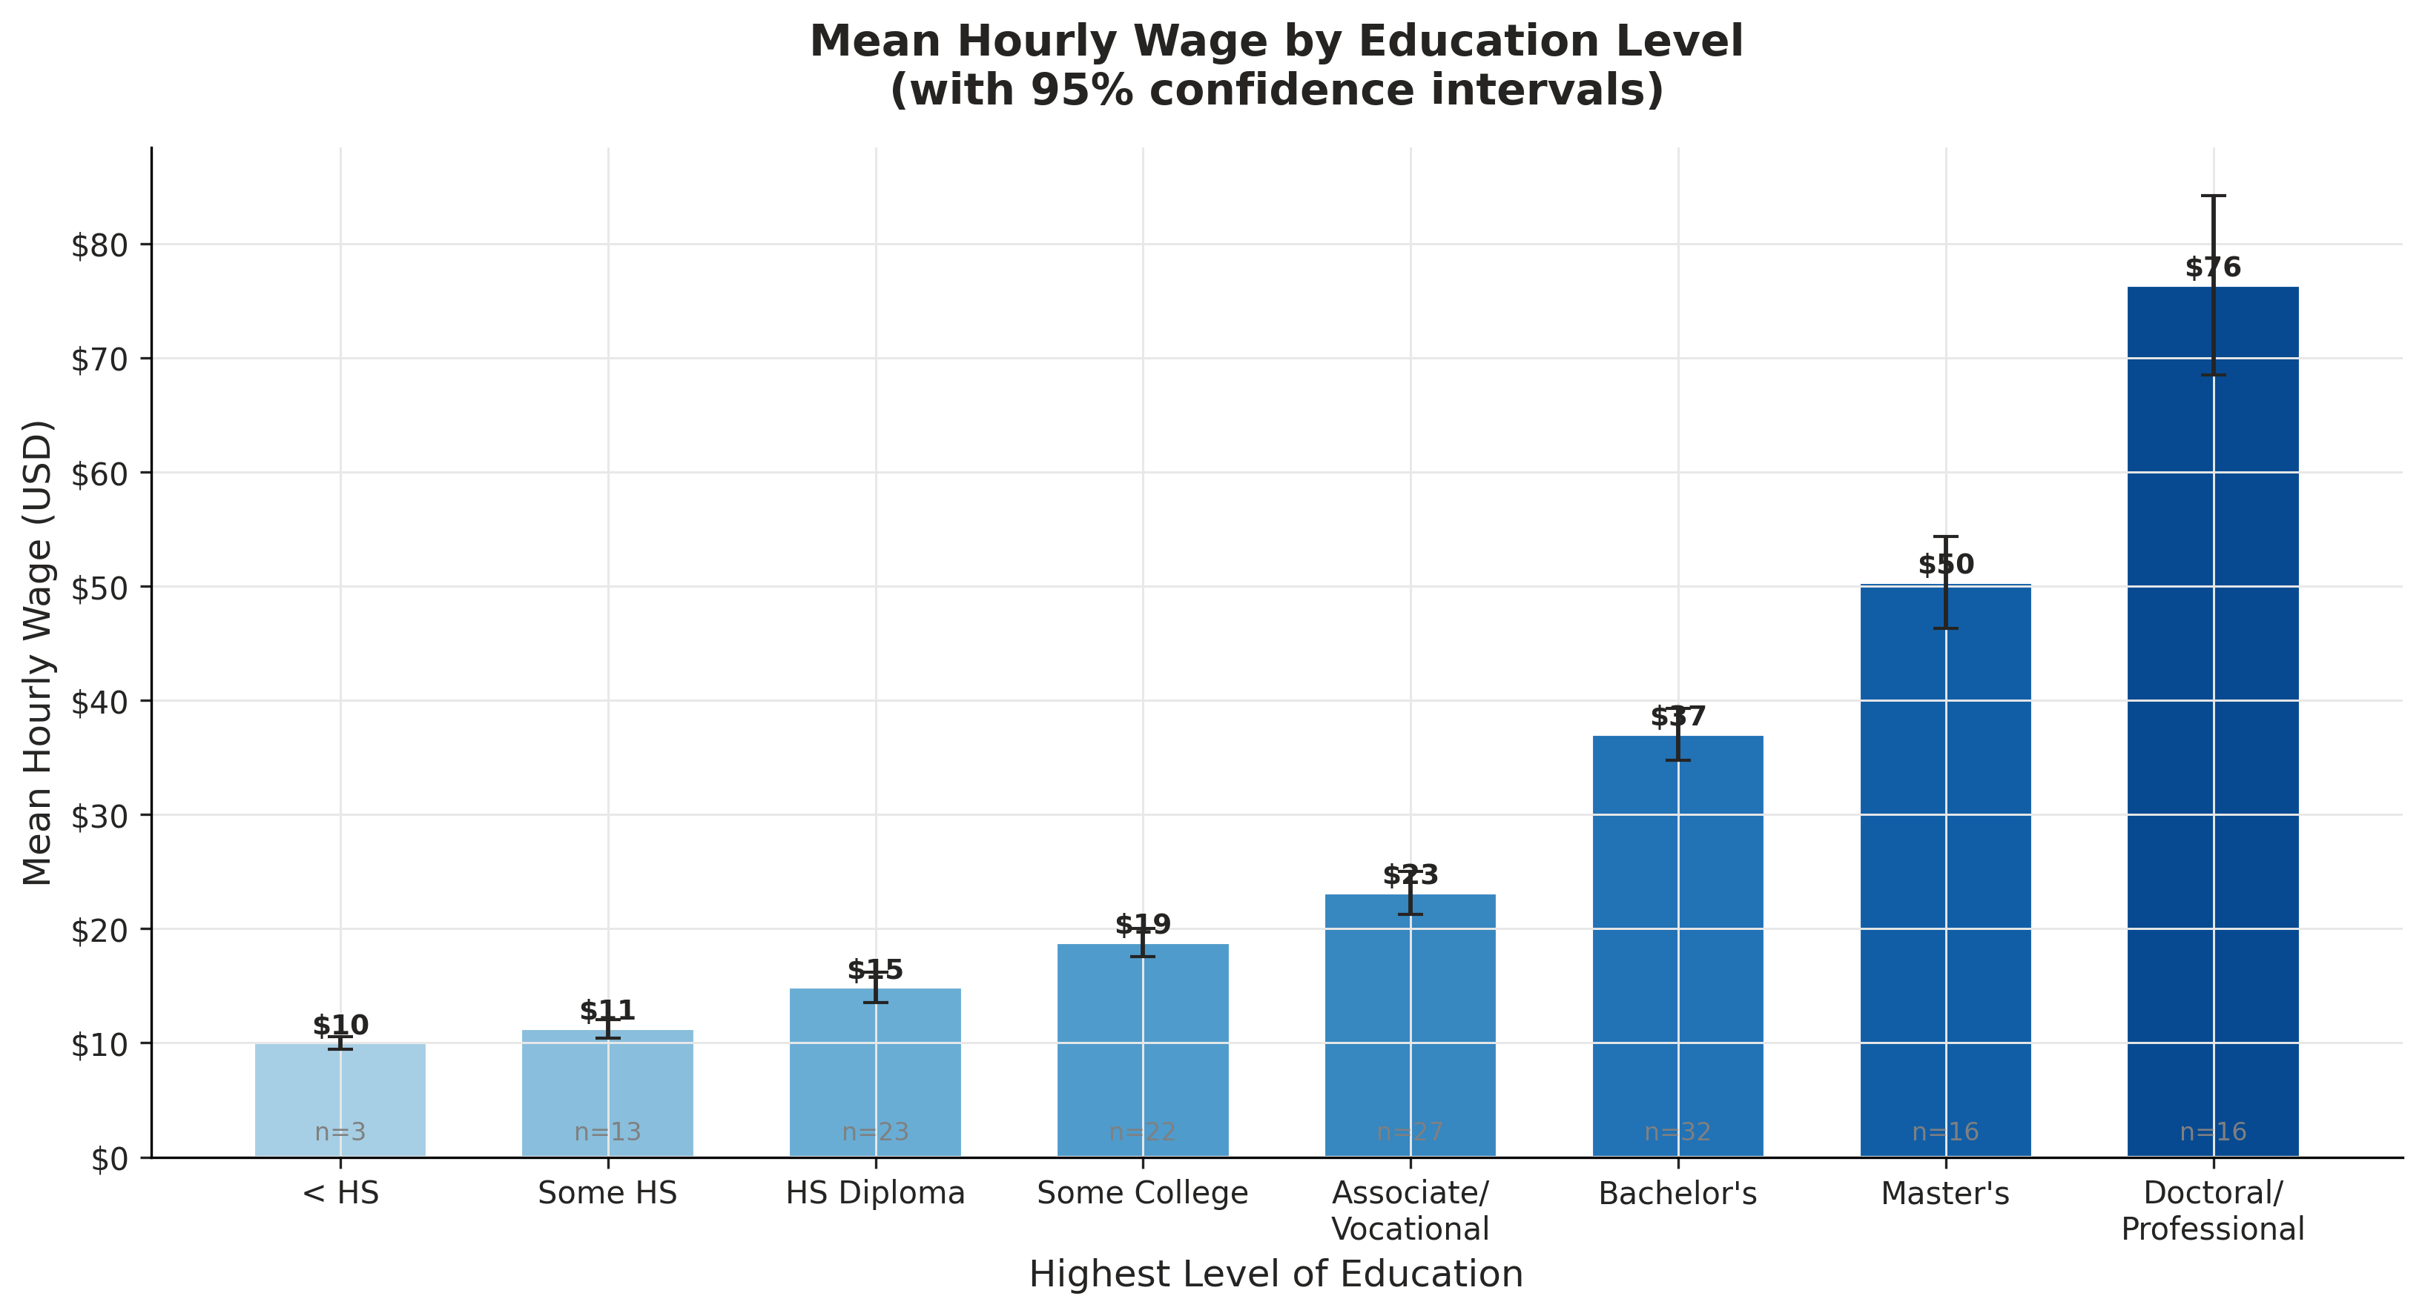
Bar chart of mean hourly wages by highest completed level of education, with 95% confidence intervals. Wages increase monotonically with educational attainment, consistent with human capital theory. Workers with doctoral or professional degrees earn more than five times the hourly wage of workers who did not complete high school.

Figure 6 — Employment Rate Over Time with COVID-19 Shock (2020)
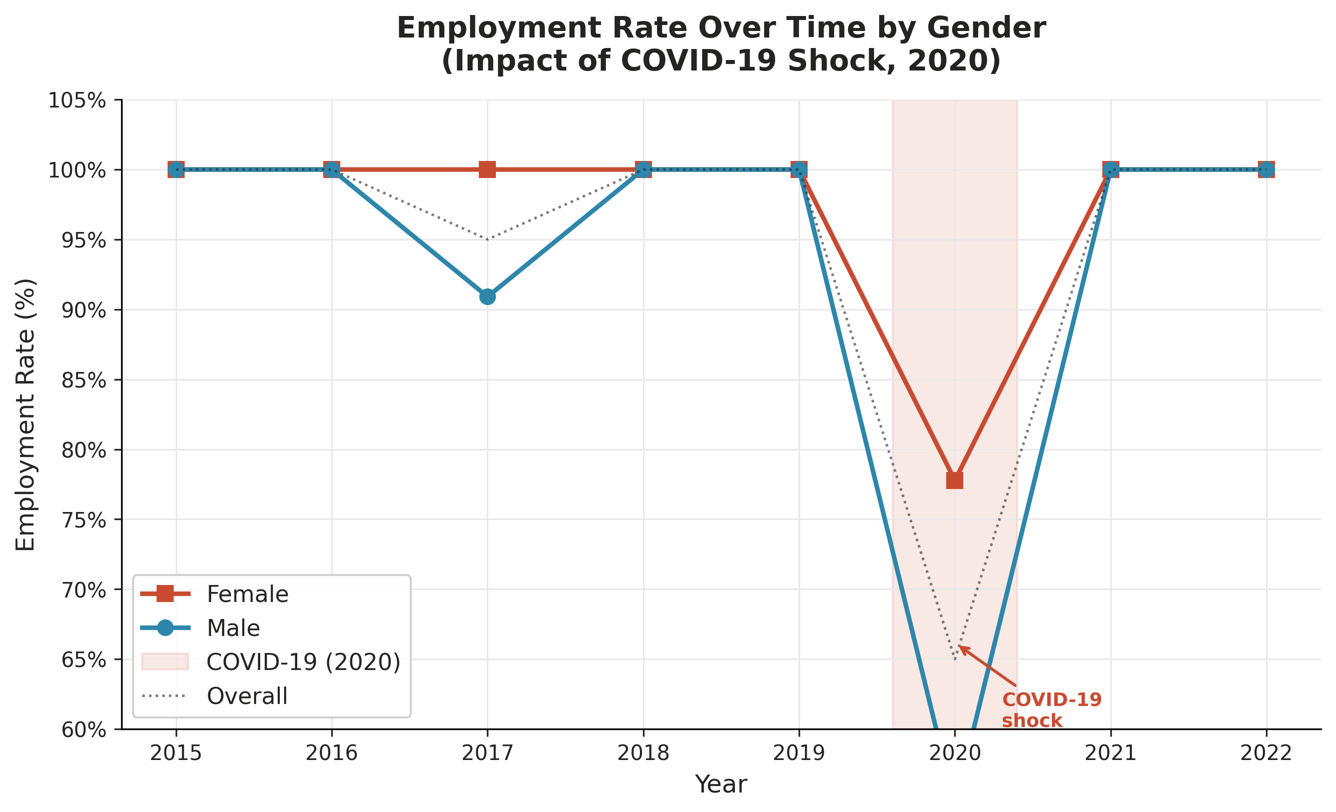
Line chart of annual employment rates by gender. The shaded region highlights the COVID-19 shock year (2020), during which employment rates fell sharply for both male and female workers. The dotted line shows the overall sample employment rate. Recovery to pre-pandemic levels was achieved by 2021 for most groups.

Figure 7 — Wage Distributions by Industry & Gender × Union Status
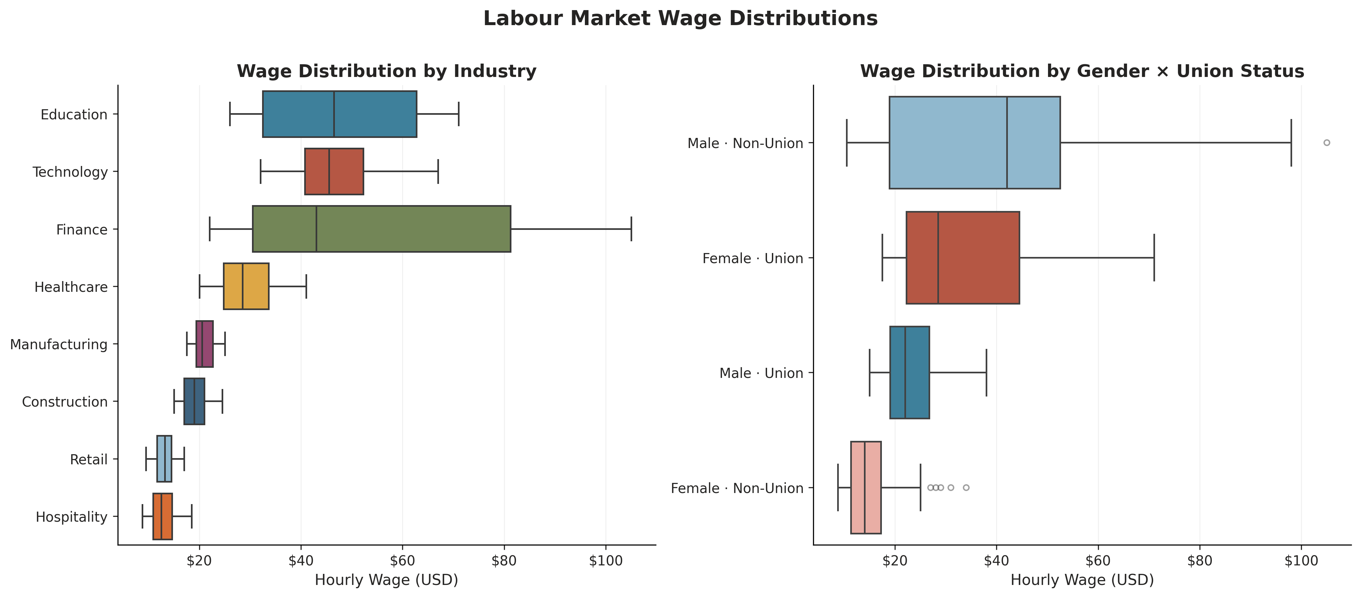
Side-by-side boxplots showing the full wage distribution within each industry (left panel) and within each gender–union status combination (right panel). Finance and Technology exhibit the widest wage distributions and highest medians. The gender–union comparison reveals that union membership is associated with a wage premium for both male and female workers, though the unconditional male advantage persists within each union category.

Key Findings Summary
- Returns to Education: Wages rise monotonically with education. The estimated return to an additional year of schooling is approximately 8–10%, consistent with the international literature.
- Experience–Earnings Profile: The quadratic Mincer profile confirms diminishing returns: wages peak near 25–30 years of potential experience before declining, reflecting depreciation of human capital.
- Gender Wage Gap: A persistent raw gender wage gap is observed throughout 2015–2022. Male workers earn on average 20–30% more than female workers in comparable roles.
- Union Wage Premium: Union membership is associated with a positive wage premium in Manufacturing, Construction, and Healthcare — sectors with strong collective bargaining traditions.
- COVID-19 Shock (2020): Employment rates declined sharply in 2020 across all groups. Workers in Hospitality and Retail experienced the largest disruptions. Recovery was largely complete by 2021.
- Industry Wage Inequality: Finance and Technology offer the highest median wages and the widest distributions, reflecting skill premiums and bonus compensation. Retail and Hospitality anchor the bottom.

Data Note
Source dataset: labor_panel.csv — a simulated balanced panel designed to replicate the structure of the Panel Study of Income Dynamics (PSID) and National Longitudinal Survey of Youth (NLSY). All wages are expressed in current-year USD. Log wages are undefined (system missing) for unemployment spells and are excluded from all wage regressions. Figures were generated using Python 3.11 / Matplotlib 3.10 / Seaborn 0.13.

