**Authentication Test Suite**

**Login Test Cases**

**1.** **Successful login**

1) Visit login page through homepage (create a loop for all login outlets to reuse code).

2) Fill the form with VALID credentials.

3) Click submit.

4) Verify the user is directed properly.

**Preconditions:**

* None.

**Expected results:**

* User is logged in successfully.
* User is redirected to their profile feed.

**Actual result:**

**Status:**

*previous logins?

*keep me logged in checkbox

*pop up that appears (save info, not now with 2 options or close pop up) / remember me

*footer

*encode password in testcase

*show password

**2.** **Invalid login, incorrect password, incorrect password that’s too short**

1) Visit login page through homepage (create a loop for all login outlets to reuse code repeated code block).

2) Fill the form with a valid email and incorrect password.

3) Click submit.

4) Verify correct error message is shown.

5) Try again with an incorrect password that is less than 6 characters

6) Verify correct error message is shown

**Preconditions:**

* None.

**Expected results:**

* The following error message “Wrong email or password. Try again or **create an account .**”
* Then this error message “The password you provided must have at least 6 characters.”
* User is not logged in

**Actual result:**

**Status:**

**3. Invalid login, unregistered email, invalid email, unregistered phone number, invalid phone number (without country code and with)**

1) Visit login page through homepage (create a loop for all login outlets to reuse code repeated code block).

2) Fill the form with an invalid email format and correct (or any) password.

3) Click submit.

4) Verify correct error message is shown.

5) Try again with an unregistered email.

6) Verify correct error message is shown.

7) Try again with an unregistered phone number with country code. {Invalid and unregistered yield the same result]

8) Verify correct error message is shown.

9) Try again with a registered phone number without the country code.

10) Verify correct error message is shown.

**Preconditions:**

* None.

**Expected results:**

* The following error message “Please enter a valid username.” *try user@linkein*
* Then this error message “Wrong email or password. Try again or **create an account**.”
* Then this error message “Wrong phone number or password. Try again or **create an account**.”
* Then this error message “Be sure to include “+” and your country code.”
* User is not logged in/ no redirection occurs

**Actual result:**

**Status:**

**\*too short of a phone number isn’t flagged, doesn’t flag valid or invalid**

**4. Empty fields (3)**

1. Leave each field empty once, then both.
2. Verify appropriate error messages are shown.

**Preconditions:**

* None.

**Expected Results:**

* The error message “Please enter your email address.” Is displayed
* Then “Please enter your password.”
* Then “Please enter your email address.” and “Please enter your password”

**Actual Result:**

**Status:**

**5. Security Test Case (Brute Force)**

1. Enter an incorrect password multiple times (5-10 attempts).
2. Verify if an account lockout message appears.

**Preconditions:**

* Captcha implemented.

**Expected Results:**

* Captcha is triggered.

**Actual Result:**

**Status:**

**6. Block post access without login, redirect to post when logged in**

1. Visit a post URL without logging in.
2. Fill out login form.
3. Ensure proper redirection.

**Preconditions:**

* Have a job post link.

**Expected Results:**

* User is redirected after being prompted to login.

**Actual Result:**

**Status:**

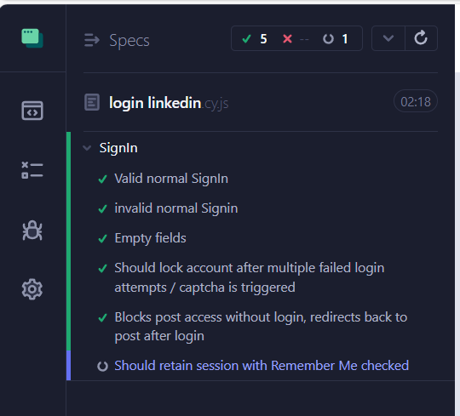

**Signup Test Cases**

1. **Successful Signup**
2. Visit the **Signup** page from the homepage.
3. Enter a **valid email, password, and full name**.
4. Click **Sign Up**.
5. Verify the user is prompted to set up their profile.

**Preconditions:**

* None.

**Expected Results:**

* User account is created successfully.
* User is redirected to profile setup.

**Actual Result:**

**Status:**

1. **Failed Signup – Email already registered**
2. Visit the **Signup** page from the homepage.
3. Enter a **pre-registered email.**
4. Click **Sign Up**.
5. Add first and last name.
6. Verify user is redirected to the signup page and the appropriate error message is displayed.

**Preconditions:**

* An existing pre-registered email.

**Expected Results:**

* The error message “Someone’s already using that email.” Is displayed
* User is redirected to signup page.

**Actual Result:**

**Status:**

1. **Failed Signup – Invalid email format**

*emails in the form [user@linkedin.com](mailto:user@linkedin.com) are not flagged as invalid by LinkedIn, as some organizations have unfamiliar emails*

1. Visit the **Signup** page from the homepage.
2. Enter an invalid email format “user.com” (no @)
3. Verify appropriate error message is shown.

**Preconditions:**

* None.

**Expected Results:**

* The error message “Please enter a valid email address.”

**Actual Result:**

**Status:**

1. **Failed Signup – Weak password**
2. Visit the **Signup** page from the homepage.
3. Enter an email address
4. Enter a password that’s 5 elements or less, then one that’s 6.
5. Verify appropriate error message is shown.

**Preconditions:**

* None.

**Expected Results:**

* The error message “Password must be 6 characters or more.”
* Then “Please enter a more secure password and use 6 or more characters.”

**Actual Result:**

**Status:**

1. **Failed Signup – Empty fields**
2. Visit the **Signup** page from the homepage.
3. Leave each field empty once, then both fields.
4. Verify appropriate error message is shown.

**Preconditions:**

* None.

**Expected Results:**

* The error message “Please enter your email address.” Is displayed
* Then “Please enter your password.”
* Then “Please enter your email address.” and “Please enter your password”

**Actual Result:**

**Status:**

1. **Filed Signup – Email is too long**
2. Visit the **Signup** page from the homepage.
3. Enter a long email (>128 characters).
4. Verify appropriate error message is shown.

**Preconditions:**

* None.

**Expected Results:**

* The error message “Email must be between 3 to 128 characters.” Is displayed

**Actual Result:**

**Status:**

1. **Signup with google (enter a registered and a non-registered email), (forgot mail?)**
2. Visit the **Signup** page from the homepage.
3. Click on signup with google.
4. Verify appropriate error message is shown.

**Preconditions:**

* None.

**Expected Results:**

* The error message “Please enter your email address.”
* Then “Please enter your password.”
* Then “Please enter your email address.” and “Please enter your password”

**Actual Result:**

**Status:**

1. **Sign up while logged into another account [selenium]**

*corner case when you log in from the second tab first*

1. Visit the **Sign In** page from the homepage.
2. Sign in normally.
3. Open the Sign up page from another tab.
4. Ensure redirection to feed.

**Preconditions:**

* None.

**Expected Results:**

* User should be redirected to feed and not allowed to sign up while logged in from another tab

**Actual Result:**

**Status:**