LE-SFMC Integration

As a part of this project, we will be exploring various solutions and ways we can incorporate sales force marketing cloud campaign and offer management system to our current scene+ and LE ecosystem without impacting user experience, performance.

Solutions 1 :

Leverage Salesforce API and integration in LE.

For this solution no changes required in scene+ and no effect/changed needed on website/mobile apps.
We will use salesforce integration and API within LE to consolidate the request and response at real time on demand.

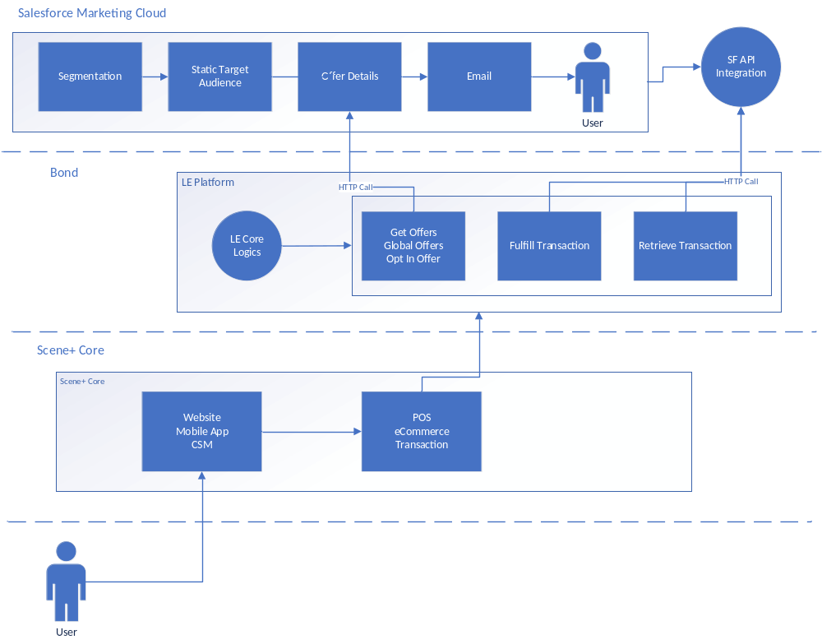

Pros:
- No impact on the cost since mostly it will be real time on demand.
- No changes required in scene core.

Cons:
- LE implementation will be challenging considering it is platform for all.
- Might have performance impact depending on SF API performance.

Solutions 2 :

Create custom integration module for SF cloud loyalty offering.

We will create our own very light integration module where we stream all the data from sales force back to bond and that will include all the campaigns, offers and user base.
And then we map those entries to our similar metadata as LE and load it to LE system so no programming or changes will be required in LE and scene core system.
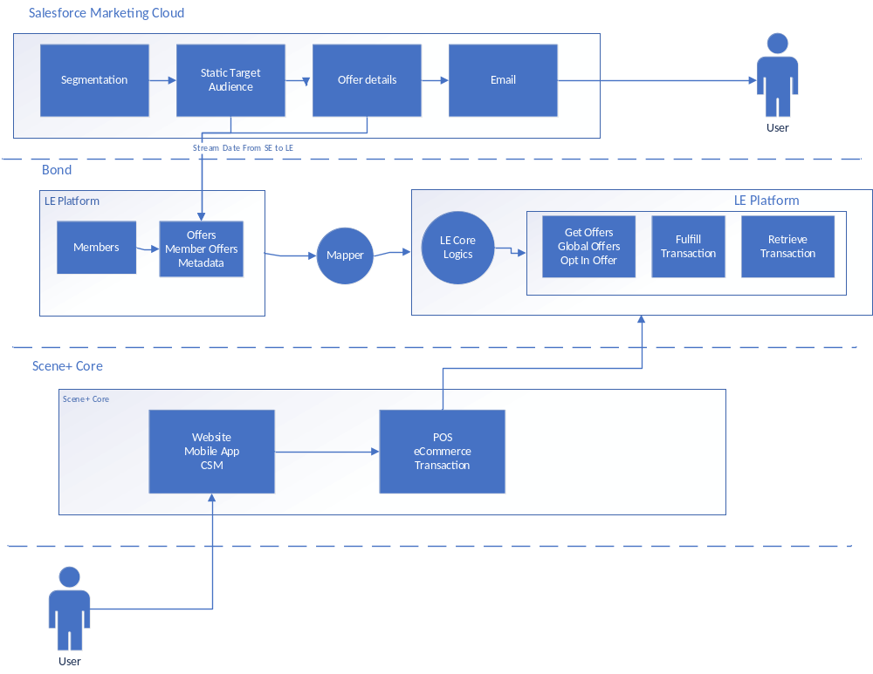

Pros:
- No Impact on curent LE implementation.
- Separate integration module will allow more and more flexibility.

Cons:
- This will have a huge impact on costs since we have to store and stream all the data from SF to bond middleware.
- Mapping those offers and user based and sending them back to LE might be challenging depending on what we will be able to receive from the sales force and how it is set up there.

Solutions 3:

Sales force will integrate with Bond Loyalty engine platform API to inject those data directly.

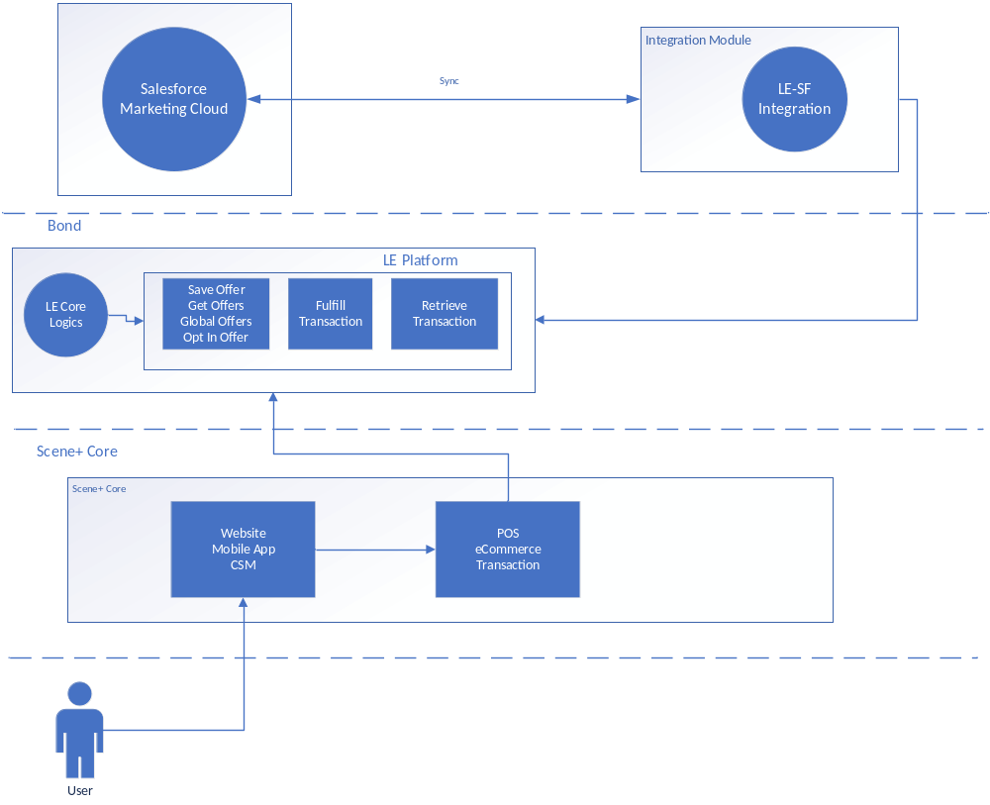

Pros:
- No Impact on curent LE implementation.
- Separate integration module on SF side will allow more and more flexibility.

Cons:
- Mapping needs to be defined as per current object structure.
- Custom checkpoint required for real time streaming from SF.

Our recommendation will be option 3

