
25 King Street West  Commerce Court, 20th Floor  Toronto, Ontario M5L 2A1 | 905-696-9400  1-844-277-2663 | info@bondbl.com  www.bondbl.com
Salesforce Integration.
Phase 1
Prepared By: Nik, AUGUST 2024

Overall Architecture

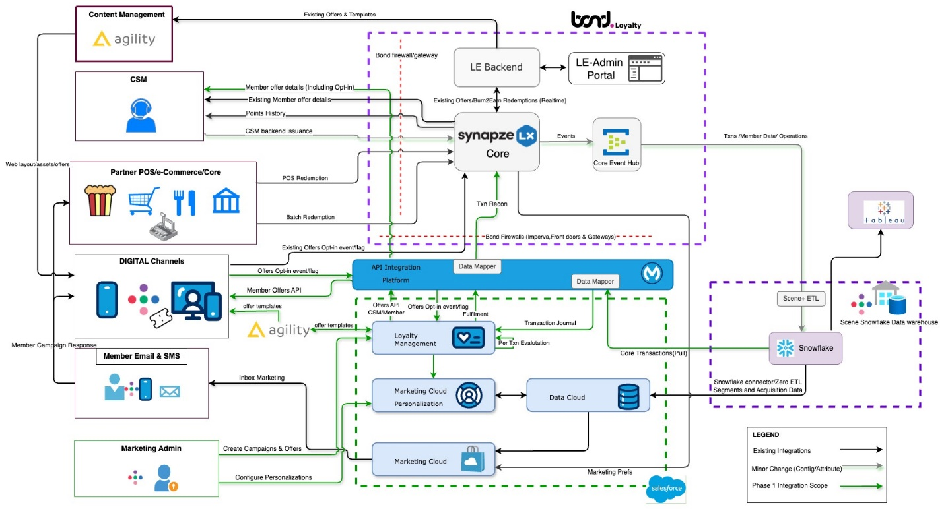

Bond Event Based Architecture

Authentication and authorization.
- JWT Bearer Tokens
Bond uses two levels of authentication: subscription key and JWT bearer token.
Requests with invalid tokens generate 401 Unauthorized error.
Access token request parameters
Parameter | Required? | Description
tenant | Yes | The directory tenant the application plans to operate against.
client_id | Yes | The client ID assigned to the application.
scope | Yes | The application ID uniform resource identifier (URI) of the requested resource.
client_secret | Yes | The client secret generated for the application. This value must be URL-encoded before being sent in an access token request.
grant_type | Yes | Must be set to client_credentials
API requests must be made over HTTPS TLS v1.2 with the following request headers. Calls made over plain HTTP or without authentication/authorization request headers will fail.

Transaction API.

HTTP Method | Route | Description
POST | /points/transaction | Process point transaction

Process Point Related Transactions.
POST /points/transaction
Request body
Request body:
{
"transactionId":"guid",
"transactionDate":"datetime_utc",
"pointDate":"datetime_utc",
"customerUniqueId":"guid",
"Partner":{
"partnerCode":"ENUM",
"locationCode":"string"
},
"items":[
{

"Points":"int",
"PointCategory":"ENUM",
"PointDescription":"Desc",
"Offer":{
"id":"string",
"name":"string",
"code":"string"
}
}
],
"metadata":"string"
}

PartnerCode
{
SCENE = 1,
BNS,
RAKUTEN,
RECIPE,
CINEPLEX,
EXPEDIA,
BAKKT,
HRG,
BLACKHAWK,
BOND,
SOBEYS = 19,
HOMEHARDWARE = 20,
SDR = 21
}

PointCategory
{
Earn = 1,
Adjustment,
Transfer,
Bonus
}
Response
Sample response body:
{
"statusCode": 202,
"requestMethod": "POST",
"requestUri": "/points/transaction",
"product": "env-partner",
"apiName": "Transaction API (Partner) (ENV)",
"responseTimestamp": "8/30/2024 00:00:00 PM +00:00",
"acknowledgmentToken": "1724089179-P-190e94eb-6102-4da2-bb2d-e1610bcdcf1f
}

Offer API.

HTTP Method | Route | Description
POST | /offers | Get Salesforce offers

POST /offers
Request body
Request body:

{
"Filters": {
"CampaignType": [
"all"
],
"Partner": [
"all"
],
"OfferOptIn": [
"all"
],
"OfferType": [
"all"
],
"FromDate": "2024-07-30T18:45:10+00:00",
"ToDate": "2024-08-29T18:45:10+00:00"
},
"Sort": "expiring",
"Pagination": {
"Limit": 20,
"Page": 1
}
}
Response
Sample response body:
{
"offers": [
{
"offerId": "offerId",
"offerCode": "offerCode",
"name": "name",
"startDate": "2024-08-23T00:00:00Z",
"endDate": "2024-08-29T23:59:59Z",
"category": [
"Pharmacy",
"all"
],
"tags": [
"expiring",
"limitedtime"
],
"priority": 4131,
"cmsContent": null,
"isPersonalized": false,
"offerType": [
"limitedtime",
"all"
],
"isOptedIn": false,
"optedInDate": null,
"provinces": [
"NB",
"NS",
"PE",
"NL",
"all"
],
"partner": "SOBEYS"
}
],
"itemsCount": 1,
"pageNumber": 1,
"totalItemCount": 1
}

Bond Brand Loyalty Inc.
25 King Street West
Commerce Court, 20th Floor
Toronto, Ontario
M5L 2A1
bondbl.com
© 2024 Proprietary and Confidential.

