Stream and Reporting Specific Redeem Rejection

As a part of this project, we will be handling specific redeem rejections due to daily threshold hit.

Solution 1:

Stream & Store as an Activity
This will follow same as scene database CDC activity flow.

Implementation Steps:

At the time of redeem rejection due to the daily threshold limit, we will create and save cosmos activity log for that customer.
And we don’t have to worry about streaming it to data lake and back to scene because that process is already in place so as soon as activity created it will stream to data lake and back to partner.
And this will also help our partner for those type of call center inquiry since sales rep agent will be able to see those rejection activity in CSM.

Cost:
- It will not have any impact on the cost or performance if volume remains less than 5K rejection / Day.
- Minimal Development Effort
- Anything more than 5K will have minor cost storage increase but worse case it will be around $500/month (assuming those events will never go 1GB/month).

Pros:
- Provide the highest level of flexibility so not only this but any other type of activity or custom rejection or business rule can we sent to cosmos.
- Full visibility on CSM that way it will avoid and remove bond internal investigation and review from partner, and they can review and manage it from CSM only.

Cons:
- Same data is now stored in two places cosmos and data lake (Proper retention policy and archive discussion in progress so until then we will have two copies of it)
- Custom development will be required if we need to stream those even to their respective partner.

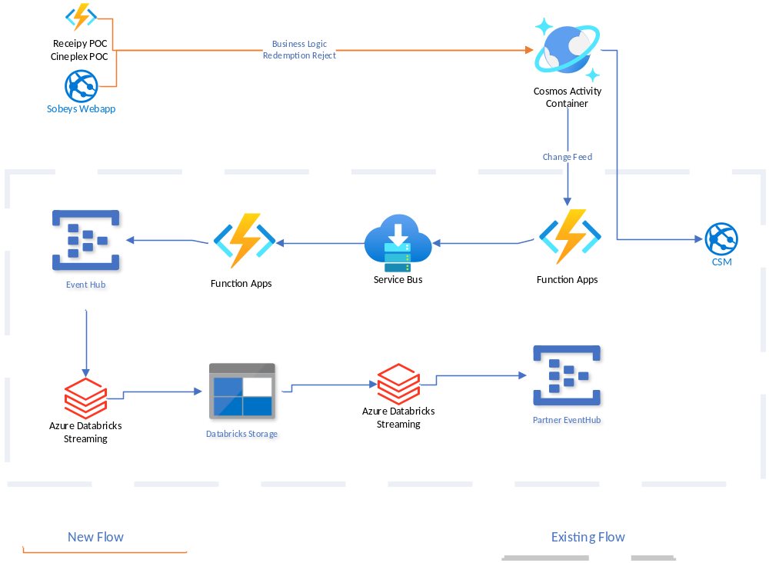

Solution 2:

Stream to EventHub Directly
This will follow our EventHub streaming flow that we are using to stream Cosmos and SQL events.

Implementation Steps:

At the time of redeem rejection due to the daily threshold limit, we stream to the new EventHub in existing name space that is streaming cosmos change feed and SQL CDC
And from databricks side we will read those newly type events and add it to separate table so also have to modify existing partner streaming job so we can include this type of event as well back to partner.

Cost:
- It will not have any impact on the cost or performance if volume remains less than 5K rejection / Day.
- If we start sending more than 1GB data a day, then Streaming cluster and cost will be around $200-500 a month.

Pros:
- Provide flexibility to stream those events back to partner and we can customize that as per partners need.
- Also provide flexibility to stream any other custom event as well.

Cons:
- Require some initial one-time infrastructure setup.
- Streaming needs to develop and setup to stream that to data lake and back to partners.
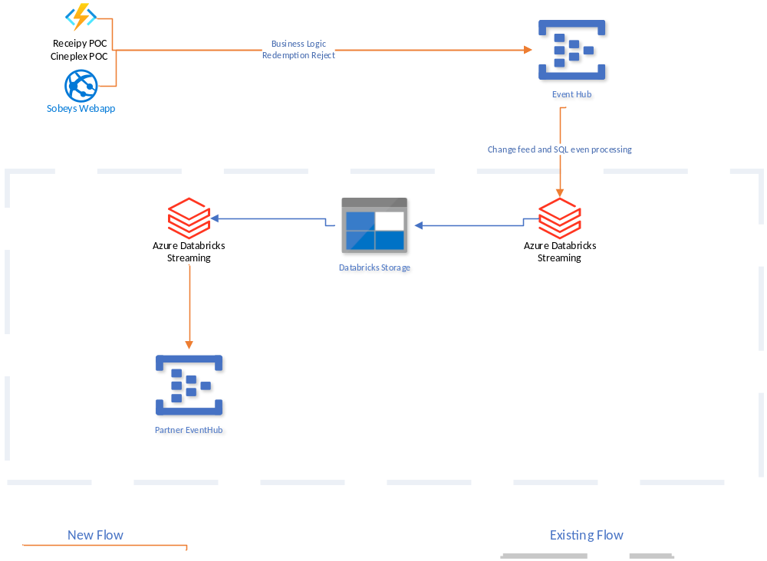

Recommendation:

Both options are good and somewhat similar, but I am suggesting and recommending “Solution 1” only because it will provide output and flexibility at CSM as well. Otherwise in terms of cost, development, and performance they both are the same.

