This function is responsible for point calculation and allocation to user: scene-uat-camapignfulfillment-servicebus-p

Pipeline URL: https://dev.azure.com/BondBL/Harmony/_build/results?buildId=145160&view=results

Last deployment: Jan 29 at 10:01 AM

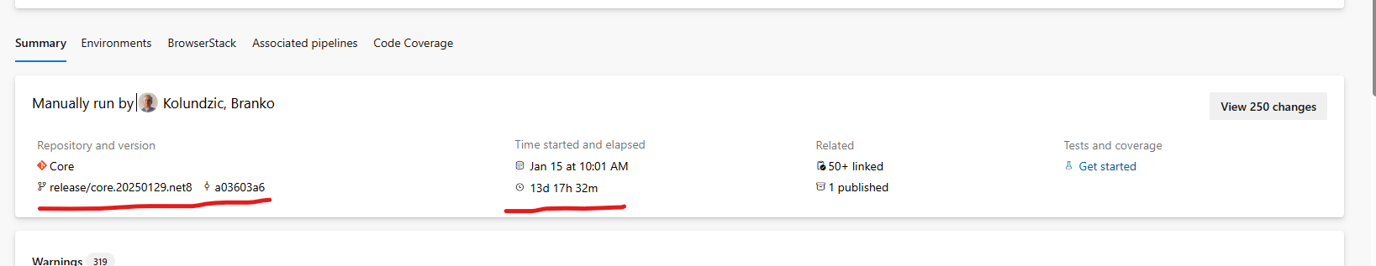

13 days because of the entire journey of the deployment through Dev, QA, IST, UAT and PROD and testing along the way and some artifacts got deployed everywhere since we only built once.

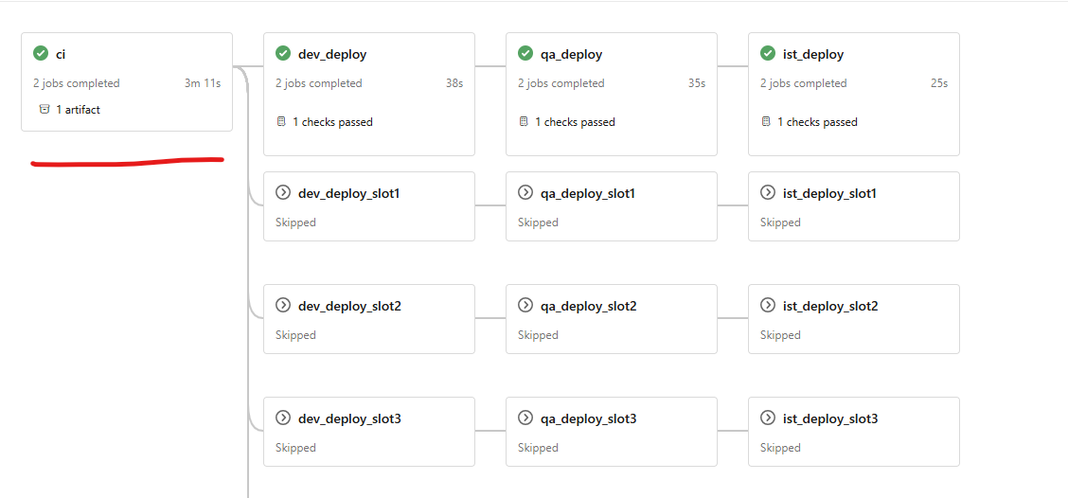

This shows only one building, and some artifacts will deploy to all the environments.

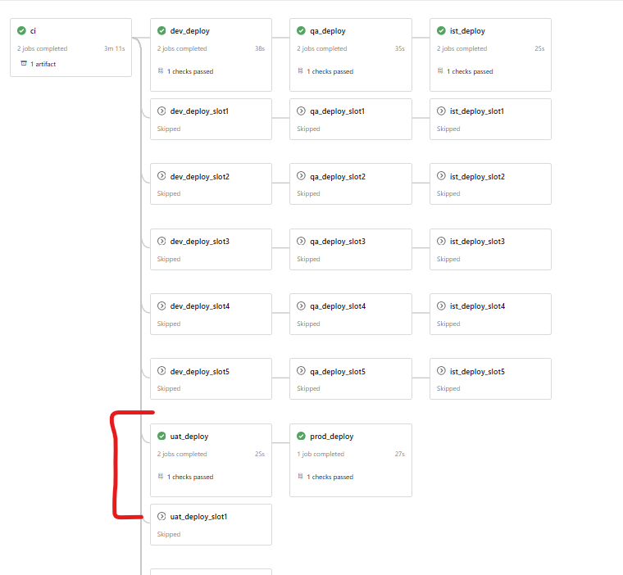

This shows PROD and UAT have the same code base and to go to PROD you must go through UAT otherwise we wont able to deploy to PROD.
So only time UAT and PROD code base is not aligning which is at the period of new deployment and newer code is deployed to UAT that is ready for PROD deployment date.

