**Week 2 Day 1 – Conditionals**

**Conditionals with if else and Booleans**

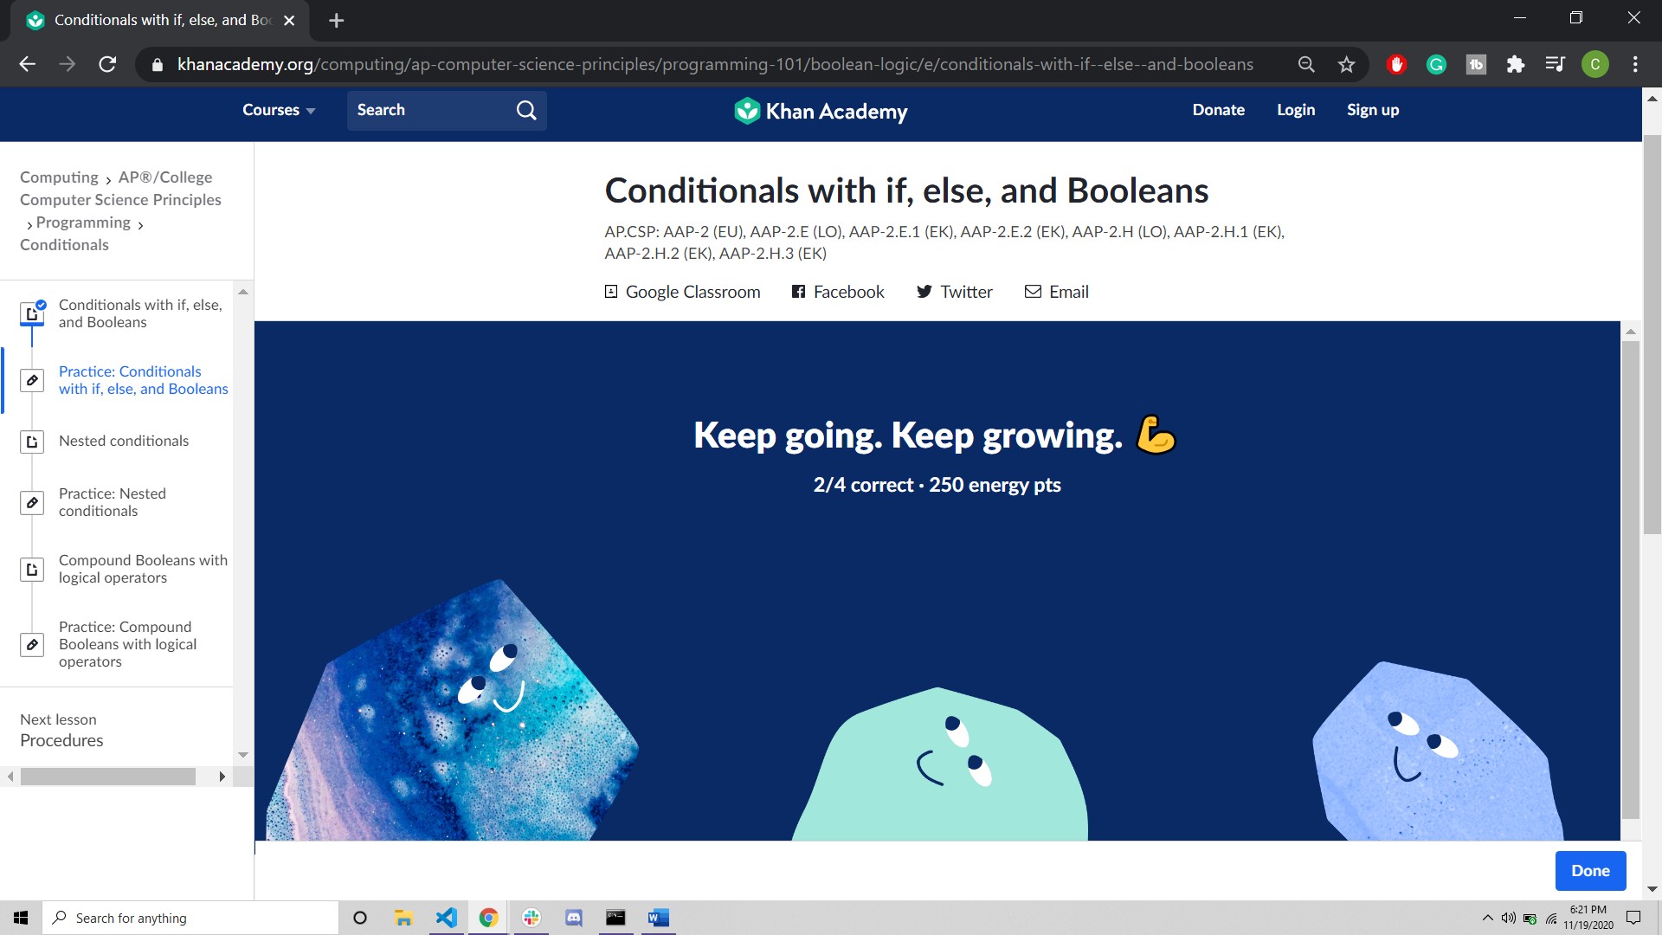

**Nested Conditionals**

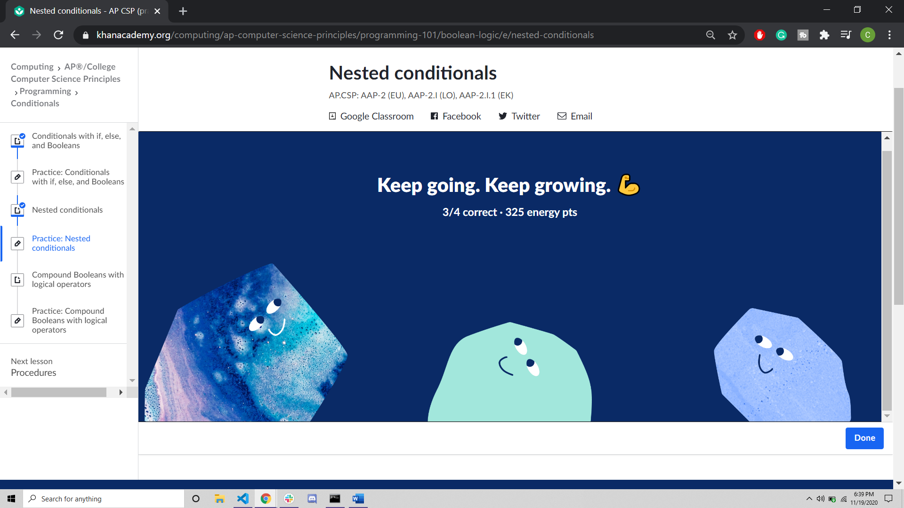

**Compound Booleans with Logical Operators**

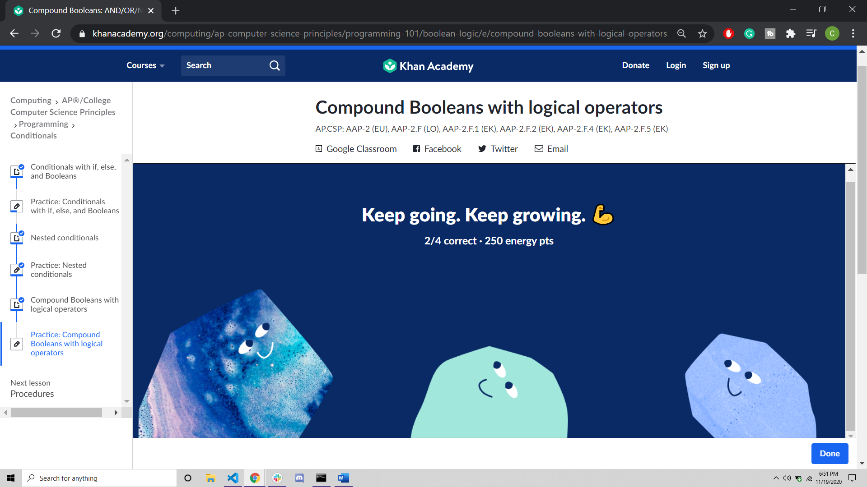

**Random Numbers**

