Module 8: Portfolio Project Part 2
Concurrency Concepts/Java Application

Clint Ledbetter
25WB-CSC450-1
Professor Herbert Pensado
Colorado State University Global
April 8, 2026

Pseudocode
1. Start program

2. Create class CountUpThread
3. Loop from 0 to 20
4. Print "Counting Up" with current value
5. Pause briefly
6. End loop

7. Create class CountDownThread
8. Loop from 20 down to 0
9. Print "Counting Down" with current value
10. Pause briefly
11. End loop

12. In main method:
13. Create thread1 using CountUpThread
14. Print "Starting Thread 1"
15. Start thread1
16. Wait for thread1 to finish (join)

17. Create thread2 using CountDownThread
18. Print "Starting Thread 2"
19. Start thread2
20. Wait for thread2 to finish (join)

21. Print "Program complete"
22. End program

Source code
package csc450.mod08;

public class CSC450_Mod08_Portfolio {

// Thread 1: count up from 0 to 20
static class CountUpThread extends Thread {
@Override
public void run() {
for (int i = 0; i <= 20; i++) {
System.out.println("Counting Up: " + i);
try {
Thread.sleep(100); // small pause so output is easier to follow
} catch (InterruptedException e) {
System.out.println("CountUpThread was interrupted.");
Thread.currentThread().interrupt(); // preserve interrupt status
return; // safely exit the thread if interrupted
}
}
}
}

// Thread 2: count down from 20 to 0
static class CountDownThread extends Thread {
@Override
public void run() {
for (int i = 20; i >= 0; i--) {
System.out.println("Counting Down: " + i);
try {
Thread.sleep(100); // small pause so output is easier to follow
} catch (InterruptedException e) {
System.out.println("CountDownThread was interrupted.");
Thread.currentThread().interrupt(); // preserve interrupt status
return; // safely exit the thread if interrupted
}
}
}
}

public static void main(String[] args) {
CountUpThread thread1 = new CountUpThread();
CountDownThread thread2 = new CountDownThread();

System.out.println("Starting Thread 1 (Count Up)...");
thread1.start();

try {
thread1.join(); // wait until thread 1 finishes
} catch (InterruptedException e) {
System.out.println("Main thread interrupted while waiting for Thread 1.");
Thread.currentThread().interrupt();
return;
}

System.out.println("Starting Thread 2 (Count Down)...");
thread2.start();

try {
thread2.join(); // wait until thread 2 finishes
} catch (InterruptedException e) {
System.out.println("Main thread interrupted while waiting for Thread 2.");
Thread.currentThread().interrupt();
return;
}

System.out.println("Thread safely completed execution.");
System.out.println("Program complete.");
}
}

Screenshots of the application executing the application and results
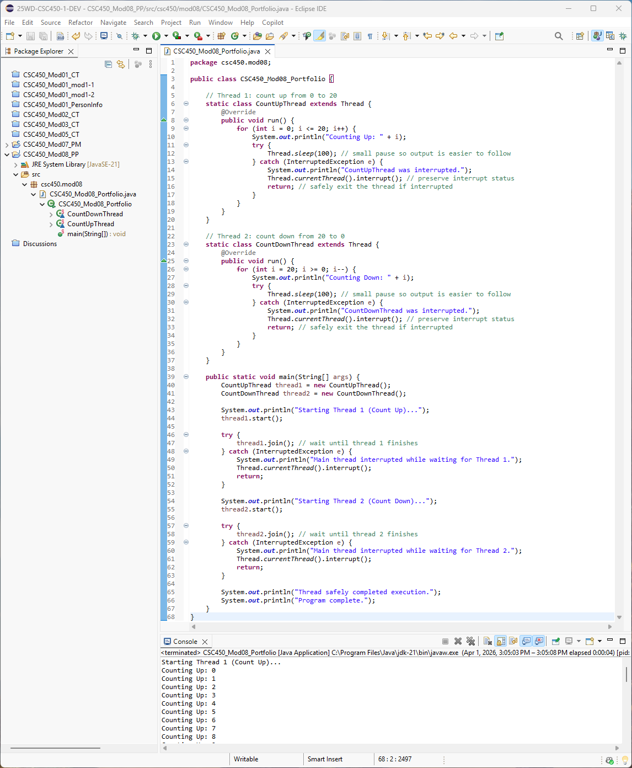
Fig. 1 Complete source code and partial console output

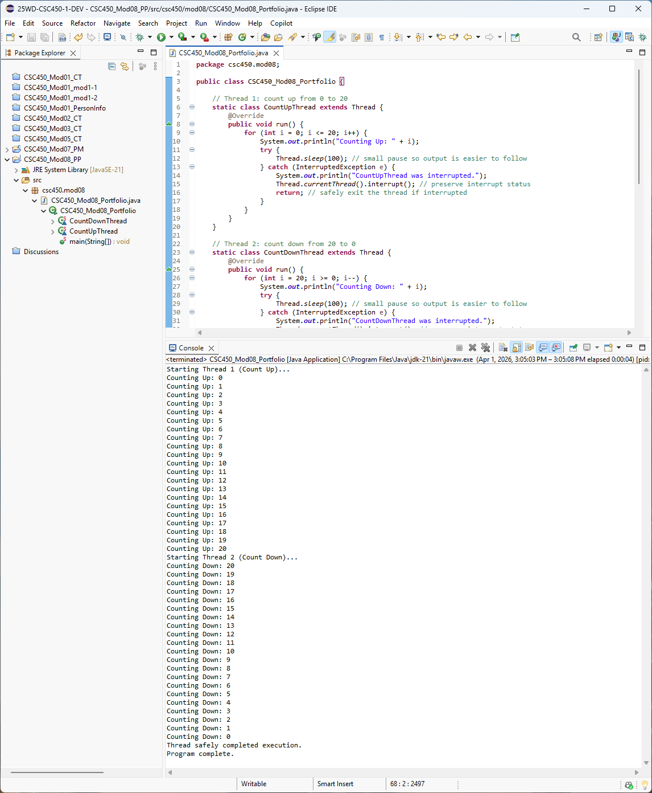
Fig. 2 Complete console output

Programming Analysis

This Java program uses two threads to demonstrate basic concurrency. The first thread counts up from 0 to 20, and after it finishes, the second thread counts down from 20 to 0. The use of join() makes the threads run in sequence instead of at the same time, which keeps the execution order predictable and easy to follow.

One performance issue with concurrency is the overhead of creating threads and switching between them. In this program, the threads do not run in parallel because the first thread must finish before the second thread starts. Because of that, the program does not gain a performance advantage from concurrency, but it still demonstrates how threads are created and managed. The use of Thread.sleep() also slows the program on purpose so the thread activity can be seen clearly in the output. The program also improves reliability by properly handling thread interruptions using a try/catch block and restoring the interrupt status, which ensures the thread can exit safely instead of continuing with potential errors.

There are minimal risks with strings in this program because the strings are only simple output messages and are not shared or modified by multiple threads. In larger Java applications, shared string data or user input processed across threads could still create issues if not handled carefully.

For data type security, this program mainly uses integer values for counting, which are safe in this example because they are local to each thread and not shared. If shared variables were used between threads, synchronization would be needed to avoid race conditions or inconsistent results. Overall, this Java program demonstrates concurrency in a simple and controlled way while avoiding many common thread-related problems.

Screenshot of Git Repository
Repo URL: https://github.com/ClintLedbetter/CSC450/tree/main/CSC450_Mod08_PP
