Comparison of Dictionary Data Structure Implementations
Abstract:
Any algorithm is inherently limited by the speed with which it can access and modify the data upon which it acts. Using the correct abstract data type can make an algorithm much easier to implement correctly, but different implementations can result in vastly different runtimes for the structure's operations. In this brief survey three unique implementations are tested and compared on a common system.
Method:
Three implementations were chosen and coded in Java:
- Sequential Dictionary
  - An unsorted Collection's ArrayList using linear search for finds and inserting in constant time at the next available end space
  - The underlying array was resized automatically as space required
- Sorted Dictionary
  - A sorted array using binary search for finds and inserting in linear time in sorted order
  - The underlying array was resized automatically as space required
- Hash Dictionary
  - A hash table implemented with an array, java.lang.String's default hashCode function, and open addressing using secondary hashing
  - The underlying array was resized automatically to the greatest prime number >= 2x the current size
  - The prime's used for the table size and secondary hash function were pre-calculated and hard coded
Each implementation was run and timed with three different dictionary sizes, searching two medium length text files each. The approximate time required to open, read, and parse the text files was timed separately immediately before the searches were timed, and subtracted from the results.
Results:
As shown in Table 1 below, while the Sequential Dictionary implementation suffers from fast degradation of runtime as the dictionary size grows large, the Sorted and Hash implementations remain nearly constant across a 100k increase in dictionary size. In fact, the supposedly linear Sequential dictionary time appears to increase exponentially in real application.
Table 1: Total and average times in seconds for each test run
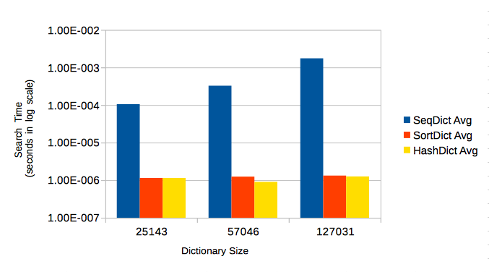Chart 1: Average search times for each implementation
Summary:
It is clear that a sequential implementation is impractical in real application—a document freeze of 9+ seconds for a single complete spellcheck is more than a user can reasonablly be expcted to tolerate. The hash-based dictionary appears to maintain a very slight advantage over the sorted array implementation, and should provide faster dictionary loading with realistic dictionary sizes of many millions of words, but for medium to large-sized text files (documents, books, etc.) there should be little noticable difference between the O(lgN) binary search and O(1) hash access for searches.

Mac OSX 10.9.3, 2.4 GHz Intel Core 2 Duo, 4 GB 667 MHz DDR2 SDRAM, 5400RPM 8MB cache HD

