Project 1

CSCE 4600

Members: Robert Martinez, Isaac Thomas, Thomas Truong, Clint Wyatt

**Project 1 implementation**

All threads use a while loop to cause the program to run indefinitely to allow the threads to execute multiple times in any order. The first semaphore in a thread is a counting semaphore on one of the lists to ensure that there is a node to unlink followed by a binary semaphore shared by all threads for mutual exclusion.

For thread 1, known as the producer, uses a counting semaphore for the free list because the goal of thread 1 is to move a block from the free list to list 1. The key to making thread 1 to work is having the counting semaphore equal to the number of blocks in the free list – 1 (n -1). The reason for this is the free list must always have at least 1 node. Thread 2 always takes a block from the free list and if there are no blocks in the free list, the program will crash because list 1 in thread 2 will try to access memory that is not there. While thread 2 executes, the counting semaphore for the free list will not change because after thread 2 executes 1 loop, the size of the free list does not change.

Thread 2 uses list 1 as its counting semaphore since the number of blocks from list 1 reduces by 1. While thread 2 unlinks a block from the free list, the number of blocks does not change, so it does not need to use a counting semaphore for the free list and the binary semaphore ensures that no other thread modifies it.

Thread 3, known as the consumer, uses list 2 for the counting semaphore as is the similar to thread 1 just with different lists. However, unlike thread 1, thread 3 adds back to the free list counting semaphore since that resource is being linked back to free list.

For concurrency, this system is concurrent if the free list does not give n -1 nodes to list1, shown below with a list size of n = 15:

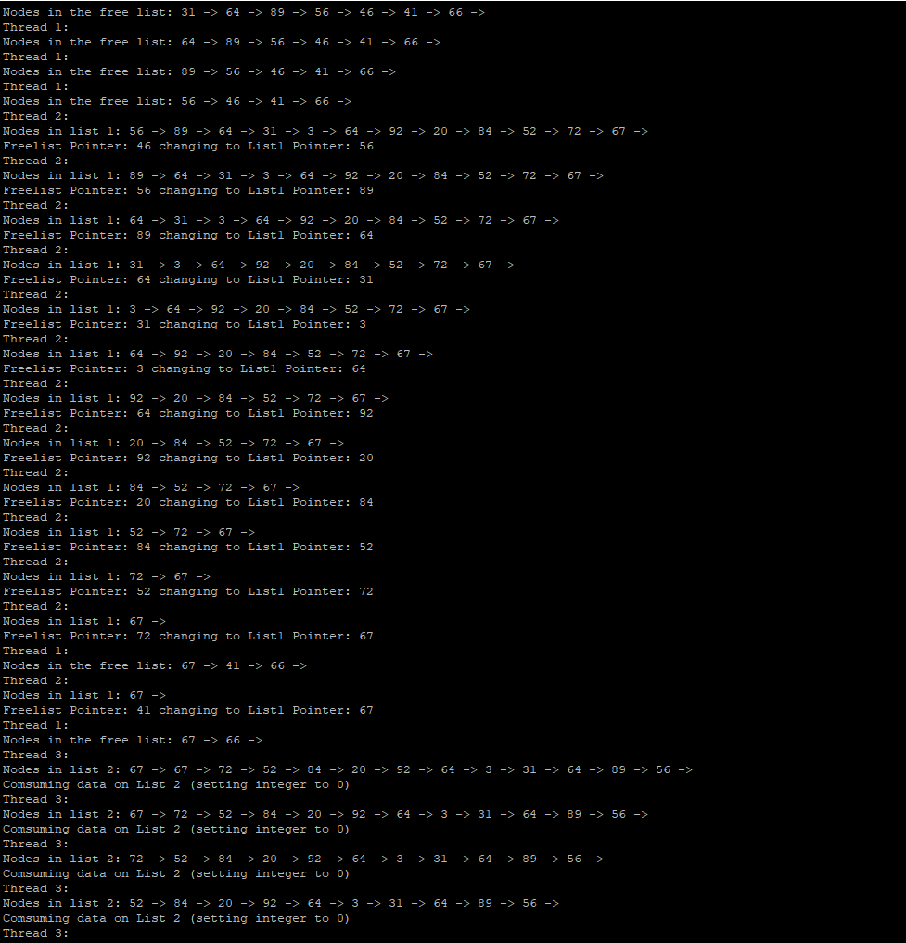

If the scheduler decides to switch to any other thread before the free list gives n-1 nodes to list 1, then the scheduler could possibly switch thread 2 with thread 1 or thread 3 instead switching thread 2 to only thread 3. In the top portion of the picture, the freelist from thread 1 gives list1 from thread 2 n-4 nodes. Towards the bottom of the photo, the scheduler switches from thread 2 to thread 1, and then switches from thread 1 to thread 3.