REPORT

INTRODUCTION:-
Hierarchical clustering is an unsupervised machine learning technique used to group similar data points into clusters based on distance and similarity measures. Unlike classification algorithms, clustering does not require labeled data. Hierarchical clustering builds a hierarchy of clusters either by merging smaller clusters into larger ones (agglomerative approach) or by splitting larger clusters into smaller ones (divisive approach).
In this project, agglomerative hierarchical clustering was implemented using the Iris dataset. Four linkage strategies were compared: Single Linkage, Complete Linkage, Average Linkage, and Ward Linkage. Dendrograms were generated for each method to visualize cluster formation. Silhouette score analysis and PCA-based cluster visualization were also performed to evaluate clustering quality and compare the effectiveness of different linkage methods.

DATASET DESCRIPTION:-
The Iris dataset is one of the most commonly used datasets in machine learning and pattern recognition. It contains 150 flower samples belonging to three species of Iris flowers:
Iris Setosa
Iris Versicolor
Iris Virginica

Each sample contains four numerical features:

Sepal Length
Sepal Width
Petal Length
Petal Width

The dataset was loaded directly from the Scikit-learn library for clustering analysis.

METHODOLOGY:-

Agglomerative hierarchical clustering was used in this project. In agglomerative clustering, each data point initially forms its own cluster. The algorithm repeatedly merges the closest clusters until all data points become part of a single hierarchy.

Four linkage methods were implemented:

Single Linkage: Uses minimum distance between clusters
Complete Linkage: Uses maximum distance between clusters
Average Linkage: Uses average distance between clusters
Ward Linkage: Minimizes variance within clusters
Euclidean distance was used as the distance metric for clustering.

IMPLEMENTATION:-
The project was implemented using Python in Google Colab. Several scientific and machine learning libraries were used, including NumPy, Pandas, Matplotlib, Scikit-learn, and SciPy.
The Iris dataset was loaded from the Scikit-learn library. Agglomerative hierarchical clustering was then applied using four different linkage methods:
Single Linkage
Complete Linkage
Average Linkage
Ward Linkage
Dendrograms were generated using the SciPy hierarchy library to visualize the hierarchical cluster formation process. Silhouette scores were calculated to compare clustering quality among the linkage methods.
Principal Component Analysis (PCA) was also applied to reduce the four-dimensional dataset into two dimensions for cluster visualization. A distance matrix heatmap was generated to visualize pairwise distances between samples.

RESULTS AND VISUALIZATION:-

A) Single Linkage Dendrogram
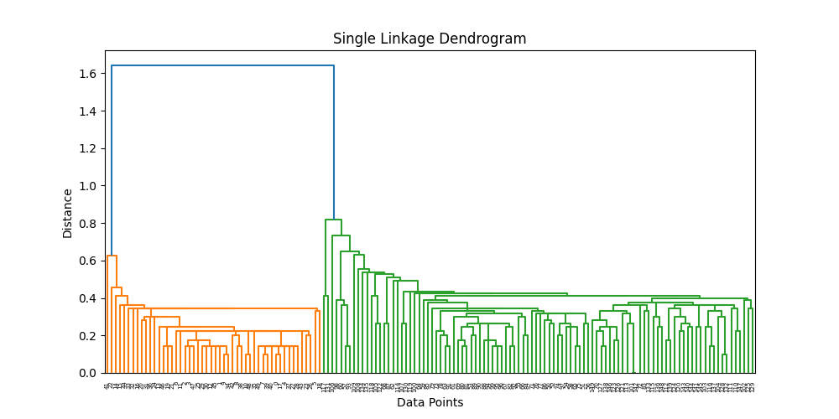
The single linkage dendrogram showed chain-like cluster formation due to the minimum-distance merging strategy. This method was sensitive to nearby data points and produced elongated clusters.

B) Complete Linkage Dendrogram
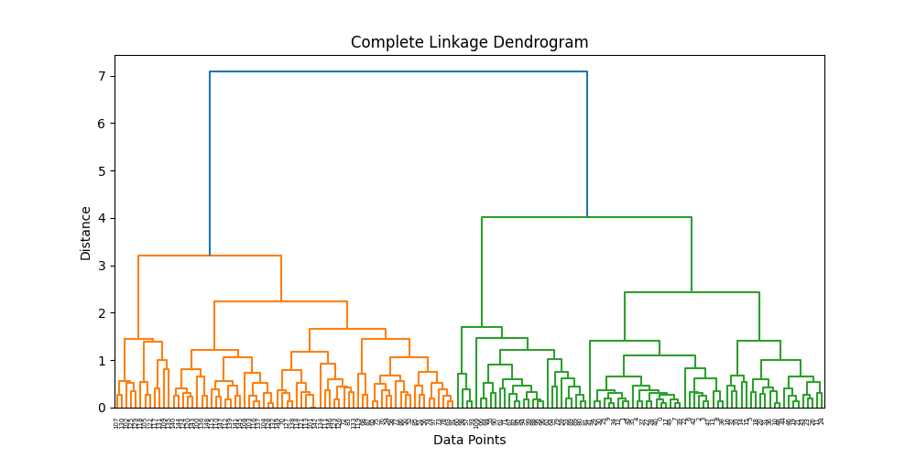
Complete linkage produced more compact and well-separated clusters by considering the maximum distance between cluster members.
C) Average Linkage Dendrogram
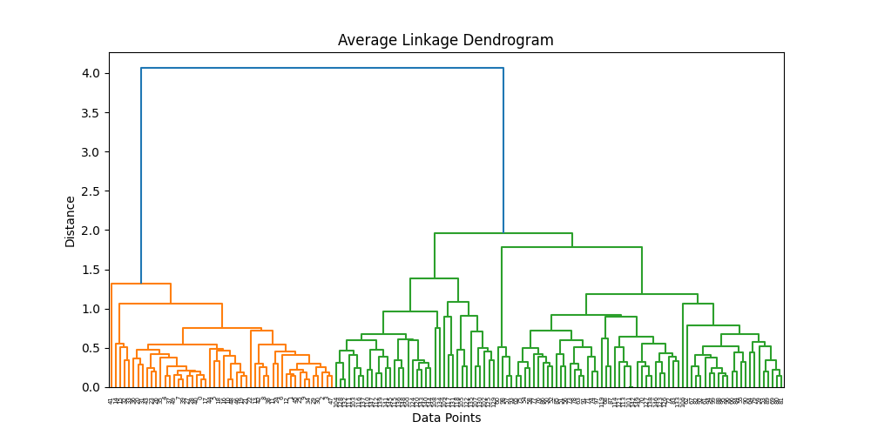
Average linkage balanced the behavior of single and complete linkage by using average distances between clusters.

D) Ward Linkage Dendrogram
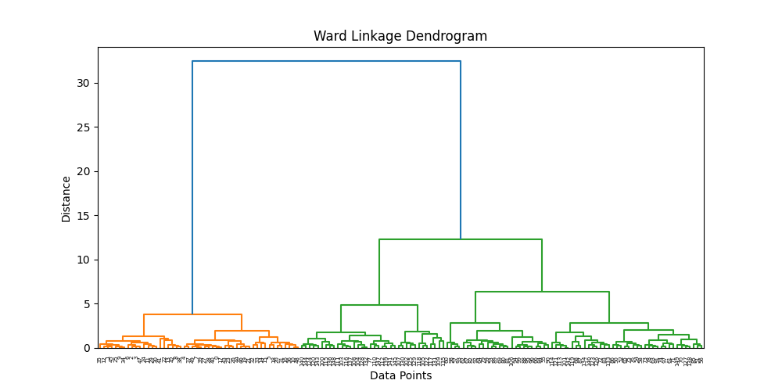
Ward linkage produced the clearest cluster separation by minimizing variance within clusters. Large vertical distances between merges indicated strong cluster separation.

E) Silhouette Score Comparison
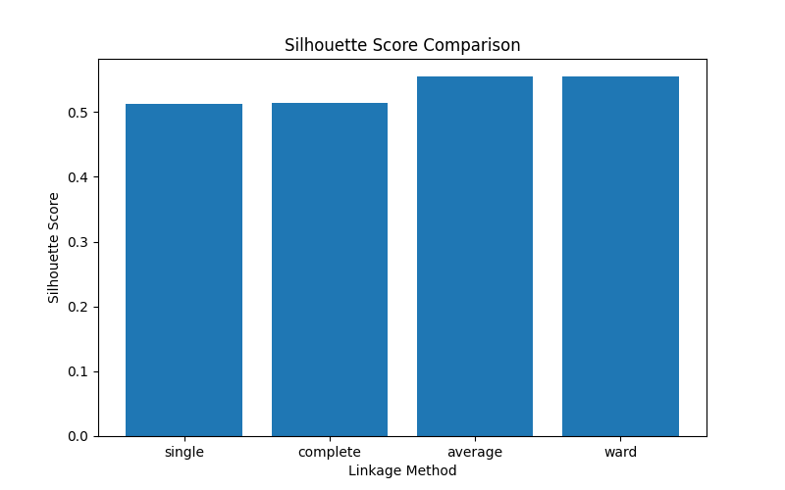
Silhouette scores were used to evaluate clustering quality. Average linkage and Ward linkage produced the highest scores, indicating better cluster separation and compactness.

F) PCA Cluster Visualization
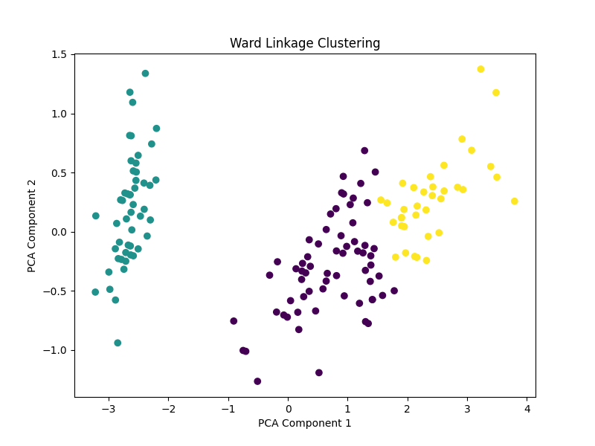
PCA reduced the four-dimensional Iris dataset into two dimensions for visualization. The Ward linkage clustering showed clear separation between clusters, especially for the Iris Setosa class.

G) Distance Matrix Heatmap
The distance matrix heatmap visualized pairwise Euclidean distances between all samples in the dataset. Darker regions represented smaller distances while brighter regions represented larger distances.
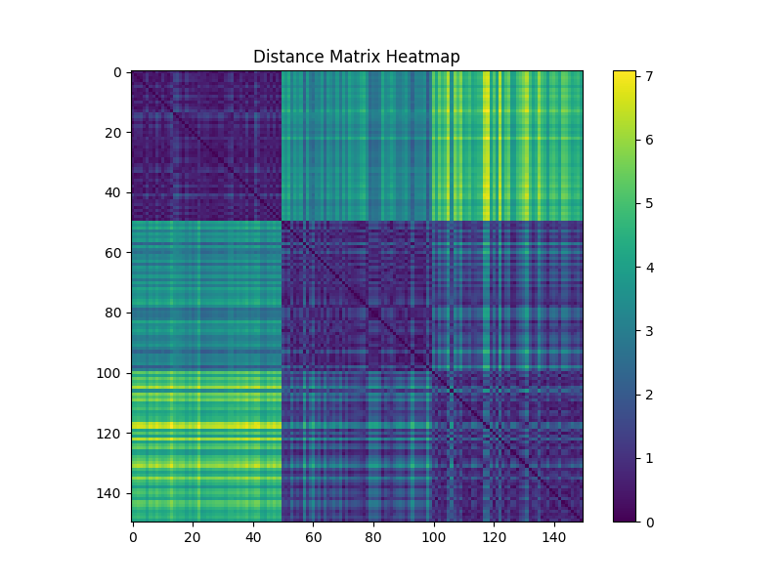
The distance matrix heatmap visualized pairwise Euclidean distances between all samples in the dataset. Darker regions represented smaller distances while brighter regions represented larger distances.

Comparison of Linkage Methods:-
Among all linkage methods, Ward linkage and Average linkage produced the best clustering performance based on silhouette score analysis. Single linkage suffered from the chaining effect, leading to elongated clusters, while complete linkage produced tighter but sometimes overly separated clusters.
Ward linkage generated the clearest dendrogram structure and achieved strong cluster compactness and separation, making it the most effective method for the Iris dataset.

Conclusion:-
This project successfully implemented hierarchical clustering using four linkage methods on the Iris dataset. Dendrogram analysis, silhouette score comparison, PCA visualization, and distance matrix analysis were performed to evaluate clustering performance.
The results showed that Ward linkage and Average linkage provided the best clustering quality. Ward linkage particularly produced compact and well-separated clusters, making it the most suitable clustering method for the dataset used in this project.
The project demonstrated how hierarchical clustering can effectively discover patterns and relationships within unlabeled datasets.

References:-
1) Scikit-learn Documentation
2) SciPy Documentation
3) Matplotlib Documentation
4) Iris Dataset – UCI Machine Learning Repository

