# Load the dataset

data = pd.read_excel('/content/accidents data science.xlsx')

# Define the dependent variable and independent variables

Y = data['Accident_Severity']

X = data[['Accident_ID','Traffic_Volume', 'Speed_Limit']]

# Create and fit the linear regression model

model = LinearRegression()

model.fit(X, Y)

# Save the model for future use

import joblib

joblib.dump(model, 'accident_severity_model.pkl')

# Load the saved model

loaded_model = joblib.load('accident_severity_model.pkl')

# Provide hypothetical independent variables for prediction

new_data = pd.DataFrame({'Accident_ID':2, 'Traffic_Volume': 200, 'Speed_Limit': 50,}, index=[0])

# Make a prediction

predicted_severity = loaded_model.predict(new_data)

print(f'Predicted Accident Severity: {predicted_severity[0]}')

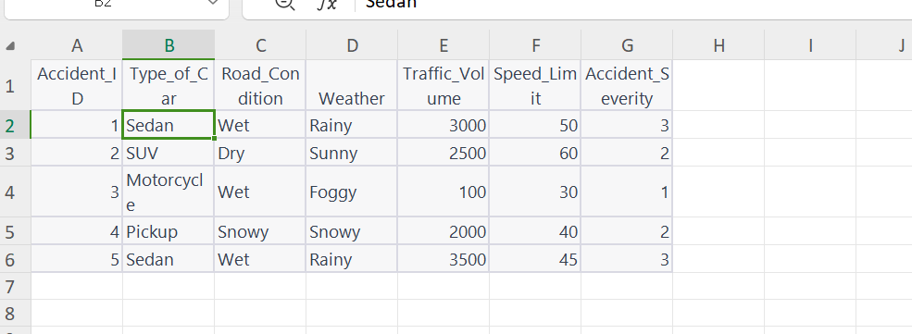

HOW THE MODEL COULD BE BENEFITIAL FOR TRAFFIC ACCIDENT ANALYSIS AND PREVENTION IN UNDERD EVELOPED COUNTRIES

1. The model could help in making decisions in the right time example real time traffic manageme nt systems can be implemented, rerouting traffic away from areas with predicted high accident severity

2. The model could help in Law Enforcement, where Traffic police can be deployed strategically in a reas with a higher likelihood of severe accidents, ensuring stricter enforcement of traffic rules t

hus prevent road accidents

3. The model also could be significant to researchers and data scientists -Researchers can utilize t he data and insights to conduct further studies, leading to a deeper understanding of the compl ex factors influencing accidents. This could help them minimize road accidents

4. It could help in infrastructure planning the models help plan and build safer road infrastructur e, such as improved signage, better lighting, and safer intersections, in areas predicted to have s evere accidents.