**Global Economic Analysis - Summary Report**

**1. Introduction**

To truly understand the global economy, we must analyze key indicators such as GDP, unemployment rates, and remittances. This report visualizes economic trends across different countries using Matplotlib, shedding light on strengths, challenges, and underlying patterns that shape financial landscapes worldwide.

**2. Key Insights from Visualizations**

**GDP Trends Over Time (Top 3 Countries)**

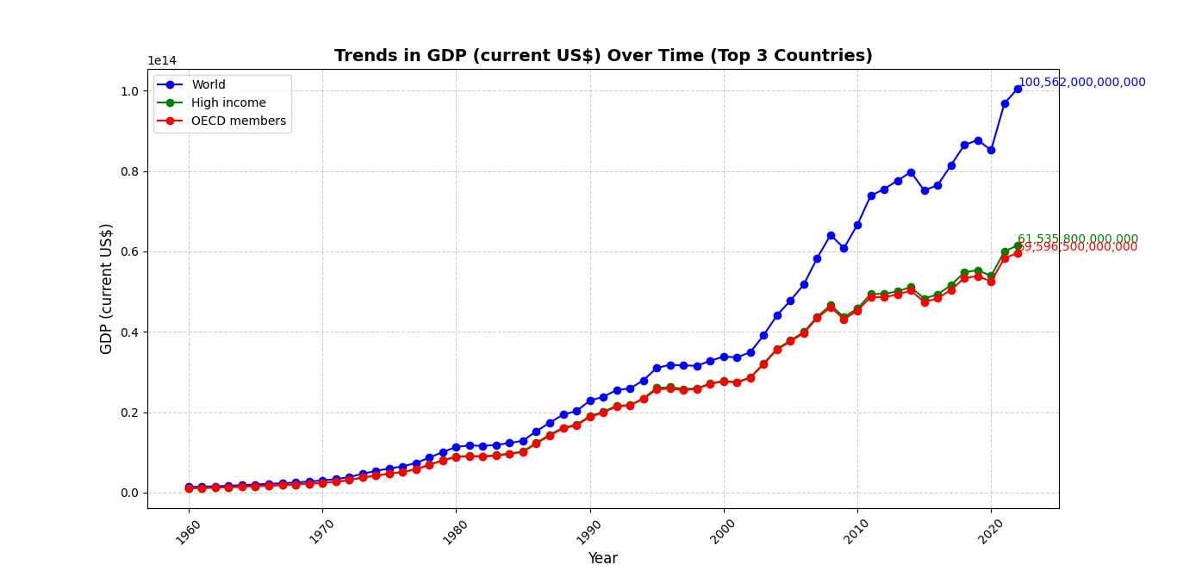

* **Steady Growth:** The top three economies exhibit consistent GDP growth, reflecting strong financial expansion and resilience.
* **Fluctuations:** Periods of economic slowdowns and surges highlight the influence of recessions, policy shifts, and global events.
* **Economic Powerhouses:** These nations thrive on a mix of technology, finance, and industry, reinforcing their economic dominance.
* **Takeaway:** To ensure sustained growth, countries should prioritize economic diversification and investment in innovation-driven industries.

**Unemployment Rate Trends Over Time**

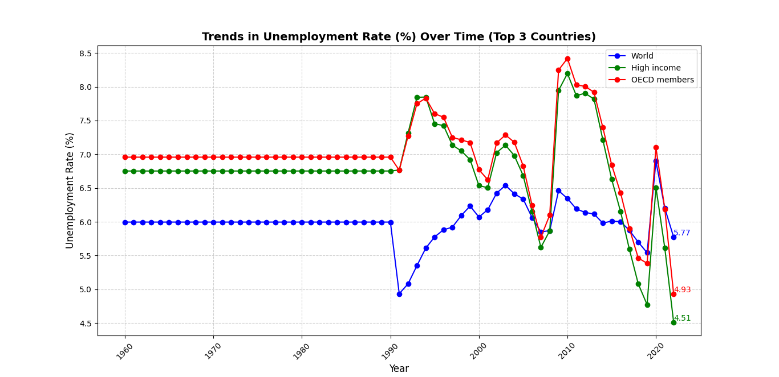

* **Declining Unemployment:** Some nations have effectively lowered unemployment through strategic labor policies and economic stability.
* **Rising Unemployment:** Others face increasing joblessness due to automation, economic downturns, or skill mismatches.
* **Economic Cycles:** Employment rates fluctuate in response to financial crises, pandemics, and labor market shifts.
* **Takeaway:** Governments should focus on workforce adaptability, job training initiatives, and investment in high-growth industries to maintain stable employment rates.

**Remittances (% of GDP) Over Time**

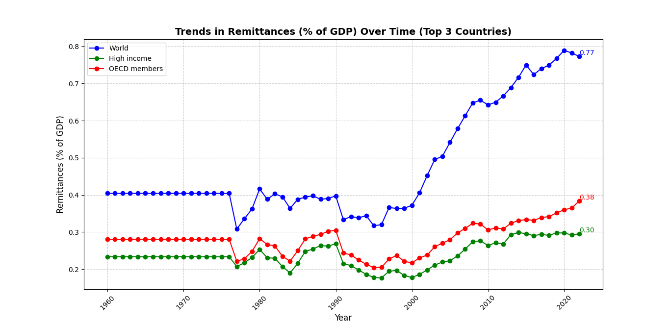

* **Economic Lifeline:** For some economies, remittances represent a crucial source of income, reflecting high dependency on migrant workers.
* **Declining Remittances:** Drops in remittance inflows may indicate reduced migration, economic improvements, or policy changes in host nations.
* **Stability Link:** Countries heavily reliant on remittances often have weaker domestic economies, while those with lower remittance dependence tend to have stronger job markets.
* **Takeaway:** Nations should focus on strengthening local industries and fostering job opportunities to reduce reliance on remittance inflows.

**3. Unemployment Rate Comparison (2022) - Bar Chart Analysis**

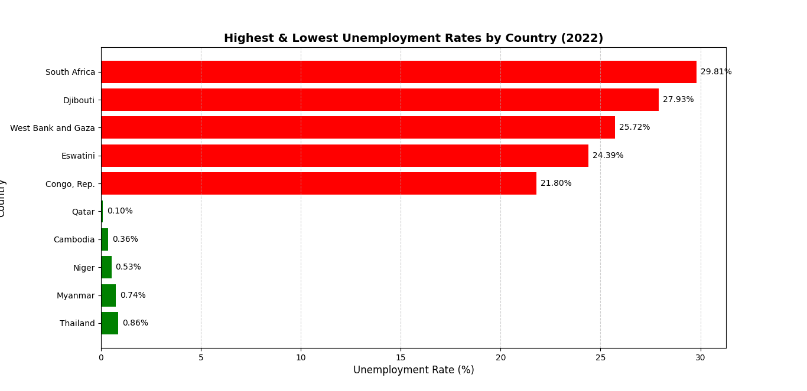

* **Highest Unemployment Rates:** Countries at the top of the unemployment spectrum may struggle with economic downturns, political instability, or weak job markets.
* **Lowest Unemployment Rates:** Nations with robust labor markets, stable economies, and business-friendly policies perform significantly better.
* **Wage and Employment Policies Matter:** High unemployment often signals labor market inefficiencies, skills mismatches, or inadequate job opportunities.
* **Takeaway:** Policymakers should analyze the successful strategies of low-unemployment nations and apply them to struggling economies by improving education, fostering entrepreneurship, and implementing effective employment policies.

**4. GDP vs. Unemployment - Scatter Plot Analysis**

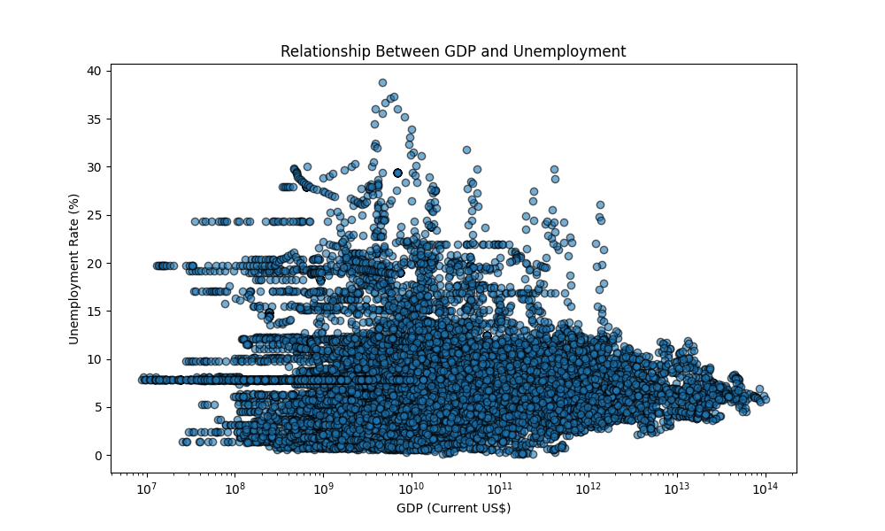

* **Negative Correlation:** Typically, nations with higher GDP levels tend to have lower unemployment, as stronger economies generate more job opportunities.
* **Exceptions Exist:** Some high-GDP countries still face moderate unemployment, often due to automation, labor policies, or economic restructuring.
* **Variability in Low-GDP Countries:** Economic size alone doesn’t dictate employment levels—factors like governance, industry diversity, and economic policies also play a significant role.
* **Policy Implications:**
  + Developing nations should emphasize industrialization, skill development, and entrepreneurship.
  + Wealthier economies should focus on job creation policies, reducing labor market inefficiencies, and addressing skill mismatches.

**5. GDP Growth Rate Distribution - Histogram Analysis**

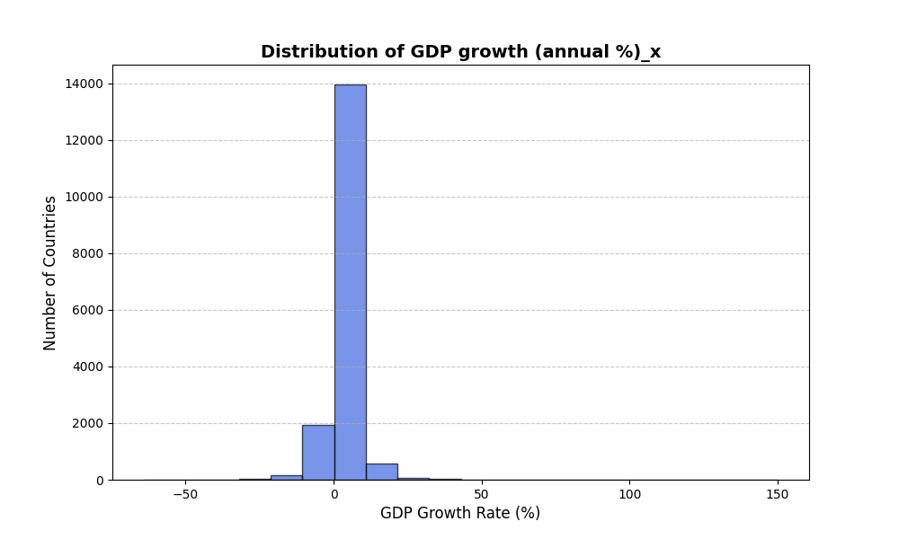

* **Most Countries Have Moderate Growth:** The majority of nations experience GDP growth rates between 0% and 5%.
* **Outliers Exist:** Some countries report negative or exceptionally high growth rates, indicating either economic recessions or rapid expansion.
* **Economic Stability Patterns:** The data suggests that while most economies experience steady but moderate growth, occasional shocks disrupt this stability.
* **Takeaway:** Policymakers should monitor outlier economies for potential financial instability and ensure that sustainable growth strategies are in place.

**6. GDP Growth Distribution by Region - Box Plot Analysis**

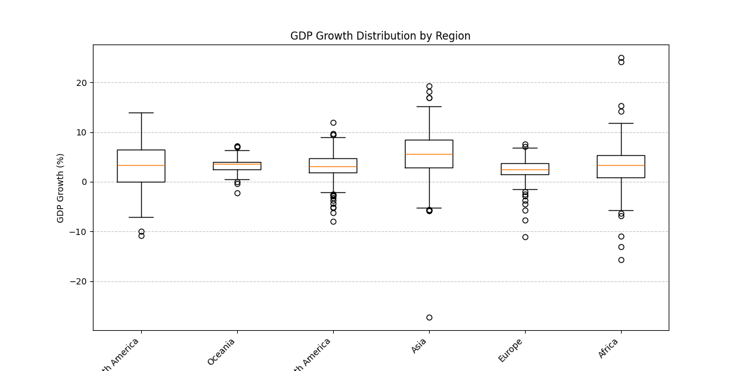

* **Stable vs. Volatile Growth:** Some regions demonstrate consistent economic expansion, while others face unpredictable fluctuations due to external factors.
* **Outliers & Economic Shocks:** Sharp increases or declines in GDP highlight economic booms, recessions, or impactful policy decisions.
* **Regional Disparities:** Variations in growth trends suggest differing levels of industrialization and economic resilience across regions.
* **Takeaway:** Policymakers should identify best practices from stable-growth regions and apply them to improve economic resilience in struggling areas.

**7. Final Recommendations**

* **GDP Growth & Stability:** Governments should prioritize sustainable economic policies and technology-driven expansion.
* **Job Market Improvements:** Investing in education, job training programs, and economic diversification is essential for reducing unemployment.
* **Reducing Remittance Dependency:** Nations should strengthen domestic industries to minimize reliance on foreign income.

**8. Conclusion**

This analysis provides valuable insights into global economic strengths and weaknesses, offering a data-driven foundation for informed policymaking. By leveraging these insights, governments and businesses can foster sustainable growth, reduce unemployment, and build resilient economies.

**Next Steps:** Future research should explore additional economic factors such as inflation, trade balances, and foreign investments to gain a deeper understanding of global economic trends.