Sunday Horror Night Scoring Form

* Scare Factor /10
* Lasting Effect /10
* Acting /10
* Plot /10

Overall /40

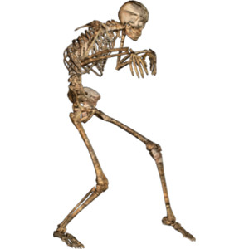

Sunday Horror Night Scoring Form

* Scare Factor /10
* Lasting Effect /10
* Acting /10
* Plot /10

Overall /40



Sunday Horror Night Scoring Form

* Scare Factor /10
* Lasting Effect /10
* Acting /10
* Plot /10

Overall /40

