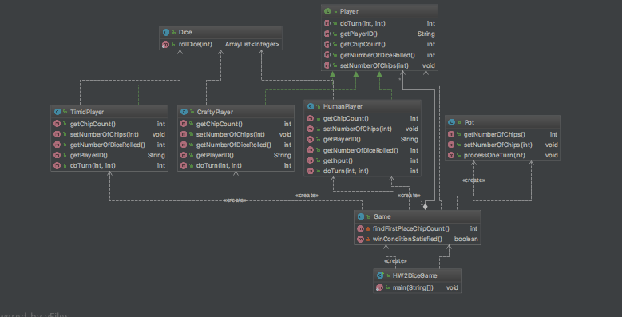

This is my class diagram. The classes I made were Timid Player, Crafty Player, Human Player, Dice, Pot, Game, and HW2DiceGame. The 3 player classes seemed like a natural choice because of their slight differences in the way they process moves. They are united under the player interface to keep consistence. This allowed the game class to be slightly more manageable. The dice class I made because I writing the dice roll ability across all the player classes seemed redundant, and also it made it easy to convert from a 4-sided dice to a 6-sided dice if that was ever an option. The pot class could have been built under Game but I decided that it had enough functionality to warrant its own class, and also to make it easier to change the starting amount of chips in the pot or the mechanics of refilling the pot.