Mine Sweep

Introduction
When the user clicks on a button
the program will search all the surrounding area looking for bombs
and adding them up.
Location of mines in relation to button click.

B = Current button
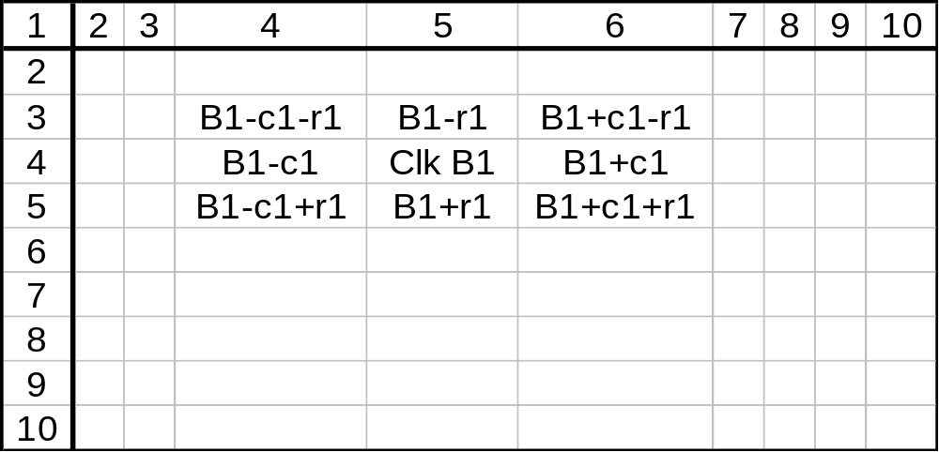R = Row
C = Column

Possible map of mines.
For the user to play the game should they click on the square in Column 6, row 4, the square would indicate that there are 2 mines close by.

If they then click on column 10, row 2 it would show there are no mines by displaying the figure 0.

However should the user click on square containing a mine all bombs would be displayed and the screen would show the game over movie.

M = Mine
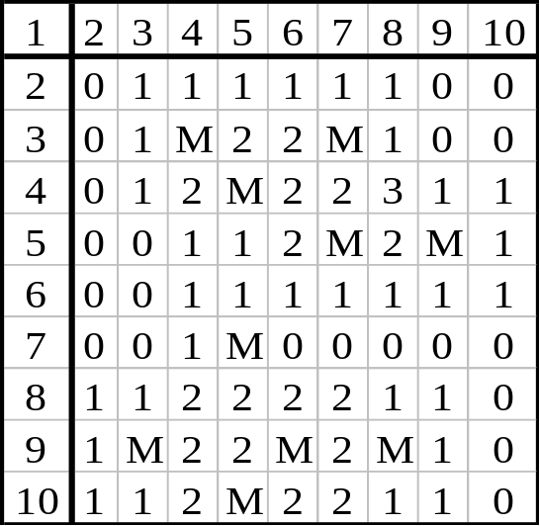

Objects
 | This image would indicate that there is a mine in this location when the game is over.
 | The user may wish to use this by right clicking on a square to indicate that he suspects that a bomb is in this location.
 | When the user clicks on a location the square displays a number to tell him how close the mines are, this image tells the user that there are no mines in the immediate vicinity.
 | This image indicates that there is one mine next to this square.
 | This image indicates that there are two mines next to this square.
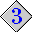 | This image indicates that there are three mines next to this square.
 | This image indicates that there are four mines next to this square.
 | This image indicates that there are five mines next to this square.
 | This image indicates that there are six mines next to this square.
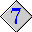 | This image indicates that there are seven mines next to this square.
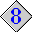 | This image indicates that there are Eight mines Surrounding this square.

Testing

In order to test the game it is necessary to find all the bombs and confirm that each bombs location changes with every turn. The code shown below must be developed as a testing button, which will be invisible when testing is complete.
Private Sub Cmd_Test_Click()

'setup Object controls
Dim Obj_Control As Control
Dim Obj_Button As MSComctlLib.Button

Dim int_row3 As Integer 'Setup rows for end game
Dim Int_Mines As Integer 'mines

int_row3 = 1

'show all buttons with bombs as image 10 and disable
For Each Obj_Control In Controls

'reset buttons on toolbar
If TypeOf Obj_Control Is Toolbar Then

'reset each button individually
For Each Obj_Button In Obj_Control.Buttons

'If mines = 10 Then Resume Next
If Bool_Bomb(int_row3, Obj_Button.Index) = True Then

'change current button image
Obj_Button.Image = 10

End If
Next
'add one to row count for bomb viewing
int_row3 = int_row3 + 1

'add one to mine count
Int_Mines = Int_Mines + 1
End If

Next

End Sub

Testing List
Test 1: Each game should contain 10 mines the position of which should change with every game. Also the timer should restart every time a new game is played.

Test 2: The number of mines in close proximity should always be indicated on the position that the mouse is clicked.

Test 3: The “Best Times Board” should always keep the score in memory.

Test 4: The game is won when the user has pressed all the buttons without mines.

Test 5: The mines should always be shown for a losing game.

Test 6: The correct Video should always be played for winning or losing.

To document this test it will necessary to comment the Unload Frm_Sin line of the code to disable it.

Private Sub MdPlay1_EndOfStream(ByVal Result As Long)

'play file untill end of file
If MdPlay1.SelectionEnd = MdPlay1.CurrentPosition Then
'remove form
Unload Frm_Sin
End If
End Sub

Test 1

Start Game 1st New Game 2nd New Game
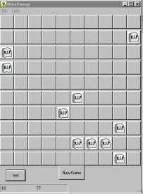
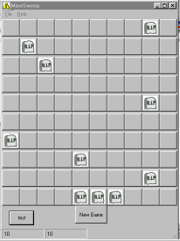
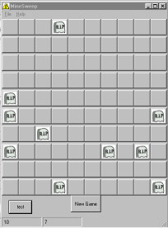
The bombs location changes with each new game, and in each case there are 10 bombs plus the timer starts anew.
Test 2

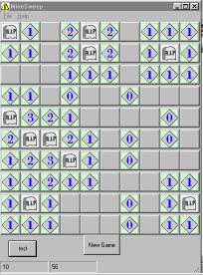
As expected, each square clicked indicates whether there is a mine near by and shows the quantity.

If there are no bombs in the surrounding squares the square displays 0 mines adjoining.

Test 3

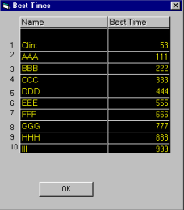
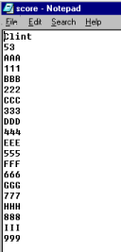
Old best times New Best Times new file written
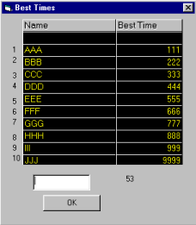
With this file, the contents are read and updated as necessary.

Test 4
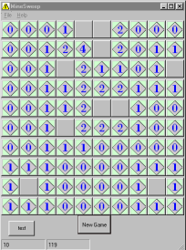
After 90 buttons were clicked the winning game message was shown.

Test 5

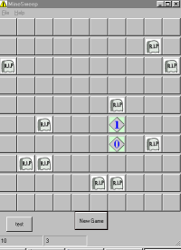
All mines are shown for this losing game.

Test 6

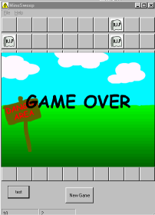
Winning Game Losing Game
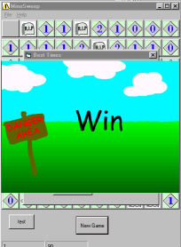

The above shows game selected the correct file for a winning or losing game.

