陈钰坤

电子科技大学论文格式Word插件 用例规约

# 一、Use Case Diagram

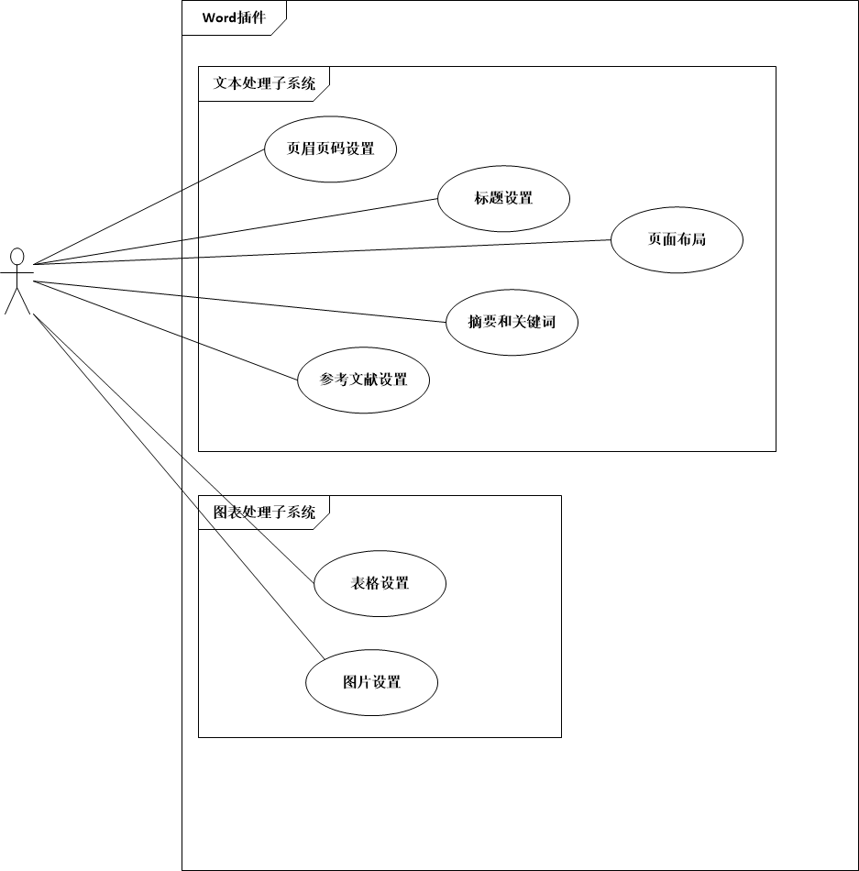

Picture 1

# 二、用例规约

## 1、Text Processing Subsystem

### 1.1 Header & Footer Setting

Header Setting: set the header automatically.

Footer Setting: set the footer automatically after you have set the Headings.

### 1.2 Title Setting

Chinese Heading: set the selected part as the title of this passage.

English Heading: set the selected part as the title of this passage. (when title is written by English)

Chinese Heading 1: set the selected part as the Heading 1.

Chinese Heading 2: set the selected part as the Heading 2.

Chinese Heading 3: set the selected part as the Heading 3.

English Heading 1: set the selected part as the Heading 1.

English Heading 2: set the selected part as the Heading 2.

English Heading 3: set the selected part as the Heading 3.

### 1.3 Page Layout

Font Setting: set the font of the selected part.

Delete Blank Lines: delete the blank lines of the selected part.

### 1.4 Abstract And Keywords

Chinese Title: Insert “摘要” when the button is clicked.

Chinese Abstract Content: set the selected part as the Abstract.

Chinese Keywords: set the selected part as the keywords.

English Title: Insert ‘Abstract’ when the button is clicked.

English Abstract Content: set the selected part as the Abstract.

English Keywords: set the selected part as the keywords.

### 1.5 Reference Setting

Insert Reference: Insert the reference when the button is clicked, the selected part will be formatted as reference when the button is clicked with something be selected.

## 2、Picture & Table Processing Subsystem

### 2.1 Table Setting

Title Formatting: set the chosen part as the title of table.

Insert Table Title: create the title of the tables in this passage.

Table Formatting: format the tables in this passage.

### 2.2 Picture Setting

Insert Title: create the title of the pictures in this passage.

Title Formatting: set the chosen part as the title of picture.