# OCR Output

Archivo: Advanced_OCR.pages.pdf

## Page 1

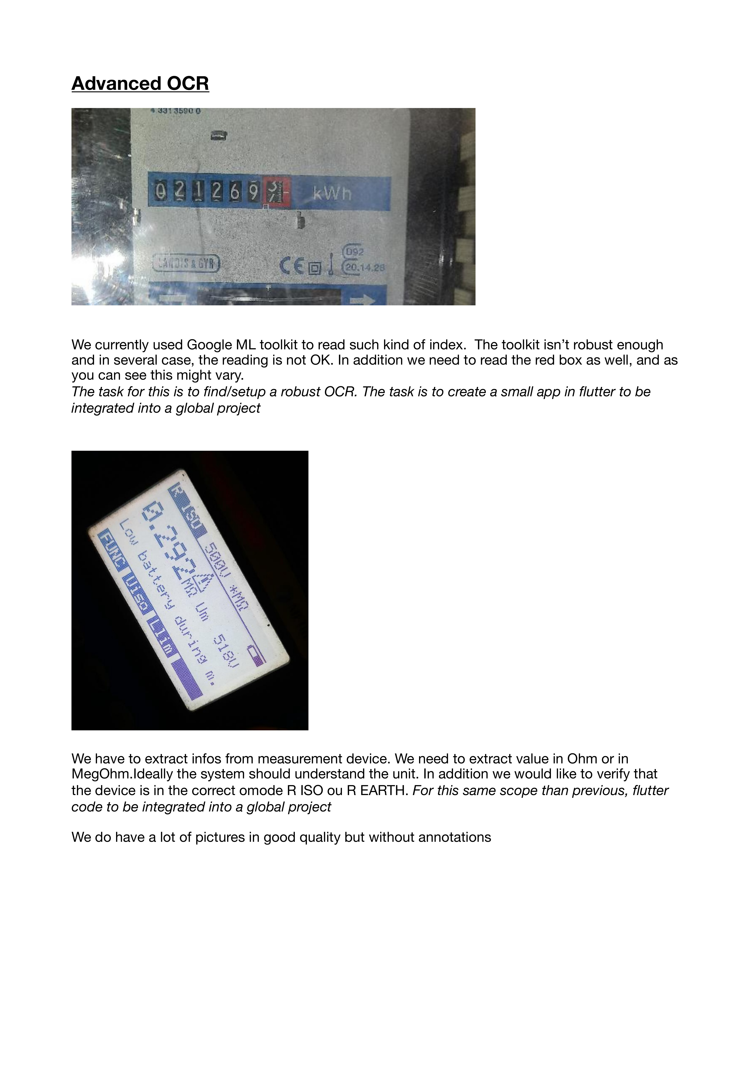

Detected red boxes (extracted text):

Red box #1 (bbox=(1144, 763, 144, 156)):

[NO TEXT DETECTED]

Full page OCR:

Advanced_OCR  
133135900  
2 6  
kWh  
(092  
"XMdXs 4 GYR  
6p  
69.14.28  
We currently used Google ML toolkit to read such kind of index:  
The toolkit isn't robust enough  
and in several case, the reading is not OK. In addition we need to read the red boX as well, and as  
you can see this might vary:  
The task for this is to findlsetup a robust OCR: The task is to create a small app in flutter to be  
integrated into a global project  
We have to extract infos from measurement device. We need to extract value in Ohm or in  
MegOhm Ideally the system should understand the unit. In addition we would like to verify that  
the device is in the correct omode R ISO ou R EARTH: For this same scope than previous, flutter  
code to be integrated into a global project  
We do have a lot of pictures in good quality but without annotations  
E  
9  
3  
9  
1  
3  
3  
6  
1  
g