Mamma Mia Accounts Payable System
Cartraill Love
MIS350- Information Systems Analysis and Design
Colorado State University – Global Campus
Dr. Jamia Mills
September 8, 2018

MAMMA MIA Company Description and System Environment
Mamma Mia is a nationwide dry pasta company based out of Denver, Colorado. They currently have 20 plants and distribution centers throughout the States. Mamma Mia has their current system that does the job exceedingly well. However, they lack Purchasing and Accounts Payable systems to compliment and drive the organizations success further. Currently they use a fusion of MS Access and client-server-server architecture through an Oracle database. The main office in Denver functions as the host and the Plants communicate through a centralized server farm. Based on their current success, Management has a fear of using cloud-based services due to security concerns but knows that it is time for change.
Detailed Requirement Lists
The constraints, or request are primarily found within utilizing Software as a Service (SaaS). Since, the steering committee looks forward to modernizing and upgrading the purchasing system we first look at security. A well-run SaaS company has a strong, dedicated, and trusted security team that is solidly engaged in the security industry (Diginomica.com,2017). Hence, the importance of User authentication and permissions to be enforced through logins and passwords. Other requirements are listed below:
User Authentication and Permissions (previously listed)
Data Entry: Purchase order, ship-to address, date, contact number and other sales details.
Data Entry: Order must include quantity, price, and currency code, date ordered and delivered.
Data Entry: Payment type (Cash, Card, Checking Account), due date (if applicable).

Project Scope Statement
This project is for the creation of accounts payable system that will reduce the usage of invoices manually and physically through an automated system that will communicate securely, consistently and directly from accounts payable to the treasury to cover any cost for vendors and any allocation of unused funds back within the business.

Feasibility Analysis
There are generally several elements and in some cases six. Here are the elements that are covered within this projects feasibility:
- Economic- Based on previous numbers provided by the Customer Service Manager it was found that the organization would benefit tremendously with the implementation of SaaS (Software as a Service) with purchasing and accounts payable. There will be a savings in time and cost creating both tangible and intangible benefits. Current System produces $1,080,800 Return of investment (ROI) annually with a Total Cost of Ownership (TCO) $1,357,236 annually. The updated systems TCO will cost $361,929.60 annually and have an ROI of $2,075,929.60. The benefits are found in the numbers and reduction in use of manual and physical invoices.
- Technical- Rather than having a division between the headquarters and plants there will be a centralized area where all data travels outwardly, inwardly, and becomes stored. Project size, structure, development group and user group are all be covered. Risk factors were determined, and training is available for employees through the software itself.
- Operational- Within Accounts Payable or A/P being that the old system required more of a manual approach to pay vendors there will be an automated system that pay vendors for use and logically allocating funds to other parts of the organization. This system will connect Treasury/cash management department with the vendor as an automated approach, yet also produce detailed invoices regarding any transactions going in/out of the treasury department.
- Scheduling- Upon initiation and implementation of the A/P system it will take four weeks to develop the system, an additional two weeks for evolutionary prototyping and completion the following week. Estimated time of completion seven weeks.
- Legal and Contractual- Once all conditions are met there will be a trial period of 14 days after that there is the option between an annual contract or semi-annual contract. Data and user content are protected (it is not sold to a third party). Warranties and maintenance are all covered cost. Termination prior to fulfillment agreement can lead to a cancellation fee.
- Political- Key stakeholders have been shown the power point presentation that breaks down the system and the benefits associated with its uses. They understand and have agreed that it will save time and money. Not only that, it will counter micro managing by giving end users the ability to train themselves, or in groups when the company allows for it.

Structure of the Project
- Product Owner- WAGATUK Software Solutions and Services for Mamma Mia Pasta Company.
- Development Team- This is the cross functional team that will perform all the technical tasks. They will focus on the accounts payable system and transaction quality. Within the development team you will find the designer, coder, tester, programmer and analyst developing the system based on historical data and stories of end users.
- Scrum Master- Responsible for facilitating the meetings, making certain communication between Product Owner and development team breed synergy to accomplish system objective(s).

Scrum Meetings (Initialization Activities)
The project vision, key stakeholder’s involvement, identification of who the scrum master will be, and which individuals will be a part of the Scrum Team. Upon assembling the proper team and understanding of the company’s vision the scrum product backlog is produced, presented and sprints are given as guidelines with time frames and estimates based on the scrum team’s synergy. Sprint list include:

1.Preparaton of Inventory order numbers synchronized with each send/receive Purchase Order and Return. (Week 1)
2. Acceptance, rejection and pending status updates and confirmation based on form of payment (Terms and conditions included). (Week 1)
3. Retrieval of copy of PO, ETA and tracking confirmation. (Week 2)
4. Sending/Receiving PO and Return(s) to proper department (i.e., Vendor(s) and Treasury) through E-mail, fax and other avenues. (Week 2)
5. Distribution of funds owed to vendor sent at set time and proper distribution or allocation of funds back within the business for other business needs signaled to Treasury department.
(Week 3)
6. Storing of payment information and data securely within the repository for business future reference. (Week 4)
7. Evolutionary prototyping and testing scrum development team then implementation and execution occur. (week 5-7)
Proposed Intermediate Scrum Deliverables
Intermediate scrum deliverables will include a list of team members and key stakeholders, Sprint and product backlog, burn charts, sprint velocity charts, a sprint retrospective log and budget given.

Mamma Mia Accounts Payable Logical ER-D

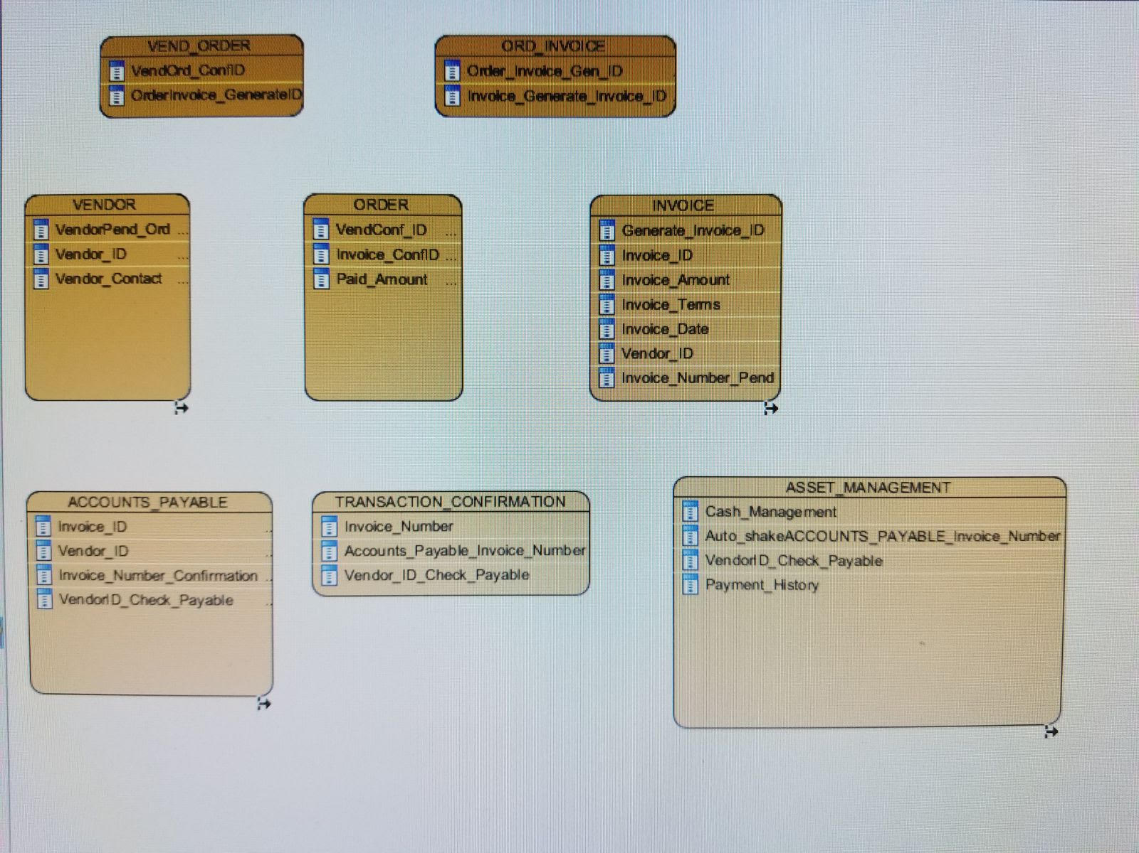

Mamma Mia Accounts Payable Physical ER-D

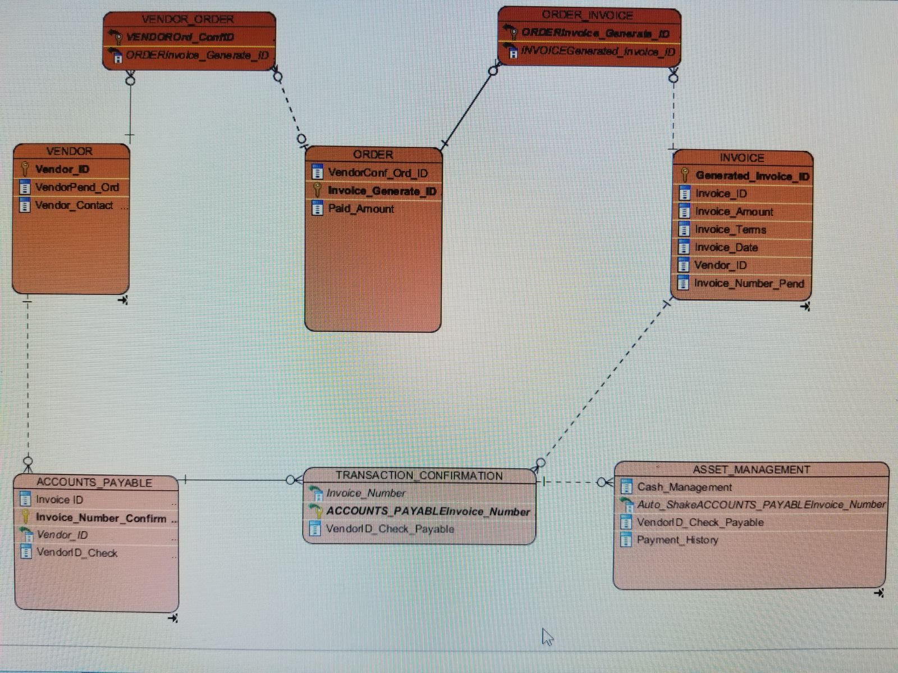

MAMMA MIA ACCOUNTS PAYABLE SYSTEM
Test Plan
Version 1.0
09/08/2018

Version History

ID & Version  # | Prepared  By | Revision  Date | Approved  By | Approval  Date | Reason
1.0 | WAGATUK | 09/07/18 | Thorough Nine | 09/08/2018 | Mamma Mia Accounts Payable Test Plan

Introduction

MAMMA MIA ACCOUNTS PAYABLE SYSTEM Test Plan Document
Implementation of SaaS Mamma Mia Accounts Payable system to suit business needs.

Test ITEM

Project description
Utilize the WAGATUK stand alone Accounts Payable SaaS system for transaction processing, transaction history, and invoice generation (purchasing system connected as well).

Items to be Tested / Not to be Tested
Some of the items to be tested are Vendor, Order, Invoice, Transaction Confirmation, and Asset Management. Other items that should not be tested include purchasing system.

Item(s) to Test | Test Description | Test Date | Responsibility
Vendor, Vendor_Order process. | Communication between Vendor, Vendor_Order processing. | 8/11/2018 | Order process accurately.
Vendor_Order, Process Confirm Pending Order | Order_invoice, generate invoice, invoice efficiently processes, sends confirmation. | 8/11/2018 | Confirm order; generate invoice.
Order_Invoice, invoice generated, Invoice transaction_confirmation, Invoice accounts_payable | Order_Invoice generates invoice efficiently and sends transaction_confirmation invoices to accounts_payable and asset_management. | 8/11/2018 | Invoices sent to transaction_confirmation, asset_management and accounts_payable.
Transaction_Confirmation | Transaction_Confirmation communicates concisely with Asset_Management and Accounts_Payable with invoices, saves invoices, and transfers funds to Accounts_Payable. Three-way match. | 8/11/2018 | Transaction_Confirmation makes certain that all transactions complete, record history and process additional request.
Asset_Management | Asset_Management saves invoices, properly allocates funds VIA cash_management, | 8/11/2018 | Asset_Management provides of funds and allocation of funds.
Accounts_Payable | Invoice confirmation and check distribution. | 8/11/2018 | Confirms invoices, distributes check and invoice to vendors
Security | Attempt to ethically hack to test strength of encryption, firewall and three-way match. | 8/11/2018 | Protect data

Items to be tested
Item Not to Test | Comment
Purchasing system | Purchasing system separate. Leave purchasing elements out.

Test Approach(s)
The test strategy involved includes Mamma Mia making initial agreement purchase from WAGATUK LLC. Mamma Mia Accounts Payable system receives information from Purchasing system VIA online automated system. Upon receiving information invoice generated and sent back to WAGATUK.
Asset Management and Accounts Payable monitored on dual screens to manage efficiency and accuracy of details provided. This test should be performed several times to ensure everything works accordingly.
Ensure three-way match acts accordingly (security mechanism) and encryption occurs throughout process.

Test Pass / Fail Criteria
If the system is successful then it will properly produce invoices, complete cash management through storing invoice history and properly allocating funds of business in other areas of Business needed. Three-way match and encryption work thoroughly.
If system fails it will emit the wrong invoice numbers, not produce invoice automatically, crash, process and allocate funds improperly, fail security required test.

Test Entry / Exit Criteria
Upon WAGATUK order confirmation and system handshake invoice should be developed and information stored accordingly. Exit criteria completion upon successful emit of invoice to Asset management, Transaction confirmation, and Accounts Payable.

Test Deliverables
Confirmation of successful testing VIA reports. Data Flow Diagram Logical/Physical and Mamma Mia Accounts Payable system Manual.

Test Suspension / Resumption Criteria
[Describe the suspension criteria that may be used to suspend all or portions of testing. Also describe the resumption criteria that may be used to resume testing.]

Staffing / Training Needs
Mamma Mia Accounts Payable system Manual provided for Information Systems Managers. Software has separate installed modules for subordinates to learn and utilize the system.

Risk and mitigation

Test Risks / Issues
Three-way match and encryption accurate. Allow several tests from Ethical Hackers. Ethical Hackers attempt to take over system to determine level of risk and security.

Test Environment and infrastructure

Required Infrastructure
Mamma Mia main facility include hardware servers, application servers, and firewalls within facility to name a few.

Availability Plan
High availability software.

Roles and responsibilities

Roles and assigned responsibilities
Roles are given based on the Project Manager upon release of Mamma Mia Accounts Payable software.

Test Schedule

Milestones and schedule

Milestone | Deliverable | Start Date | End Date
System Implementation and testing completion | Information Systems Manager manual | 8/1/2018 | 8/8/2018
Training Module installation | Walk Information Systems Manager through set up of training modules for other employees | 8/1/2018 | 8/9/2018
Trial of WAGATUK System use for Mamma Mia | WAGATUK Full system conversion (trial completion and agreement) | 8/1/2018 | 8/15/2018
DevOps meeting | Meeting for Developers and Operations. Provide PowerPoint presentation on why and provide system app introduction for both o communicate. | 8/1/2018 | 9/7/2018

Test Plan Approval
All who sign agree to WAGATUK SaaS for Mamma Mia Accounts Payable Test Plan document agree with and approve test plans. If any changes need to occur, the organizations Information Systems Manager, or Project Manager, can contact a Systems Analyst at WAGATUK.

Signature: |  | Date:
Print Name:
Title:
Role:

Signature: |  | Date:
Print Name:
Title:
Role:

Signature: |  | Date:
Print Name:
Title:
Role:

Summary of Training Plan
Upon successful installation of the WAGATUK SaaS Accounts Payable system there will be a follow up to install additional software. The additional software will have a total of eight modules that will guide the Information Systems Manager and an additional eight for subordinates based on their role within the operations of the system and organization itself. The training for subordinates can be self-regulated and scheduled around the company’s time and the training for the system itself will require at three days or 24 hours to train the Information Systems Manager. Note: Training is continuous and updated documents will be provided whenever any updates are made to the system based on the company’s request.

Introducing DevOps
DevOps integrates Operations and Developers. Many organizations utilize DevOps strategically Utilizing DevOps will save money, time and overall maintenance. DevOps focus on automaton of code testing, workflows and infrastructure. Not only that, Operations and Developers are synchronized with work and often doing operations and code at a faster and more efficient rate. The approach is more iterative, rather than ad hoc. DevOps is the combination of cultural philosophies, practices, and tools that increases an organization’s ability to deliver applications and services at a high velocity: evolving and improving products at a faster pace than organizations using traditional software development and infrastructure management processes (aws.amazon.com, n.d.,).

Mamma Mia DevOps

Mamma Mia should utilize DevOps for many purposes and benefits. DevOps enforces the concept of communication between Developers and Operations being consistent functioning as one unit rather than Developers having their approach and Operations having theirs. DevOps ensures that collaboration is consistent and if for any reason there are changes needed they can be implemented within hours versus days, weeks or months. This is done through consistent updates when needed. Below is a list of other benefits associated with DevOps:
- Continuous Integration
- Continuous Delivery (Shorter cycle time and quick responses)
- Microservices
- Infrastructure as a Code
- Security, Monitoring and Logging
- Communication and Collaboration
It is critical that DevOps becomes the glue to all building blocks for the System Development Life Cycles continued maintenance. Maintenance tends to cost organizations the most. Our goal is to minimize cost and increase productivity.

Implementing DevOps
DevOps and Cloud computing are linked. The core component of this relationship is value through agility (techbeacon.com, 2018). In strategizing and implementing DevOps everything below should be considered:
- Understand requirements, develop communication plan between Developers and Operations to utilize and maintain.
- Make certain that services are updated frequently, traffic is managed properly, trends are monitored and if changes are needed they are be mitigated immediately.
- The collective (DevOps) should focus on end user satisfaction.
- A universal tool implemented between Ops and Dev so that each can see how the other operates with regards to apps.
- Automation is idea.

Overall, Mamma Mia should implement and keep a consistent DevOps approach to maintain success.

References
Atchison, L. (2017, October 25). Your data is more secure with SaaS companies than it is with you. Retrieved September 8, 2018, from https://diginomica.com/2017/10/25/your- data-is-more-secure-with-SaaS-companies-than-it-is-with-you/
Developing Analytics for Your AP Team. (n.d.). Retrieved September 8, 2018, from https://www.theaccountspayablenetwork.com/best-practices/best-practices-strategic- management/managing-payables/developing-analytics-ap-team
Lemkin, J. (2018, June 05). What is a SaaS company cancellation policy on yearly contracts? Retrieved September 8, 2018, from https://www.saastr.com/saas-company- cancelation-policy-yearly-contracts/
Linthicum, D. (2018, April 12). Best DevOps strategies to ensure success in the cloud. Retrieved September 8, 2018, from https://techbeacon.com/bulletproof-devops-strategy- ensure-success-cloud
Mitchell, I. (2017, February 24). A Typical Sprint, Play-By-Play. Retrieved September 8, 2018, from https://www.scrum.org/resources/blog/typical-sprint-play-play
What is DevOps? - Amazon Web Services (AWS). (n.d.). Retrieved September 08, 2018, from https://aws.amazon.com/devops/what-is-devops/

