Clint Kline

Wk 3 Part 1 A

**Ch6 Prog Ex 2:**

*// Filename: Wk3ProgEx2.cpp*

*// Created date: 10-28-2021*

*// Author: Clint Kline*

*// Purpose: isVowel() - Chapter 6 Program Execise 2.*

#include <iostream>

using *namespace* std;

*bool* isVowel(*char* *ch*);

*int* main()

{

*char* ch;

    cout << "Enter a character: ";

    cin >> ch;

    cout << endl;

    cout << ch << " is a vowel: " << isVowel(ch) << endl;

    return 0;

}

*bool* isVowel(*char* *ch*)

{

    switch (*ch*)

    {

    case 'A':

    case 'E':

    case 'I':

    case 'O':

    case 'U':

    case 'a':

    case 'e':

    case 'i':

    case 'o':

    case 'u':

        return true;

    default:

        return false;

    }

}

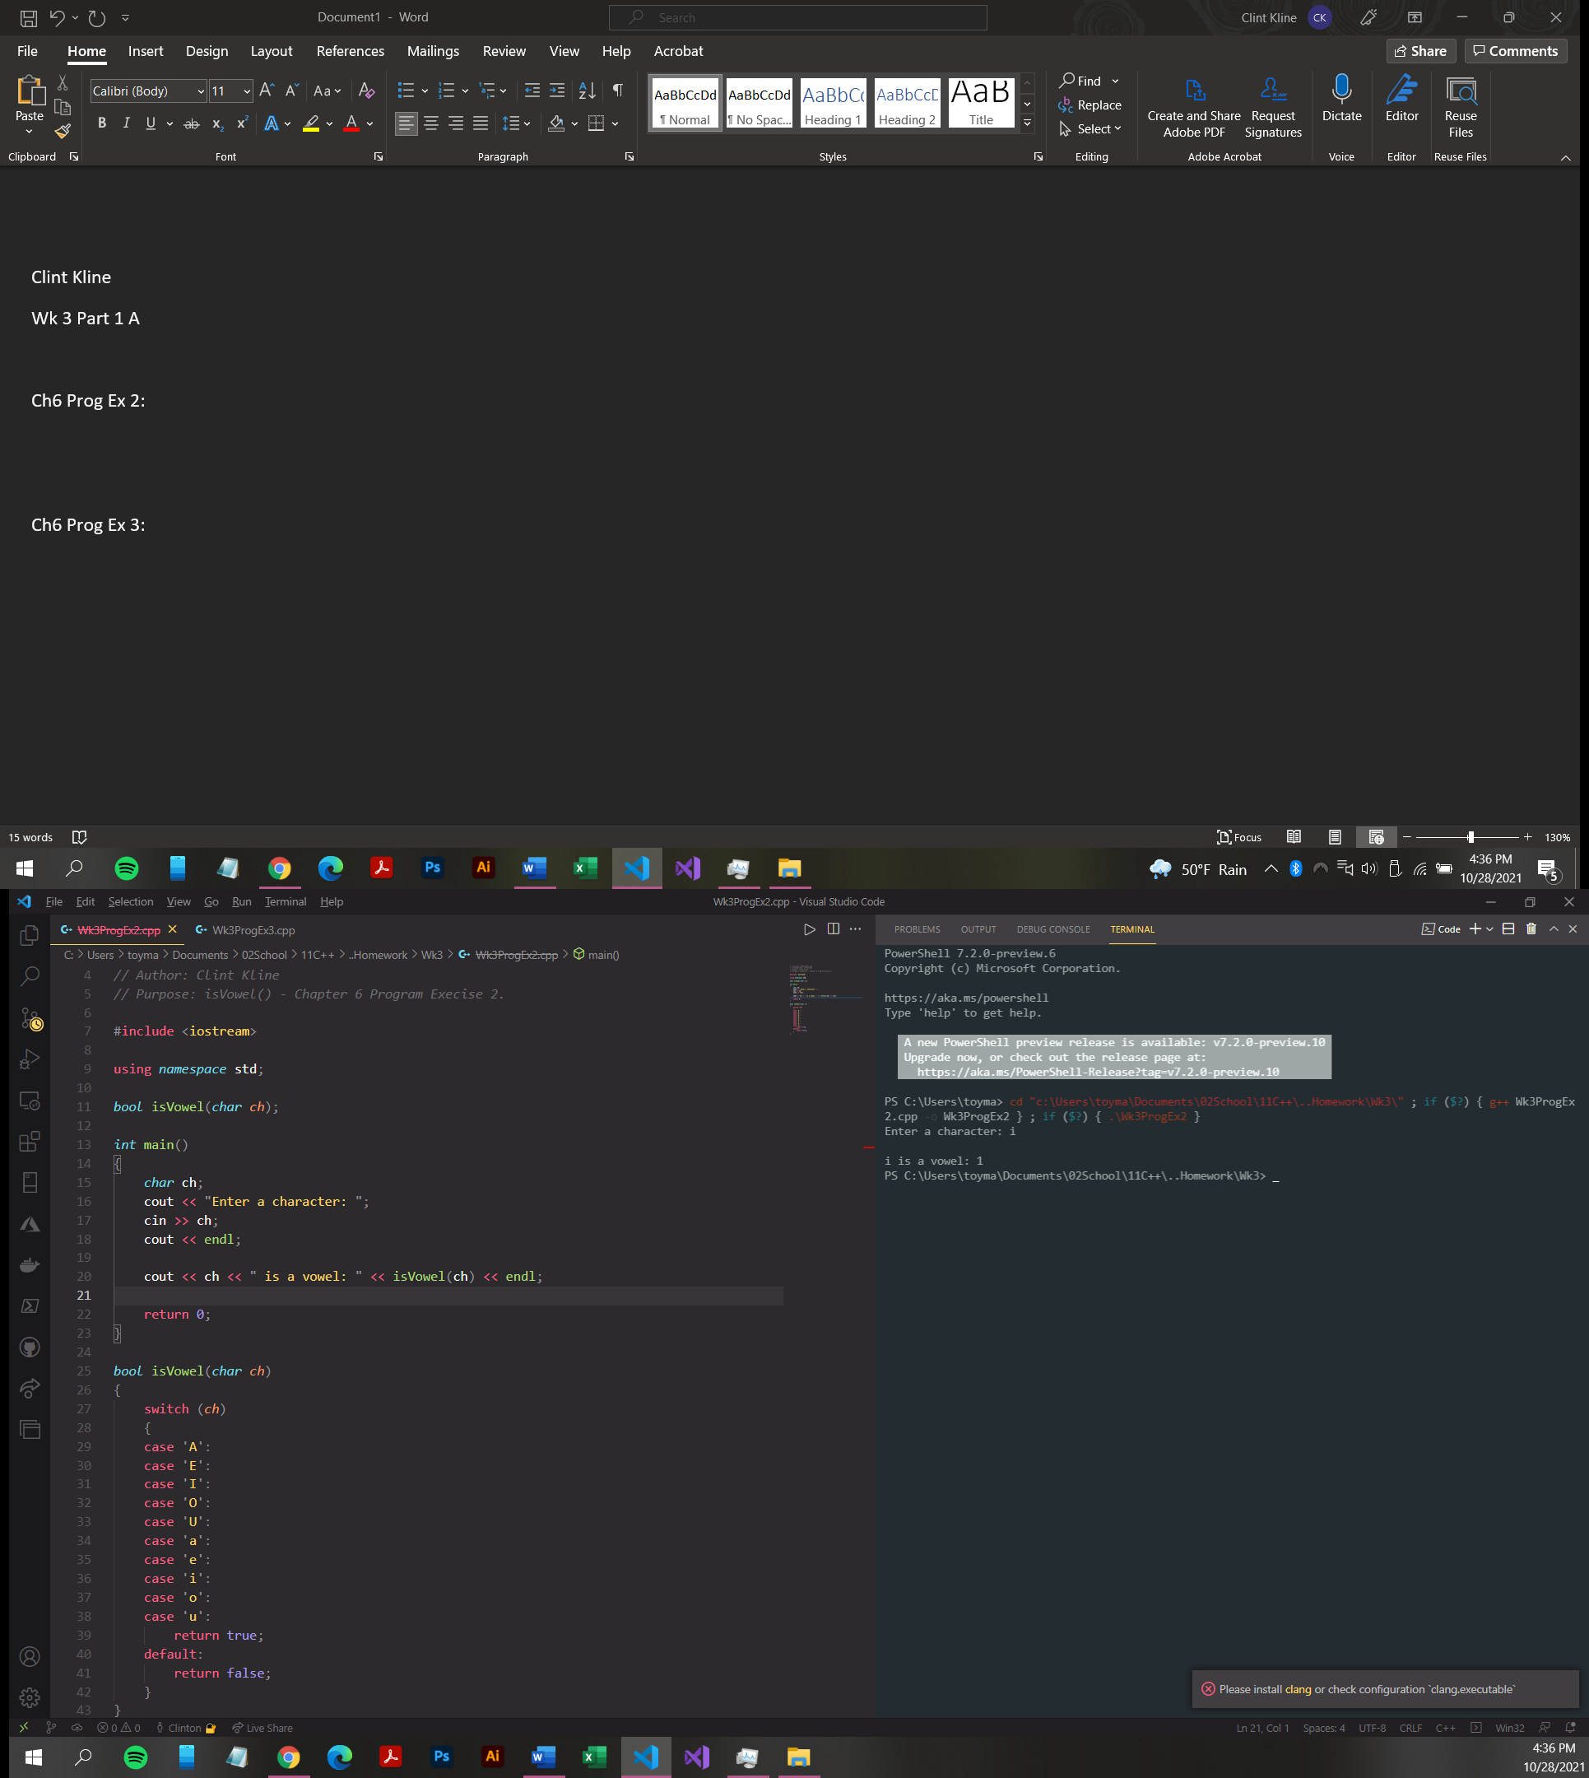

**Ch6 Prog Ex 3:**

*// Filename: Wk3ProgEx2.cpp*

*// Created date: 10-28-2021*

*// Author: Clint Kline*

*// Purpose: isVowel() - Chapter 6 Program Execise 2.*

#include <iostream>

using *namespace* std;

*bool* isVowel(*char* *ch*);

*int* main()

{

*char* ch;

*int* numOfVowels = 0;

    cout << "Enter a sentence: " << endl;

    cin.get(ch);

    while (ch != '\n')

    {

        if (isVowel(ch))

            numOfVowels++;

        cin.get(ch);

    }

    cout << "ther are " << numOfVowels << " vowels in this sentence." << endl;

    return 0;

}

*bool* isVowel(*char* *ch*)

{

    switch (*ch*)

    {

    case 'A':

    case 'E':

    case 'I':

    case 'O':

    case 'U':

    case 'a':

    case 'e':

    case 'i':

    case 'o':

    case 'u':

        return true;

    default:

        return false;

    }

}

