Clint Kline

ASD 102 – Object Oriented Programming with C++

10-20-2021

**Chapter 4 Exercise 19:**

#include <iostream>

#include <string>

using *namespace* std;

*int* main()

{

*double* sale;

*double* bonus;

    cout << "What was the sale amount? " << endl;

    cout << ">> ";

    cin >> sale;

    if (sale > 20000)

    {

        bonus = .10 * sale;

    }

    else if (sale > 10000 && sale <= 20000)

    {

        bonus = .05 * sale;

    }

    else

    {

        bonus = 0;

    }

    cout << "Your bonus is: $" << bonus << "\n"

         << "\n"

         << endl;

    return 0;

}

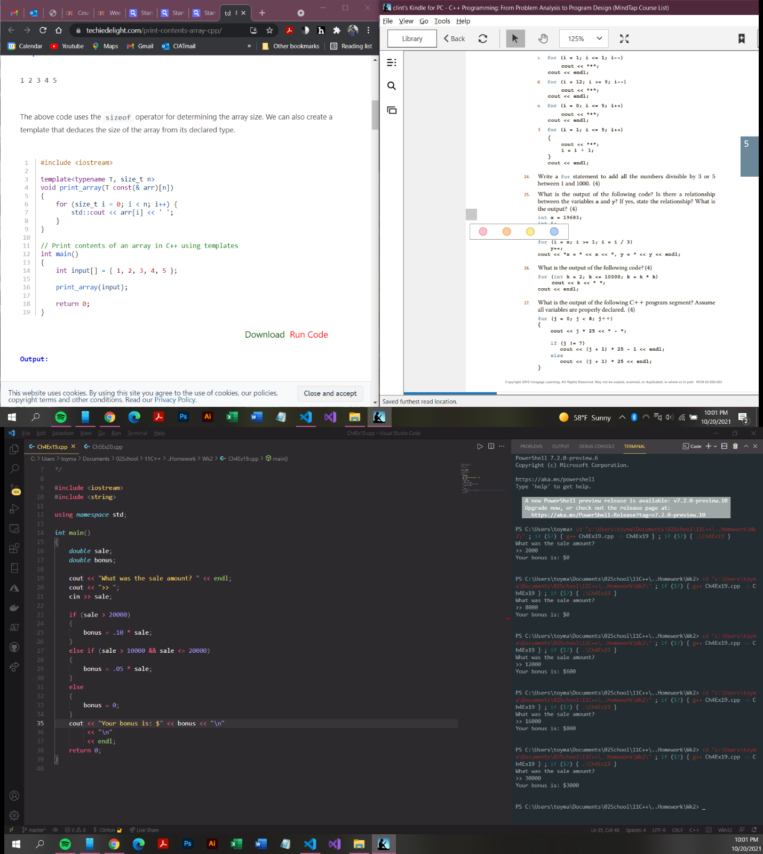

**Chapter 5 Exercise 24:**

#include <iostream>

#include <fstream>

#include <string>

#include <ctime>

using *namespace* std;

*int* main()

{

    ifstream inData;

*int* counter = 0;

    inData.open("Exp_5_23.txt");

    while (counter < 5)

    {

*int* num;

*int* sum = 0;

        inData >> num;

        while (num != -999)

        {

            sum += num;

            inData >> num;

        }

        cout << "Line " << counter << ": Sum = " << sum << endl;

        counter++;

    }

};

