Clint Kline

ASD 102 – Object Oriented Programming with C++

10-20-2021

Chapter 4 Programming Exercise 1:

*/\**

*Filename:Ch5Ex20.cpp*

*Creation Date: 10-20-2021*

*Author: Clint Kline*

*Purpose:*

*- desription.*

*\*/*

#include <iostream>

#include <string>

using *namespace* std;

*int* main()

{

*int* num;

    cout << "\*\*\*\* - 0 or + \*\*\*\*"

         << "\n"

         << endl;

    cout << "Please Enter a Number: " << endl;

    cout << ">> ";

    cin >> num;

    if (num == 0)

    {

        cout << "\n"

             << num << " is 0"

             << "\n"

             << "\n";

    }

    else if (num < 0)

    {

        cout << "\n"

             << num << " is a negative number."

             << "\n"

             << "\n";

    }

    else if (num > 0)

    {

        cout << "\n"

             << num << " is a positive number."

             << "\n"

             << "\n";

    }

    else

    {

        cout << "PLEASE ENTER A NUMBER... " << endl;

    }

    cout << "Again.. "

         << "\n"

         << endl;

    main();

    return 0;

}

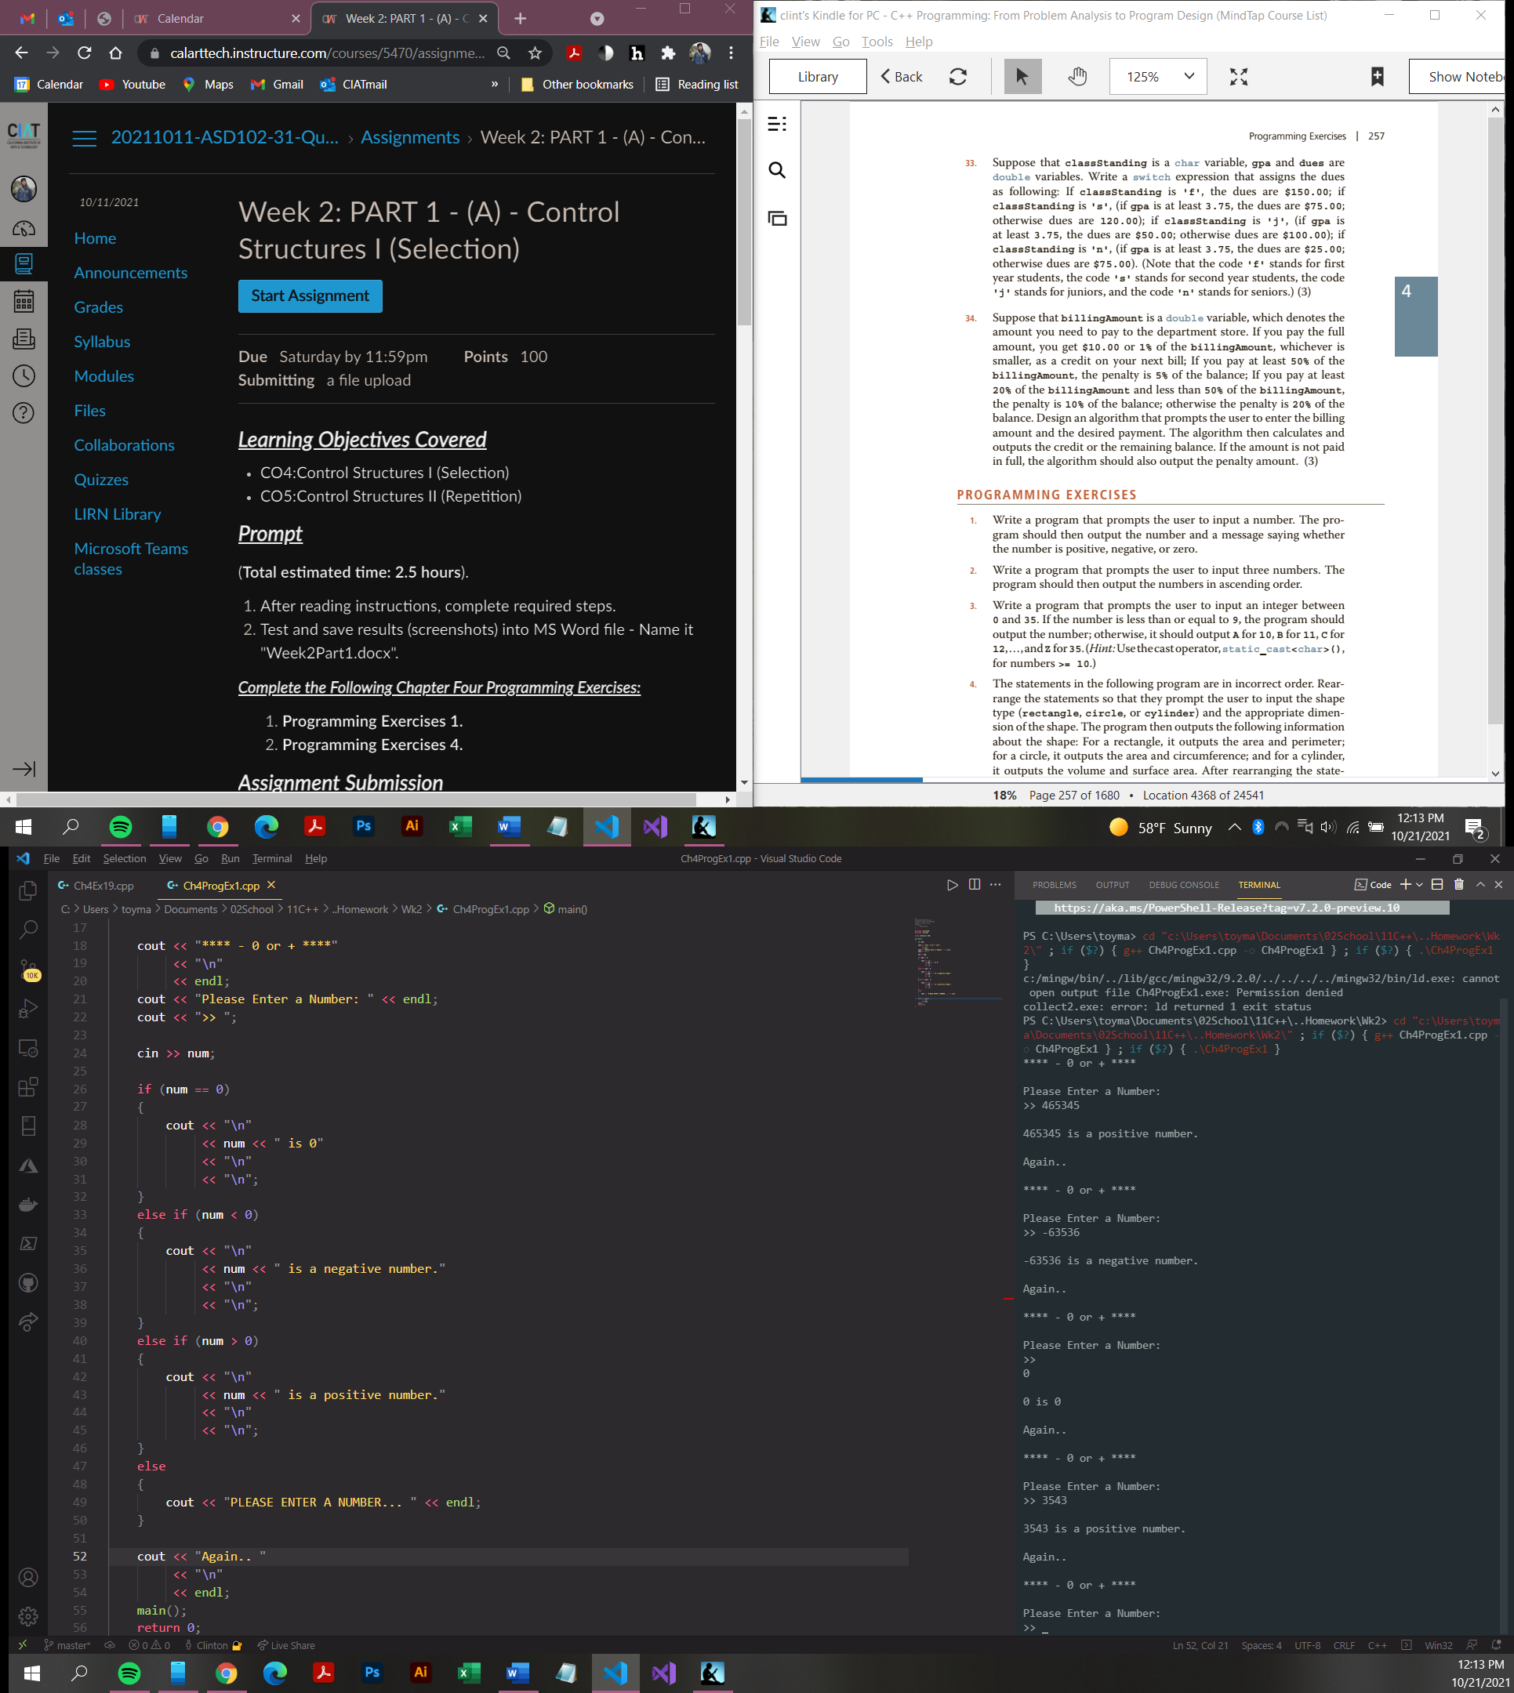

Chapter 4 Program Exercise 2:

*/\**

*Filename:Ch4ProgEx4.cpp*

*Creation Date: 10-21-2021*

*Author: Clint Kline*

*Purpose:*

*- homework*

*\*/*

#include <iostream>

#include <iomanip>

#include <string>

#include <cmath>

using *namespace* std;

*int* main()

{

*const* *double* PI = 3.1416;

    string shape;

*double* width;

*double* length;

*double* height;

*double* radius;

    cout << fixed << showpoint << setprecision(2);

    cout << "\nEnter the shape type (rectangle, circle, cylinder): " << endl;

    cout << ">> ";

    cin >> shape;

    cout << endl;

    if (shape == "rectangle")

    {

        cout << "Enter the width of the rectangle: ";

        cin >> width;

        cout << endl;

        cout << "Enter the length of the rectangle: ";

        cin >> length;

        cout << endl;

        cout << "Perimeter of the rectangle = " << 2 \* (length + width) << endl;

        cout << "Area of the rectangle = " << length \* width << endl;

    }

    else if (shape == "circle")

    {

        cout << "Enter the radius of the circle: ";

        cin >> radius;

        cout << endl;

        cout << "Circumference of the circle: " << 2 \* PI \* radius << endl;

        cout << "Area of the circle = " << PI \* pow(radius, 2.0) << endl;

    }

    else if (shape == "cylinder")

    {

        cout << "Enter the radius of the cylinder: ";

        cin >> radius;

        cout << endl;

        cout << "Enter the height of the cylinder: ";

        cin >> height;

        cout << endl;

        cout << "Volume of the cylinder = " << PI \* pow(radius, 2.0) \* height << endl;

        cout << "Surface area of the cylinder: " << 2 \* PI \* radius \* height + 2 \* PI \* pow(radius, 2.0) << endl;

    }

    else

    {

        cout << "The program does not handle " << shape << endl;

    }

    main();

    return 0;

};

