Clint Kline

Week 4 Part 1A

Chapter 8 Programming Ex 1:

*// Filename: Wk4Pt1.cpp*

*// Created Date: 11-3-2021*

*// Author: Clint Kline*

*// Purpose:*

*//  - week 4 homework*

#include <iostream>

#include <iomanip>

using *namespace* std;

*void* initialize(*double* *list*[], *int* *size*);

*void* print(*double* *list*[], *int* *size*);

*// entry point*

*int* main()

{

*double* alpha[40];

    initialize(alpha, 50);

    print(alpha, 50);

    return 0;

}

*void* initialize(*double* *list*[], *int* *size*)

{

*int* count;

    for (count = 0; count < 25; count++)

*list*[count] = count * count;

    for (count = 25; count < *size*; count++)

    {

*list*[count] = 3 * count;

    }

}

*void* print(*double* *list*[], *int* *size*)

{

*int* count;

    for (count = 0; count < *size*; count++)

    {

        cout << setw(4) << *list*[count] << " ";

        if ((count + 1) % 10 == 0)

            cout << endl;

    }

    cout << endl;

}

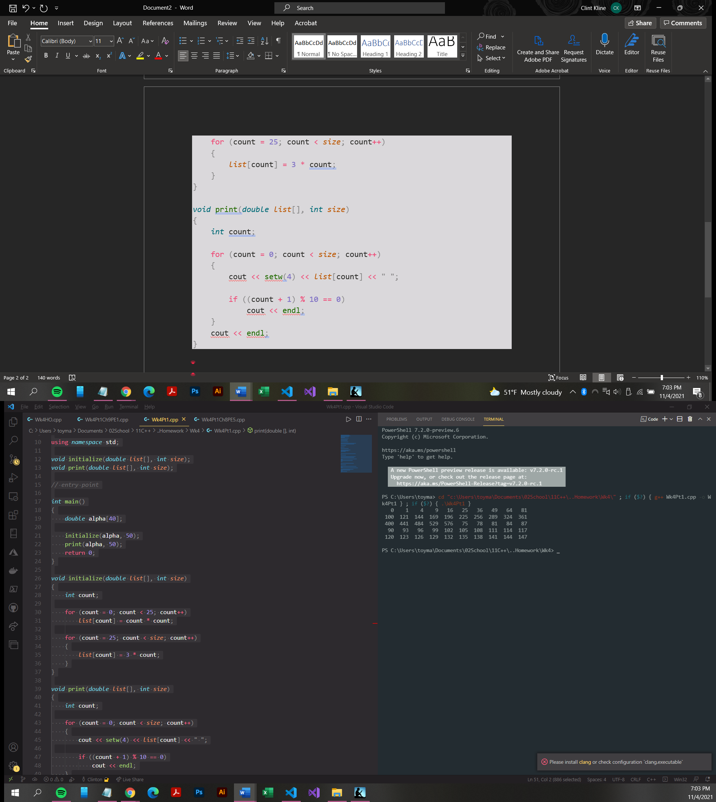

Ch 8 Programming Exercise 5:

#include <iostream>

#include <cctype>

#include <cstring>

using *namespace* std;

*int* main()

{

*char* str[81];

*int* len;

*int* i;

    cout << "Enter a lowercase string : ";

    cin.get(str, 81);

    cout << endl;

    cout << "String in uppercase letters is : " << endl;

    len = strlen(str);

    for (i = 0; i < len; i++)

    {

        cout << static_cast<*char*>(toupper(str[i]));

    }

    return 0;

}

