Clint Kline

11-4-2021

C++ Wk4 Part 2B

Chapter 9 Prog Ex 1 :

#include <iostream>

#include <string>

#include <iomanip>

#include <istream>

using *namespace* std;

*struct* computerType

{

    string manufacturer;

    string modelType;

    string processorType;

    string ram;

    string hardDriveSize;

    string yearBuilt;

    string price;

};

*int* main()

{

    computerType computer;

*// cout << fixed << showpoint << setprecision(2);*

    cout << "Enter the name of the Manufacturer: ";

    cin >> computer.manufacturer;

    cout << endl;

    cout << "Enter the name of the Model: ";

    cin >> computer.modelType;

    cout << endl;

    cout << "Enter the type of the Processor: ";

    cin >> computer.processorType;

    cout << endl;

    cout << "Enter the amount of the RAM in GB: ";

    cin >> computer.ram;

    cout << endl;

    cout << "Enter the hard-drive capacity: ";

    cin >> computer.hardDriveSize;

    cout << endl;

    cout << "Enter the year the computer was built: ";

    cin >> computer.yearBuilt;

    cout << endl;

    cout << "Enter the computer's price: ";

    cin >> computer.price;

    cout << endl;

    cout << "manufacturer: " << computer.manufacturer << endl;

    cout << "model: " << computer.modelType << endl;

    cout << "processor: " << computer.processorType << endl;

    cout << "RAM: " << computer.ram << endl;

    cout << "harddrive space: " << computer.hardDriveSize << endl;

    cout << "year built: " << computer.yearBuilt << endl;

    cout << "proce: " << computer.price << endl;

    return 0;

}

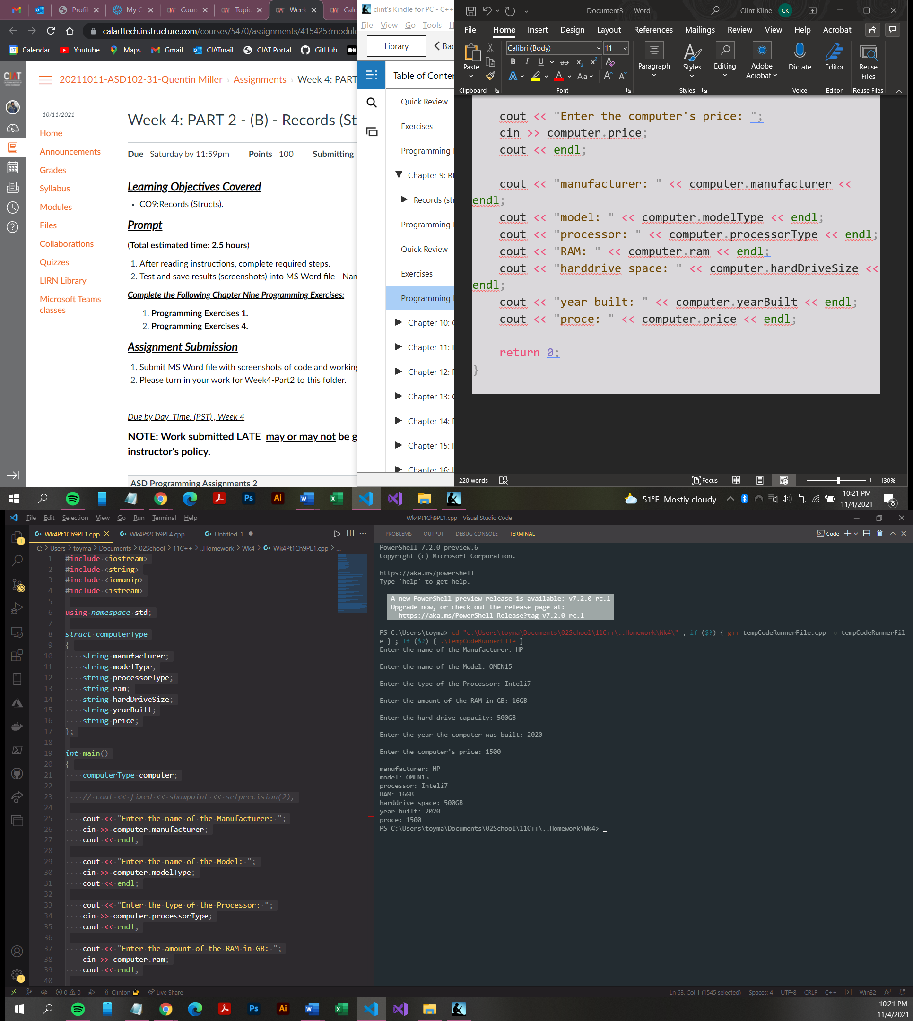

Chapter 9 Prog Ex 4 :

*//  Filename: Wk4Pt2Ch9PE4.cpp*

*// Creation Date: 11-4-2021*

*// Author: Clint Kline*

*// Purpose:*

*//  - 4. Write a program to help a local restaurant automate*

*// its ast billing system. The program should do the following:*

*// a. Show the customer the different ast items offered by the  restaurant.*

*// b. Allow the customer to select more than one item from the menu.*

*// c. Calculate and print the bill.*

#include <iostream>

#include <string>

#include <iomanip>

using *namespace* std;

*void* menu();

*void* order();

*void* finalize();

*double* total = 0;

*int* main()

{

    menu();

    return 0;

}

*void* menu()

{

    cout << "\*\*\*\*\*\*\*\*\*\*\*\*\*\*\*\*\*\*\*\*\*\*\*\*\*\*\*\*\*\*\*\*\*\*\*\*\*\*\*\*\*\*\*\*\*\*\*\*\*\*\*\*\*\*\*\*\*\*" << endl;

    cout << "\*                                                        \*" << endl;

    cout << "\*            Clint's Breakfast Burrito Bodega!!          \*" << endl;

    cout << "\*                                                        \*" << endl;

    cout << "\*                       \*\*\* MENU \*\*\*                     \*" << endl;

    cout << "\*                                                        \*" << endl;

    cout << "\*                                                        \*" << endl;

    cout << "\*   code   item                                  price   \*" << endl;

    cout << "\*   ----   ----                                  -----   \*" << endl;

    cout << "\*                      -- BURRITOs --                    \*" << endl;

    cout << "\*                                                        \*" << endl;

    cout << "\*    b1 - Clint's Brek Bomb -------------------- $5.00   \*" << endl;

    cout << "\*    b2 - Tex-Mex Breks ------------------------ $5.00   \*" << endl;

    cout << "\*    b3 - Hash Wrap ---------------------------- $5.00   \*" << endl;

    cout << "\*    b4 - Heart Attack in a Wrap --------------- $5.00   \*" << endl;

    cout << "\*    b5 - The FlapStack ------------------------ $5.00   \*" << endl;

    cout << "\*                                                        \*" << endl;

    cout << "\*                      -- OMELETs --                     \*" << endl;

    cout << "\*                                                        \*" << endl;

    cout << "\*    o1 - The good, The bad, and the eggy ------ $4.00   \*" << endl;

    cout << "\*    o2 - New England Omelet ------------------- $4.00   \*" << endl;

    cout << "\*    o3 - Lobster Omelet ----------------------- $4.00   \*" << endl;

    cout << "\*                                                        \*" << endl;

    cout << "\*                       -- SIDEs --                      \*" << endl;

    cout << "\*                                                        \*" << endl;

    cout << "\*    s1 - Toast and Jam ------------------------ $1.50   \*" << endl;

    cout << "\*    s2 - Hashbrowns --------------------------- $2.00   \*" << endl;

    cout << "\*    s3 - The Muffin, man. --------------------- $4.00   \*" << endl;

    cout << "\*    s4 - Regular Muffin ----------------------- $2.00   \*" << endl;

    cout << "\*    s5 - Fruit -------------------------------- $0.50   \*" << endl;

    cout << "\*    s6 - Bag Cereal d'jour -------------------- $1.50   \*" << endl;

    cout << "\*                                                        \*" << endl;

    cout << "\*                      -- DRINK's --                     \*" << endl;

    cout << "\*                                                        \*" << endl;

    cout << "\*    d1 - Cowboy Coffee ------------------------ $1.00   \*" << endl;

    cout << "\*    d2 - Bloody Gary -------------------------- $5.00   \*" << endl;

    cout << "\*    d3 - Orange Joose ------------------------- $1.50   \*" << endl;

    cout << "\*    d4 - NutMilk ------------------------------ $2.00   \*" << endl;

    cout << "\*                                                        \*" << endl;

    cout << "\*                                                        \*" << endl;

    cout << "\*\*\*\*\*\*\*\*\*\*\*\*\*\*\*\*\*\*\*\*\*\*\*\*\*\*\*\*\*\*\*\*\*\*\*\*\*\*\*\*\*\*\*\*\*\*\*\*\*\*\*\*\*\*\*\*\*\*" << endl;

    order();

}

*void* order()

{

    string item;

    cout << fixed << showpoint << setprecision(2);

    cout << "\nPlease enter the code for the item youd like to order >> ";

    cin >> item;

    cout << "Code Entered : " << item << endl;

    if (item == "s5")

        total += 0.50;

    else if (item == "d1")

        total += 1.00;

    else if (item == "s1" || item == "s6" || item == "d3")

        total += 1.50;

    else if (item == "s2" || item == "s4" || item == "d4")

        total += 2.00;

    else if (item == "o1" || item == "o2" || item == "o3" || item == "s3")

        total += 4.00;

    else if (item == "b1" || item == "b2" || item == "b3" || item == "b4" || item == "b5" || item == "d2")

        total += 5.00;

    else

        cout << "Please check the code and enter it again. " << endl;

    cout << "Subtotal : $" << total << endl;

    finalize();

}

*void* finalize()

{

    string yesOrNo;

    cout << "Can we get you anything else? (y/n)" << endl;

    cout << ">> ";

    cin >> yesOrNo;

    if (yesOrNo == "y" || yesOrNo == "n")

    {

        if (yesOrNo == "y")

        {

            order();

        }

        else if (yesOrNo == "n")

        {

            cout << "Your Total is : $" << total << endl;

        }

    }

    else

    {

        cout << "Please enter 'y' for yes or 'n' for no.. ";

        finalize();

    }

}

