Numerical Study of Traveling Wave Solutions to 2D Boussinesq Equation

Abstract
In this paper we examine once again the stationary propagating wave solution to the two dimensional Boussinesq Equation. We focus on the boundary condition and examine and validate an explicit function for the asymptotic behavior of the wave solution. This gives more precise information on the boundaries of the domain with less computational effort and will help significantly any further numerical calculations on the topic.

Introduction
In this paper we consider the two dimensional Boussinesq Equation (BE)

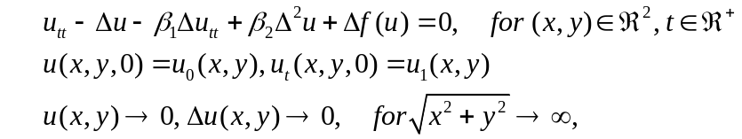

where 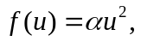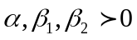 are real constants, and is the Laplace operator. The BE arises in several physical applications: propagation of long waves in shallow water, vibrations in a nonlinear string, etc. A derivation of the BE from the original Boussinesq system can be found in [6]. Our ultimate goal is to show numerically that there exists a soliton solution to 1.1 and that the equation itself is a law that governs the overtaking of such wave solutions as shown in the 1D case ??. Our interest (transforms into) is to seek for traveling wave solutions to in direction y with phase velocity c, i.e. solutions of type 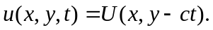 The waves U satisfy the nonlinear fourth order elliptic equation:
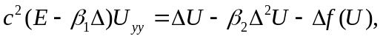

The solution of both the hyperbolic and elliptic problems are examined in ?? and ?? respectively. We will use the same techniques defined in ?? in order to test our new explicit formula used as boundary condition.
The asymptotic decay of the solution and the boundary condition used in ?? are given by:

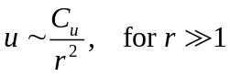
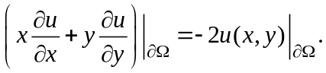

An important generalization in ?? is the following rule

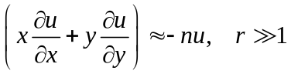

which applies if the expected behavior at infinity is algebraic of n-th order (i.e. 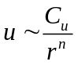). The formula that we provide below satisfies all conditions , and even .

Asymptotic behavior of the solution
Choosing a grid in order to prototype the method of approach and to choose the right numerical tools for a solution to both problems is an essential step. The uniform and non-uniform grids define two lines of investigation for this problem. The meshing that has been predominantly used till now for the numerical analysis is the non-uniform one. It has big time advantage of generating a fast solution for the elliptic equation but also creates a major problem when moving the wave/waves in the hyperbolic equation . (In order to go from a non-uniform to a uniform grid, one needs an interpolation rule ..... etc ). The situation reverses when working with the uniform grid. Having in mind our goals that are defined in the first paragraph of this article, makes the decision of choosing the uniform grid an easy one. This means that we will

- spend less computational effort for solving the hyperbolic equation
- spend more computational time and effort in order to obtain a robust method for a solution of the elliptic equation .
- work with computational box saturated with points that represent vast space of the solution's asymptotic.

( This underlines three important follow-ups:
- We choose to spend more time and effort in order to obtain a robust method for a solution of the elliptic equation 1.2.
- we have a computational box saturated with points that represent vast space of the solution's asymptotic.
- we will have the advantage of investigating solitons with higher phase speed c.
)
This raises the problem of the solution asymptotic and the boundary condition. The behavior of the solution U as 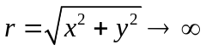 is studied in details in ??. From the mathematical analysis and numerical results provided there it follows that u has 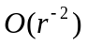 asymptotic decay at infinity.

