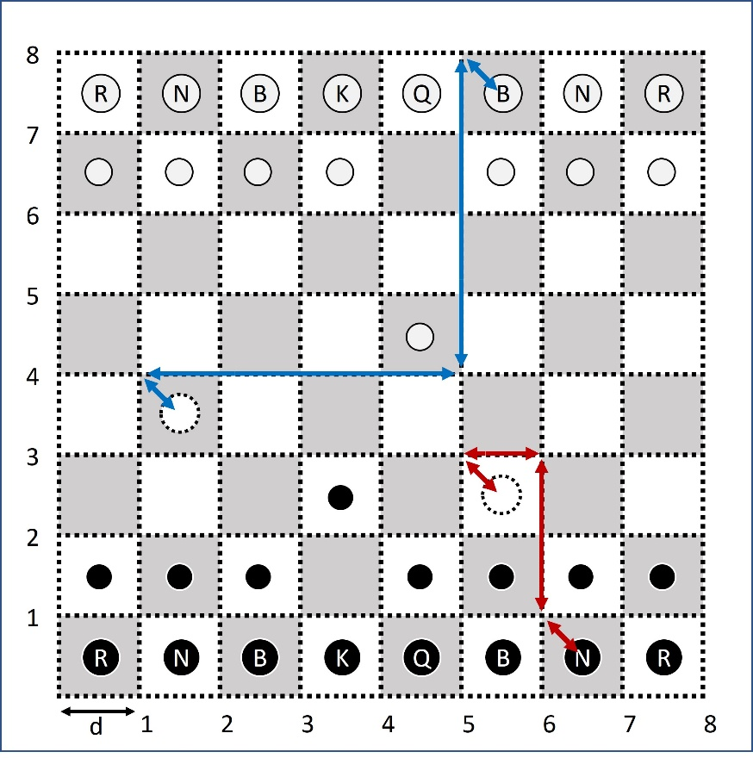

Say we have to move a piece from (x1, y1) to (x2, y2). The centers are the places where the pieces rest, and the dotted lines are paths to move the pieces. At first, we move the piece from resting place to the path. Then we transfer the piece to desired location and move it back to the resting place. We define a function:

function (x, y) = rest_to_path(x1, y1)

x = x1-d/2;

y =y1+d/2;

end

Main Program:

(x1’, y1’) = rest_to_path(x1, y1);

(x2’, y2’) = rest_to_path(x2, y2);

Move from (x1, y1) to (x1’, y1’);

Move from (x1’, y1’) to (x2’, y2’);

Move from (x1’, y1’) to (x2’, y2’);

Move from (x2’, y2’) to (x2, y2);

The move function is like:

function move(x1, y1, x2, y2)

move along y axis from x1 to x2;

move along x axis from y1 to y2;

end

In this method, the two pieces will never collide because we move them along the path between two pieces. We can add further instructions to the above function like ths:

move(x1, y1, x2, y2)

move servo to (x1, y1)

catch the piece

move along y axis from x1 to x2;

move along x axis from y1 to y2;

release piece

end

current position of the servo is set as a global variable. We can write more functions to do specific tasks:

move_servo(x1, y1)

moves servo from current_position to (x1, y1)

end