**BANGLADESH UNIVERSITY OF ENGINEERING AND TECHNOLOGY**



**Department of Electrical and Electronic Engineering**

**Course No. :** EEE 304

**Course Title:** Digital Electronics Laboratory **Section :** A1

**Digital Electronics Project Proposals**

**Submitted to:**

|  |  |
| --- | --- |
| Teacher Name |  |
| Dr. Sajid Muhaimin Choudhury | Department of Electrical and Electronic Engineering |
| Rajat Chakraborty |

**Submitted by:**

|  |  |  |  |
| --- | --- | --- | --- |
| Student Name | Student ID | Lab Group No. |  |
| Himaddri Roy | 1606002 | 1 | Department of Electrical and Electronic Engineering |
| Mir Sayeed Mohammad | 1606003 | 2 |
| Munshi Sanowar Raihan | 1606021 | 11 |

**Proposal No 1**

**Project Title:** *Poor Man’s Piano*

**Summary:** The project contains a key based input system, an audio synthesiser block for generating notes using logic circuits, necessary audio processing blocks for filtering and a soundbox in the output.

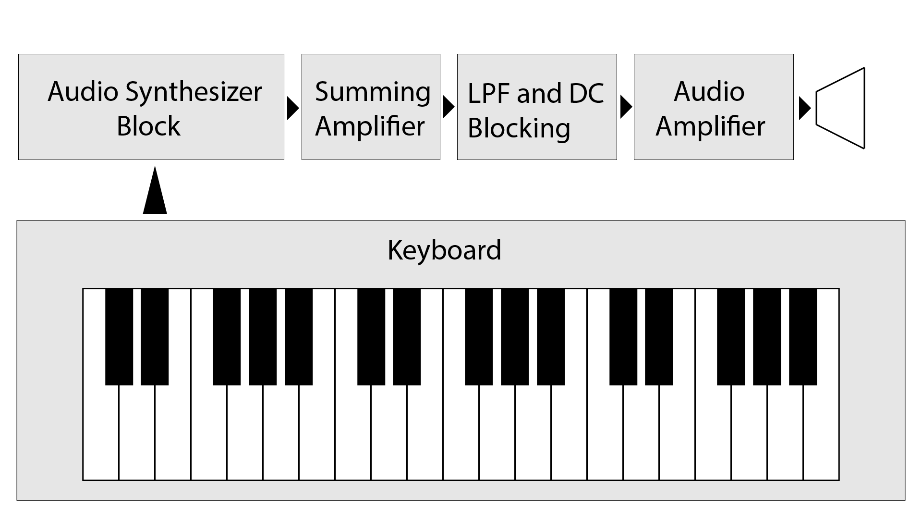

*Fig: Overall diagram*

**Implementation Details:**

We have a system clock frequency of 1MHz (1 us per pulse). Say a note C3 has frequency 130.81 Hz (7.6446 ms per cycle). Thus one cycle of C3 note = 7644.6 clock pulses. Taking half of that value C3_mod_val = 3822. If a 12 bit binary counter is set to reset at 3822 (1110 1110 1110)2 and reset signal is used as input to a single bit flip flop, then that flip flop will show a square wave of frequency 130.81. (Minterm = A11 A10 A9 ~A8 A7 A6 A5 ~A4 A3 A2 A1 ~A0 )

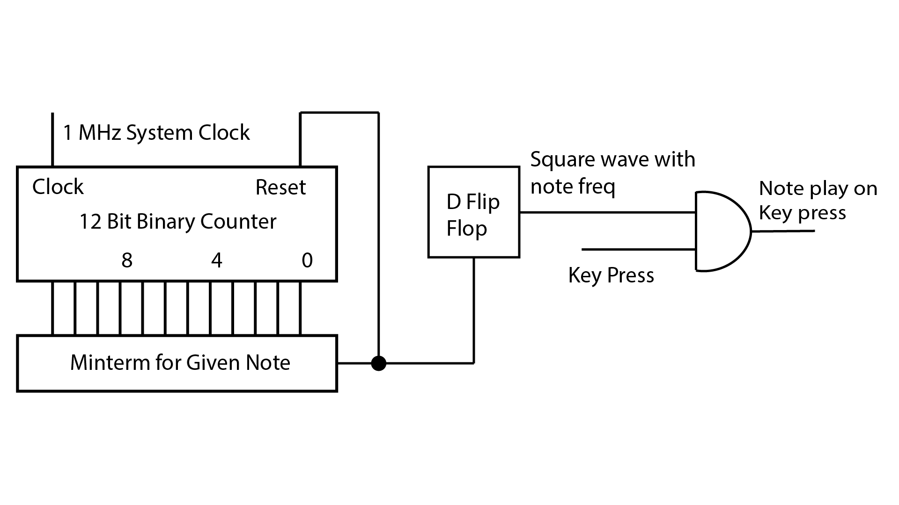

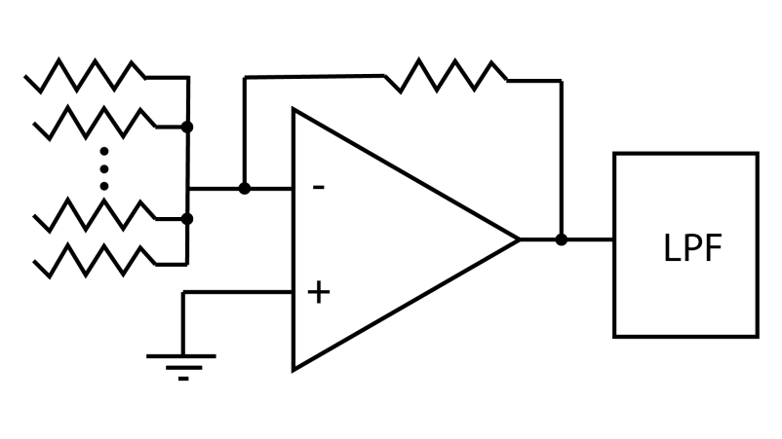

*Fig: Single unit frequency generator*

Each of the available key notes will have a frequency source, and the sources are connected to the physical keys. Outputs are connected with a summing amplifier (alternatively a summing amplifier with dynamic gain) for allowing multiple key presses. Finally a low pass filter is used to filter the overlapping square wave frequencies into sinusoidal audio waves. At the last stage, an audio amplifier connects the generated audio to a speaker.

*Fig: Summing all the frequencies*

*Table: Frequency chart*

|  |  |  |  |  |  |  |  |  |
| --- | --- | --- | --- | --- | --- | --- | --- | --- |
| **Notes** | **Freq (Hz)** | **Clock pulses per cycle** | **Notes** | **Freq (Hz)** | **Clock pulses per cycle** | **Notes** | **Freq (Hz)** | **Clock pulses per cycle** |
| ***C3*** | 130.81 | 7644 | ***C4*** | 261.63 | 3822 | ***C5*** | 523.25 | 1911 |
| ***C3#*** | 138.59 | 7215 | ***C4#*** | 277.18 | 3608 | ***C5#*** | 554.37 | 1804 |
| ***D3*** | 146.83 | 6811 | ***D4*** | 293.66 | 3405 | ***D5*** | 587.33 | 1703 |
| ***D3#*** | 155.56 | 6428 | ***D4#*** | 311.13 | 3214 | ***D5#*** | 622.25 | 1607 |
| ***E3*** | 164.81 | 6068 | ***E4*** | 329.63 | 3034 | ***E5*** | 659.25 | 1517 |
| ***F3*** | 174.61 | 5727 | ***F4*** | 349.23 | 2863 | ***F5*** | 698.46 | 1432 |
| ***F3#*** | 185.00 | 5405 | ***F4#*** | 369.99 | 2703 | ***F5#*** | 739.99 | 1351 |
| ***G3*** | 196.00 | 5102 | ***G4*** | 392.00 | 2551 | ***G5*** | 783.99 | 1276 |
| ***G3#*** | 207.65 | 4816 | ***G4#*** | 415.30 | 2408 | ***G5#*** | 830.61 | 1204 |
| ***A3*** | 220.00 | 4545 | ***A4*** | 440.00 | 2273 | ***A5*** | 880.00 | 1136 |
| ***A3#*** | 233.08 | 4290 | ***A4#*** | 466.16 | 2145 | ***A5#*** | 932.33 | 1073 |
| ***B3*** | 246.94 | 4050 | ***B4*** | 493.88 | 2025 | ***B5*** | 987.77 | 1012 |