Uber Analysis Report
Clodia Nkuna | Junior Analyst
2026-06-02

Uber data analysis report

Summary
This is an R Markdown document contains the necessary step done while analyzing the uber data data. it also reports the code, code’s output, plots , and the business analysis found by the authoring analyst. This Markdown produces a HTML Report.

Environment setup
The environment setup entails the packages and imported data used to perform this analysis.For this analysis the tidyverse, lubridate, skimr,janitor, and corrplot packages were installed and their libraries called to be utilized during the analysis process. The output of code values were also set to not provide a scientific notation answer, it must produce not more than 4 digits after the decimal point for numeric values, and the data rows printed in the console were configured to 10000 per print to increase accessibility, and the display width and style were also set to tibble
install.packages(c("tidyverse", "lubridate", "skimr","janitor", "corrplot", "plotly"))
## Installing packages into 'C:/Users/student/Documents/Clodia Nkuna/R/Uber Analysis/renv/library/windows/R-4.7-r90092/x86_64-w64-mingw32'
## (as 'lib' is unspecified)
## package 'tidyverse' successfully unpacked and MD5 sums checked
## package 'lubridate' successfully unpacked and MD5 sums checked
## Warning: cannot remove prior installation of package 'lubridate'
## Warning in file.copy(savedcopy, lib, recursive = TRUE): problem copying
## C:\Users\student\Documents\Clodia Nkuna\R\Uber
## Analysis\renv\library\windows\R-4.7-r90092\x86_64-w64-mingw32\00LOCK\lubridate\libs\x64\lubridate.dll
## to C:\Users\student\Documents\Clodia Nkuna\R\Uber
## Analysis\renv\library\windows\R-4.7-r90092\x86_64-w64-mingw32\lubridate\libs\x64\lubridate.dll:
## Permission denied
## Warning: restored 'lubridate'
## package 'skimr' successfully unpacked and MD5 sums checked
## package 'janitor' successfully unpacked and MD5 sums checked
## package 'corrplot' successfully unpacked and MD5 sums checked
## package 'plotly' successfully unpacked and MD5 sums checked
##
## The downloaded binary packages are in
## C:\Users\student\AppData\Local\Temp\Rtmpe87vdK\downloaded_packages
#install packages and load libraries
library(tidyverse)
## ── Attaching core tidyverse packages ──────────────────────── tidyverse 2.0.0 ──
## ✔ dplyr 1.2.1 ✔ readr 2.2.0
## ✔ forcats 1.0.1 ✔ stringr 1.6.0
## ✔ ggplot2 4.0.3 ✔ tibble 3.3.1
## ✔ lubridate 1.9.5 ✔ tidyr 1.3.2
## ✔ purrr 1.2.2
## ── Conflicts ────────────────────────────────────────── tidyverse_conflicts() ──
## ✖ dplyr::filter() masks stats::filter()
## ✖ dplyr::lag() masks stats::lag()
## ℹ Use the conflicted package (<http://conflicted.r-lib.org/>) to force all conflicts to become errors
library(lubridate)
library(skimr)
library(janitor)
##
## Attaching package: 'janitor'
##
## The following objects are masked from 'package:stats':
##
## chisq.test, fisher.test
library(corrplot)
## corrplot 0.95 loaded
library(ggplot2)
library(dplyr)
library(plotly)
##
## Attaching package: 'plotly'
##
## The following object is masked from 'package:ggplot2':
##
## last_plot
##
## The following object is masked from 'package:stats':
##
## filter
##
## The following object is masked from 'package:graphics':
##
## layout
#import data
Uber <- read.csv("~/Clodia Nkuna/R/Uber Analysis//DATA/Uber.csv")
# diable scientific notation
options(scipen =999)
#set decimal points
options(digits = 4)
#icrease minimum rows printed in console
options(max.print = 10000)
#expand tibble display width
options(tibble.width = Inf)
#display all coloumns in tibble outputs
options(tibble.priny_max = 100)

Data inspection and formatting
The imported data was inspected off it’s shape, variables class , and the first row was formatted to header making it the data variables(columns). The date variable was formatted to the required format
#view data
str(Uber)
## 'data.frame': 29101 obs. of 13 variables:
## $ pickup_dt: chr "2015-01-01 01:00:00" "2015-01-01 01:00:00" "2015-01-01 01:00:00" "2015-01-01 01:00:00" ...
## $ borough : chr "Bronx" "Brooklyn" "EWR" "Manhattan" ...
## $ pickups : int 152 1519 0 5258 405 6 4 120 1229 0 ...
## $ spd : num 5 5 5 5 5 5 5 3 3 3 ...
## $ vsb : num 10 10 10 10 10 10 10 10 10 10 ...
## $ temp : num 30 30 30 30 30 30 30 30 30 30 ...
## $ dewp : num 7 7 7 7 7 7 7 6 6 6 ...
## $ slp : num 1024 1024 1024 1024 1024 ...
## $ pcp01 : num 0 0 0 0 0 0 0 0 0 0 ...
## $ pcp06 : num 0 0 0 0 0 0 0 0 0 0 ...
## $ pcp24 : num 0 0 0 0 0 0 0 0 0 0 ...
## $ sd : num 0 0 0 0 0 0 0 0 0 0 ...
## $ hday : chr "Y" "Y" "Y" "Y" ...
# first row Header
head(Uber)
## pickup_dt borough pickups spd vsb temp dewp slp pcp01 pcp06
## 1 2015-01-01 01:00:00 Bronx 152 5 10 30 7 1024 0 0
## 2 2015-01-01 01:00:00 Brooklyn 1519 5 10 30 7 1024 0 0
## 3 2015-01-01 01:00:00 EWR 0 5 10 30 7 1024 0 0
## 4 2015-01-01 01:00:00 Manhattan 5258 5 10 30 7 1024 0 0
## 5 2015-01-01 01:00:00 Queens 405 5 10 30 7 1024 0 0
## 6 2015-01-01 01:00:00 Staten Island 6 5 10 30 7 1024 0 0
## pcp24 sd hday
## 1 0 0 Y
## 2 0 0 Y
## 3 0 0 Y
## 4 0 0 Y
## 5 0 0 Y
## 6 0 0 Y
#identify the variable
sapply(Uber, class)
## pickup_dt borough pickups spd vsb temp
## "character" "character" "integer" "numeric" "numeric" "numeric"
## dewp slp pcp01 pcp06 pcp24 sd
## "numeric" "numeric" "numeric" "numeric" "numeric" "numeric"
## hday
## "character"
# convert character to date time
Uber$pickup_dt <- ymd_hms(Uber$pickup_dt)
#check if it changed
class(Uber$pickup_dt)
## [1] "POSIXct" "POSIXt"

Feature Creation
The pick up date and time was divided into hour, day,month , and weekday to determine the pickups trends by hour, day , month ,and if there is more pickups during weekdays or weekends.A peak hour feature was also created to show the pickups trend during the generally known busy hours of the day.

Hour
# separate the date for accuracy
#hour
Uber$hour <- hour(Uber$pickup_dt)

DAY
#day
Uber$day <- day(Uber$pickup_dt)

Month
#month
Uber$month <- month(Uber$pickup_dt)

Weekdays
#weekday
Uber$Weekday <- wday(Uber$pickup_dt, label = TRUE )

Peak Hours
#Peak hours feature
Uber$peak_hour <- ifelse(Uber$hour %in% c(7:9, 16:19),
"peak",
"Off-Peak")
table(Uber$peak_hour)
##
## Off-Peak peak
## 20494 8607

Handling missing data

Identifying missing value criteria
#assign the missing value criteria
na <- c("", "NA", "NULL")

Check missing values
#check for missing values
colSums(is.na(Uber))
## pickup_dt borough pickups spd vsb temp dewp slp
## 0 3043 0 0 0 0 0 0
## pcp01 pcp06 pcp24 sd hday hour day month
## 0 0 0 0 0 0 0 0
## Weekday peak_hour
## 0 0
#missing data percentange
missing_pct <- round(colSums(is.na(Uber))/nrow(Uber)*100,2)
missing_pct
## pickup_dt borough pickups spd vsb temp dewp slp
## 0.00 10.46 0.00 0.00 0.00 0.00 0.00 0.00
## pcp01 pcp06 pcp24 sd hday hour day month
## 0.00 0.00 0.00 0.00 0.00 0.00 0.00 0.00
## Weekday peak_hour
## 0.00 0.00
#total missing value
sum(is.na(Uber))
## [1] 3043

Remove missing data
#remove missing values
Clean_uber_data <- na.omit(Uber)

check for duplicates
#check for duplicates
sum(duplicated(Clean_uber_data))
## [1] 0
#remove duplicates
Clean_uber_data <- distinct(Clean_uber_data)

Clean Data
# data summary
summary(Clean_uber_data)
## pickup_dt borough pickups spd
## Min. :2015-01-01 01:00:00 Length :26058 Min. : 0 Min. : 0
## 1st Qu.:2015-02-15 06:00:00 N.unique : 6 1st Qu.: 1 1st Qu.: 3
## Median :2015-04-01 12:00:00 N.blank : 0 Median : 86 Median : 6
## Mean :2015-04-01 12:00:00 Min.nchar: 3 Mean : 547 Mean : 6
## 3rd Qu.:2015-05-16 18:00:00 Max.nchar: 13 3rd Qu.: 506 3rd Qu.: 8
## Max. :2015-06-30 23:00:00 Max. :7883 Max. :21
##
## vsb temp dewp slp
## Min. : 0.00 Min. : 2.0 Min. :-16.0 Min. : 991
## 1st Qu.: 9.10 1st Qu.:31.5 1st Qu.: 14.0 1st Qu.:1012
## Median :10.00 Median :45.0 Median : 30.0 Median :1018
## Mean : 8.82 Mean :47.5 Mean : 30.7 Mean :1018
## 3rd Qu.:10.00 3rd Qu.:64.0 3rd Qu.: 49.0 3rd Qu.:1023
## Max. :10.00 Max. :89.0 Max. : 73.0 Max. :1043
##
## pcp01 pcp06 pcp24 sd
## Min. :0.00000 Min. :0.0000 Min. :0.0000 Min. : 0.00
## 1st Qu.:0.00000 1st Qu.:0.0000 1st Qu.:0.0000 1st Qu.: 0.00
## Median :0.00000 Median :0.0000 Median :0.0000 Median : 0.00
## Mean :0.00382 Mean :0.0261 Mean :0.0910 Mean : 2.54
## 3rd Qu.:0.00000 3rd Qu.:0.0000 3rd Qu.:0.0517 3rd Qu.: 3.17
## Max. :0.28000 Max. :1.2400 Max. :2.1000 Max. :19.00
##
## hday hour day month Weekday
## Length :26058 Min. : 0.0 Min. : 1.0 Min. :1.00 Sun:3744
## N.unique : 2 1st Qu.: 6.0 1st Qu.: 8.0 1st Qu.:2.00 Mon:3744
## N.blank : 0 Median :12.0 Median :16.0 Median :4.00 Tue:3744
## Min.nchar: 1 Mean :11.5 Mean :15.6 Mean :3.51 Wed:3600
## Max.nchar: 1 3rd Qu.:18.0 3rd Qu.:23.0 3rd Qu.:5.00 Thu:3738
## Max. :23.0 Max. :31.0 Max. :6.00 Fri:3744
## Sat:3744
## peak_hour
## Length :26058
## N.unique : 2
## N.blank : 0
## Min.nchar: 4
## Max.nchar: 8
##
##
# detailed stats
skim(Clean_uber_data)
Data summary
Name | Clean_uber_data
Number of rows | 26058
Number of columns | 18
_______________________
Column type frequency:
character | 3
factor | 1
numeric | 13
POSIXct | 1
________________________
Group variables | None
Variable type: character
skim_variable | n_missing | complete_rate | min | max | empty | n_unique | whitespace
borough | 0 | 1 | 3 | 13 | 0 | 6 | 0
hday | 0 | 1 | 1 | 1 | 0 | 2 | 0
peak_hour | 0 | 1 | 4 | 8 | 0 | 2 | 0
Variable type: factor
skim_variable | n_missing | complete_rate | ordered | n_unique | top_counts
Weekday | 0 | 1 | TRUE | 7 | Sun: 3744, Mon: 3744, Tue: 3744, Fri: 3744
Variable type: numeric
skim_variable | n_missing | complete_rate | mean | sd | p0 | p25 | p50 | p75 | p100 | hist
pickups | 0 | 1 | 547.22 | 1037.31 | 0.0 | 1.0 | 86 | 506.00 | 7883.00 | ▇▁▁▁▁
spd | 0 | 1 | 6.00 | 3.71 | 0.0 | 3.0 | 6 | 8.00 | 21.00 | ▅▇▂▁▁
vsb | 0 | 1 | 8.82 | 2.44 | 0.0 | 9.1 | 10 | 10.00 | 10.00 | ▁▁▁▁▇
temp | 0 | 1 | 47.49 | 19.77 | 2.0 | 31.5 | 45 | 64.00 | 89.00 | ▂▇▇▇▅
dewp | 0 | 1 | 30.65 | 21.24 | -16.0 | 14.0 | 30 | 49.00 | 73.00 | ▃▇▇▆▅
slp | 0 | 1 | 1017.81 | 7.78 | 991.4 | 1012.4 | 1018 | 1023.00 | 1043.40 | ▁▃▇▃▁
pcp01 | 0 | 1 | 0.00 | 0.02 | 0.0 | 0.0 | 0 | 0.00 | 0.28 | ▇▁▁▁▁
pcp06 | 0 | 1 | 0.03 | 0.09 | 0.0 | 0.0 | 0 | 0.00 | 1.24 | ▇▁▁▁▁
pcp24 | 0 | 1 | 0.09 | 0.22 | 0.0 | 0.0 | 0 | 0.05 | 2.10 | ▇▁▁▁▁
sd | 0 | 1 | 2.54 | 4.52 | 0.0 | 0.0 | 0 | 3.17 | 19.00 | ▇▁▂▁▁
hour | 0 | 1 | 11.50 | 6.92 | 0.0 | 6.0 | 12 | 18.00 | 23.00 | ▇▇▆▇▇
day | 0 | 1 | 15.61 | 8.73 | 1.0 | 8.0 | 16 | 23.00 | 31.00 | ▇▇▇▇▆
month | 0 | 1 | 3.51 | 1.71 | 1.0 | 2.0 | 4 | 5.00 | 6.00 | ▇▅▅▅▅
Variable type: POSIXct
skim_variable | n_missing | complete_rate | min | max | median | n_unique
pickup_dt | 0 | 1 | 2015-01-01 01:00:00 | 2015-06-30 23:00:00 | 2015-04-01 12:00:00 | 4343

Overall data plots

pickup distribution plots
# pick_up distribution plots
hist(Clean_uber_data$pickups,
main = "Distribution of Uber Pickups",
xlab = "Pickups")
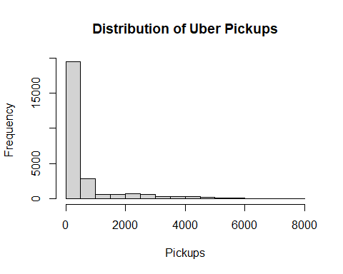
# pick_up distribution plots
hist(Clean_uber_data$pickups,
main = "Distribution of Uber Pickups",
xlab = "Pickups")
#density plot
plot(density(Clean_uber_data$pickups, na.rm = T),
main = "Density plot of pickups")
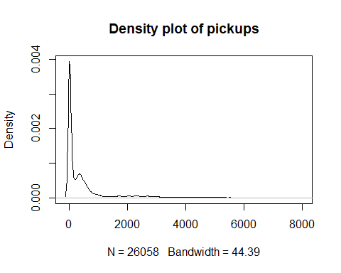
#box plot
boxplot(Clean_uber_data$pickups,
main = "Boxplot of Pickups")
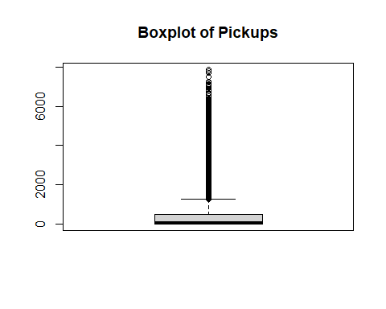

Data recorded per AREA
#Borough Distributiopn
table(Clean_uber_data$borough)
##
## Bronx Brooklyn EWR Manhattan Queens
## 4343 4343 4343 4343 4343
## Staten Island
## 4343

Average pickups per Area
#calculate the average pickups by barough
pickups_by_borough <- Clean_uber_data %>%
group_by(borough)%>%
summarize(avg_pickups = mean(pickups))
#hist plot of borough by average pickup
ggplot(pickups_by_borough,
aes(x = reorder(borough, avg_pickups), y = avg_pickups, fill = borough)) +
geom_col() +
scale_y_continuous(
breaks = seq(
0,
max(pickups_by_borough$avg_pickups),
by = 200
))+
labs(
title = "AVERAGE PICKUPS PER AREA",
x = "AREA",
y ="AVERAGE PICKUPS"
)+
theme_minimal()
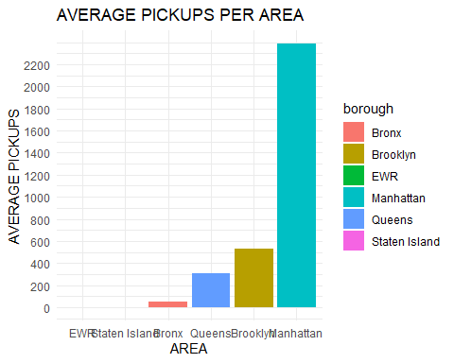

Pickups by holidays
ggplot(Clean_uber_data,
aes(x=hday, fill = hday))+
geom_bar()+
labs(
title = " TOTAL PICK UPS ON NORMAL DAY VS HOLIDAY",
x = "HOLIDAY?",
y = "PICKUPS"
)+
scale_fill_manual(values = c("N" = "darkgreen", "Y" = "navy")) +
theme_minimal()
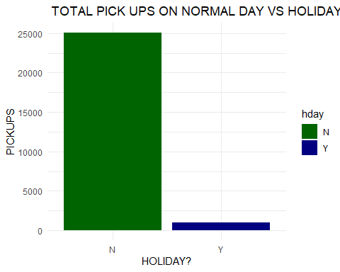

Monthly pickups
#Pick ups per month
pickups_by_month <- Clean_uber_data %>%
group_by(month)%>%
summarize(Total_pickups = sum(pickups))
ggplot(pickups_by_month ,
aes(x = month, y = Total_pickups, fill = month ))+
geom_col()+
theme_minimal()+
labs(
title = "MONTHLY PICKUPS",
x = "MONTH",
y = "TOTAL PICKUPS"
)
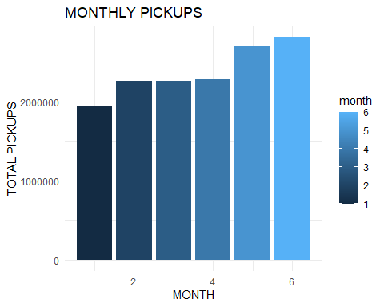

pickups by weekday
pickups_by_weekday <- Clean_uber_data %>%
group_by(Weekday)%>%
summarize(Total_pickups = sum(pickups))
# pickups by day
ggplot(pickups_by_weekday,
aes(x = Weekday,y = Total_pickups , fill = Weekday))+
geom_col()+
theme_minimal()
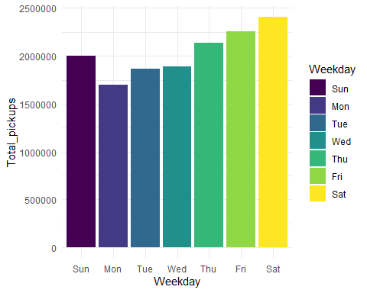

Pickups per day
pickups_by_day <- Clean_uber_data %>%
group_by(day)%>%
summarize(Total_pickups = sum(pickups))
#picks per day
ggplot(pickups_by_day,
aes(x = day, y = Total_pickups, fill = day))+
geom_col()+
theme_minimal()
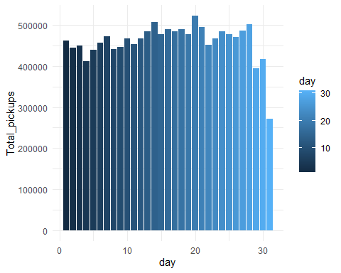

Pickups by Temperature
#temperature and pickups
#corelation
cor(Clean_uber_data$temp,
Clean_uber_data$pickups)
## [1] 0.06369
#plot
ggplot(Clean_uber_data,
aes(x = temp,y = pickups))+
stat_summary_bin(
fun = "mean",
bin_width = 5,
geom = "bar",
aes(fill = after_stat(x)), colour = "black"
)+
scale_fill_viridis_c() +
facet_wrap(~ borough) +
theme_minimal()+
labs(
x = "TEMPERATURE",
y = "AVERAGE PICKUPS"
)
## Warning in stat_summary_bin(fun = "mean", bin_width = 5, geom = "bar", aes(fill
## = after_stat(x)), : Ignoring unknown parameters: `bin_width`
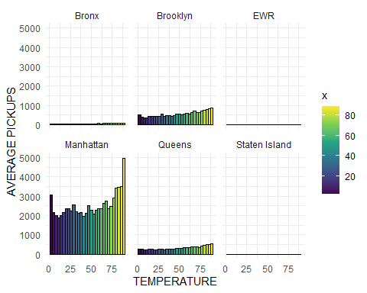

Pickups by Wind speed
#wind speed vs pickups
cor(Clean_uber_data$spd,
Clean_uber_data$pickups)
## [1] 0.009741
##rm(pickups_by_spd)
pickups_by_spd <- Clean_uber_data %>%
group_by(spd)%>%
summarize(Total_pickups = sum(pickups))
#plot
ggplot(pickups_by_spd,
aes(x = spd,y = Total_pickups, group =1)) +
geom_line()+
geom_point()+
theme_minimal()+
labs(
x = "SPD (WIND SPEED)",
y = "TOTAL PICKUPS"
)
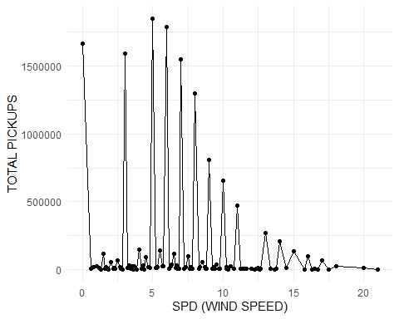

Pickups by hour
pickups_by_hour <- Clean_uber_data %>%
group_by(hour)%>%
summarize(Total_pickups = sum(pickups))
#pickups by hour
ggplot(pickups_by_hour,
aes(x = hour, y = Total_pickups, fill = hour))+
geom_col()+
theme_minimal()
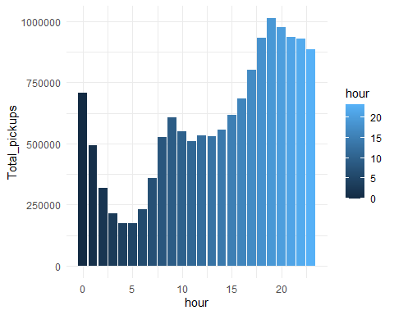

Identifying outliers
#identifying outliers pickups
Q1 <- quantile(Clean_uber_data$pickups,0.25)
Q3 <- quantile(Clean_uber_data$pickups,0.75)
IQR_value <- IQR(Clean_uber_data$pickups)
lower <- Q1 - 1.5*IQR_value
upper <- Q3 + 1.5*IQR_value
outliers <- Clean_uber_data$pickups[
Clean_uber_data$pickups < lower |
Clean_uber_data$pickups > upper
]
length(outliers)
## [1] 3348

correlation Analysis(numeric variables)
#full correlation
num_data <- Clean_uber_data %>%
select(
pickups,
spd,
vsb,
temp,
dewp,
slp,
pcp01,
pcp06,
pcp24,
sd
)
corr_matrix <- cor(num_data)
corr_matrix
## pickups spd vsb temp dewp slp pcp01
## pickups 1.000000 0.0097410 -0.0084288 0.06369 0.040082 -0.01571 0.0050069
## spd 0.009741 1.0000000 0.0861772 -0.29613 -0.321606 -0.09276 -0.0003565
## vsb -0.008429 0.0861772 1.0000000 0.02521 -0.231294 0.16704 -0.4884073
## temp 0.063692 -0.2961261 0.0252143 1.00000 0.896544 -0.22454 -0.0133433
## dewp 0.040082 -0.3216062 -0.2312943 0.89654 1.000000 -0.31116 0.1153985
## slp -0.015708 -0.0927611 0.1670391 -0.22454 -0.311156 1.00000 -0.0897520
## pcp01 0.005007 -0.0003565 -0.4884073 -0.01334 0.115399 -0.08975 1.0000000
## pcp06 -0.002821 0.0166684 -0.1183456 -0.03729 0.013293 -0.10494 0.1280642
## pcp24 -0.022935 -0.0104125 0.0008947 -0.01441 0.001519 -0.13469 0.0009974
## sd -0.009676 0.0970405 -0.0478337 -0.54556 -0.489372 0.12151 0.0003095
## pcp06 pcp24 sd
## pickups -0.002821 -0.0229348 -0.0096759
## spd 0.016668 -0.0104125 0.0970405
## vsb -0.118346 0.0008947 -0.0478337
## temp -0.037295 -0.0144079 -0.5455576
## dewp 0.013293 0.0015186 -0.4893718
## slp -0.104940 -0.1346889 0.1215076
## pcp01 0.128064 0.0009974 0.0003095
## pcp06 1.000000 0.2511660 0.0399431
## pcp24 0.251166 1.0000000 0.0696639
## sd 0.039943 0.0696639 1.0000000
corrplot(corr_matrix,
method="color",
type="upper")
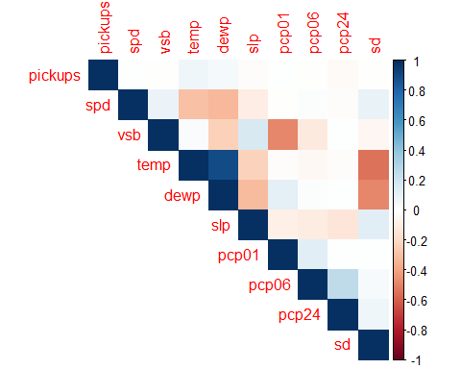

Manhattan
# manhattan analysis
manhattan_data <- Clean_uber_data %>%
filter( borough == "Manhattan")

Monthly analysis
# manhattan monthly summary
manhattan_monthly <- manhattan_data %>%
group_by(month) %>%
summarize(Total_pickups = sum(pickups))
ggplot(manhattan_monthly,
aes(x = factor(month) , y = Total_pickups, fill = factor(month)))+
geom_col()+
labs(
x = "MONTH",
y = "TOTAL PICKUPS",
fill = "MONTH"
) +
scale_fill_manual(
values = c(
"1" = "skyblue",
"2" = "blue",
"3" = "navy",
"4" = "purple",
"5" = "orange",
"6" = "maroon"
) ) +
theme_minimal()
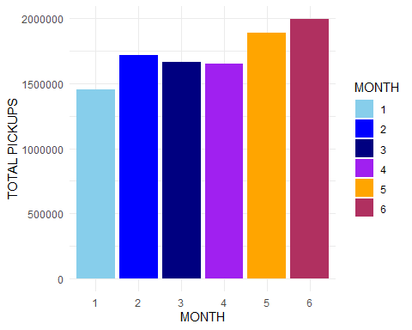

Weekly Analysis
manhattan_by_week <- manhattan_data %>%
group_by(Weekday)%>%
summarize(Total_pickups = sum(pickups))
#manhattan weekly analysis
ggplot(manhattan_data,
aes(x =Weekday))+
geom_bar()
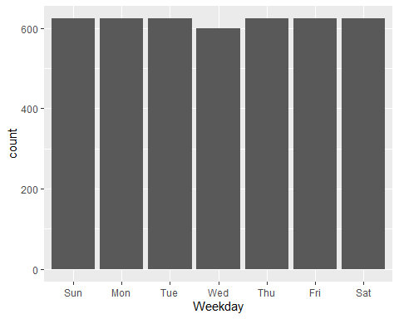
#plot
ggplot(manhattan_by_week,
aes(x= Weekday, y = Total_pickups, fill = Weekday))+
geom_col()+
theme_minimal()
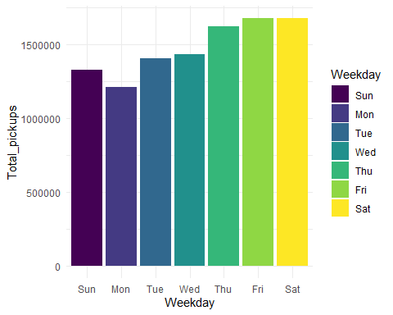

Daily Analysis
manhattan_by_day <- manhattan_data %>%
group_by(day)%>%
summarize(Total_pickups = sum(pickups))
# day
ggplot(manhattan_by_day ,
aes(x = day, y =Total_pickups, fill = day))+
geom_col()+
theme_minimal()
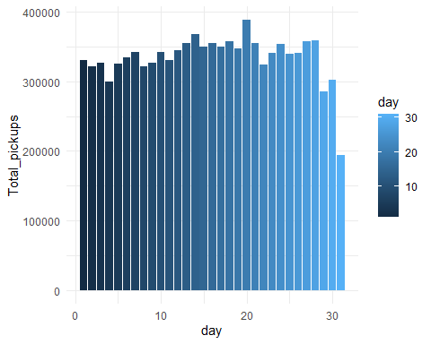

Hourly Analysis
manhattan_by_hour <- manhattan_data %>%
group_by(hour)%>%
summarize(Total_pickups = sum(pickups))
# hour
ggplot(manhattan_by_hour,
aes(x = hour, y =Total_pickups, fill = hour))+
geom_col()+
theme_minimal()
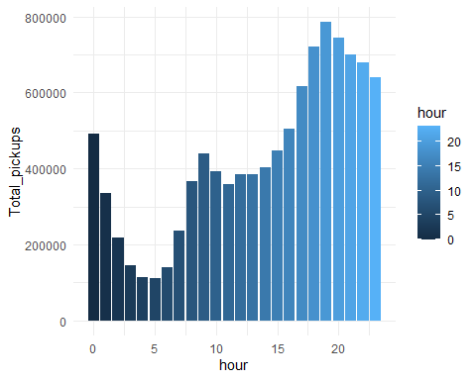

Key Findings
Missing Values Borough contains missing values. missing values were removed. Borough Demand Manhattan generally records the highest pickup volume. EWR records the lowest. Weather Impact Temperature tends to have a positive relationship with pickups. Heavy precipitation often reduces ride demand.

Holidays
Pickup patterns differ between holidays and non-holidays.

Correlations
Weather variables such as temperature and dew point are often strongly correlated. Pickups show moderate relationships with weather conditions.

Business Recommendations
Increase driver availability during peak hours. Deploy more drivers in Manhattan due to higher demand. Use weather-based demand forecasting. Build predictive models using weather and time variables. Monitor holiday demand separately for better resource allocation.

