The Battle of the Neighbourhoods - Report
Battling for the bus in Nantes

NB: This project is the final assignment of the “Applied Data Science Capstone” and IBM Data Science Professional Certificate. There are many caveats to this study and bias in the data, the sole purpose of this study was to use data and methods discovered during the lessons.

1. Introduction

Nantes is the fifth biggest city in France in terms of number of inhabitants. The city benefits from its proximity to the Atlantic, its international airport and a 2-hour train line connecting it to Paris. Consequently, Nantes hosts more than a million visitors every year (1,735,000 in 2016, the equivalent of 50% of its population). However, public transportation in Nantes are still being developed and the rapidly growing city is suffering from a more and more congested traffic.

We will explore Nantes’ public transport service and identify areas where it seems to lack. In doing so we will also focus on venues and places which attract tourists and make sure that they are all connected to a sufficiently close transport station. This will allow us to make recommendations to public bodies to improve connections for commuters as well as specific connections for tourists.

2. Data acquisition and cleaning

2.1 Data sources
To solve this question, we will leverage several data sources:

Data about existing public transportation in Nantes.
Public transports in Nantes include buses, tramways and a public bike-share service. Thankfully, Nantes Metropole is providing open source datasets about the bus/tram stops and their location, as well as the bike stations:

Bus and tram stops
https://data.nantesmetropole.fr/explore/dataset/244400404_tan-arrets/table/
From this dataset, we extract information about the ID and name of each stop, as well as their geolocation (latitude and longitude). Before cleaning, we have information about 3,637 stops.
Bike stations
https://data.nantesmetropole.fr/explore/dataset/244400404_stations-velos-libre-service-nantes-metropole-disponibilites/table/
From this dataset, we extract only information about the stations which status is “OPEN”. For each of them, we collect the ID number and name , the number of available bike stands as well as the geolocation of the stations (latitude and longitude). Before cleaning, we have information about 123 stations.
- Data about popular venues among tourists.
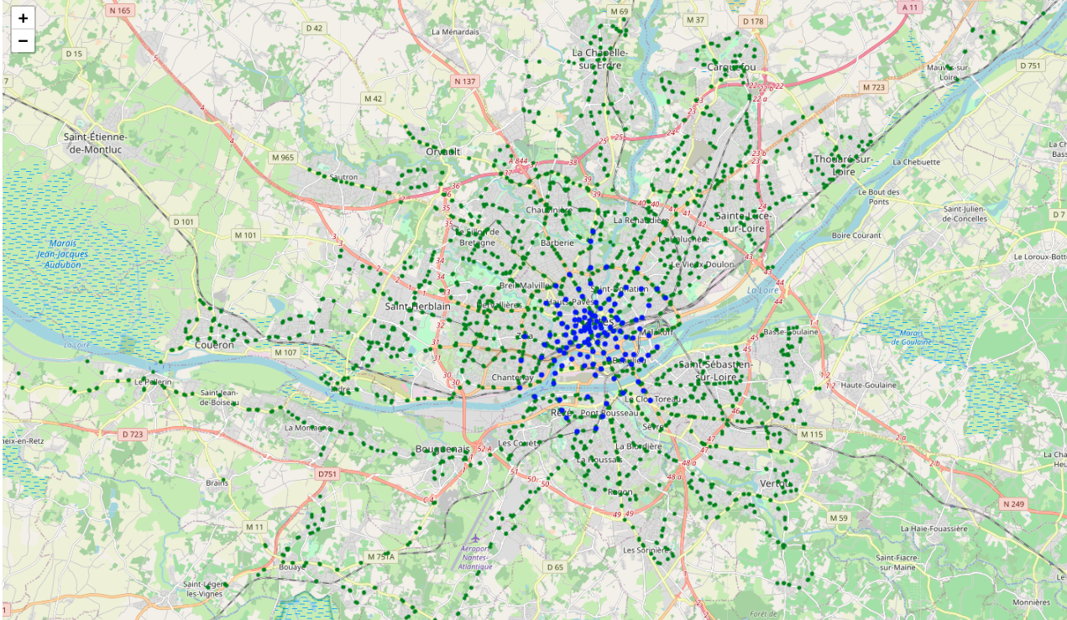Illustration 1: Public transport stations (bike stations in blue and bus stops in green)

Foursquare API
For that part we will leverage Foursquare API to collect data about venues in Nantes. A study published in 2011, a time when Foursquare was most popular, uncovered that most French users of Foursquare were from Paris and its region (56%) while only 3% were from Pays de la Loire, Nantes' region. We will therefore assume (for the purpose of this rapid study) that the venues we will find on Foursquare are frequented by tourists.
We first collect information about the boundaries and centre of each 11 boroughs of Nantes on the Nantes Metropole website:
https://data.nantesmetropole.fr/explore/dataset/244400404_quartiers-nantes/download/?format=geojson&timezone=Europe/Berlin&lang=fr
We then collect from the Foursquare API all the venues located within a 900-meter radius of each borough centre. This should be enough given the size of each borough. We keep information about the borough, name, geolocation and category of each venue. Before cleaning, the dataset contains 84 different categories and a total of 257 venues.

Cultural places
https://data.nantesmetropole.fr/explore/dataset/244400404_equipements-publics-nantes-metropole/table/?disjunctive.libtheme&disjunctive.libcategorie&disjunctive.libtype&disjunctive.statut&disjunctive.commune
From this dataset we keep information about the name, category and geolocation of the equipment. Before cleaning, the dataset contains 7 different categories and a total of 247 venues.

Swimming pools
https://data.nantesmetropole.fr/explore/dataset/244400404_piscines-nantes-metropole/download/?format=csv&timezone=Europe/Berlin&lang=fr&use_labels_for_header=true&csv_separator=%3B
From this dataset we keep the ID, name and geolocation of each swimming pool. The dataset contains 15 swimming pools before cleaning.
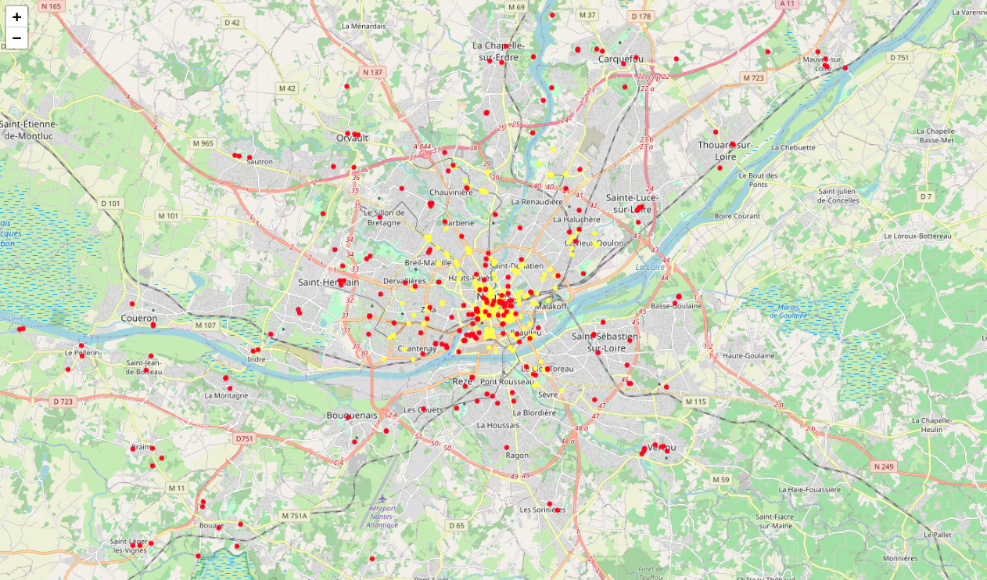Illustration 2: Venues (Cultural places and swimming pools in red, Foursquare venues in yellow)

2.2 Data cleaning

Dealing with duplicated venues and missing data
There is a risk that the cultural places and swimming pools referenced in the Nantes Metropole data will also appear in the Foursquare data. Furthermore, the points and radius combinations that we have used to download the Foursquare data might overlap in some places, so places might exist twice in our dataset under different borough names. To ensure that we are not counting venues twice, we need to compare the geolocation from the three dataset and deal with any potential duplicate.
In the first step a dataset grouping all the venues is built, including a variable indicating the data source. It contains 519 venues, of which 13 are missing geolocation data and are dropped. Then, geolocation data is used to look for duplicates. Two couples of venues are found to be duplicates according to the geolocation data. In both cases the potential duplicates are a cultural place and swimming pool. This might be due to the fact that they are very close to each other and the coordinates are not precise enough. Therefore, both venues are kept. There also are 13 couples of duplicate Foursquare venues, the first one of each couple are kept, boroughs will be cleaned in the next step. The final venue dataset contains 506 places.

Cleaning boroughs
As shown on the map in Illustration 2, some venues are outside of the area of interest for this project. Moreover, the venues from Nantes Metropole’s data have not yet been assigned to any boroughs and the boroughs from the Foursquare API dataset might not all be correct as they were computed from a point and a radius. Henceforth, the Point and Polygon functions of Shapely are used to assign each venue to a borough using their coordinates and the GeoJSON file previously downloaded at the data acquisition stage. Venues unassigned to a borough are considered outside of the area of interest and are therefore discarded from the venue dataset. 139 such venues were found and the final venue dataset contains 367 different venues.

2.3 Data preparation
Several computations will be necessary in order to answer the research questions. The distances between the venues and the transportations have to be computed, and the nearest stops or stations have to be determined

Computing distances
Several modules and built-in functions exist in Python to compute distances between points. In this case, the distance (in meter) between two geolocations needs to be computed. Ideally, it would take into account the existing streets and walking paths, but to speed up the analysis, the distance as the crow flies will be used as a proxy. For such a small area, the Euclidian distance could have sufficed, but since it is not much more complicated with Python, geodesic distance is used.
First, we compute the distance between each venue and the city centre. The city centre coordinates is found using Nominatim funtion from the Geocode package, it actually points to the city hall. The city centre is the busiest part of the city, and it is assumed that the further from it, the less busy it gets. The assumption seems to be sufficiently accurate as shown by the repartition of the venues on the map. The distance from the city centre will be a proxy of how busy the area in which each venue is located is. The minimum is 92m, maximum 7,951m (almost 8km) and mean 1,709m.

Finding the nearest stop
Given that computing and storing distances in a dataframe is a lengthy process, the cKDTree module of Scipy is first used to find the nearest transport station from each venue. It uses array instead of dataframe is therefore much more efficient. We then use the geodesic module from Geopy to get the geodesic distance in meters for each venue. The distance between a venue and a transport station goes from 3.7m to 398.3m, with an average of 96.0m.

Creating new overarching categories
The dataset currently has 92 categories, a lot of which only have one or very few observations. To help analyse the boroughs and their compositions, the categories are grouped under broader categories (e.g. French, Italian, Asian restaurants etc. are grouped under “Restaurants”). The distribution of small categories under broader categories was carried out separately in a spreadsheet, before to be imported in the Notebook and merged. The transport category is excluded since the observations are not relevant for this study. There are 328 observations left and 11 broad categories.

3. Methodology

3.1 Exploratory data analysis

Broad categories and boroughs
As shown in Illustration 3, the larger category are the cultural places with 117 venues, followed by restaurants with 74 venues.
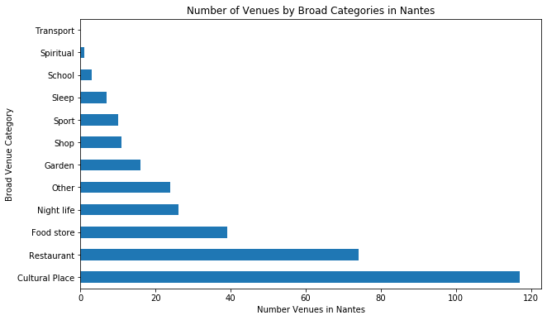Illustration 3: Number of venues by broad category type
Most restaurants found on Foursquare are located in the city centre (“Centre ville”) with a few on the island (“Ile de Nantes”) as per Illustration 4. Similarly, there are 44 cultural places in the city centre, but there are a bit more spread through the entire city.
Illustration 5 gives more insight on how venues are distributed between boroughs. Almost 40% of the venues are located in the city centre, and 12.7% are on the island. Since Foursquare is not used as much in Nantes than Paris, nor in France than in the U.S. in general, the data misses a lot of venues, which might introduce bias in the analysis. Ideally, this analysis should be performed on official data instead. Although the distribution of venues might still be close to reality, there is a high probability that the city centre is over-represented in the data while a higher proportion of missing venues would be found in boroughs further from the centre. The difficulty is that this is probably away from the city centre that are venues isolated from the public transportations. However, the traffic there might also be lighter.
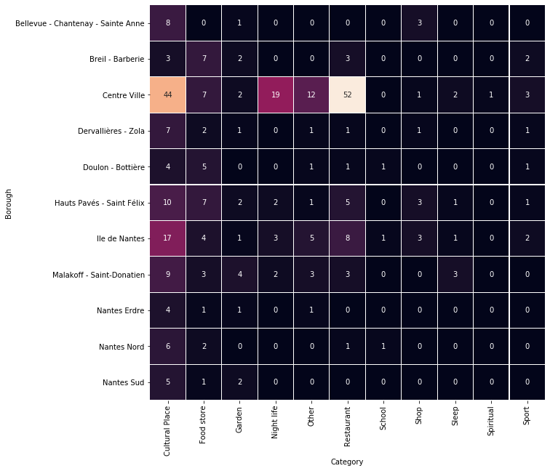Illustration 4: Heat map of number of venues by category and by borough

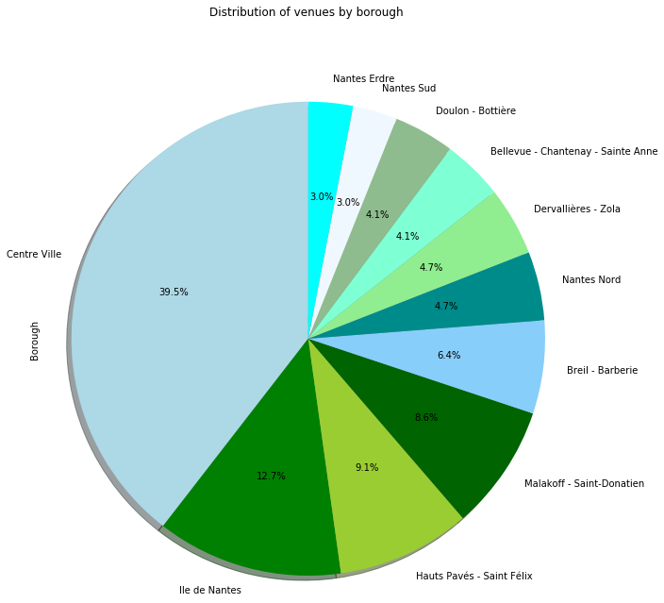Illustration 5: Percentage of venues by borough

Distance to the nearest transport station
As shown on Illustration 7 50% of the venues are located within 100m of a public transport, with only a few outliers located between 250n and 400m. Interestingly, some of these outliers are even located in the city centre according to Illustration 6. There are some important differences between boroughs: 75% of venues in the borough called Nantes Erdre are located further than 100m away from a public transport.
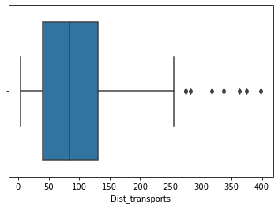Illustration 7: Box plot of the distance to the nearest public transport
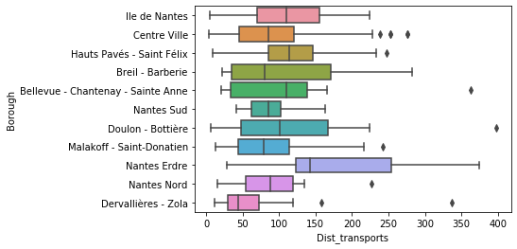Illustration 6: Box plots of distances by borough
The average distance varies from 74.6m in “Dervallières – Zola” borough to 185.6m in “Nantes Erdre” borough.

Relationship between distance from the city centre and distance to public transports
On the above plot, each venue is represented by a point with its x coordinate representing its distance to the city centre and its y coordinate its distance to the nearest public transport. There is a higher concentration of venues closer to the city centre, with the number of venues decreasing with distance.
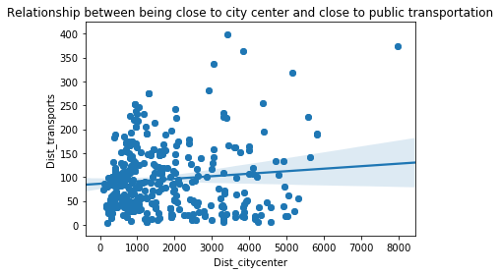Illustration 8: Relationship between distance from the city centre and distance to public transports
The blue line is the regression line such that:and the blue shadow surrounding the line is the confidence interval. The larger the distance to the city centre, the larger the confidence interval. This is because the data is become more scarse. The line is slightly increasing which suggest a positive relationship, ie the further the location from the city centre, the further the closest transport. However, the likely bias in the data prevents any clear conclusion.
3.2 Density-Based Clustering
Density-Based Clustering is an unsupervised learning method which allows to distinguish groups of similar observations in a dataset, by locating regions of high density in a data space and regions of lower density separating them. The observations in the lower-density regions are typically considered noise/outliers. Martin Ester, Hans-Peter Kriegel, Jörg Sander et Xiaowei Xu (1996) proposed an algorithm called “density-based spatial clustering of applications with noise” (DBSCAN) to partition the data based on density. The algorithm uses two input parameters: a distance eps and a minimum number of points MinPts required to form a dense region.
The idea here is to look at clusters of venues and there distance to the closest public transports. If a cluster is further to public transports, it is likely that people will drive there and the traffic will be more important.
The DBSCAN algorithm is run on the data using the Haversine distance (in kilometers) to account for the fact that the earth in not flat, even though the difference is minimal in such a small area. The epsilon is set at 0.15 (150m) and MinPts at 3. Thus an area is considered dense if a venue is surrounded by at least two other venues within 150m.

4. Results
The algorithm returned 22 clusters as follow:
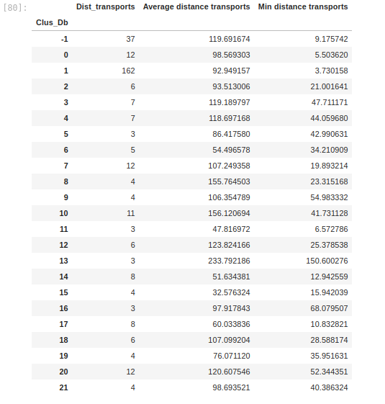Illustration 9: Description of clusters
Cluster number -1 is actually not a cluster but all the outliers. They are also shown in red on the map below (Illustration 10). The largest cluster is cluster 1, actually located in the city centre. It is shown in green below.

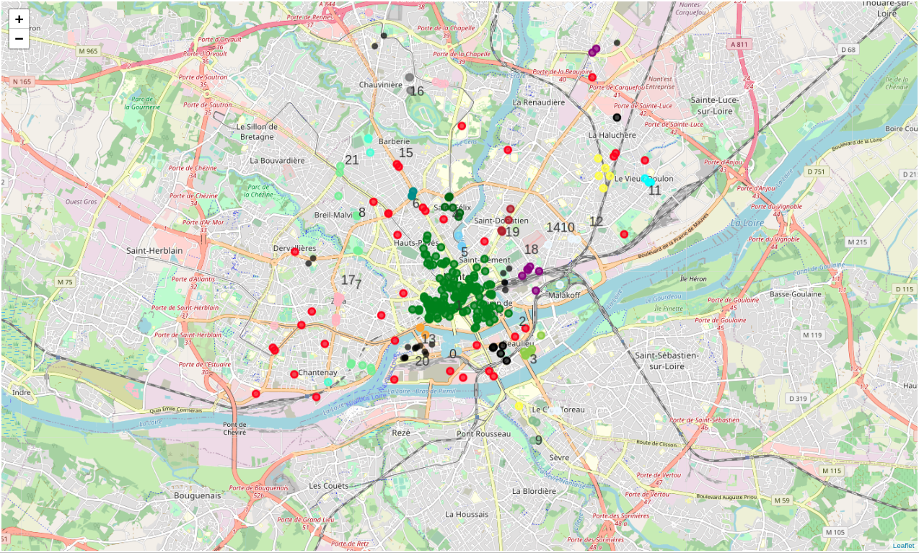Illustration 10: Map of the clusters
In addition to these results, it is also interesting to filter further the outliers that are located the furthest from a public transport. The threshold to define “furthest” was the third quartile of the distance distribution (135m). It means that these venues are somewhat difficult to access through public transports and are isolated from other venues. They are therefore costly to access for people, so either people won’t go there or they will generate unnecessary traffic going there. There were 10 such places as shown below. They are coloured by category, purple for cultural places (3), dark blue for food stores, (2) light blue for gardens (2), light green for shops (2) and red when the category is missing.
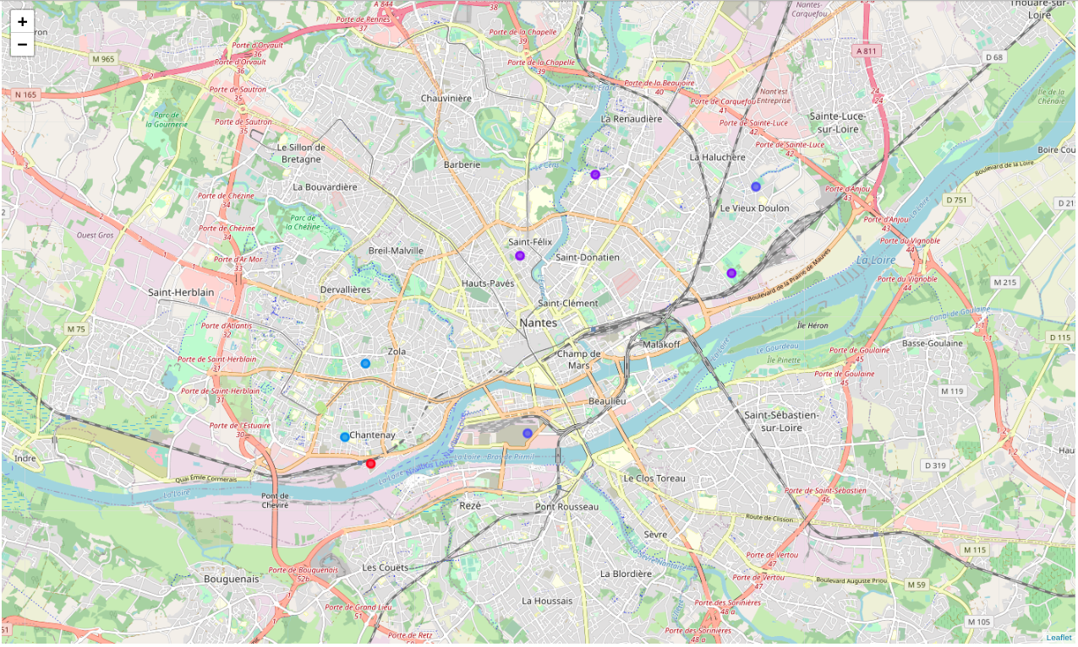Illustration 11: Map of isolated venues

5. Discussion
Illustration 9 helps to understand how big/dense clusters are and how far they are from the nearest public transport. It also shows the average distance from the nearest public transports. It might be relevant as people might go there to visit only one venue. Cluster 13, composed of 3 venues, is located on average at 234m from public transports, this is the highest average distance, and at minimum 150.6m (highest minimum). This means that it is likely to generate traffic of people going there. It might be a good idea to better connect this cluster. Similarly for clusters 10 with 11 venues and an average distance of 156m and cluster 8 with 4 venues and an average distance of 156m.
The venues shown in Illustration 11 should also be considered as they are costly to access for people (isolated and far from transports). They are costly because people need to go there especially for them so the whole transportation cost will be directed towards visited only one venue. They are likely to generate unnecessary traffic as people are more likely to go there by car and might then use their car to join other denser areas.
Of course, the dataset considered in this exercise is very biased and is missing a lot of observations. There are many caveats to this study, the sole purpose of this study was to use data and methods discovered during the Coursera “Applied Data Science Capstone” and IBM Data Science Professional Certificate.

6. Conclusion
Traffic is becoming more and more of an issue in Nantes, the 5th biggest French city. This study attempted to use publicly available datasets on public transports and venues in the city to identify areas where public transports could be improved. Using DBSCAN algorithm, three dense clusters and 10 isolated venues poorly connected were identified. The three dense clusters are likely to attract traffic which is an issue and the 10 venues are likely to generate traffic in other areas so should also be considered. Further studies should consider analysing the number of visitors of these 10 venues as well as their characteristics to make a final decision.

M. Ester, H.-P. Kriegel, J. Sander, and X. Xu, “A density-based algorithm for discovering clusters in large spatial databases with noise,” in Proceedings of the 2nd International Conference on Knowledge Discovery and Data mining, 1996, pp. 226–231

