1. Process file Test_task_1.csv using a script, in any programming language. Follow coding industry standards.

Formatting rules:

1. Split the file into minimum number of new files so each file had only uniq id-s in it.
2. All files must have a header.
3. All commas must be replaced with a dot. Example: 4,5 -> 4.5 .
4. Column Date must be formated to dd-mmm-yy. Example: 21/08/2019 -> 21-Aug-19
5. Column No skip values that are in format 20180615, values in format dd/mm/yyyy must be stored if format yyyy-mm-dd. Example: 20180615 -> 20180615 , 15/06/2018 -> 2018-06-15 .

Please find attached: Task folder

1. Add comments in file SQL_2.txt about what it doing.

Visualize, the how part of the DB structure based on query. Can be done by hand and attached as a picture.

|  |
| --- |
| SELECT *-- SELECT based on the value of another SELECT sometimes called sub-select.  FROM (  SELECT  -- AS used for aliasing, it simply means change column names to what is on  -- the right side of it in the final result.  R.id AS receivable_id,  R.contract_id,  R.balance AS receivable_balance, R.amount AS receivable_amt,  -- SUM(column_name) calculates the sum of a set of values stored in  -- each row of table with column "column_name".  SUM(RI.amount) AS ri_amount,  SUM(RI.balance) AS ri_balance,  SUM(RIC.ric_amount) AS ric_amount  -- Aliasing is used here for Table name,  -- we can refer in our SQL to "receivables" table as "R"  FROM receivables AS R  -- LEFT JOIN, takes all selected values from the left table,  -- combines them with the specified condition,  -- retrieve the matching rows from both the associated tables.  LEFT JOIN receivable_items AS RI ON RI.receivable_id = R.id  LEFT JOIN (  -- Calculate negative sum amount of each identical value on "receivable_item_id"  SELECT  receivable_item_id,  -- SUM of amount collected by GROUP BY CLAUSE  -SUM(amount) AS ric_amount  FROM receivable_item_changes  -- collect data from multiple records(rows) and group the result by  -- identical values for "receivable_item_id".  GROUP BY 1  ) AS RIC ON RIC.receivable_item_id = RI.id  -- It was meant to be a comment probably, the space is missing.  --WHERE R.contract_id = 1469  -- collect data from multiple records and group the result by  -- identical values for all sql result in columns number 1 to 4  GROUP BY 1,2,3,4 ) AS A  -- The COALESCE() function returns the first non-null value in a list.  -- here it means if value was null for first argument consider that as zero  WHERE COALESCE(receivable_amt, 0) <> COALESCE(ri_amount, 0)  OR COALESCE(receivable_amt, 0) <> COALESCE(ric_amount, 0) + COALESCE(receivable_balance, 0)  OR COALESCE(ri_amount, 0) <> COALESCE(ric_amount, 0) + COALESCE(ri_balance, 0) |

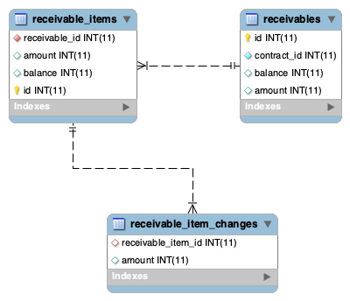

1. Support ticket was created with description.

Unable to open application for offer AS6 with id 676. When opening the application error 500 appears.

Values are stored in DB in format. Applications with id-s 716 and 718 are correct and working as intended.

|  |  |  |  |
| --- | --- | --- | --- |
| id | liabilities | income | amount |
| 676 | 21,36 | 650 | 321,11 |
| 716 | 0 | 2000 | 4700.0 |
| 718 | 100.1 | 750 | 159.99 |

What would you do to fix the issue?

1. Quick solution
2. Permanent solution

Answers:

Id 676 has wrong value format 21,36.

**Possible caused:** value is entered without validation of the value format.

**As a quick solution** -: Edit the DB to correct the value format “,” -> “.” for both column liabilities and amount.

**Permanent solution -:** Validate values format before values are saved into DB,