National Time and Signal Addressing Tool

User Manual

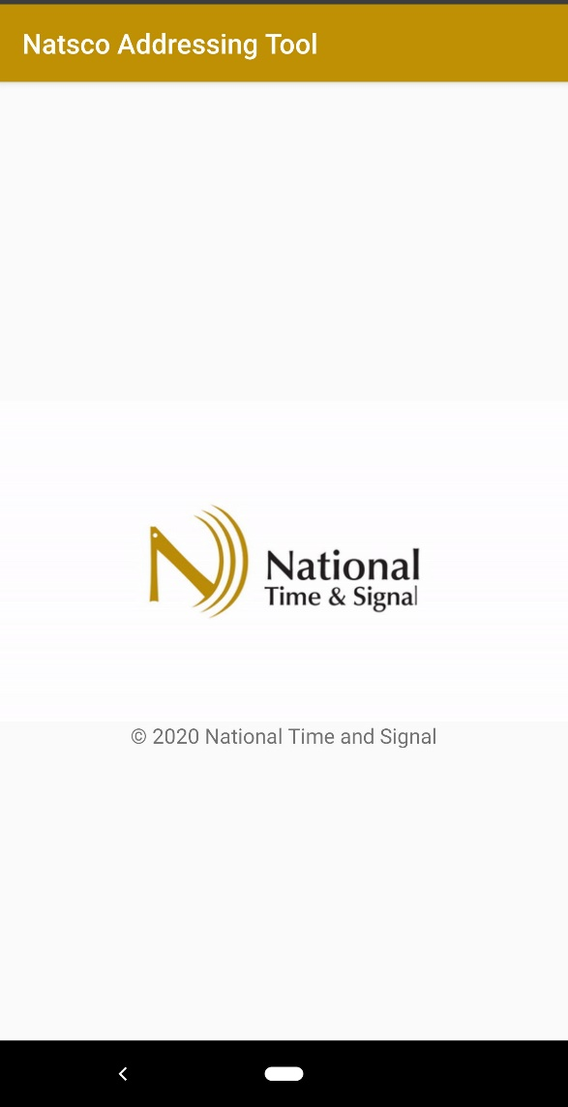

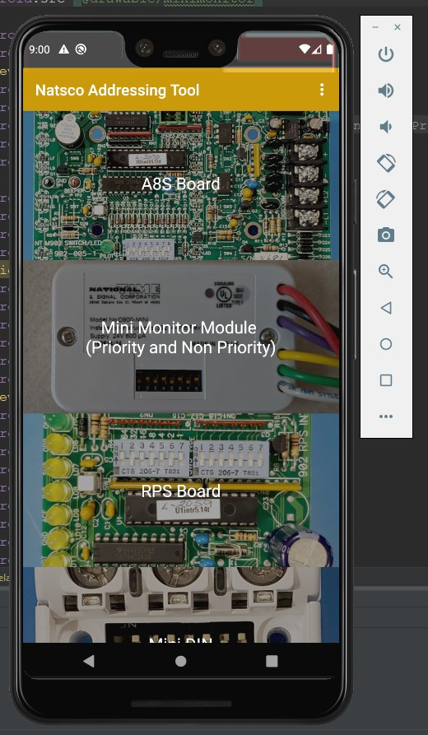The first screen you will see is the device selection screen. This contains a list of all the different devices the app supports. The list is long, and you may need to scroll down to find the device you are looking for. Once you find the device you are looking for, tap anywhere on the picture or letters to be taken to the next screen. Notice that some entries in this list apply to more that 1 device, for example the Priority Mini Monitor Module and the Non-Priority Mini Monitor Module share the same list entry.

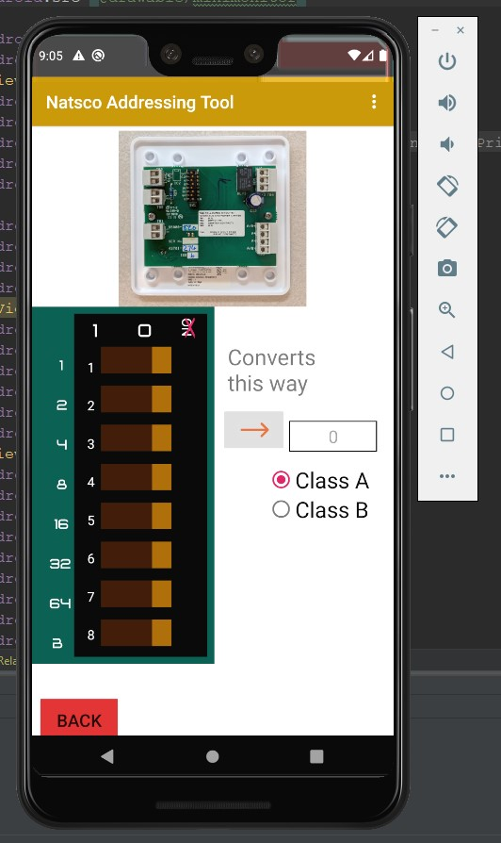This is an example of a vertical device layout; you would see this once you have selected a device from the main screen. At the top is a picture of the device, use this to orient yourself on the device you are working with. Below the picture you will see a row of switches on the left side, these correspond to the Dip Switches on the physical device. In the center of the screen, below the picture is an arrow button, tap this button to change the direction of the app’s conversion. In this screenshot the arrow is pointing to the right, this means that you can tap on the row of switches to turn them on or off, then the numerical address will be displayed in the box to the right of the arrow. If the arrow is pointed to the left, you can input a number in the box, and the switches will position themselves to display that address. Press the red back button to return to the main screen.

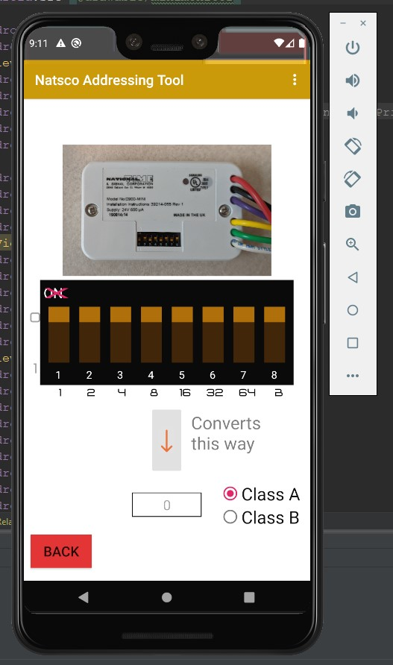This is an example of a horizontal device layout. It works the same as a vertical layout, but the switches are displayed horizontally, and the arrow points either up or down. On some devices there is the word “ON” on the Dip Switch, this is crossed out in red on our app because “ON” does not correspond to the switch being in the 1 position.

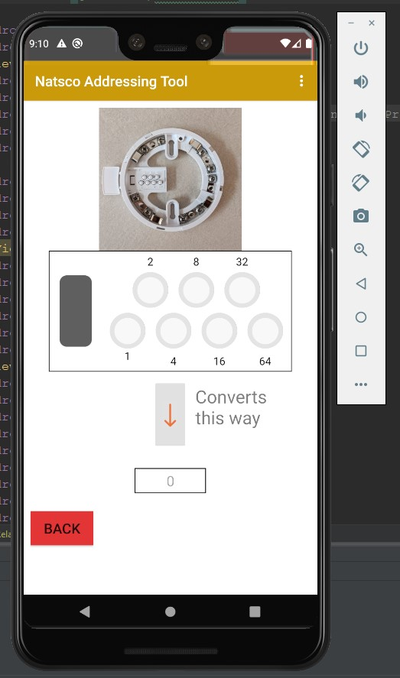

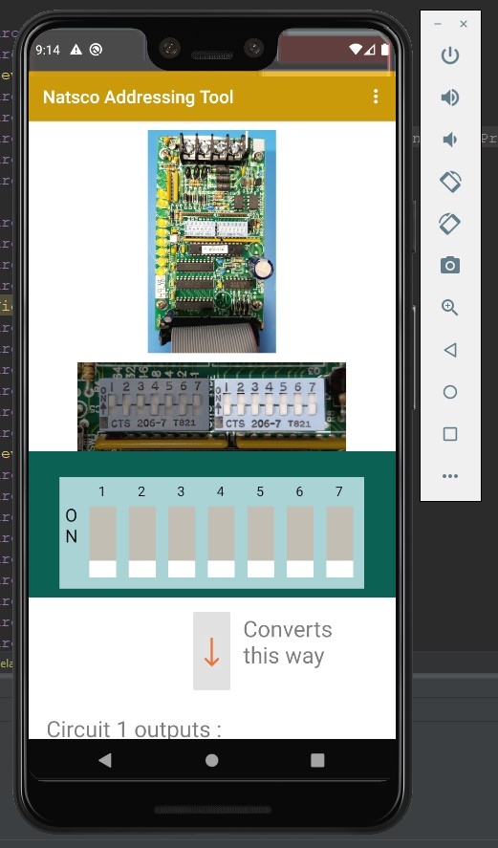This is an example of a device with an Ident Card. Instead of switches there are dots that you can remove from the card, a removed dot represents a 1. You can tap on the dots to remove or replace them, you can also give it a number and it will tell you what dots to remove.

The RPS Board has 2 Dip Switches and you can switch between them by tapping on the image of switches below the large picture of the device. The Dip Switch you are working with is light while the one you are NOT decoding is grayed out.

The right Dip Switch determines the circuit output scheme. Set the switches at the top and you can see below what output scheme each circuit is set to. You can also select which circuit scheme you want and the switched at the top will change to reflect your selection.