Online Clothing Store System

GUI DESIGN & DATABASE CONNECTIONS – FE2 PROJECT

EOGHAN O’BRIEN, THOMAS MURDOCK & AARON BROE

2021

**Table of Contents**

**Introduction** 2

# **Introduction**

This is the design document for our formal element two in the GUI Design & Database Connections. The project idea is an online stores system in which we use many elements such as Java Swing & MS Access databases. The members of this group are Eoghan O’Brien, Thomas Murdock & Aaron Broe. In this report, we will outline the structure of this application and the different elements within this that outlines the GUI, database and Java aspects present within, in order to fully create our system accordingly.

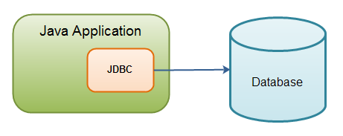

# **High-Level Description of System**

Like mentioned above, this system is an online clothes store system, in which we are taking inspiration from many online clothes vendors on the real market such as ASOS and Boohoo. These online vendors are very popular, especially with young adults, in which they can view many popular brands and what they have to offer, as well as many different types of clothes, such as hoodies, trousers and jumpers.