Eoghan O'Brien, Thomas Murdock & Aaron Broe

GUI DESIGN & DATABASE CONNECTIONS  22/04/2021

FE2 PROJECT – USER MANUAL FOR ONLINE CLOTHES STORE

**Table of Contents**

**Landing Pages** 2

**Login Pages** 2

**Customer Related Areas** 3

**Employee Related Areas** 3

# **Landing Pages**

Upon opening of the application, the user will be shown the main landing page for this online clothes store system, in which they must choose whether to use an employee login or a customer login. This will show the two different streams a person using this app can go through. Below is the landing page:

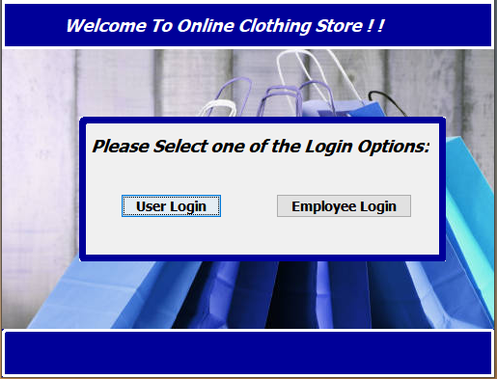

The next section will outline the login pages in detail and the structure of them. However, once they log in, there will be home/landing pages in which the customer or employee will be able to choose what tasks they want to perform once they access the system. For example, the employee homepage has enabled to user to easily access different tasks within the system which three simple buttons on the “JPanel” are presented to them to be selected.

# **Login Pages**

The user will have chosen their path of customer or employee, and they can log into their accounts accordingly. Typically in a professional setting, the company will assign a new account for an employee in their system, however, a customer will need to register their new account in a page on this system, which we have implemented as seen below:

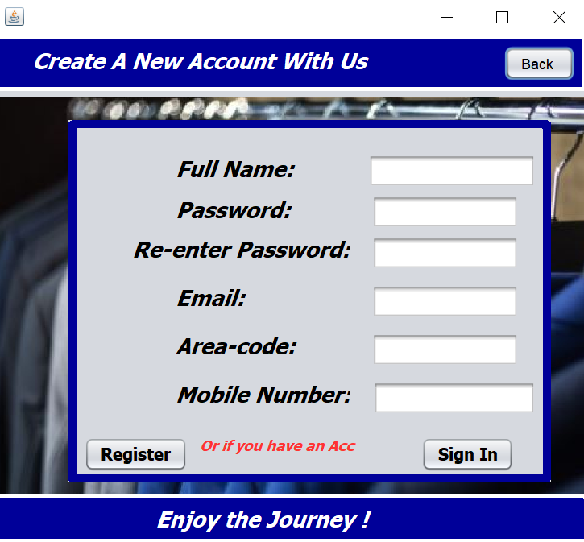

So, if a customer needs to register they can do so on this page, but both target parties will be able to login on these especially made login pages created us as seen below. These pages will then bring the users to different areas of the business, in which the employee will perform maintenance and the customer can purchase/rent as they wish.

# **Customer Related Areas**

To detail the different sections within the homepages, like previously stated, the customer will be able to purchase and rent items within this portal system. An example below is the purchases page in which they will be able to purchase goods. As seen on this page, they can view and select products within the system, add what they want to their order, view the total cost and then confirm this order. They can also rent and return suits in a form-style page within this system accordingly.

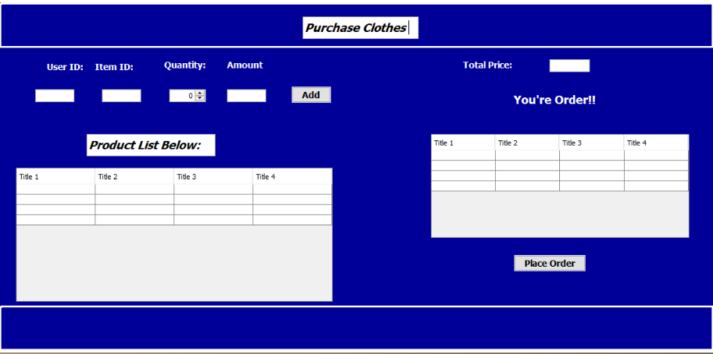

# **Employee Related Areas**

Much like the customer, the employee will have chosen the path in which they want to access their certain area within this system. There will be different areas they will be able to work on, following a minimalistic, simple view and be able to see their edits. For example with the stock and user management, the employee can view the table of the stock or users and can edit, add or remove at their own accord when necessary. Below is an example of one of these pages, being the stock management, and you can see the ease of use in this. They can also check overdue accounts for different scenarios, such as, when users have rented a suit and see what date they are meant to return it on, which in turn shows which accounts are overdue. This conveys how the employee can perform maintenance within this clothes store.

