Solution Architecture Design Document (SAD)
Project Title: Zero Trust, Multi-Tenant SaaS Audio Streaming Platform on Microsoft Azure
Document Version: v1.0
Author: Solution Architect
Date: (dd/mm/yyyy)

1. Executive Summary
This document defines the solution architecture for a secure, scalable, multi-tenant SaaS audio streaming platform hosted on Microsoft Azure. The proposed architecture replaces a costly and inflexible on-premise environment with a cloud-native, PaaS-first platform designed to meet rapid growth demands, regulatory compliance (GDPR, ISO 27001 readiness), high availability, and cost efficiency.

2. Business Context and Problem Statement
The organisation currently operates an on-premise infrastructure that is expensive to maintain, difficult to scale, and fails to consistently pass security audits. As customer demand increases, the platform struggles with reliability, agility, and innovation.
Key Business Drivers
- Rapid customer and tenant growth
- Regulatory pressure (GDPR, ISO 27001 readiness)
- Cost optimisation
- Improved reliability and availability
- Faster feature delivery

3. Solution Objectives
- Deliver a secure multi-tenant SaaS platform for external B2B and B2C users
- Support elastic scaling and high availability
- Improve audit readiness and compliance posture
- Reduce operational overhead through PaaS adoption
- Enable future innovation using event-driven and AI services

4. Architecture Overview
The solution adopts a PaaS-first, cloud-native architecture, leveraging managed Azure services to minimise operational burden while maximising security, scalability, and resilience.
Architecture Layers
- Edge & Traffic Layer: Azure Front Door (global ingress, SSL, WAF)
- Frontend Layer: Azure Static Web Apps
- Identity & Tenant Management: Azure AD B2C (B2C users), Microsoft Entra ID (B2B users), MFA, Zero Trust
- Application Layer: Azure App Service
- Event & Integration Layer: Azure Functions and Azure Service Bus
- Data Layer:
  - Azure SQL Database (tenant-isolated & transactional data)
  - Azure Blob Storage (shared application data)
  - Azure Redis Cache (performance optimisation)
- AI Layer: Azure OpenAI and Azure Speech Services
- Observability Layer: Azure Monitor and Log Analytics
- Security Layer: Microsoft Defender for Cloud and Azure Key Vault
- Migration Layer: Azure Migrate

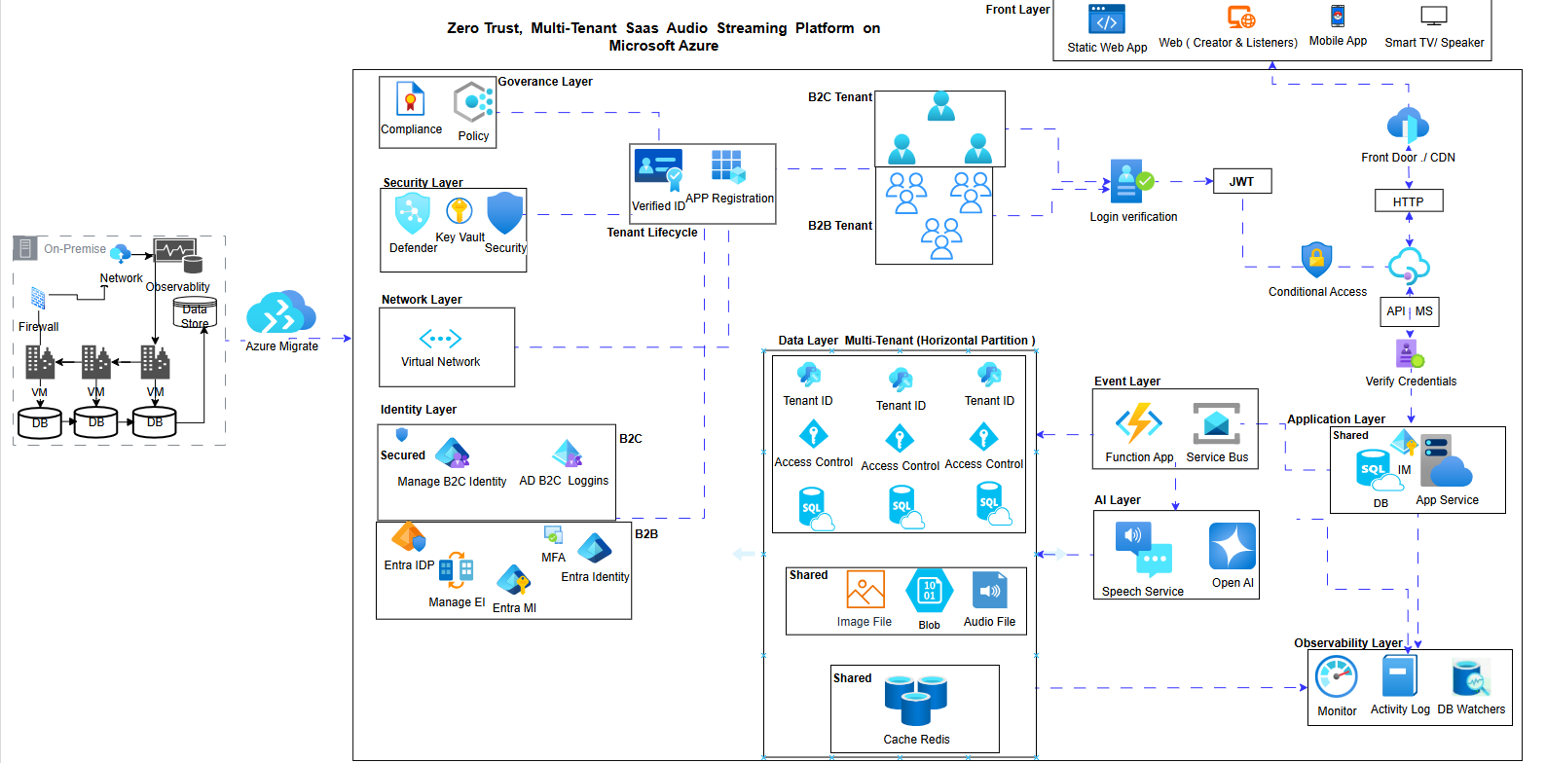

The diagram should show layers, trust boundaries, and major services only.
Detailed internals belong in implementation documentation, not the SAD.

5. Architecture Decisions, Justifications, and Trade-offs
Component | Purpose | Justification | Trade-off
Azure Front Door | Global traffic management & WAF | Low latency, global availability, security at edge | Higher cost than regional load balancers
Azure Static Web Apps | Frontend UI | Cost-efficient, globally distributed, CI/CD integrated | Limited backend logic
Azure AD B2C / Entra ID | Identity management | Supports B2C and B2B tenants, MFA, Zero Trust | Increased configuration complexity
Azure App Service | Application hosting | Fully managed runtime with autoscaling | Less control than AKS
Azure Functions & Service Bus | Event-driven processing | Decouples components, improves scalability | Eventual consistency
Azure SQL Database | Transactional & tenant data | ACID compliance, tenant isolation | Higher cost than NoSQL
Blob Storage | Shared app data | Durable, scalable object storage | No ACID transactions
Redis Cache | Performance optimisation | Reduces database load, low latency | Additional service cost
Azure Monitor & Log Analytics | Observability | Centralised monitoring and audit readiness | Telemetry cost
Defender for Cloud & Key Vault | Security | Threat detection and secret protection | Additional cost
Azure Policy & RBAC | Governance | Enforces compliance and standards | Reduced flexibility
Azure OpenAI & Speech Services | AI capabilities | Managed AI without infrastructure overhead | Variable consumption cost

6. Assumptions and Constraints
- Usage volumes are estimated using scenario-based modelling
- Tenant numbers are expected to grow over time
- The architecture supports future evolution without major redesign

7. Governance & Cost Model (Design-Time)
Governance Controls
- Tagging Strategy: Application, Environment, TenantType, Owner, CostCenter, DataSensitivity
- Policy Controls:
  - Mandatory resource tagging
  - Encryption at rest and in transit
  - Approved regions only
  - Approved SKUs for production workloads

Design-Time Cost Model (Estimated Monthly Cost)
Resource | Design-Time Budget (USD/month) | Notes
Azure App Service | 200 | Production tier with autoscaling
Azure SQL Database | 150 | Elastic pool for tenant databases
Blob Storage | 50 | Hot + Cool tiers
Azure Functions | 30 | Consumption plan
Azure AI Services | 100 | Estimated via Azure Pricing Calculator
These figures are design-time estimates, not commitments, and are validated using the Azure Pricing Calculator.

8. Pre-Deployment Architecture Validation
- Azure Well-Architected Framework:
Reviewed against Security, Reliability, Performance Efficiency, Cost Optimisation, and Operational Excellence pillars.
- Reference Architecture Alignment:
Validated against Azure SaaS and multi-tenant reference architectures.
- Scenario-Based Cost Validation:
Evaluated scaling, tenant growth, and AI usage scenarios.
Output: Architecture Validation Summary
(Well-Architected assessment may be attached as an appendix if required)

9. Delivery Plan
Phased Rollout
- Phase 0: Foundation (identity, governance, landing zone)
- Phase 1: Core platform services
- Phase 2: Data and integration
- Phase 3: Security and compliance hardening
- Phase 4: Observability and optimisation
- Phase 5: Advanced AI and scaling
Key Risks
- Tenant data isolation failure
- Cost overruns due to AI consumption
- Identity misconfiguration
- Regional outages
Next Steps
- Architecture approval
- Landing zone deployment
- Proof of Concept (PoC)
- Security threat modelling
- Cost baseline confirmation

10. Conclusion
The proposed architecture delivers a secure, scalable, cost-efficient, and compliant SaaS foundation on Microsoft Azure. It supports both B2B and B2C tenants, aligns with industry best practices, and enables future innovation while maintaining strong governance and operational excellence.

