**DESIGN & FABRICATION OF PNEUMATIC PUNCHING MACHINE**

**ABSTRACT**

Pneumatics systems are extensively used in a wide range of industries and factories and manufacturing sector entities. Pneumatics system are noted for their simplicity, reliability, and ease of operation. Also they are suitable for fast and rapid application of force.

The purpose of this project is to therefore design a simple, easily operated pneumatic punching machine that is sturdy and strong. The pneumatic press tool has an advantage of working in low pressure, that is even a pressure of 6 bar is enough for operating the unit. The pressurized air passing through the tubes to the cylinder, forces the piston out whose power through the linkage is transmitted to the punch.

The work piece thus got is for required dimensions and the piece can be collected through the land clearance provided in the die. The die used in this is fixed such that the die of required shape can be used according to the requirement. This enables us to use different type punch dies resulting in a wide range of products. Different types of punch as requirement can be thus got. According to the work material the operating pressure can be varied.

**TABLE OF CONTENTS**

**CHAPTER NO. TITLE PAGE NO.**

**ABSTRACT V**

**LIST OF TABLES X**

**LIST OF SYMBOLS XI**

**LIST OF FIGURES X11**

1. **INTRODUCTION**

1.1 PUNCHING 13

1.2 NEED FOR AUTOMATION 14

1.3 SELECTION OF PNEUMATICS 15

1.4COMPRESSED AIR 15

**2.PNEUMATICS**

2.1 FLUID POWER 17

2.2 PNEUMATICS 17

2.3 ADVANTAGES OF PNEUMATICS 18

2.3.1 SIMPLICITY OF DESIGN 18

2.3.2 RELIABILITY 18

2.3.3 STORAGE 18

2.3.4 SAFETY 18

**3.PRESSES FOR SHEET METAL WORKING**

3.1 CLASSIFICATION OF PRESSES 19

3.1.1 BASIS OF SOURCE OF POWER 19

3.1.2 BASIS OF NUMBER OF SLIDES 19

3.1.3 BASIS OF FRAME CONSTRUCTION 20

3.1.4 PRESS SELECTION 21

3.1.5 PRESS FEEDING DEVICES 22

**4.PNEUMATIC CONTROLLED PUNCHING MACHINE**

4.1 OBJECTIVE 23

4.2 LINE DIAGRAM 23

4.3 WORKING PRINCIPLE 24

4.4 COMPONENTS USED 24

4.5 DESGN AND DEVELOPMENT 25

4.5.1 DESIGN CONSIDERATIONS 25

4.5.2PROCEDURE FOR MATERIAL SELECTION 25

**5.PNEUMATIC CONTROL COMPONENTS**

5.1 PNEUMATIC CYLINDER 26

5.1.1 SINGLE ACTING CYLINDER 26

5.1.2 DOUBLE ACTING CYLINDER 26

5.2 PARTS OF A PNEUMATIC CYLINDER 27

5.2.1 PISTON 27

5.2.2 PISTON ROD 28

5.2.3 CYLIDER COVER PLATES 29

5.2.4 DIRECTION CONTROL VALVE 30

5.2.4.1 WORKING OF 3/2 DCV 31

5.2.5 HOSE AND FITTINGS 31

5.2.6 SEALS AND CONNECTORS 31

5.2.7 PRESSURE REGULATOR 32

5.2.8 FRAME 33

5.2.9 PUNCH AND DIE 33

5.2.9.1 CLEARANCE 34

5.2.9.2 TYPES OF DIES 34

5.2.10 BOLTS AND NUTS 38

**6. WORKING 39**

**7. PNEUMATIC COMPONENTS SPECIFICATIONS**

7.1 DOUBLE ACTING PNEUMATIC CYLINDER 40

7.2 LEVER OPERATED DCV 41

7.3 PRESSURE REGULATOR 41

7.4 CONNECTORS 41

7.5 HOSES 41

**8. DESIGN CALCULATION**

8.1 CUTTING FORCE 42

8.2 SPECIFICATION 43

8.3 AREA CALCULATION 43

8.4 FORCE CALCULATION 43

8.5 THEORETICAL AIR CONSUMPTION 44

8.6 CALCULATION FOR ALUMINIUM 44

**9. FEATURES OF PNEUMATIC PUNCHING MACHINE**

9.1 PNEUMATIC PUNCHING MACHINE 45

9.2 ADVANTAGES 45

9.3 LIMITATIONS 46

9.4 APPLICATIONS 46

9.4.1 DISCHARGE OF WORK PIECE 46

9.4.2 JOB CLAMPING 46

9.4.3 TRANSFER OF JOBS 46

**10. COST ESTIMATION** 47

**11. WORKING MODEL PICTURE** 48

**12. CONCLUSION** 49

**13. REFERENCE** 50

**LIST OF TABLES**

**S.NO. DESCRIPTION PAGENO.**

1 LIST OF MATERIALS 24

2 ACTUATOR 41

3 DCV 42

4 PRESSURE REGULATOR 42

5 CONNECTORS 42

6 HOSES 42

7 COST ESTIMATION 48

**LIST OF SYMBOLS**

A - Area of cylinder (m²)

D - Diameter of Piston (m)

F - Force exerted on the piston (N)

H - Height (m)

L - Length (m)

P - Pressure (N/m²)

V - Volume (m³)

**LIST OF FIGURES**

**S.NO. DESCRIPTION PAGENO.**

3.1 FRAME DESIGNS 21

4.2 PNEUMATIC CYLINDER 23

4.4 3D DIAGRAM OF WORKING MODEL 24

5.2.1 PNEUMATIC PISTON 26

5.2.2 PISTON ROD 28

5.2.3 CYLINDER PLATES 29

5.2.4 DIRECTION CONTROL VALVE 30

5.2.6 CONNECTOR 32

5.2.7 PRESSURE REGULATOR 32

5.2.8 FRAME DIAGRAM 3D 33

5.2.9 PUNCH AND DIE 34

5.2.9.2 GENERAL DIAGRAM 35

5.2.9.3 INVERTED DIE 36

5.2.9.4 COMPOUND DIE 37

5.2.9.5 PROGRESSIVE DIE 38

5.2.10 BOLT AND NUT 39

11 WORKING MODEL PICTURE 49

**CHAPTER - 1**

**INTRODUCTION**

**1.1 PUNCHING**

Punching is a [metal forming](http://en.wikipedia.org/wiki/Metal_forming) process that uses a [punch press](http://en.wikipedia.org/wiki/Punch_press) to force a tool, called a punch, through the work piece to create a hole via [shearing](http://en.wikipedia.org/wiki/Shearing_%28physics%29). The punch often passes through the work into a [die](http://en.wikipedia.org/wiki/Die_%28manufacturing%29). A scrap slug from the hole is deposited into the die in the process. Depending on the material being punched this slug may be recycled and reused or discarded. Punching is often the cheapest method for creating holes in sheet metal in medium to high production volumes. When a specially shaped punch is used to create multiple usable parts from a sheet of material the process is known as blanking. In forging applications the work is often punched while hot, and this is called hot punching.

Punch tooling (punch and die) is often made of hardened steel or [tungsten carbide](http://en.wikipedia.org/wiki/Tungsten_carbide). A die is located on the opposite side of the work piece and supports the material around the perimeter of the hole and helps to localize the shearing forces for a cleaner edge. There is a small amount of clearance between the punch and the die to prevent the punch from sticking in the die and so less force is needed to make the hole. The amount of clearance needed depends on the thickness, with thicker materials requiring more clearance, but the clearance is always less than the thickness of the work piece. The clearance is also dependent on the hardness of the work piece. The punch press forces the punch through a work piece, producing a hole that has a diameter equivalent to the punch, or slightly smaller after the punch is removed.

The pneumatic press makes an important contribution to the output of engineering work shops and is indispensable for the cheap production of large quantity of similar articles when the type of articles concerned is suited of this method of production. A pneumatic press utilizes a compressed air source to control operation of piston for high pressure to obtain desire component by using press tools. The press includes a piston operated by the compressed air source to drive a piston rod to operate the press. This pneumatic press is suitable for small press tool works. It works on the principal of compressed air. A compressor plant, pipe lines control valve, drive-members and related auxiliary application. The air is compressed in an air compressor and for the compressor plant, the flow medium is transmitted to the pneumatic system, it is of vital important that the pressure drop between generation and consumption of compressed air is kept very low, it has been seen that pipeline fittings and joints are mostly responsible for drop in pressure, if any in pneumatic system.

**1.2 NEED FOR AUTOMATION**

Automation is the use of control systems and information technologies to reduce the need for human work in the production of goods and services. In the scope of industrialization, automation is a step beyond mechanization. Whereas mechanization provide human operators with machinery to assist them with the muscular requirements of work, automation greatly decreases the need for human sensory and mental requirements as well. Automation plays an increasingly important role in the world economy and in daily experience.

Manufacturing company usually produce hundred thousand products a days, and most of the time they rely on automation to meet their client’s expectation and deadline in able to have good profit. Thousand manpower is very effective, new technologies today have important to increase the productivity of a certain company.

If you will choose between manufacturing hundreds of employees and maintaining machine, you will probably choose maintaining machines, you will probably choose maintaining machine because it is easier to handle machines then people who have different personalities. The ability of hundreds of people can be done by a single machine which means that you can save a lot of money in terms of using automated machines in manufacturing certain products less stress of those personnel that do have attitude problem on their work. Though machines is considered as one of the biggest investments that you will have for your business, this will soon worth all the cost you have incurred due to the productivity that can provide to your company.

All that is need is to have few people who are experienced enough in handling this kind of machines. A lot of times these machines contain program logic controller that are considered as the heart and brain of the machine’s automation. Learning things about program logic controller is a big advantage regarding maintenance and trouble shooting.

**1.3 SELECTION OF PNEUMATICS**

* Pneumatics is an attractive medium for low cost mechanization particularly for sequential and repetitive operations.
* Many factories and plant already have a compressed air system, which is capable of providing energy requirements and control system
* The main advantage of pneumatics system are usually economic and simplicity the latter reducing maintenance to a low level.
* It can have outstanding advantages in term of safety.

Mechanization is broadly defined as the replacement of manual effort by mechanical power. Pneumatic is an attractive medium for low cost mechanization particularly for sequential (or) repetitive operations. Many factories and plants already have a compressed air system, which is capable of providing the power (or) energy requirements and the control system (although equally pneumatic control systems may be economic and can be advantageously applied to other forms of power). The main advantage of an all pneumatic system are usually economic and simplicity the latter reducing maintenance to a low level. It can also have outstanding advantages in terms of safety.

**1.4 COMPRESSED AIR**

Pneumatic systems operate on a supply of compressed air, which must be made available. In sufficient quantity and at a pressure to suit the capacity of the system. When pneumatic system is being adopted for the first time, however it wills indeed the necessary to deal with the question of compressed air supply.

The key part of any facility for supply of compressed air is by means using reciprocating compressor. A compressor is a machine that takes in air, gas at a certain pressure and delivered the air at a high pressure.

Compressor capacity is the actual quantity of air compressed and delivered and the volume expressed is that of the air at intake conditions namely at atmosphere pressure and normal ambient temperature. Clean condition of the suction air is one of the factors, which decides the life of a compressor. Warm and moist suction air will result in increased precipitation of condense from the compressed air. Compressor may be classified in two general types.

* Positive displacement compressor.
* Turbo compressor

Positive displacement compressors are most frequently employed for compressed air plant and have proved highly successful and supply air for pneumatic control application.

The types of positive compressor

* Reciprocating type compressor
* Rotary type compressor

Turbo compressors are employed where large capacity of air required at low discharge pressures. They cannot attain pressure necessary for pneumatic control application unless built in multistage designs and are seldom encountered in pneumatic service.

**CHAPTER -2**

**PNEUMATICS**

**2.1 FLUID POWER**

Fluid power is the technology that the generation, control and transmission of power, using pressurized fluids. It is almost impossible to find a manufactured product that has not been “fluid-powered” in some way at some stage of its production and distribution. Fluid power is called hydraulics when the fluid used is a liquid and is called pneumatic when the fluid is a gas.The fluid power system are designed specifically to perform work. The work is accomplished by a pressurized fluid cylinder produces a force resulting in linear motion, whereas a fluid motor produces a torque resulting in rotary motion. Cylinders and motors are called actuators. The control components such as valves are needed to ensure that the work is done smoothly, accurately, efficiently and safely.

**2.2 PNEUMATICS**

Pneumatics is a branch of fluid power technology, which deal with the study and application of use of pressurized gas to affect mechanical motion. Pneumatics system are extensively used in industry, where factories are commonly plumbed with compressed air or other compressed inert gases. This is because a centrally-located and electrically- powered compressed that powers cylinders and other pneumatic devices through lever operated valves in often able to provide motive power in a cheaper, safer, more flexible, and more reliable way than a large number of electric motors and actuators. Pneumatic system in fixed installation such as factories use compressed air because a sustainable supply can be made by compressing atmospheric air. The air usually has moisture moved and a small quantity of oil added at the compressor, to avoid corrosion of mechanical components and to lubricate them.

**2.3ADVANTAGES OF PNEUMATICS**

**2.3.1 SIMPLICITY OF DESIGN AND CONTROL**

Machines are easily designed using standard cylinder & other components. Control is as easy as it is simple ON-OFF type control.

**2.3.2RELIABILITY**

* Pneumatic system tends to have long operating lives and require very little maintenance.
* Because gas is compressible, the equipment is less likely to be damages by shock.
* The gas in pneumatics absorbs excessive force, whereas the fluid of hydraulics directly transfers force.

**2.3.3 STORAGE**

* Compressed gas can be stored, allowing the use of machines when electrical power is lost.

**2.3.4 SAFETY**

* Very low chance of fire (Compared to hydraulic oil).
* Machines can be designed to be overload safe.

**CHAPTER - 3**

**PRESSES FOR SHEET METAL WORKING**

**3.1 CLASSIFICATION OF PRESSES.**

Types of presses for sheet metal working can be classified by one or a combination of characteristics, such as source of power, number of slides, type of frame and construction, type of drive, and intended applications.

**3.1.1 CLASSIFICATION ON THE BASIS OF SOURCE OF POWER.**

* **Manual presses**. These are either hand or foot operated through levers, screws or gears. A common press of this type is the arbor press used for assembly operations.
* **Mechanical presses**. These presses utilize flywheel energy which is transferred to the work piece by gears, cranks, eccentrics, or levers.
* **Hydraulic presses**. These presses provide working force through the application of fluid pressure on a piston by means of pumps, valves, intensifiers, and accumulators. These presses have better performance and reliability than mechanical presses.
* **Pneumatic presses**. These presses utilize air cylinders to exert the required force. These are generally smaller in size and capacity than hydraulic or mechanical presses, and therefore find use for light duty operations only.

**3.1.2 CLASSIFICATION ON THE BASIS OF NUMBER OF SLIDES.**

* **SINGLE ACTION PRESSES.**

A single action press has one reciprocation slide that carries the tool for the metal forming operation. The press has a fixed bed. It is the most widely used press for operations like blanking, coining, embossing, and drawing.

* **DOUBLE ACTION PRESSES.**

A double action press has two slides moving in the same direction against a fixed bed. It is more suitable for drawing operations, especially deep drawing, than single action press. For this reason, its two slides are generally referred to as outer blank holder slide and the inner draw slide. The blank holder slide is a hollow rectangle, while the inner slide is a solid rectangle that reciprocates within the blank holder. The blank holder slide has a shorter stroke and dwells at the bottom end of its stroke, before the punch mounted on the inner slide touches the workpiece. In this way, practically the complete capacity of the press is available for drawing operation. Another advantage of double action press is that the four corners of the blank holder are individually adjustable. This permits the application of non-uniform forces on the work if needed. A double action press is widely used for deep drawing operations and irregular shaped stampings.

* **TRIPLE ACTION PRESSES.**

A triple action press has three moving slides. Two slides (the blank holder and the inner slide) move in the same direction as in a double – action press and the third or lower slide moves upward through the fixed bed in a direction opposite to that of the other two slides. This action allows reverse – drawing, forming or bending operations against the inner slide while both upper actions are dwelling. Cycle time for a triple – action press is longer than for a double – action press because of the time required for the third action.

**3.1.3 CLASSIFICATION ON THE BASIS OF FRAME AND CONSTRUCTION.**

* **Arch – frame presses**. These presses have their frame in the shape of an arch. These are not common.
* **Gap frame presses**. These presses have a c-shaped frame. These are most versatile and common in use, as they provide UN – obstructed access to the dies from three sides and their backs are usually open for the ejection of stampings and / or scrap.
* **Straight side presses**. These presses are stronger since the heavy loads can be taken in a vertical direction by the massive side frame and there is little tendency for the punch and die alignment to be affected by the strain. The capacity of these presses is usually greater than 10 mm.
* **Horn presses**. These presses generally have a heavy shaft projecting from the machine frame instead of the usual bed. This press is used mainly on cylindrical parts involving punching, riveting, embossing, and flanging edges.

[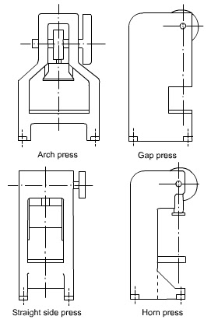](http://4.bp.blogspot.com/-JW4n4i5reLE/T2A9ulBvFPI/AAAAAAAABCU/MKrJ5HWfDUA/s1600/untitled.bmp)

FIG –3.1TYPICAL FRAME DESIGNS USED FOR POWER PRESSES.

**3.1.4 PRESS SELECTION:**

Proper selection of a press is necessary for successful and economical operation. Press is a costly machine, and the return on investment depends upon how well it performs the job. There is no press that can provide maximum productively and economy for all application so, when a press is required to be used for several widely varying jobs, compromise is generally made between economy and productivity. Important factors affecting the selection of a press are size, force, energy and speed requirements.

**SIZE.**Bed and slide areas of the press should be of enough size so as to accommodate the dies to be used and to make available adequate space for die changing and maintenance. Stroke requirements are related to the height of the parts to be produced. Press with short stroke should be preferred because it would permit faster operation, thus increasing productivity. Size and type of press to be selected also depends upon the method and nature of part feeding, the type of operation, and the material being formed.

**FORCE AND ENERGY**. Press selected should have the capacity to provide the force and energy necessary for carrying out the operation. The major source of energy in mechanical presses is the flywheel, and the energy available is a function of mass of flywheel and square of its speed.

**PRESS SPEED**. Fast speeds are generally desirable, but they are limited by the operations performed. High speed may not, however, be most productive or efficient. Size, shape and material of workpiece, die life, maintenance costs, and other factors should be considered while attempting to achieve the highest production rate at the lowest cost per piece.

**3.1.5PRESS FEEDING DEVICES:**

Safety is an important consideration in press operation and every precaution must be taken to protect the operator. Material must be tried to be fed to the press that eliminates any chance of the operator having his or her hands near the dies. The use of feeding device allows faster and uniform press feeding in addition to the safety features.

**CHAPTER- 4**

**PNEUMATIC CONTROLLED PUNCHING MACHINE**

**4.1 OBJECTIVE**

The main objective of selecting this project is to design and fabricate an easy and portable punching machine which reduces requirement of skilled labour. With this project we also intend to increase the production rate of industries by reducing the machining time since it is fully automated.

**4.2 LINE DIAGRAM**

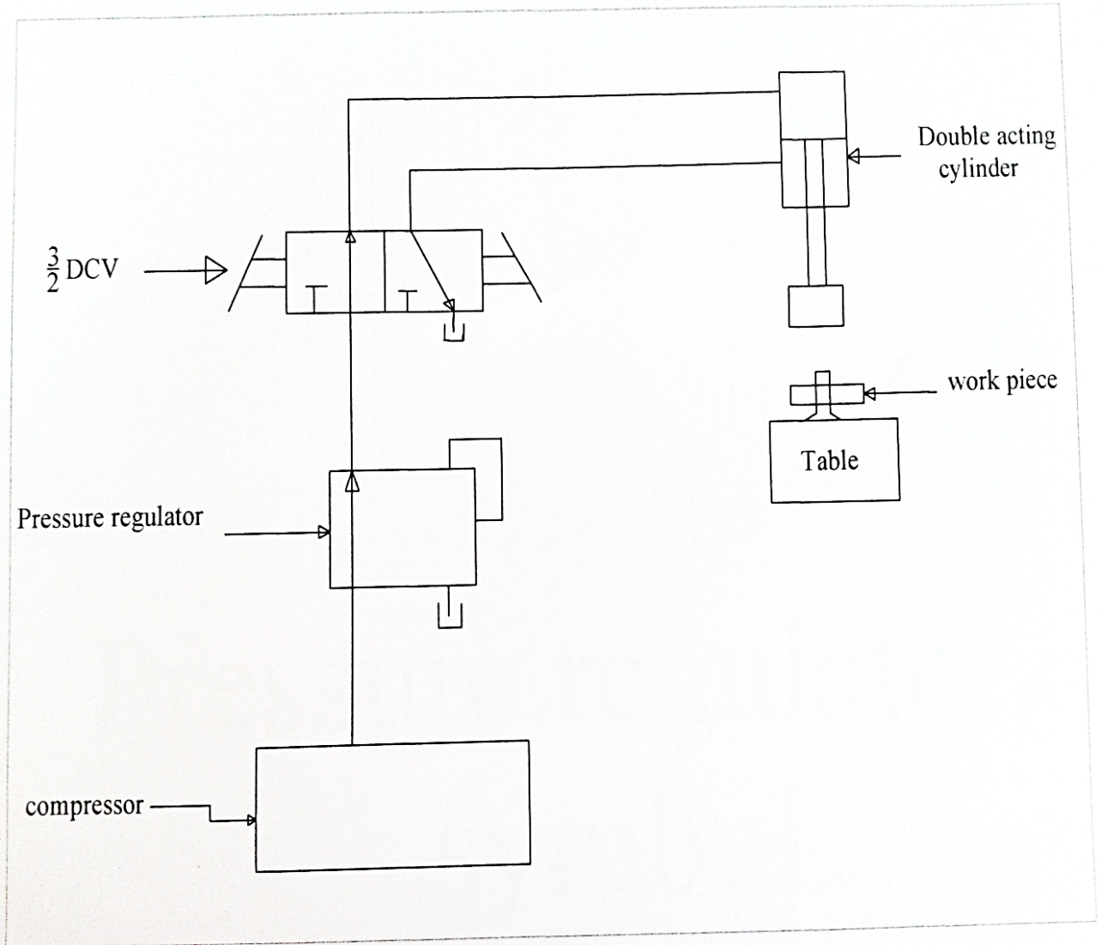

FIG – 4.2 LINE DIAGRAM.

**4.3 WORKING PRINCIPLE**

In this project we are using the pneumatic cylinder as punching equipment. The compressed air from the compressor is used as the force medium for this operation. In one position, air enters to the top of the cylinder and pushes the piston so that the punching is done. In next position, air enters to the bottom of the cylinder and pushes the piston return back, so that the return stroke is obtained.

**4.4 COMPONENTS USED**

This project consist of

* Pneumatic cylinder
* 3/2 D.C.V (lever operated)
* Pressure regulator
* Connecting hose
* Connectors
* Nuts & bolts
* Frame & stand

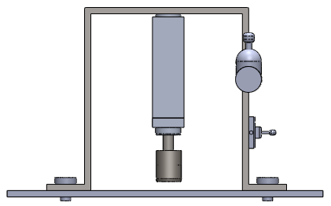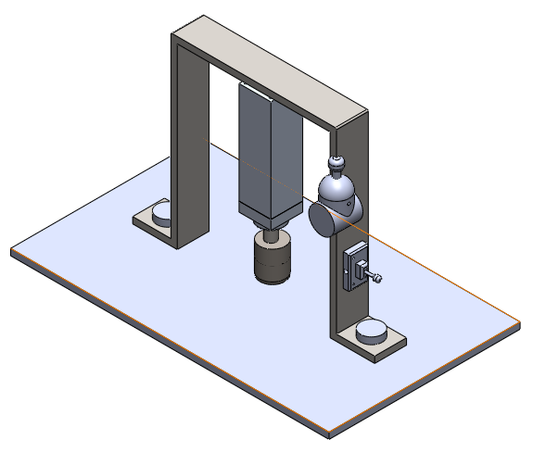

FIG 4.4 3D DIAGRAM OF WORKING MODEL.

**4.5DESIGN AND DEVELOPMENT**

The design is either to formulate a plan for the satisfaction of a special need or to solve a problem. If the plan result in the creation of something having a physical reality, then the product must be functional, safe, reliable, competitive, usable, manufacturable and marketable. A design imperative can be expressed as follows:

* Invent alternate solution.
* Through analysis and test, simulate and predict the performance of each alternative, retain satisfactory alternative, and discard unsatisfactory ones.
* Choose the best satisfactory alternative discovered as an approximation to optimality.
* Implement the design.

**4.5.1 DESIGN CONSIDERATIONS**

Sometimes the strength required of an element in a system is an important factor in determination of the geometry and the dimension of the element. In such a situation we say that strength is an important design consideration. When we use the expressions design consideration, we are referring to some characteristic which influence the design of the element or perhaps, the entire system. Usually quite a number of such characteristics are taken for consideration in a given design situation, many of the important ones are follows-

Strength/Stress, Distortion/Deflection/Stiffness, Wear, Corrosion, Safety, Usability, Utility, Cost, Processing, Weight, Life, Noise, Shape, Size, Control, Thermal properties, Surface.

**4.5.2 PROCEDURE FOR MATERIAL SELECTION**

The first step in any material selection problem is to define the needs of product. Without prior basis about material or method of fabrication, the engineer should develop a clear picture of all the characteristic necessary for this part to adequately perform its intended function. These requirements will fail into three major areas-

* Shape or geometry considerations
* Property requirement
* Manufacturing concerns

**CHAPTER - 5**

**PNEUMATIC CONTROL COMPONENTS**

**5.1 PNEUMATIC CYLINDER**

An air cylinder is an operative device in which the state input energy of compressed air i.e. pneumatic power is converted in to mechanical output power, by reducing the pressure of the air to that of the atmosphere.

**5.1.1 SINGLE ACTING CYLINDER**

Single acting cylinder is only capable of performing an operating medium in only one direction. Single acting cylinders equipped with one inlet for the operating air pressure, can be production in several fundamentally different designs.

Single cylinders develop power in one direction only. Therefore no heavy control equipment should be attached to them, which requires to be moved on the piston return stoke single action cylinder requires only about half the air volume consumed by a double acting for one operating cycle.

**5.1.2 DOUBLE ACTING CYLINDERS**

A double acting cylinder is employed in control systems with the full pneumatic cushioning and it is essential when the cylinder itself is required to retard heavy messes. This can only be done at the end positions of the piston stock. In all intermediate position a separate externally mounted cushioning derive most be provided with the damping feature.

The normal escape of air is out off by a cushioning piston before the end of the stock is required. As a result the sit in the cushioning chamber is again compressed since it cannot escape but slowly according to the setting made on reverses. The air freely enters the cylinder and the piston stokes in the other direction at full force and velocity.

**5.2 PARTS OF A PNEUMATIC CYLINDER**

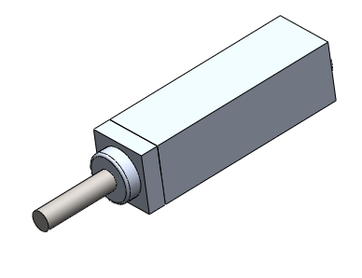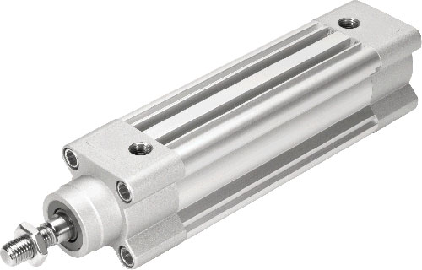

FIG 5.2.1 PNEUMATIC PISTON

**5.2.1 PISTON**

The piston is a cylindrical member of certain length which reciprocates inside the cylinder. The diameter of the piston is slightly less than that of the cylinder bore diameter and it is fitted to the top of the piston rod. It is one of the important part which converts the pressure energy into mechanical power. The piston is equipped with a ring suitably proportioned and it is relatively soft rubber which is capable of providing good sealing with low friction at the operating pressure. The purpose of piston is to provide means of conveying the pressure of air inside the cylinder to the piston of the oil cylinder.

Generally piston is made up of

* Aluminium alloy-light and medium work.
* Brass or bronze or CI-Heavy duty.

The piston is double acting type. The piston moves forward when the high-pressure air is turned from the right side of cylinder. The piston moves backward when high pressure acts on the piston from the left side of the cylinder. The piston should be as strong and rigid as possible.The efficiency and economy of the machine primarily depends on the working of the piston. It must operate in the cylinder with a minimum of friction and should be able to withstand the high compressor force developed in the cylinder and also the shock load during operation.

The piston should possess the following qualities.

* The movement of the piston not creates much noise.
* It should be frictionless.
* It should withstand high pressure.

**5.2.2 PISTON ROD**

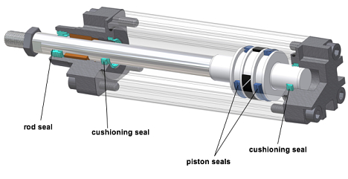

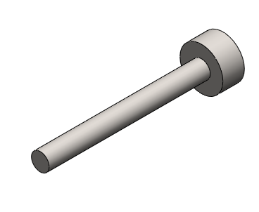

5.2.2PISTON ROD

The piston rod is circular in cross section. It connects piston with piston of other cylinder. The piston rod is made of mild steel ground and polished. A high finish is essential on the outer rod surface to minimize wear on the rod seals. The piston rod is connected to the piston by mechanical fastening. The piston and the piston rod can be separated if necessary. One end of the piston rod is connected to the bottom of the piston. The other end of the piston rod is connected to the other piston rod by means of coupling. The piston transmits the working force to the oil cylinder through the piston rod. The piston rod is designed to withstand the high compressive force. It should avoid bending and withstand shock loads caused by the grinding force. The piston moves inside the rod seal fixed in the bottom cover plate of the cylinder. The sealing arrangements prevent the leakage of air from the bottom of the cylinder while the rod reciprocates through it.

**5.2.3 CYLINDER COVER PLATES**

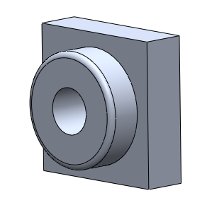

FIG 5.2.3 CYLINDER PLATES

The cylinder should be enclosed to get the applied pressure from the compressor and act on the pinion. The cylinder is thus closed by the cover plates on both the ends such that there is no leakage of air. An inlet port is provided on the top cover plate and an outlet ports on the bottom cover plate. There is also a hole drilled for the movement of the piston.The cylinder cover plate protects the cylinder from dust and other particle and maintains the same pressure that is taken from the compressor. The flange has to hold the piston in both of its extreme positions. The piston hits the top plat during the return stroke and hits the bottom plate during end of forward stroke. So the cover plates must be strong enough to withstand the load.

**5.2.4 DIRECTION CONTROL VALVE:**

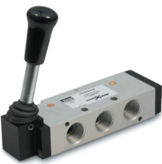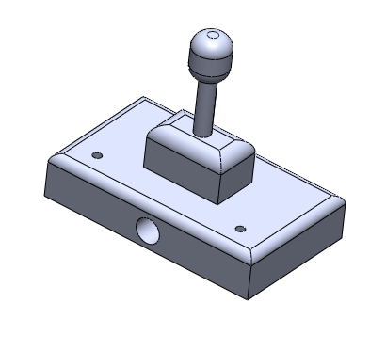

FIG 5.2.4 DIRECTION CONTROL VALVE

Various types of control valves are used to regulate, control and monitor the air energy for control of direction pressure, flow, etc. Pneumatic energy is regulated and controlled by pneumatic valves. Functionally valves are divided into four major groups.

* Direction Control
* Flow Control

In our project 3/2 DC valves are used.

* A directional control valve with three ways, three ports, and two positions.

It ensures

* Quick and sure action
* Long life.
* Easy maintenance.
* Less wastage of energy.

**5.2.4.1 WORKING OF A LEVEROPERATED VALVE**

The Lever operated valve has 3 openings. This ensure easy exhausting of 3/2 valve. The spool of the 3/2 valve slide inside the main bore according to spool position; the ports get connected and disconnected. The working principle is as follows

**POSITION-1**

The lever is pushed front so that the air flows in one side of the cylinder making the piston rod to give forward stroke.

**POSITION-2**

The lever is pushed back so that the air flows in other end of the cylinder making the piston rod to give return stroke.

**5.2.5 HOSE AND FITINGS**

It is provided for the passage of compressed air from the compressor outlet to the operating valve.

Two separate pipes also connect the operating valve with the working cylinder pressure drop through and airline depends on the flow rate, pipe diameter, pipe length and geometry. It can be determined directly for straight pipes of any given length. A small chaining bore size can have marked effect on pressure drop, whereas even doubling the pipe length, will only result in doubling the pressure drop. Pressure drop through bends and fittings can only be determined by empirical tests, since it is specific to the internal geometry involved. Rigid pipes however are less manipulated through remain form of bends with arrangements increase and variable air have to flow and the flow itself may be of fluctuating or pulsating nature. In this case it is thus normally based on practical recommendation.

**5.2.6 SEALS AND CONNECTORS**

Seal is an important component of a pneumatic system and is used to prevent the air leakage through the joint. This project passes the static seal which are used to prevent the leakage through the stationary surface.Material of the seal is Teflon tape. Teflon has the following properties

* Withstand the system pressure and temperature without any damage.
* Resist the wear and abrasion.
* Recover from deformation.
* Resists the adverse effects such as deterioration and shrinking caused by the system air.

Connectors are used for connecting the hoses to the components.

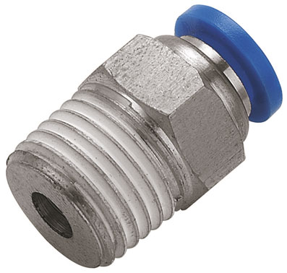

FIG 5.2.6 CONNECTOR

**5.2.7 PRESSURE REGULATOR**

Constant pressure level is required for the trouble free operation of a pneumatic control. A pressure regulator is fitted downstream of the compressed air filter. It provides a constant set pressure at the outlet of the outlet of the regulator. The pressure regulator is also called as pressure reducing valve or pressure regulating valve.

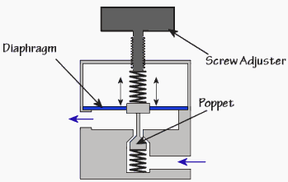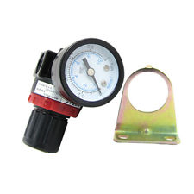

FIG 5.2.7PRESSURE REGULATOR

**5.2.8 FRAME**

Highly tempered mild steel plate smelted and forged to the required shape shown below.

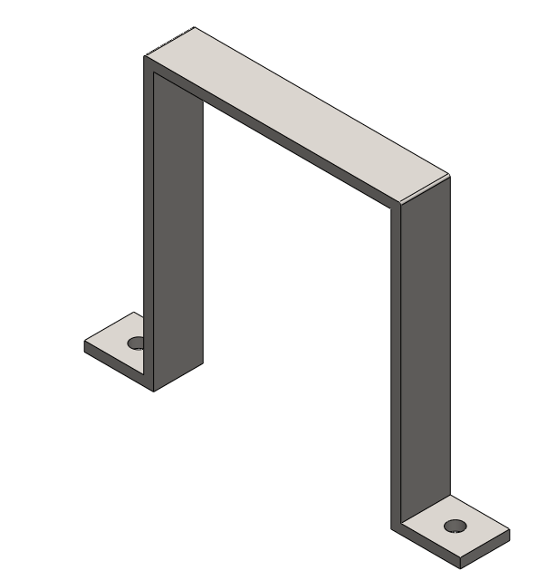

FIG 5.2.8 FRAME

**5.2.9 PUNCH AND DIE**

A typical die and punch set used for blanking operation is shown in [fig](http://nptel.iitm.ac.in/courses/Webcourse-contents/IIT-ROORKEE/MANUFACTURING-PROCESSES/Metal%20Forming%20&%20Powder%20metallurgy/lecture8/lecture8.htm) XI. The sheet metal used is called strip or stock. The punch which is held in the punch holder is bolted to the press ram while die is bolted on the press table. During the working stroke, the punch penetrates the strip, and on the return stroke of the press ram the strip is lifted with the punch, but it is removed from the punch by the stripper plate. The stop pin is a gage and it sets the advance of the strip stock within the punch and die. The strip stock is butted against the back stop acting as a datum location for the center of the blank.

[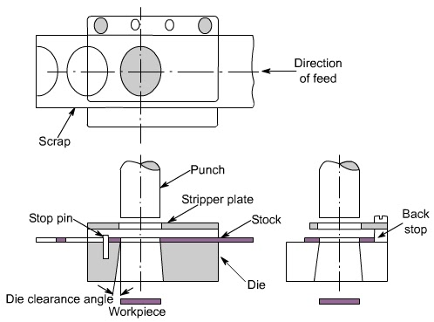](http://4.bp.blogspot.com/-kfLyrZrvT9E/T2A-wI2k94I/AAAAAAAABCc/sZFEDkKAUfw/s1600/untitled.bmp)

FIG 5.2.9 PUNCH AND DIE

The die opening is given angular clearance to permit escape of good part (blank). The waste Skelton of stock strip, from which blanks have been cut, is recovered as salvaged material.

The clearance angle provided on the die ([fig](http://nptel.iitm.ac.in/courses/Webcourse-contents/IIT-ROORKEE/MANUFACTURING-PROCESSES/Metal%20Forming%20&%20Powder%20metallurgy/lecture8/lecture8.htm) XI) depends on the material of stock, as well as its thickness. For thicker and softer materials generally higher angular clearance is given. In most cases, 2 degree of angular clearance is sufficient. The height of cutting land of about 3 mm is generally sufficient.

**5.2.9.1CLEARANCE**

In blanking operation*,* the die size is taken as the blank size and the punch is made smaller giving the necessary clearance between the die and the punch.

**5.2.9.2TYPES OF DIES**

The components generally incorporated in a piercing or blanking die are shown in fig. 5.2.9.2. This figure shown the die in the conventional closed position. The die set is made up of the punch holder which is fastened to the ram of the punch press and the die shoe which is fastened to the bolster plate of the punch press.

Generally, the punch is fastened to the punch holder and aligned with the opening in the die block. [Fig](http://nptel.iitm.ac.in/courses/Webcourse-contents/IIT-ROORKEE/MANUFACTURING-PROCESSES/Metal%20Forming%20&%20Powder%20metallurgy/lecture8/lecture8.htm) 5.2.9.2 shows one type of stripper plate and push – off pins. The stripper holds the scrap strip so that the punch may pull out of the hole. The push – off pins are needed to free the blank in instances where the material strip clings to the bottom of the punch. This may be necessary for thin material, or where lubricants are used on the material.

[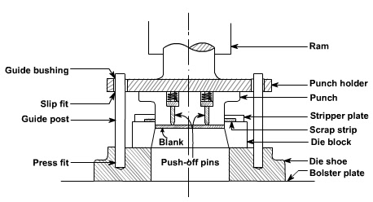](http://2.bp.blogspot.com/-sd7N4ymkyDc/T2A_HqJ5TDI/AAAAAAAABCk/xKc8T4vzWOc/s1600/untitled.bmp)

FIG 5.2.9.2 GENERAL DIAGRAM

Sometimes the die and the punch positions may be interchanged. This may become necessary when the opening in the bolster plate is too small to permit the finished product to pass through the bolster opening. [Fig](http://nptel.iitm.ac.in/courses/Webcourse-contents/IIT-ROORKEE/MANUFACTURING-PROCESSES/Metal%20Forming%20&%20Powder%20metallurgy/lecture8/lecture8.htm) XIII shows such a die.

[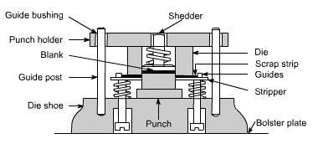](http://2.bp.blogspot.com/-u6wNn0UgRFQ/T2A_V4Dh1pI/AAAAAAAABCs/gmNK89-vwho/s1600/untitled.bmp)

FIG 5.2.9.3 INVERTED DIE

**Inverted die** ([fig](http://nptel.iitm.ac.in/courses/Webcourse-contents/IIT-ROORKEE/MANUFACTURING-PROCESSES/Metal%20Forming%20&%20Powder%20metallurgy/lecture8/lecture8.htm) 5.2.9.3) is designed with the die block fastened to the punch holder and the punch fastened to the die shoe. During the downward stroke of ram, the blank is sheared from the strip. The blank and shedder are forced back into the die opening, which loads a compression spring in the die opening. At the same time the punch is forced through the scrap strip and a spring attached to the stripper is compressed and loaded. On the upstroke of the ram, the shedder pushes the blank out of the die opening and the stripper forces the scrap strip off the punch. The finished part (blank) falls, or is blown, out the rear of the press.

**Compound die** ([fig](http://nptel.iitm.ac.in/courses/Webcourse-contents/IIT-ROORKEE/MANUFACTURING-PROCESSES/Metal%20Forming%20&%20Powder%20metallurgy/lecture8/lecture8.htm) 5.2.9.3) combines the principles of the conventional and inverted dies in one station. This type of die may produce a workpiece which is pierced and blanked at one station and in one operation. The piercing punch is fastened in the conventional position to the punch holder. Its matching die opening for piercing is machined into the blanking punch. The blanking punch and blanking die opening are mounted in an inverted position. The blanking punch is fastened to the die shoe and the blanking die opening is fastened to the punch holder.

[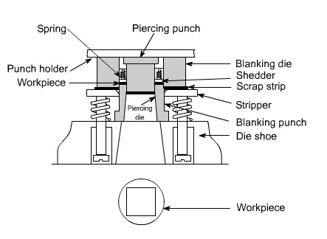](http://1.bp.blogspot.com/-5KT3jMUAbq0/T2A_sR0l8BI/AAAAAAAABC0/fsTqFTkG9z0/s1600/untitled.bmp)

FIG 5.2.9.4 COMPOUND DIE

**Progressive dies** are made with two or more stations arranged in a sequence. Each station performs an operation on the work piece, or provides an idler station, so that the work piece is completed when the last operation has been accomplished. Thereafter each stroke of the ram produces a finished part. Thus after the fourth stroke of a four – station die, each successive stroke will produce a finished part. Operations which may be carried out in a progressive die are piercing, blanking, forming, drawing, and cut – off, etc. the list of possible operations is long. The number and types of operations which may be performed in a progressive die depends upon the ingenuity of the designer.

[Fig](http://nptel.iitm.ac.in/courses/Webcourse-contents/IIT-ROORKEE/MANUFACTURING-PROCESSES/Metal%20Forming%20&%20Powder%20metallurgy/lecture8/lecture8.htm) 5.2.9.4 shows a four – station progressive die. The die block is made up of four pieces and fastened to the die shoe. This permits easy replacement of broken or worn die blocks. The stock is fed from the right and registers against a finger strop (not shown). The first stroke of the press [fig 5.2.9.5(a)](http://nptel.iitm.ac.in/courses/Webcourse-contents/IIT-ROORKEE/MANUFACTURING-PROCESSES/Metal%20Forming%20&%20Powder%20metallurgy/lecture8/lecture8.htm) produces a square hole and two notches. These notches form the left end of the first piece.

During the upstroke of ram, the stock is moved to the next station against a finger stop (not shown). The stock is positioned for the second stroke. The second station is an idler, [fig 5.2.9.5(b)](http://nptel.iitm.ac.in/courses/Webcourse-contents/IIT-ROORKEE/MANUFACTURING-PROCESSES/Metal%20Forming%20&%20Powder%20metallurgy/lecture8/lecture8.htm). The right end of the first piece, the left end of the second piece, and a second square hole are pierced.

[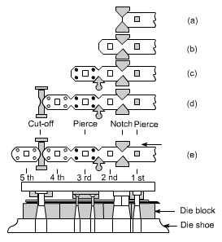](http://4.bp.blogspot.com/-S3MgkqEr-3Q/T2A_853UaoI/AAAAAAAABC8/c1EvHragI-g/s1600/untitled.bmp)

FIG 5.2.9.5 PROGRESSIVE DIE

The ram retracts and the scrap strip is moved to the third station against an automatic stop, [fig](http://nptel.iitm.ac.in/courses/Webcourse-contents/IIT-ROORKEE/MANUFACTURING-PROCESSES/Metal%20Forming%20&%20Powder%20metallurgy/lecture8/lecture8.htm) C. This stop picks up the notched v and positions the scrap strip. The third stroke of the ram pierces the four holes as shown in [fig](http://nptel.iitm.ac.in/courses/Webcourse-contents/IIT-ROORKEE/MANUFACTURING-PROCESSES/Metal%20Forming%20&%20Powder%20metallurgy/lecture8/lecture8.htm) C. The fourth stroke, D, cuts off and forms the radii at the ends of the finished piece. Thereafter every stroke produces a finished part, [fig](http://nptel.iitm.ac.in/courses/Webcourse-contents/IIT-ROORKEE/MANUFACTURING-PROCESSES/Metal%20Forming%20&%20Powder%20metallurgy/lecture8/lecture8.htm) C. Progressive dies generally have the cut – off or blanking operation as the last operation. It is preferred to have piercing operation as the first operation so that the pierced hole can be advantageously used as a pilot hole. Alternatively, special pilot holes are pierced in the scrapped part of the stock. In certain special cases, blanking is done at the first station, and the blank returned to the die by using spring plates and then moved to the subsequent station by mechanical means or manually. Progressive dies are used where higher production rates are desired and the material is neither too thick nor too thin. Their use helps in cutting down the material handling costs.

**5.2.10 BOLTS AND NUTS**

Bolts and Nuts are the most ideal components for any machine. There are five bolts and nuts needed for this pneumatics machine and they are design using CATIA software. The pitch of the screw thread is 1.5 mm. They are shown below:

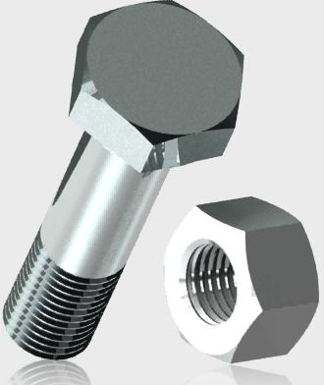

FIG 5.2.10 NUT AND BOLT

**CHAPTER –6**

**WORKING**

**WORKING**

* In this project we are using the pneumatic cylinder as punching equipment.
* The compressed air from the compressor is used as the force medium for this operation.
* In one position, air enters to the top of the cylinder and pushes the piston so that the punching is done.
* In next position, air enters to the bottom of the cylinder and pushes the piston return back, so that the return stroke is obtained.

**CHAPTER - 7**

**PNEUMATIC COMPONENTS AND ITS SPECIFICATIONS**

The pneumatic cutting and grinding machine consists of the following components to full fill the requirements of complete operation of the machine.

1. Double acting pneumatic cylinder

2. 3/2 D.C. Valve

3. Pressure regulator

4. Connectors

5. Hoses

**7.1 DOUBLE ACTING PNEUMATIC CYLINDER**

**Technical Data**

Stroke length : 50mm=0.05m

Piston rod : 20 mm = 20 x 10ˉ³ m

Quantity : 1

Seals : Nitride (Buna-N) Elastomer

End cones : Cast iron

Piston : EN – 8

Media : Air

Temperature : 0-80 º C

Pressure Range : 12 bar

**7.2LEVER OPERATED DCV**

**Technical data**

Size : 0.635 x 10 ˉ² m

Part size : 0.635 x 10 ˉ² m

Max pressure range : 0 - 9 x 10 ⁵ N/m²

Quantity : 1

**7.3PRESSURE REGULATOR**

**Technical Data**

Port size : 0.635 x 10 ֿ² m

Pressure : 0-9 x 10 ⁵ N/m²

Media : Air

Quantity : 1

**7.4 CONNECTORS**

**Technical data**

Max working pressure : 10 x 10 ⁵ N/m²

Temperature : 0-100 º C

Material : Brass

**7.5 HOSES**

**Technical data**

Max pressure : 10 x 10 ⁵ N/m²

Outer diameter : 8 mm = 8 x 10 ˉ ³m

Inner diameter : 5.5 mm = 5.5 x 10ˉ ³m

**CHAPTER – 8**

**DESIGN CALCULATION**

**8.1 CUTTING FORCE**

* Cutting force = 𝐿 × 𝑆 × 𝑇𝑚𝑎𝑥
* Stripping force =10% -20% of cutting force

𝐿 = Length of periphery to be cut in mm

𝑆 = Sheet thickness in mm

* 𝑇𝑚𝑎𝑥 = Shear strength in N/mm2
* 𝑇𝑚𝑎𝑥 = 80% of tensile strength
* The formula to calculate the press force is as follows-

Press force = cutting force + stripping force

* The punch force required to punch a piece of sheet metal can be estimated from the following equation

F = 0.7 x t x Ultimate tensile stress.

Where:

t is the sheet metal thickness,

 L is the total length sheared (perimeter of the shape), and

UTS is the ultimate tensile strength of the material.

**8.2 SPECIFICATIONS:**

* Pressure =8 kg/cm² [1kg/cm2= 0.9810 bar]

=8 x 0.9810

= 7.848 bar =8 bar (app)

* Diameter of piston (Dp) =40mm=0.04m
* Diameter of piston rod (Dr) =20mm=0.020m
* Length of piston =160mm=0.16m

**8.3 AREA CALCULATIONS:**

* Area of piston rod =(3.14X0.022)/(4)

=0.000314m²

* Area of piston =(3.14X0.042)/(4)

= 0.00125m²

**8.4 FORCE CALCULATION**

* Cylinder thrust for double acting in forward stroke -
* From equation 𝐹 = (𝜋/4) × 𝐷2 × 𝑃

𝐹 = (3.14 / 4) × 0.042× (8x105)

𝐹 = 1004.8 N

* Cylinder thrust for double acting in return stroke -

𝐹 = (𝜋/4) × (𝐷 − 𝑑) 2 × 𝑃

* Where D = Diameter of bore in mm.

P = Pressure in bar. (1 bar = 0.1N/mm2)

𝑑 = Piston rod diameter in mm.

𝐹 = (3.14/4) × (0.04 − 0.02)2 × (8x105)

𝐹 = 251.2 N

* As per our consideration the maximum force exerted by our cylinder is 1,256N

**8.5 THEORITICAL AIR CONSUMPTION**

𝐶 = [𝜋/4 × 𝐷2 × (𝑃 + 1) × 𝐿] /1000

Where, P = pressure in bar

D = Diameter of bore in cm.

L = Length of stroke in cm.

𝐶 = [𝜋/4 × 42 × (8 + 1) × 5] / 1000

C =0.4386liters

**8.6 CALCULATION FOR ALUMINIUM**

* If total length of cut, L = 20 mm.
* Sheet thickness, T = 0.2 mm.
* Maximum tensile strength of aluminum, Tmax. = 180 N/mm2
* Total cutting force = 𝐿 × 𝑇 × 𝑇𝑚𝑎𝑥.

= 20 × 0.2 × 180

= 720N

* Stripping force = 15% of the cutting force

= 108

* Pressure force = Cutting force + Stripping force =720 + 108 =828 N

**CHAPTER – 9**

**FEATURES OF PNEUMATIC PUNCHING MACHINE**

**9.1PNEUMATIC PUNCHING MACHINE**

* It is compact in size
* The electrical power consumption is very low
* This principle can be utilized at any places
* It is simple in construction
* Low cost
* Easy to handle
* It eliminate the man power

**9.2 ADVANTAGES:**

1. The outstanding advantage of pneumatic system is the control valve which consistently applies a specified load with minimum effort.
2. From thin foils to metal sheets can be pierced according to desirable shapes.
3. It can be modified to any extend to bring out the required effort.
4. Its outcome can be utilized properly in the extensive mechanical field.
5. Multiple cylinder systems can be put into action according to the need of pressing effort.
6. In modern payer plants this pneumatic system can be used for loading press roll.
7. Simple construction than the mechanical and hydraulic presses.
8. Compared to hydraulic and mechanical presses pneumatic press is economical.
9. It does not require current carrying cables.
10. No extra skill is required for operating this system.
11. Operation is very smooth and in this system we can get more output by applying less effort.
12. This system can be effectively used for punch mark in industrial materials such as industries name, address or number of product.

**9.3 LIMITATIONS:**

* Hard and thick materials cannot be riveted.
* Even a bit of leakage may result in power loss.
* Due to the linkages there will be frictional losses.
* Maintenance will be more due to the number of moving parts.
* Stroke length is fixed.

**9.4 APPLICATIONS**

**9.4.1 DISCHARGE OF WORKPIECE**

The arm fed has wide application in low cost automation. It can be used in automated assembly lines to pick-up the finished product from workstation and place them in the bins. It can also be used to pick-up the raw material and place them on the conveyor belts and vice versa.

**9.4.2 JOB CLAMPING:**

This unit can also be used in clamping operation in certain area of mass production where clamping and unclamping have to be done at high speeds. The application of this unit is limited to operations, which involves moderate clamping forces.

**9.4.3 TRANSFER OF JOBS BEWTEEN WORKS STATIONS:**

The gripping method used in a low cost automation to move the work piece from one workstation to another. The combination of an angular rotary motion is the principle behind this method. The gripper holds the work rigidly. The to and fro motion is achieved by mean of the actuating cylinder.

**CHAPTER - 10**

**COST ESTIMATION**

|  |  |  |  |
| --- | --- | --- | --- |
| **SL NO** | **COMPONENTS** | **QUANTITY** | **COST** |
| 1 | Double acting cylinder | 1 | 1000 |
| 2 | 3/2 DCV | 1 | 500 |
| 3 | Pressure regulator | 1 | 450 |
| 4 | Connector | 8 | 200 |
| 5 | Hose | 6 MTRS | 120 |
| 6 | Frame | 1 | 450 |
| 7 | Ply wood | 1 | 250 |
| 8 | Bolt &nut | 10 | 120 |
| 9 | Labour charge |  | 700 |
| 10 | Transportation |  | 500 |
| 11 | Report |  | 200 |
|  |  | **TOTAL** | **4490** |

**CHAPTER - 11**

**WORKING MODEL PICTURE:**

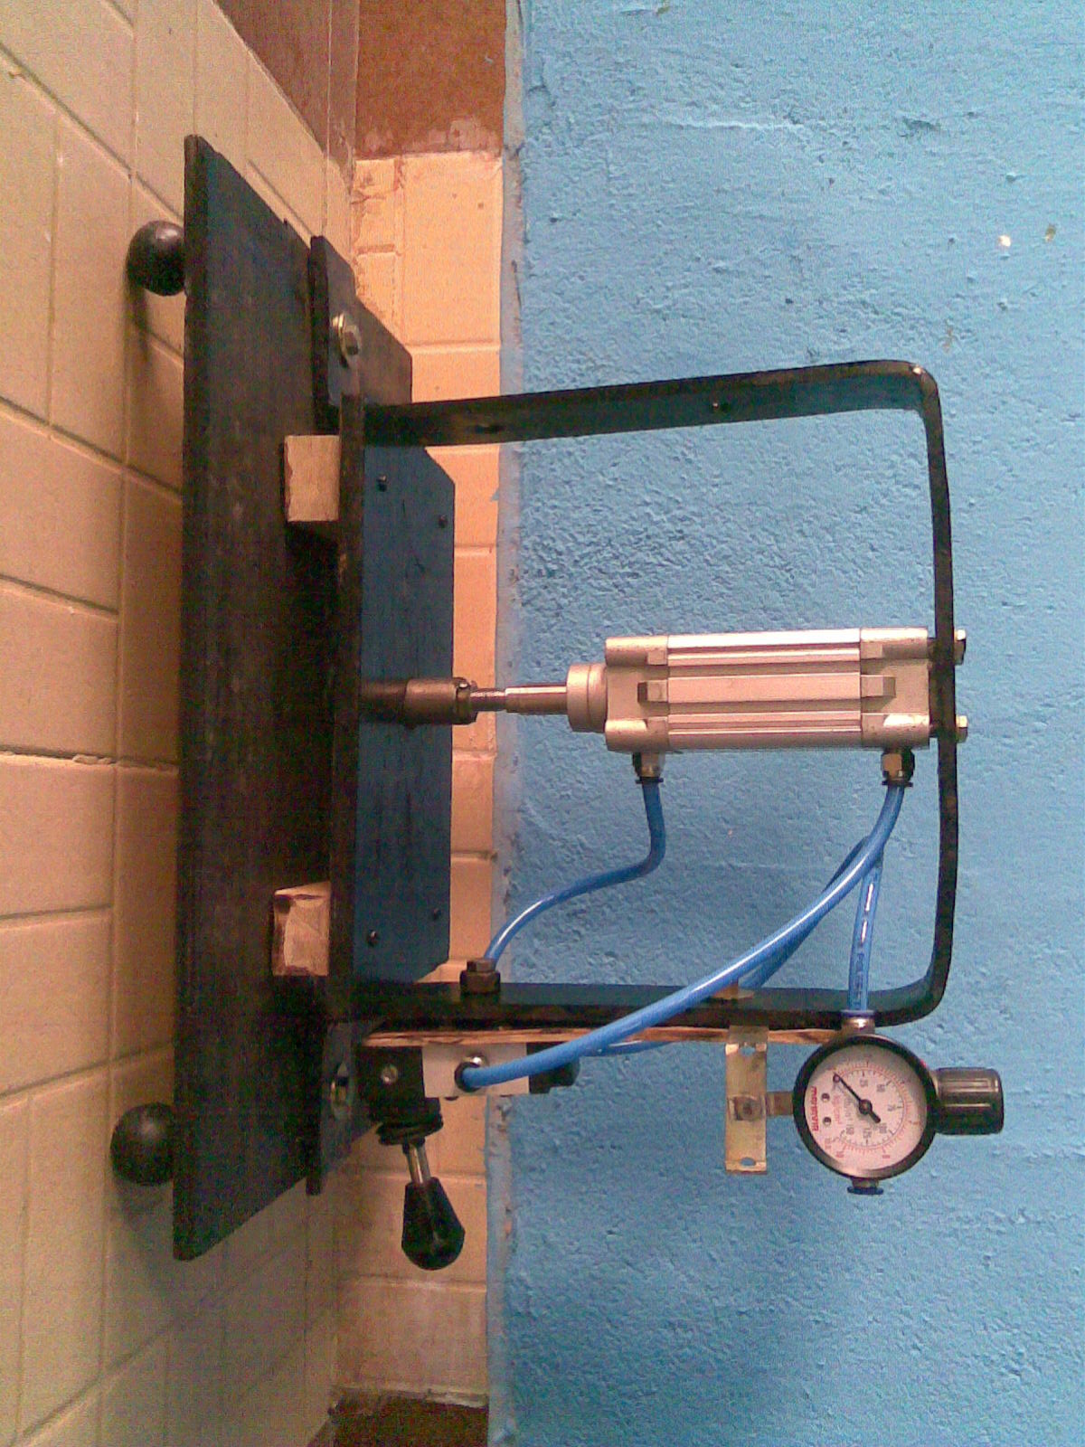

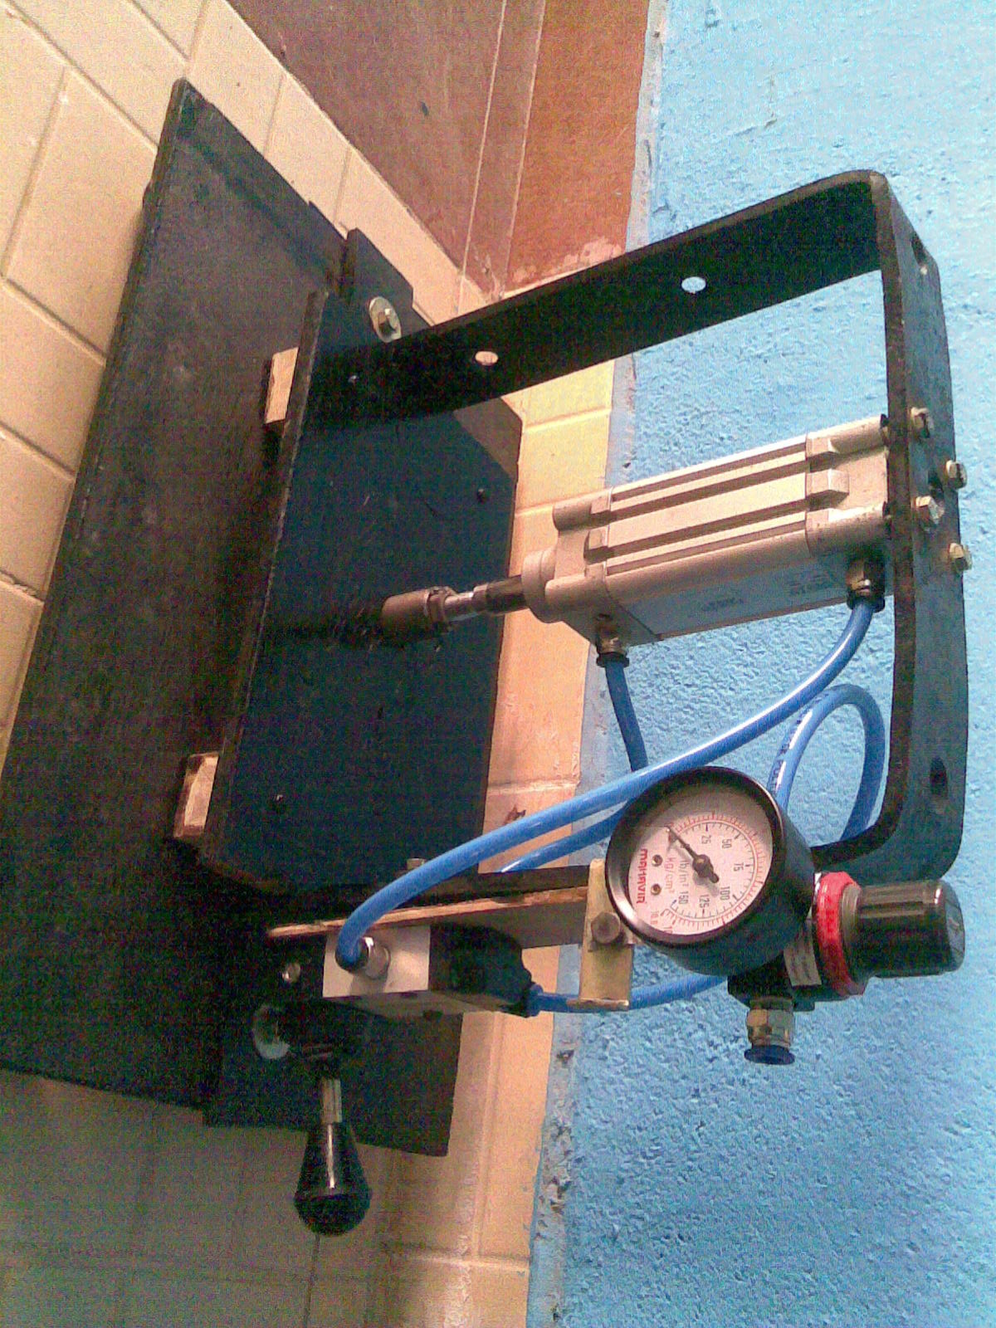

FIG 11 WORKING MODEL PICTURE

**CHAPTER – 12**

**CONCLUSION**

**CONCLUSION**

The project carried out by us made an impressing task in the field of small scale industries and automobile maintenance shops. It is very usefully for the workers to carry out a number of operations in a single machine. This project has also reduced the cost involved in the concern. Project has been designed to perform the entire requirement task which has also been provided.

**CHAPTER – 13**

**REFERENCE**

* J. Gresham, W. Cantwell, M.J. Cardew Hall, P. Compston, S. Kalyanasundaram. Drawing behaviour of metal–composite sandwich structures, Volume 75, Issues 1–4, Pages 305–312, September 2006
* A.A. Ambekar, S.K Maiti, U.P Singh, P.P Date, K Narasimhan, Assessment of influence of some process parameters on sheet metal blanking,” Volume 102, Issues 1–3, Pages 249–256, 15 May 2000.
* D. Dornfeld and S. Min, A Review of Burr Formation in Machining, Consortium on Deburring and Edge Finishing, Laboratory for Manufacturing and Sustainability, UC Berkeley, 2007.
* Prof. T. Z. Quazi, R.S.Shaikh, “An Overview of Clearance Optimization in Sheet Metal Blanking Process,”IJMER, Vol.2, Issue.6, pp-4547- 4558, Nov-Dec. 2012.
* H. Makich, L. Carpentier, G. Monteil, X. Roizard, J. Chambert, P. Picart. Metrology of the burr amount - correlation with blanking operation parameters (blanked material – wear of the punch).
* W. Klingenberg, T.W. de Boer. Condition-based maintenance in punching/blanking of sheet metal.
* S.K. Maitia, A.A. Ambekara, U.P. Singhb, P.P. Datea, K. Narasimhan. Assessment of influence of some process parameters on sheet metal blanking.