Google Compute Engine: VM Creation & NGINX Setup (Console & CLI)

Objectives
In this lab, you learn how to perform the following tasks:
- Create a VM with the Cloud console.
- Create a VM with the gcloud command line.
- Deploy a web server and connect it to a VM
Task 1. Create a new instance from the Cloud console
Create a VM Instance
- In the Cloud console, on the Navigation menu, click Compute Engine > VM Instances.
- To create a new instance, Click Create Instance
- In the Machine configuration:
Field | Value | Additional Information
Name | gcelab | Name for the VM instance
Region | europe-west1 | For more information about regions, see the Compute Engine guide, Regions and Zones.
Zone | europe-west1-b | Remember the zone that you selected to use later. For more information about zones, see the Compute Engine guide, Regions and Zones.
Series | E2
Machine Type | e2-medium | This is an e2-medium, 2-CPU, 4GB RAM instance. Several machine types are available, ranging from micro instance types to 32-core/208GB RAM instance types. For more information, see the Compute Engine guide, About machine families.
Click OS and storage.
Click Change to begin configuring your boot disk and select the values for:
- Operating system: Debian
- Version: Debian GNU/Linux 12 (bookworm)
- Boot disk type: Balanced persistent disk
- Size: 10 GB

Click Networking.
- Firewall: Allow HTTP traffic
- Once all sections are configured, scroll down and click Create to launch your new virtual machine instance.
- To use SSH to connect to the VM, click SSH to the right of the instance name, gcelab

This launches an SSH client directly from your browser.
Click Create and wait for the VM to reach RUNNING state. After that will see the instance.
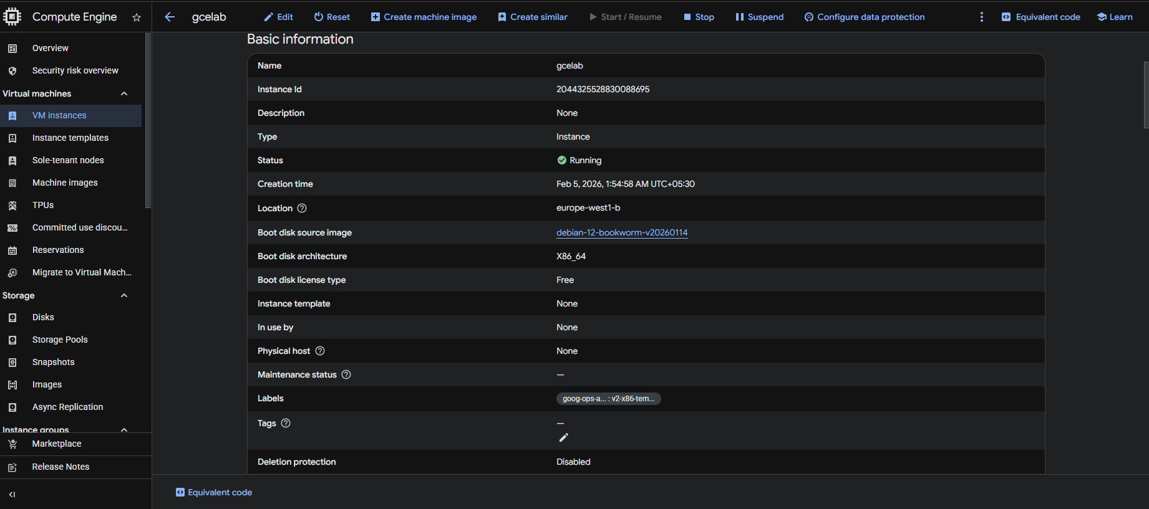

Task 2: Install NGINX Web Server
- Run the following command to update the OS: (sudo apt-get update)
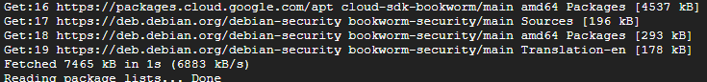
- Run the following command to install NGINX: (sudo apt-get install -y nginx)
- Run the following command to confirm that NGINX is running:(ps auwx | grep nginx)
- To see the web page, return to the Cloud console and click the External IP link in the row for your machine, or add the External IP value to http://EXTERNAL_IP/ in a new browser window or tab.
A default web page should open that says: Welcome to nginx!

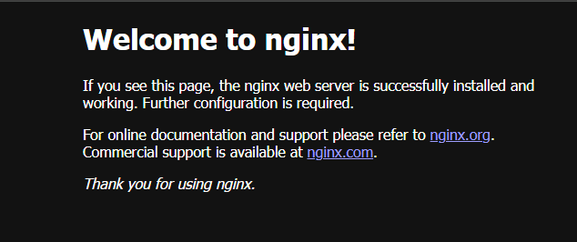

Task 3. Create a new instance with gcloud
Instead of using the Cloud console to create a VM instance, use the command line tool gcloud, which is pre-installed in Google Cloud Shell. Cloud Shell is an interactive shell environment for Google Cloud loaded with all the development tools you need (gcloud, git, and others) and offers a persistent 5-GB home directory.
- In Cloud Shell, run the following gcloud command to create a new VM instance from the command line:
gcloud compute instances create gcelab2 --machine-type e2-medium --zone=$ZONE
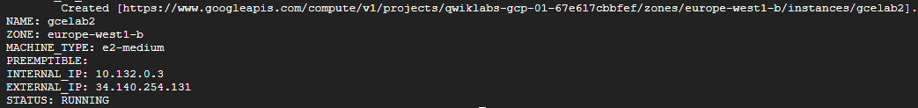
- The Debian GNU/Linux 12 (bookworm) image.
- The e2-medium machine type.
- A root persistent disk with the same name as the instance; the disk is automatically attached to the instance.
When working in your own project, you can specify a custom machine type.
- To see all the defaults, run the following command:
gcloud compute instances create --help
End of Document

