Your Name
CSD-325
Module 4 Assignment

Original Program Flowchart:

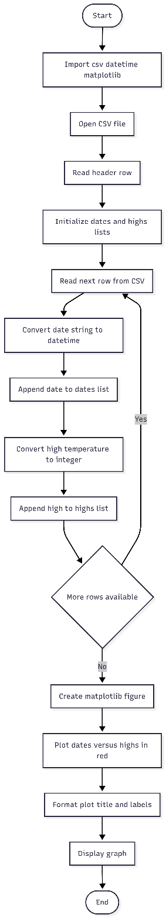

Revised Program Flowchart:
