Daniel Vance
CSD325 Week 11
Django Python Assignment

First web server start before configuration:
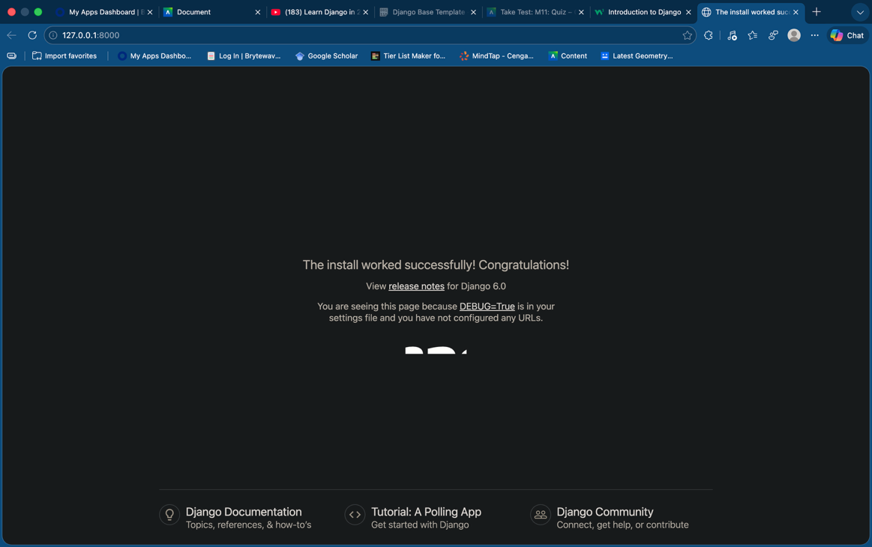

After configuration:
