Daniel Vance
CSD-325
Module 9 – APIs

Testing API connection:
This program tests the connection to a website using the requests module. The status code 200 confirms that the connection was successful. This step ensures the API is reachable before working with returned data.

Astronaut API output:
This program connects to the Open Notify API to retrieve data about current astronauts in space. The program checks the status code before converting the response to JSON format. It then loops through the data and prints the astronauts’ names and spacecraft in a readable format.
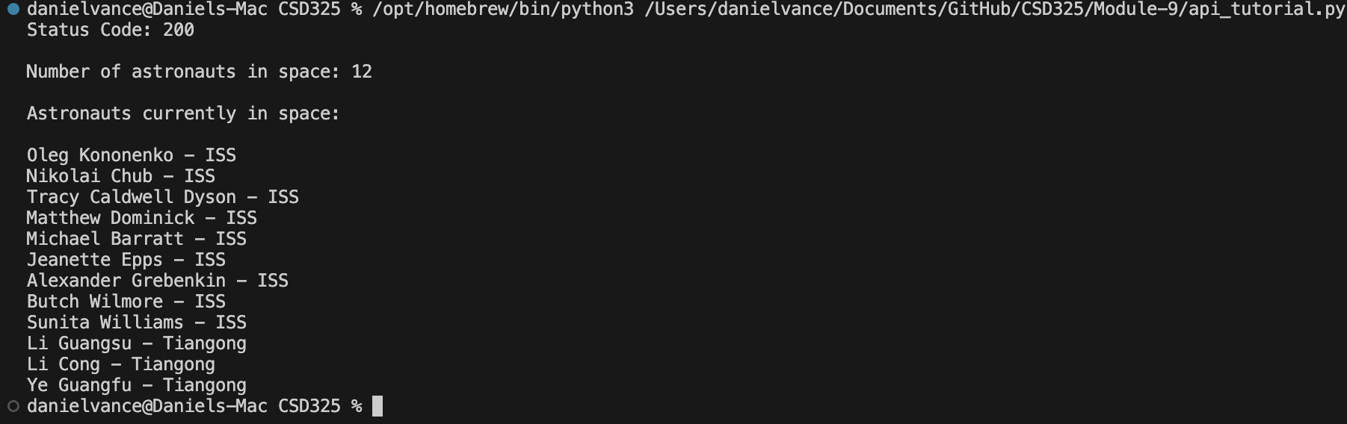

Custom API output- Weather API from open-meteo:
This program connects to the Open-Meteo weather API. First, it tests the connection and prints the raw JSON response. Then it formats the data to display the temperature, wind speed, and wind direction in a cleaner way. This demonstrates how APIs can be used to retrieve and organize real-time data.

