Daniel Vance
Module 10 – GUI ToDo Assignment

Original Program Output:
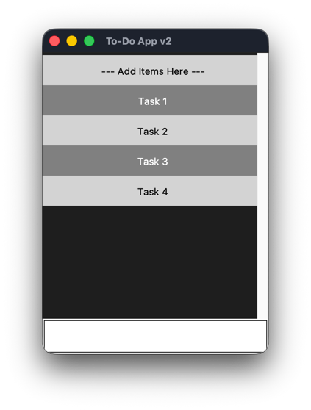
Modified Program Output:
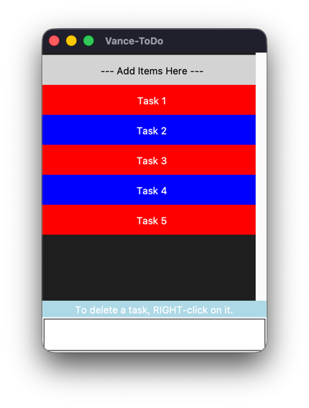
Right clicking a task and showing the file > exit menu:
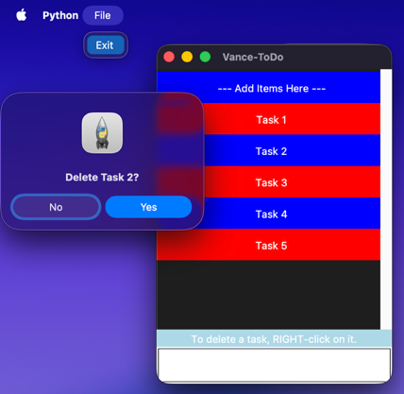
After deleting a task:
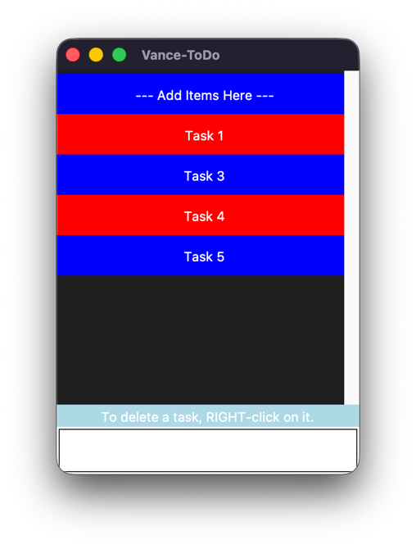
In this assignment, I modified the Scrolling To-Do application from Section 2.2. I changed the window title to “Vance-ToDo.” I added a File menu with an Exit option, so the program closes properly. I changed the menu colors to red and blue. I also modified the program so tasks are deleted using a right mouse click instead of a left click. I also added a label that gives the user instructions on how to delete a task.

