**Objective**: Comparative analysis of ChatGPT vs GitHub Co-Pilot for Software Systems to be ensuring effective uses by software developers’ community.

**ChatGPT** Vs GitHub **Copilot**—AI tools Comparisons

1. By definitions

|  |  |
| --- | --- |
| **ChatGPT** | GitHub **Copilot** |
| Is an Artificial Intelligence {AI} chatbot or Large Language Model {LLM} which is based on natural language processing (NLP) to work together among simple language • Open AI (part of Microsoft) is the company behind ChatGPT, and they are heavily backed by Generative Text APIs of Microsoft like -Bing, Speech to text etc. | Is a cloud-based artificial intelligence tool developed by GitHub and Open AI to assist users of Visual Studio Code, Visual Studio, Neovim, and JetBrains integrated development environments by autocompleting- intelligence coding. Its inbuilt in VS Professionals & Enterprises Subscriptions- latest editions. |

1. Important Use cases for **Code generation** – Highlighted Feature

* Apex Coding or Trigger
* **Triggers**

1. Map contact address details into account object
2. Create Contact record when an Account is created.
3. Prevent recursion on Trigger
4. Bulkification of Apex class for creating Accounts/Contacts in a single DML statement

* **Batch Class**

1. Create an apex batch class that will append “IamTestingCopilot” to all contacts
2. Apex class to fetch 1 million records using batch class
3. Scheduling an Apex Batch every 4 hours

* LWC/Aura/VF/Declarative Options
* **LWC/AURA Component**

1. Create LWC/AURA component with First Name and Last Name as fields
2. Write a code for creating an aura component with submit and cancel button
3. Test class for LWC Batch Class
4. Create visual force page to render 2 images side by side
5. Rendering

* **VF pages**

1. Create visual force page to render 2 images side by side
2. Rendering VF pages as PDF

* **Declarative Options**

1. Delete related contacts whenever its associated account is deleted using Lightning Flows
2. Send an email and create a task when Opportunity is closed
3. Throw an error message whenever Account Number contains alphabets using Validation Rule.
4. **Use Case Analysis**

|  |  |
| --- | --- |
| ChatGPT | GitHub Copilot |
|  |  |

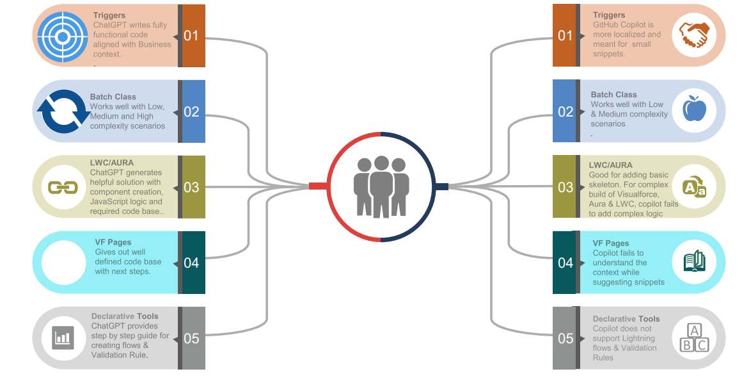

1. **Our Analysis – Overviews**

**ChatGPT** is the front-runner when it comes to accurateness and responsiveness of writing a code aligned with business requirements. Both ChatGPT and GitHub Copilot would need to be connected to one of our Salesforce / CRM -Developers -org for deeper insights into quality of code generated.

**ChatGPT model** It’s premature to do judgment on the **real time usage** and code generation, however ChatGPT delivers more accurate and Business use case related code.

**GitHub Copilot model -**GitHub Copilot is actual localized and works seamlessly with **Visual Studio Code**. It Prompts and suggest various coding solutions based on existing coding and methods residing in code base.

**Core Limitations**

* + Unable to pursue design patterns
  + AI Engine - Data resource is not yet configurable for ChatGPT
  + Compared to Java & Python, Salesforce Code generation is more secondary

1. **Model assessment instructions**

The instructions below evaluate the two models to help you decide which is best for Salesforce/ CRM Developers

|  |  |  |
| --- | --- | --- |
| **Actions** | **ChatGPT Results** | **Copilot Results** |
| Promptness | Promptness of code is governed by refined keyword inputs to ChatGPT Open AI based bot. | Gives coding solutions for same  keyword search. |
| Accuracy | Code generated using appropriate keywords, produces contextual, accurate and relatable code aligned to Business needs. | More accurate on localized code and small snippets. |
| Quality | Writes efficient Test Classes for the Apex classes.  Lesser manual intervention required to refactor the test Classes | Writes Test classes, however manual interference is needed to modify the code base |
| Efficiency | 1. Developers’ productivity likely to go up by 20-25% in case of brand-new components. 2. Developers’ productivity likely to go up by 5-10% in case of enhancing an existing component | 1. Developers’ productivity likely to go up by 20-25% in case of brand-new components 2. Developers’ productivity likely to go up by 5-10% in case of enhancing an existing Components. |
| **Licensing** (Prices mentioned are from the official website, not Organizational Licensing  Team) | ChatGPT – Free Edition with Limited Features  ChatGPT Plus – 20$ Per User/Per Month  ChartGPT Professional – 42 $ Per User/Per Month | CoPilot – Free Edition – 60 days  CoPilot Enterprise – 10$ Per User/Per Month  CoPilot Business – 19$ Per User/Per Month |

**Supplement – Practical Show cases**

1. Create an apex batch class that will append “IamTestingCopilot” to all contacts.

|  |  |
| --- | --- |
| Copilot | ChatGPT |

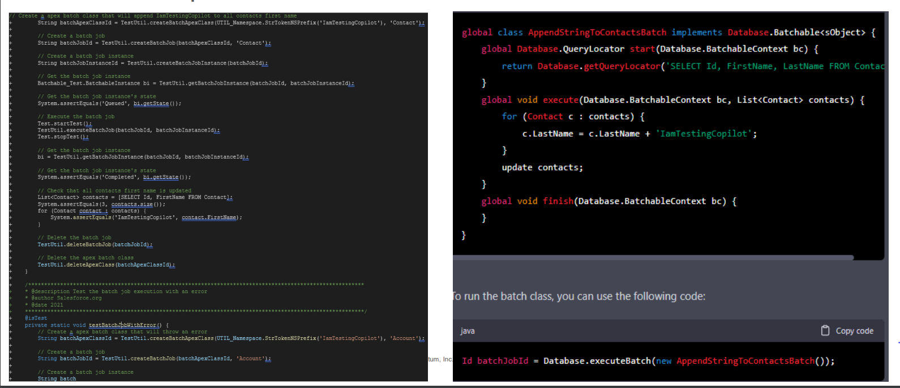

1. Create batch apex class which update contact mailing city with account billing city.

|  |  |
| --- | --- |
| Copilot | ChatGPT |

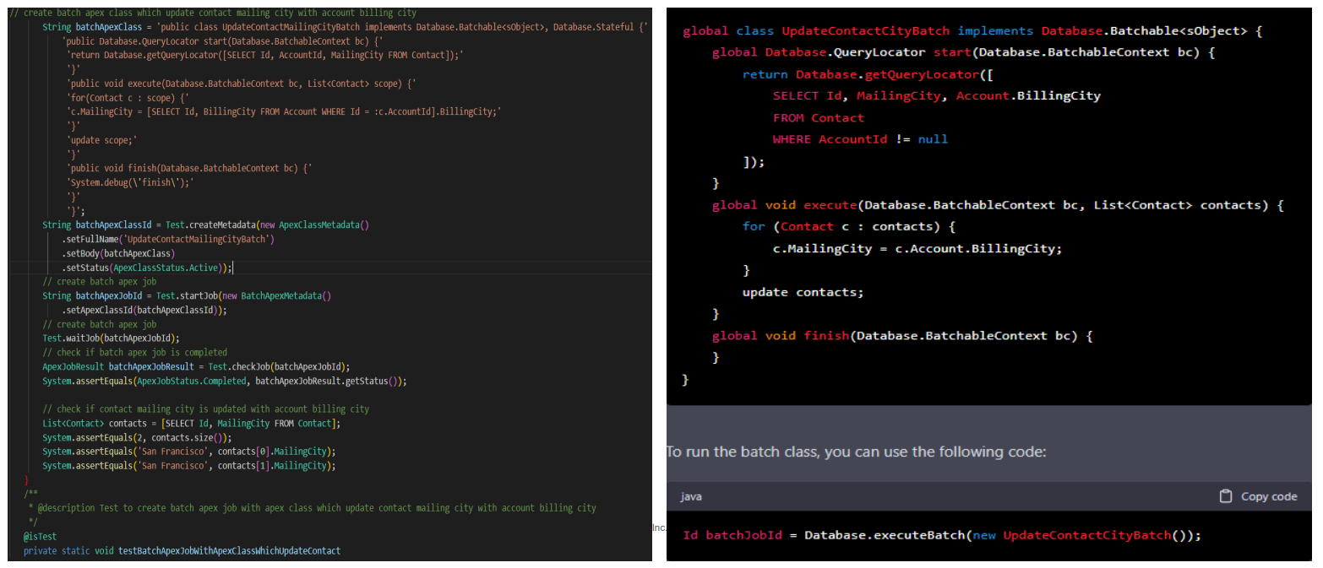

3. Create batch apex class which will create tasks for all the cases which are in New Status

|  |  |
| --- | --- |
| Copilot | ChatGPT |

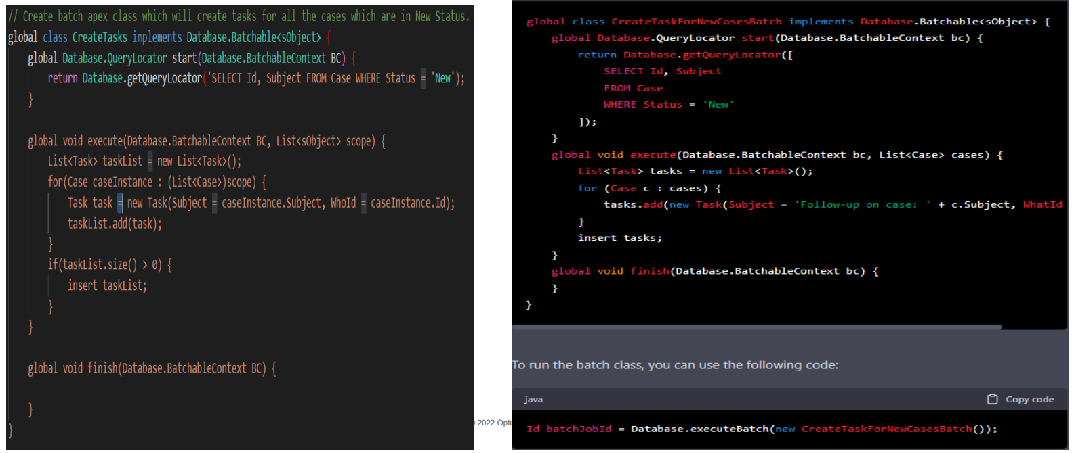

4. Write an apex class to fetch 1 million records using batch class

|  |  |
| --- | --- |
| Copilot | ChatGPT |

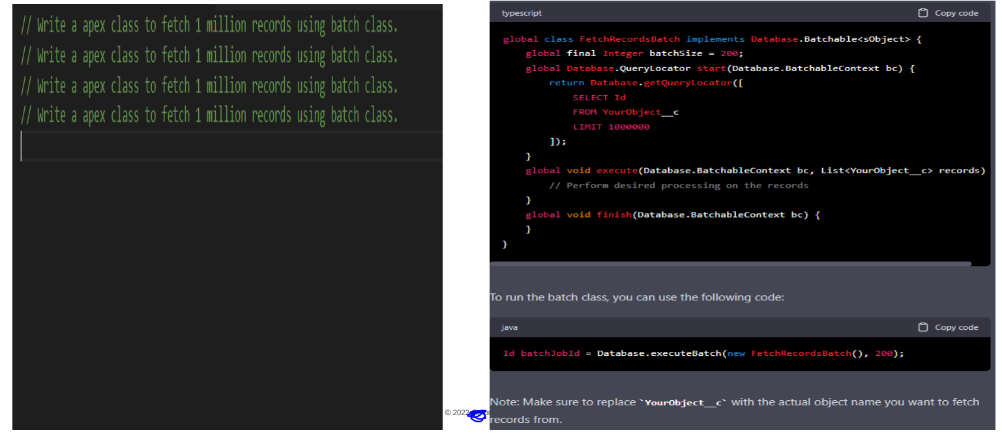

5. Write a batch apex on account record

|  |  |
| --- | --- |
| Copilot | ChatGPT |

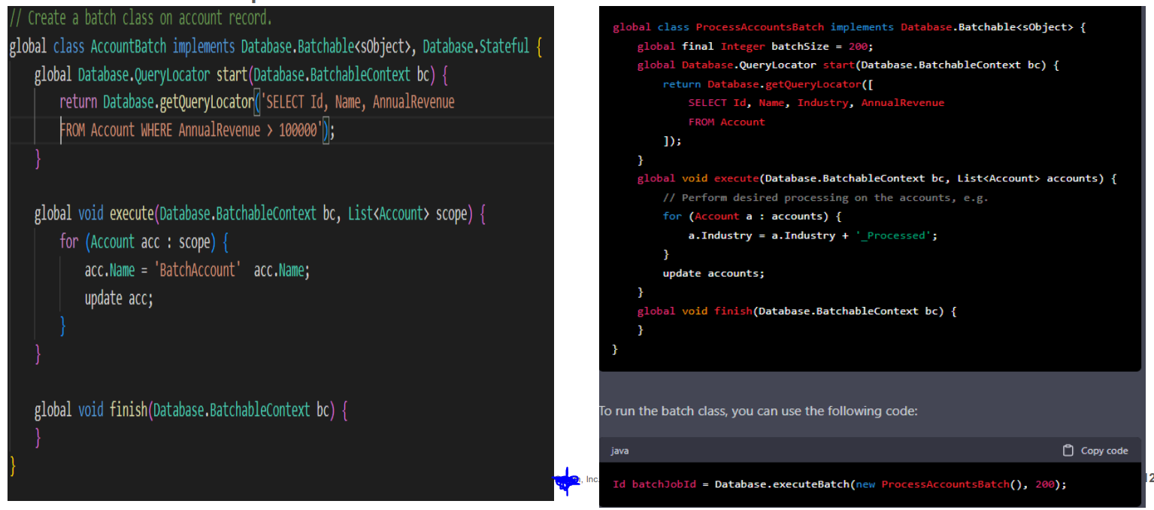

6. Write a salesforce trigger to map contact address details into account object:

|  |  |
| --- | --- |
| Copilot | ChatGPT |

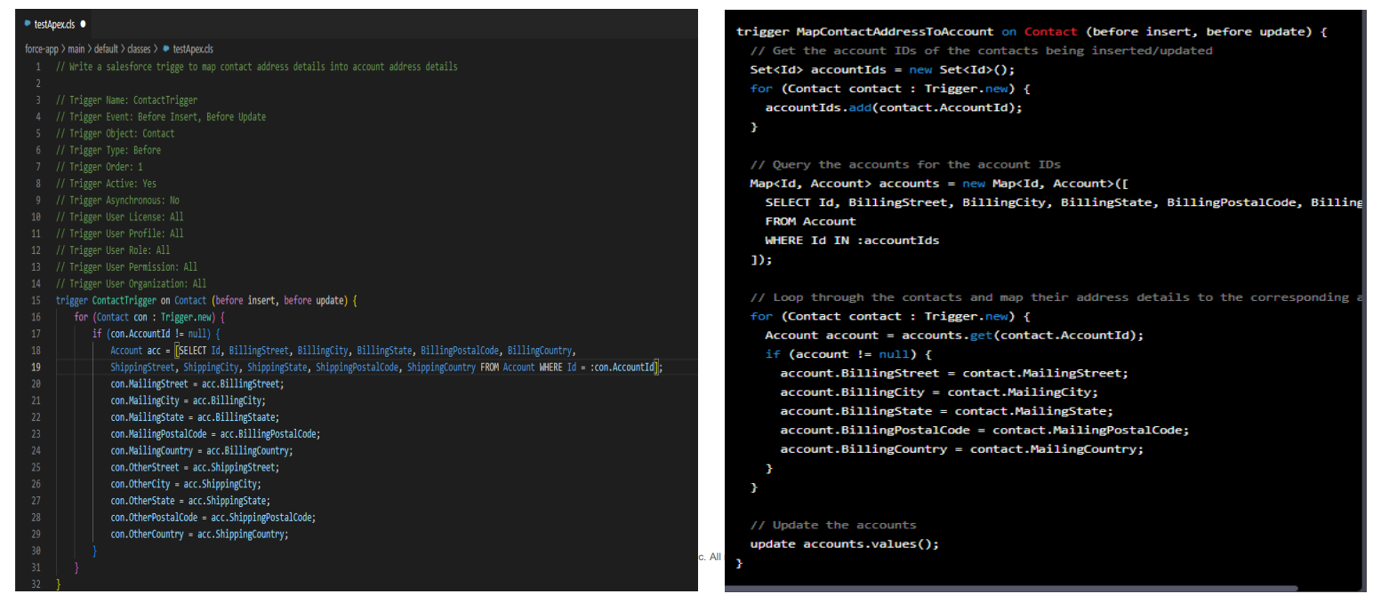

|  |  |
| --- | --- |
| Copilot | ChatGPT |

|  |  |
| --- | --- |
| Copilot | ChatGPT |

|  |  |
| --- | --- |
| Copilot | ChatGPT |

|  |  |
| --- | --- |
| Copilot | ChatGPT |

|  |  |
| --- | --- |
| Copilot | ChatGPT |

|  |  |
| --- | --- |
| Copilot | ChatGPT |

|  |  |
| --- | --- |
| Copilot | ChatGPT |

|  |  |
| --- | --- |
| Copilot | ChatGPT |

|  |  |
| --- | --- |
| Copilot | ChatGPT |

|  |  |
| --- | --- |
| Copilot | ChatGPT |

|  |  |
| --- | --- |
| Copilot | ChatGPT |

|  |  |
| --- | --- |
| Copilot | ChatGPT |

|  |  |
| --- | --- |
| Copilot | ChatGPT |

|  |  |
| --- | --- |
| Copilot | ChatGPT |

|  |  |
| --- | --- |
| Copilot | ChatGPT |

|  |  |
| --- | --- |
| Copilot | ChatGPT |

Connect me for more details >> <https://wa.me/919742970789>