Architecture Design
for
Brew Day!
Version 1.1 approved
Prepared by Wang Zimeng
Zhou Haiyun
Wu Shihua
Dan Yuxi
Hopper
<2019/4/3>
Table of Contents
Table of Contents ii
Revision History ii
1. Overview 1
1.1 Project description 1
1.2 References 1
1.3 Design purpose 1
2. Overall description 1
2.1 Use case diagram and class diagram 1
2.2 Design model 1
2.3 System architecture 1
3. System architecture 1
3.1 Recipe subsystem 1
3.1.1 Description 1
3.1.2 Database 2
3.2 Equipment subsystem 2
3.2.1 Description 2
3.2.2 Database 2
3.3 Note subsystem 2
3.3.1 Description 2
3.3.2 Database 2
4. Assessment 2
4.1 Stability 2
4.2 Reusability 2
4.3 Scalability 2
5. Alternative design (optional) 3
6. More considerations 3
7. Appendix 3

Revision History
Name | Date | Reason For Changes | Version
Wang zimeng | 4/3/2019 | Add content | 1.1

Overview

Project description
Brewing day! Is an app that allows home winemakers to maintain an organized database of their beer recipes. The app allows users to create, store and modify recipes and delete them later if the user wishes to do so. This application is only available for “whole grain” winemakers, so all formulations are suitable for this type of brewing.

References
1.http://score-contest.org/2018/index.php
2.SRS_Hopper_1.4_Final

Design purpose
The purpose of the project is to develop an app for home winemakers to maintain a list of recipes and adjust existing recipes. The application must also maintain a list of available ingredients, update the list after the batch, and when to purchase new ingredients and generate a next batch of shopping lists. A feature of the app is "What should I brew today?" Advantages: It allows for the formulation of ingredients that can be brewed using available ingredients, considering the available ingredients and brewing capabilities of the device, maximizing ingredient usage and batch size.

Overall description

Use case diagram and class diagram

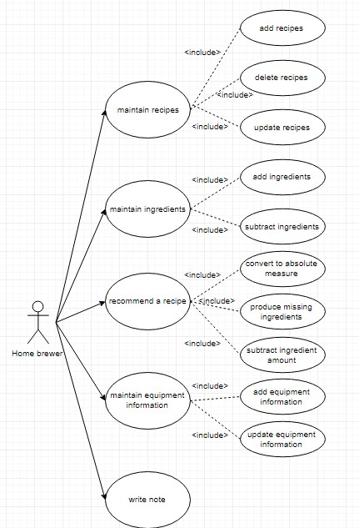
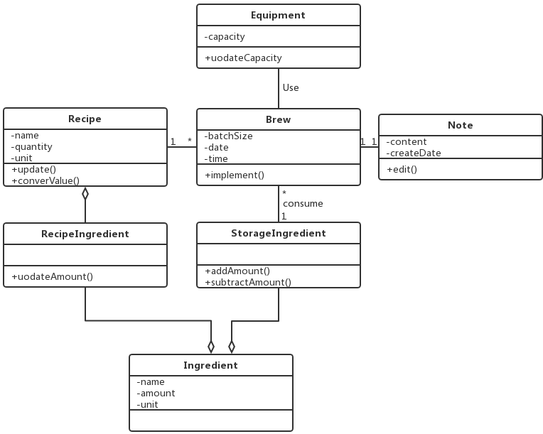

Design model
The system architecture model we used in this design is MVC model and layered model. Because MVC does not depend on any view or controller subsystems, which means it’s independent. And layered model includes all boundary objects, all control and entity objects, and can realize the storage retrieval and query of persistent.

System architecture 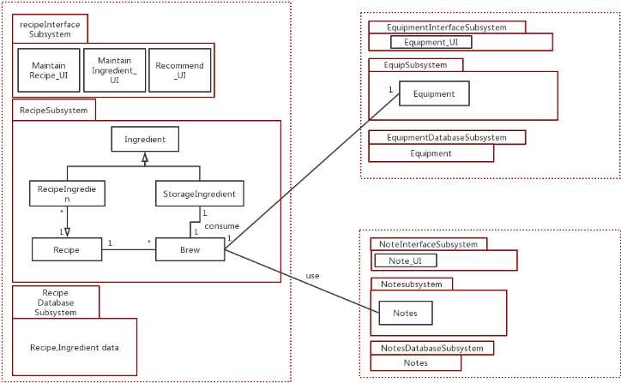
Here are three subsystems: Recipe Subsystem, Equipment subsystem and Note Subsystem. Recipe subsystem use other subsystems via class Brew.

System architecture

Recipe Subsystem
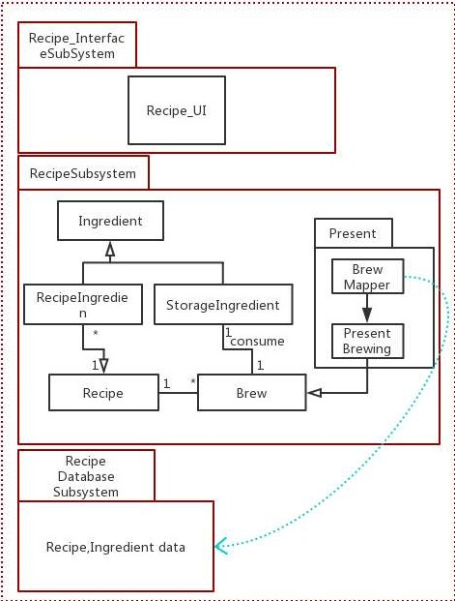

Description
Recipe subsystem has three parts, the interface part, the control part and the database part. In the control part, it contains maintain recipes, maintain ingredients and recommend a recipe function.

Database
Recipes
name | quality | Unit

Brew
batchSize | date | time

Ingredient
Name | amount | unit

Equipment subsystem
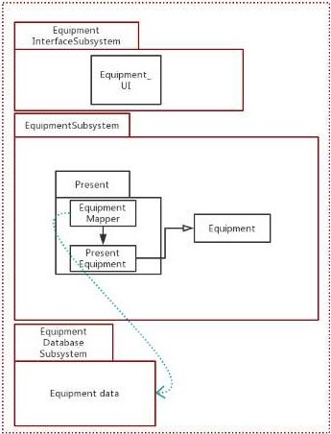

Description
It has maintaining equipment function.

Database
Equipment
id | capacity

Brew
Batch Size | Date | Time

Note subsystem
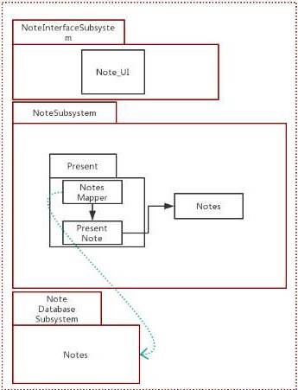

Description
This subsystem is use for write notes.

Database
Note
content | createDate

Brew
batchSize | date | time

Ingredient
Name | amount | unit

Assessment

Stability
This system is stable, since the communication between two subsystems via parameter passing. Each component within a subsystem work together performing as one function.

Reusability
Since we use JAVA to program every subsystem, the reusability of every component (except the part of UI) has high reusability.

Scalability
Its scalability may not be so good, because the MVC model view we use is too tightly connected to the controller, and the system structure is more complicated. We are not good at extending new functions, and the changes are too complicated.

Alternative design (optional)
None

More considerations
More specific about functions and database.

Appendix
None.

