Detailed Design
for
Brew Day!
Version 1.0 approved
Prepared by Wang Zimeng
Zhou Haiyun
Dan Yuxi
Wu Shihua

Hopper
2019/4/9
Table of Contents
Table of Contents ii
Revision History ii
1. Overview 1
1.1 Project description 1
1.2 References 1
1.3 Design purpose 1
2. Overall description 2
2.1 Class diagram 2
2.2 Refinements 2
3. Detailed design 3
3.1 Class diagram 3
3.2 Classes 3
3.2.1 Brew 3
3.2.2 Recipe 4
3.2.3 RecipeIngredient 4
3.2.4 StorageIngredient 5
3.2.5 Ingredient 6
3.2.6 Note 6
3.2.7 Equipment 7
4. Alternative detailed design (Optional) 7
5. More considerations 7

Revision History
Name | Date | Reason For Changes | Version

Overview

Project description
Brewing day! is an app that allows home winemakers to maintain an organized database of their beer recipes. The app allows users to create, store and modify recipes and delete them later if the user wishes to do so. This application is only available for “whole grain” winemakers, so all formulations are suitable for this type of brewing.

References
SRS_Hopper_1.4_Final.doc
Architecture_Design_Hopper_1.1.doc

Design purpose
The purpose of the project is to develop an app for home winemakers to maintain a list of recipes and adjust existing recipes. The application must also maintain a list of available ingredients, update the list after the batch, and when to purchase new ingredients and generate a next batch of shopping lists. A feature of the app is "What should I brew today?" Advantages: It allows for the formulation of ingredients that can be brewed using available ingredients, considering the available ingredients and brewing capabilities of the device, maximizing ingredient usage and batch size.

Overall description

Class diagram
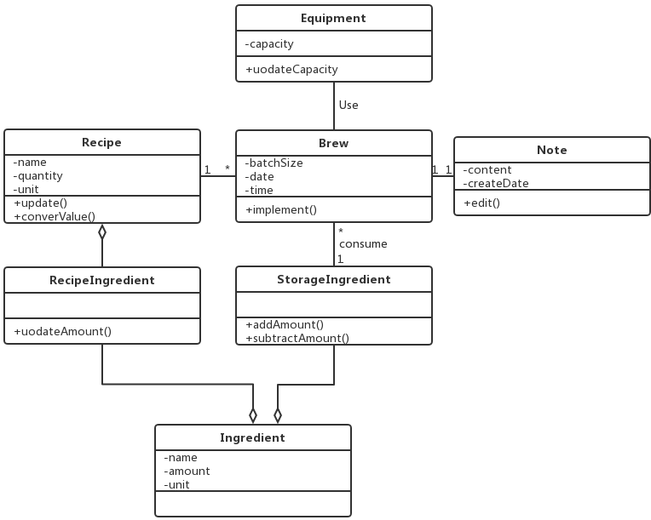

Refinements
- Brew class is added signature for all attributes and operations, and we also add pre-condition, post-condition.
- Specify pre-conditions and post-conditions and add types of parameters for the class Recipe.
- RecipeIngredient class is added three private parameters with types. Pre-conditions and post-conditions are specified and types of parameters are added.
- StorageIngredient class is added three private parameters with types. Specify pre-conditions, post-conditions and types of all parameters for this class.
- Ingredient class is added two public functions. Specify pre-conditions, post-conditions and types of all parameters for this class.
- Note class is added signature for all attributes and operations, also add pre-condition, post-condition.
- Equipment class is added signature for all attributes and operations, also add pre-condition, post-condition.

Detailed design

Class diagram
- Identifying missing attributes and operations for all the classes.
- Specify visibility and signature for all the subsystems.
- Use qualifier to change the one to many and many to many relationships.
- Correct some mistakes.
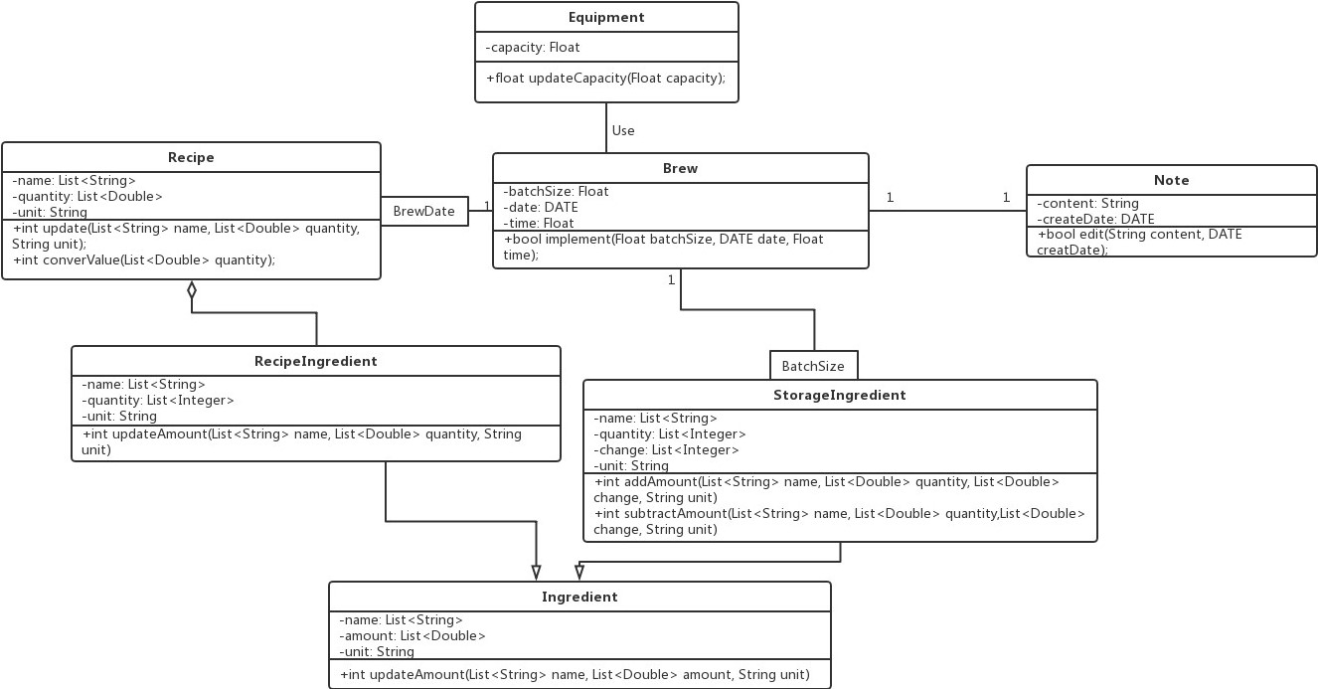

Classes

Brew
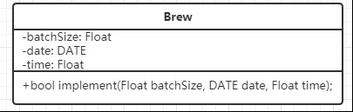

Explanations

None.

Constraints (optional)

Pre-condition: batchSize, date, time are not null.
Post-condition: 1. if system cannot find the corresponding recipe, then return FALSE.
2. otherwise, return TRUE.

Recipe
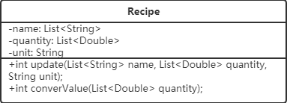
Explanations

No attributes or operations are added or removed in this class.

Constraints (optional)
For the operation int update (List<String> name, List<Double> quantity, String unit):
Pre- conditions: name, quantity, unit are not null
Post-conditions:
- If update fails because of there is any name in the list doesn’t exist, return 0;
- If quantity is minus number or invalid number (maybe too long), return 1;
- If unit is meaningless string, return 2;
- If return success, return 3;
For the operation int converValue (List<Double> quantity):
Pre- conditions: quantity is not null
Post-conditions:
- If any quantity in the list is invalid, return 0;
- If convert successes, return 1;

RecipeIngredient
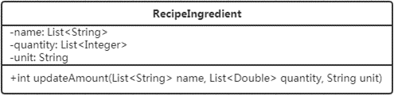
Explanations

Add parameters:
List <String> name: records of names in the recipes
List<Integer> quantity: record of quantity that have updated
String unit: unit that users want to use to record quantity

No operation is added.

Constraints (optional)
For the operation int updateAmount(List<String> name, List<Double> quantity, String unit):
Pre- conditions: name, quantity, unit are not null
Post-conditions:
- If update fails because of there is any name in the list doesn’t exist, return 0;
- If quantity is minus number or other invalid number (maybe too long), return 1;
- If unit is meaningless string, return 2;
- If return success, return 3;

StorageIngredient
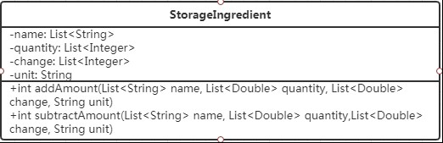
Explanations

Add parameters:
List <String> name: records of names in the recipes
List<Integer> quantity: origin quantity of every ingredient in storage
List<Integer> change: record of quantity that they want to add or subtract to the origin data.
String unit: unit that users want to use to record quantity

No operation is added.

Constraints (optional)

For the operation int addAmount(List<String> name, List<Double> quantity, String unit):
Pre- conditions: name, quantity, unit are not null
Post-conditions:
- If update fails because of there is any name in the list doesn’t exist, return 0;
- If quantity is minus number or invalid number (maybe too long), return 1;
- If unit is meaningless string, return 2;
- If change is minus, return 3;
- If return success, return 4;
For the operation int subAmount(List<String> name, List<Double> quantity, String unit):
Pre- conditions: name, quantity, unit are not null
Post-conditions:
- If update fails because of there is any name in the list doesn’t exist, return 0;
- If quantity is minus number, or other invalid number (maybe too long), or change is bigger than quantity, return 1;
- If unit is meaningless string, return 2;
- If change is minus, return 3;
- If return success, return 4;

Ingredient
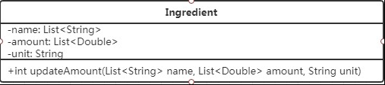
Explanations

Add operation:
int updateAmount(List<String> name, List<Double> amount, String unit):
This is used to update the information in Ingredient class.

No parameter is added.

Constraints (optional)

For the operation int updateAmount(List<String> name, List<Double> quantity, String unit):
Pre- conditions: name, quantity, unit are not null
Post-conditions:
- If update fails because of there is any name in the list doesn’t exist, return 0;
- If quantity is minus number or invalid number (maybe too long), return 1;
- If unit is meaningless string, return 2;
- If return success, return 3;

Note
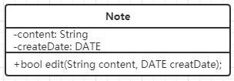
Explanations

None.

Constraints (optional)

Pre-condition: content and creatDate are not null.
Post-condition: 1. If the content is empty, return FALSE.
2. otherwise, return TRUE.

Equipment
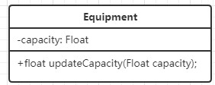
Explanations

None.

Constraints (optional)

Pre-condition: capacity is not null.
Post-condition: return the newest capacity of equipment.

Alternative detailed design (Optional)
None

More considerations
None

