Test Report
for
<Brew Day!>
Prepared by <Myron, Violet>
<Hopper>
<2019/5/12>
Contents
1. Brief description 1
2. Test date and performer 1
3. References 1
4. Error report 1
5. Appendix 1

Brief description
Testing time:
For recommending function, testing with no error occurred costs 10 seconds and with exceeding capacity error takes 20 seconds, for wrong input type costs also 10 seconds.
Difficulties:
There is a problem of data synchronization during the testing process, we fixed it for modifying the database of equipment. The user interface a little reductant for recommending, fixed for modifying the recommend recipe page. TestComplete is incompatible with eclipse, resorted for changing registry file and reboot.

Test date and performer
Test Date: 2019/5/12
Tester Name: Myron, Violet

References
Test_plan_Hopper.docx

Error report
<Describe the errors that have been found during the testing. Only the test cases (scenarios) that produced the unexpected results should be listed>

Test case ID | Expected result | Actual result
1 | When batch size is 0, there should have a warning. | When batch size is 0, the UI of Recommend Recipe occurs.
2 | When batch size exceeds equipment capacity, a warning appears. | When batch size exceeds equipment capacity, the UI of Recommend Recipe occurs.

Appendix

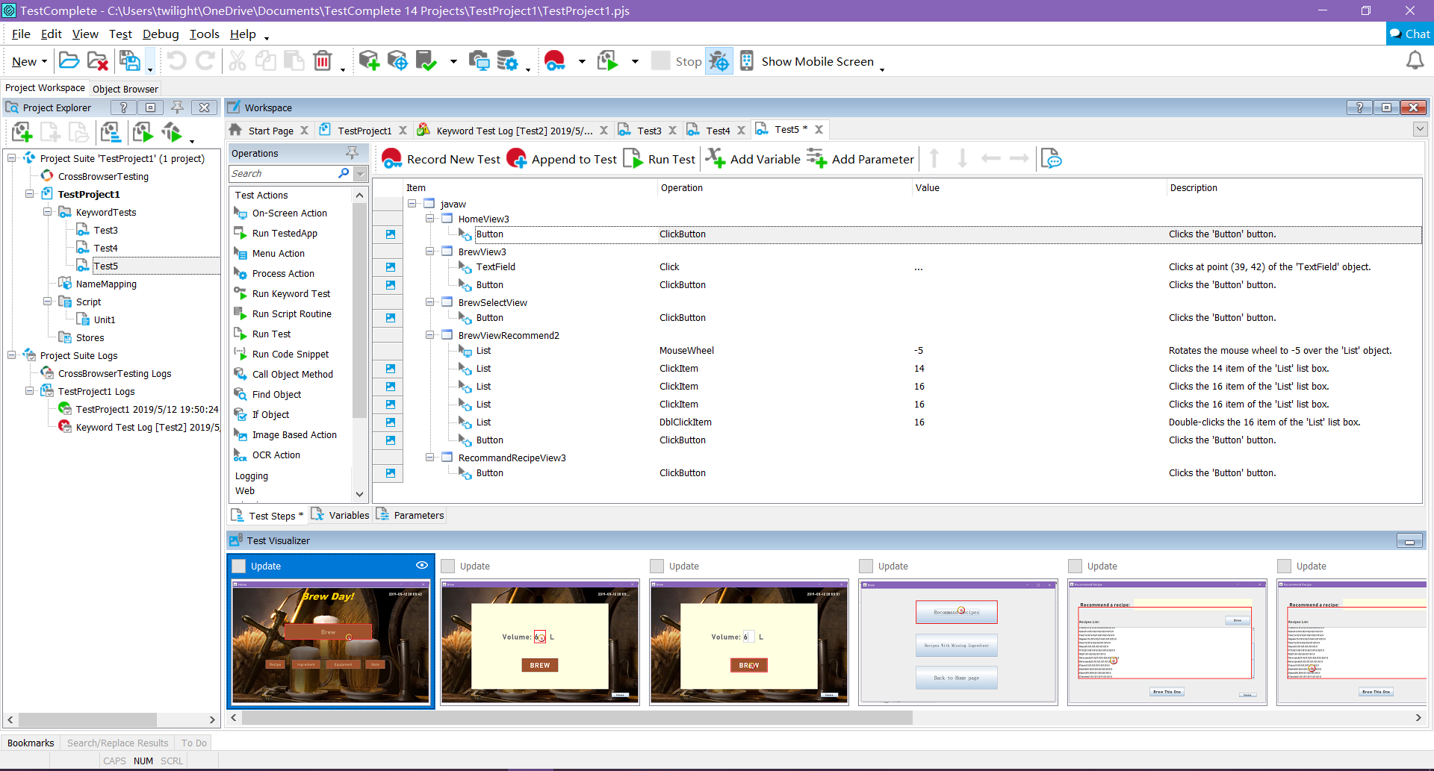
Figure 1: Build new testing script, recording the testing process.
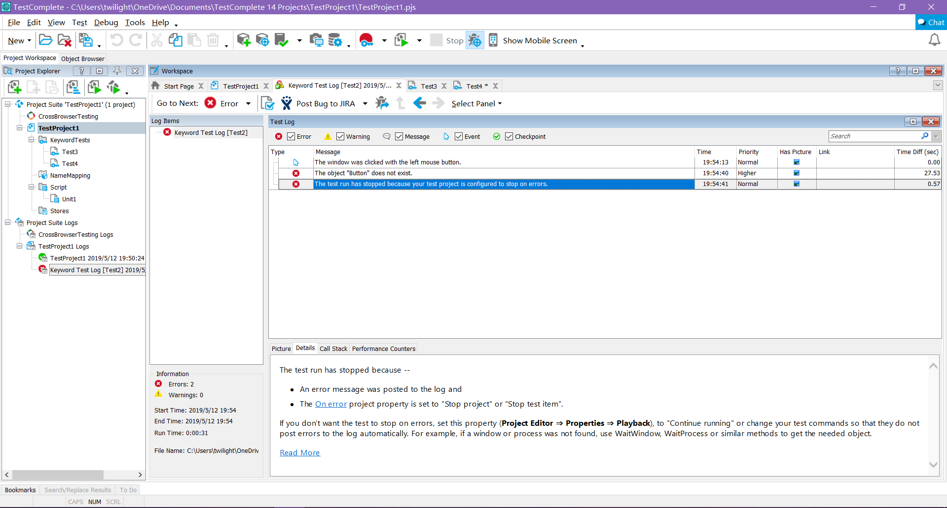

Figure 2: Errors occur for exceeding the equipment capacity.

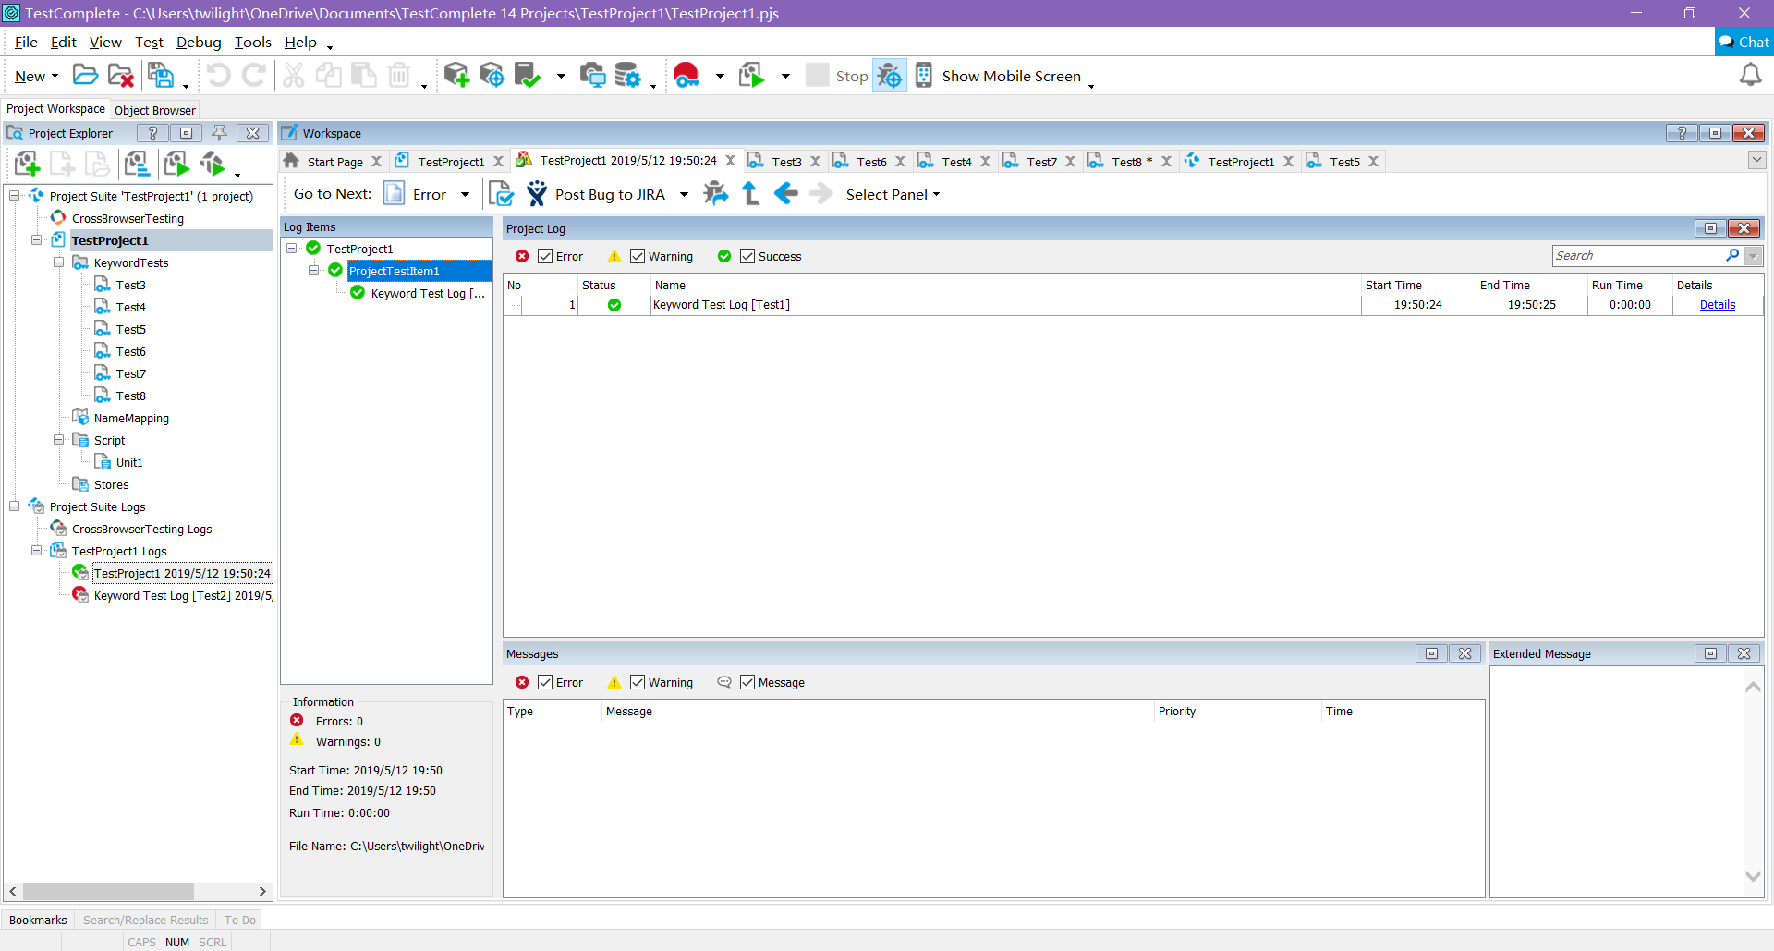
Figure 3: Passing test for input smaller than capacity.

Figure 4: Testing successes in duration of 0.5 second with 0 error and warning.
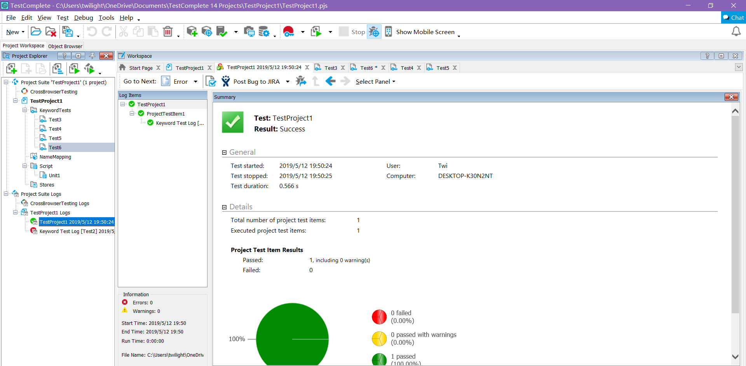

Figure 5: Testing passed log showing full health
