Create An IAM Group

Step 1: Login to AWS console and navigate to IAM.

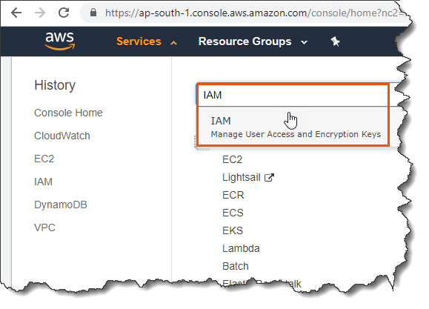

Step 2: Navigate to ‘Groups’ and click ‘Create New Group’.

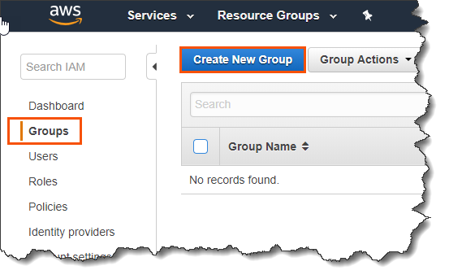

Step 3: Provide a group name and click ‘Next Step’.

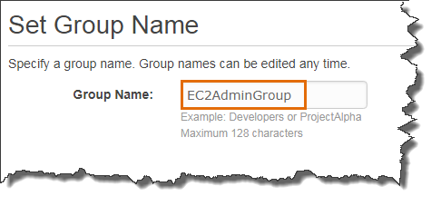

Step 4: Attach a group policy and click ‘Next Step’ and the click ‘Create Group’.

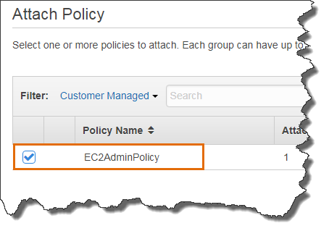

Step 5: To add user into the group, select the group and from ‘Group Actions’ click ‘Add Users to Group’.

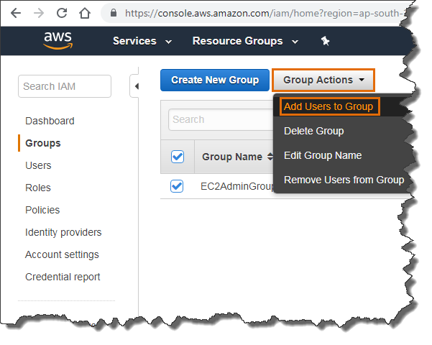

Step 6: Select the user and click ‘Add Users’.

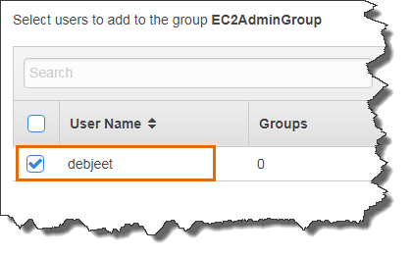

IAM user debjeet successfully added to the group.

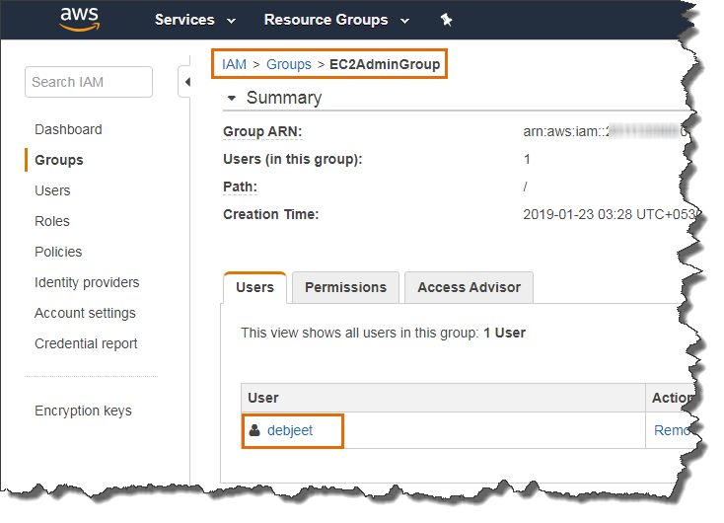

To get more details on IAM, please refer below AWS documentation

<https://docs.aws.amazon.com/iam/index.html>